**Attendee Management System (AMS)**

**Frequently Asked Questions (FAQs)**

1. **System Requirements**

* **What are the system requirements to make AMS work in a computer?**
  + *Java Runtime E­nvironment (JRE 1.8) for both Server and Client*
  + *MariaDB for Server only*

1. **Server**

* **What are the things to consider in installing MariaDB?**
  + *Use “root” as password in these two fields* 
  + *Make sure to check this setting* 
* **How to set up the database?**
  + *Open MariaDB and click File -> Load SQL file. Look for the AMS.sql in the setup folder then click*  *to run the query.*

1. **Client**

* **How can I connect client to the server?**
  + *First click*  *in the first window. Then enter the Server’s IP Address in the given field and click Save Changes.*
* **What are the possible problem when the client can’t connect to the server even if the server’s ip address is correct?**
  + *The client is connected to another router that is not used by the server.*
  + *The server is turned off.*

1. **Import the Excel File**

* **How can I import attendees using excel?**
  + *First, use the  to produce the AMS format of excel file. Then you can fill the given columns of the attendee to be saved.*

1. **Add**

* **How to add a new attendee?**
  + *Just click  then fill up the fields needed.*
  + *Fields with asterisk (*) are required fields.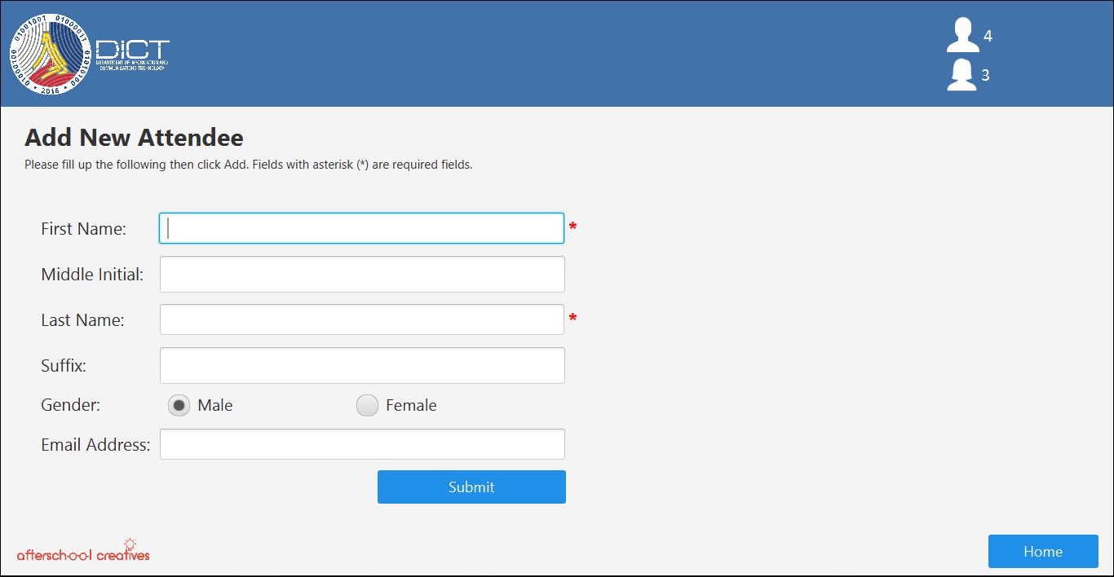*

1. **Update**

* **How to edit or update the attendee’s information?** 
  + *You can click the pen and paper button  on the right side of the attendee’s row or just double click the row itself.*

**

1. **Delete**

* **How to delete an attendee?** 
  + *Just select the attendee(s) you would like to delete then click  to proceed.*

1. **Upload Certificate Template**

* **How to upload a certificate template to be used?**
  + *First click  then click . Locate and choose the PDF file of the certificate template you want to use then click Open*.

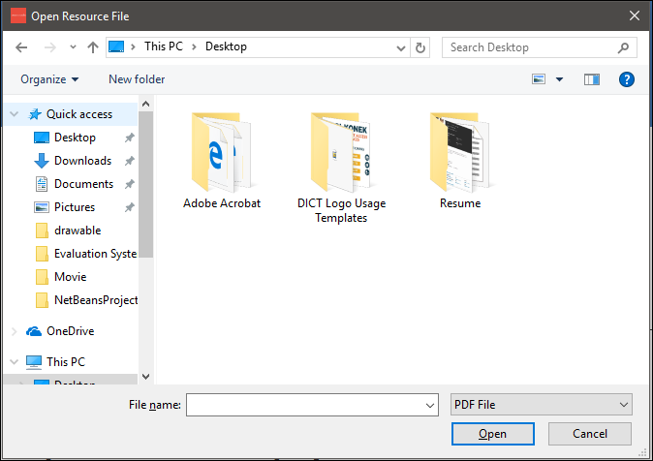

1. **Generate Certificate**

* **How to generate a certificate per attendee?**
  + *First, select the attendee(s) you want to generate a certificate.*

**

*Then click .*

* **How to set the layout into proper location of the attendee’s name?**
  + *You can change the  to move the name upward or downward position. Select the  for easier and faster checking of the layout and uncheck if done.*

1. **Header Display**

* **How to add or change the Event details to be displayed in the header of the window?**
  + *Click  then in the lower part is the Update Header Display.*

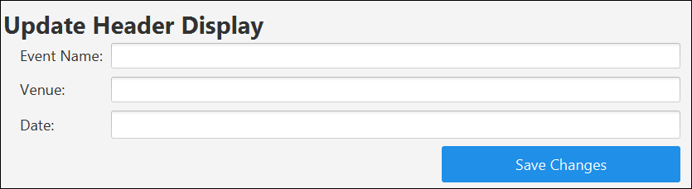

1. **View Generated Certificates**

* **How to view the generated certificates faster?**
  + *You can view all the generated certificate by clicking* .

1. **Sort**

* **Can I sort the viewed attendees by their gender?**
  + *Yes, look for  from the upper left corner of the window.*

1. **Export to Excel**

* **How can I export the saved attendees into excel file?**
  + *Click  then click . Choose a folder where you want to save the excel file then click .*
* **How can I locate and view the exported excel file without minimizing the application?**
  + *After exporting the excel file, a message will appear showing the location and folder you selected 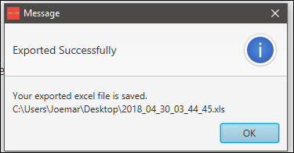 and this text will appear* .

1. **Excel File as Backup**

* **How can I use the excel file as backup of previous attendees?**
  + *You can import the exported excel file to retrieve the deleted attendees. It will automatically add the attendee if not existing.*

1. **Gender**

* **How can I easily identify the gender of the attendee?**
  + *In the attendee’s row, there are images before the ID of each attendee that represents its gender.  *

1. **Search**

* **After searching , how can I view again all the attendees?**
  + *You can clear all the inputted text here* *then click*  *again to refresh the table.*
  + *Or you can change*  *then select*  *to change the viewed result.*

1. **Select All**

* **How can I select or unselect all the attendees?**
  + *You can look for*  *in the lower left part of the window to easily select or unselect all the saved attendees.*
* **How can I know how many attendees are selected?**
  + *You can monitor the selected attendees by looking at the upper part of the Select All check box.*  *This also shows the total attendees saved.*