I seek the nerves under your skin: a movement poem

Joe Marshall
Mixed Reality Lab
University of Nottingham
Jubilee Campus
Nottingham NG8 1BB
jqm@cs.nott.ac.uk

Abstract
This work is a motion based private audio performance which aims to cause accentuated mental states in the listener similar to the heightened mental excitement of live performers.

Keywords
Movement, poetry, sound, interaction

Introduction
Experience of music and performance is linked to mental state. This work aims to alter the mental state of people listening to an audio performance by forcing them to act in a particular way if they wish to continue the performance. This work uses repackaged mobile phone technology to encourage people to move through their environment whilst reacting to the sound in a pair of headphones. This forces them into a state of deep concentration or flow, where all they can concentrate on is the sounds they are hearing and their movement.

Flow
Csíkszentmihályi[1] describes a state of ‘flow’ which is an extreme state of concentration experienced by those who are fully involved in an activity, where they are very tightly focused on that particular activity to the exclusion of any external distractions.
The concept of flow has been widely attributed as a description of performers; as the quote below shows it is clear that a performer may reach extreme mental states during their performances, allowing them to go far beyond societal norms:
I would measure the success of a night by the way by the way by the amount of piss and seed I could exude over the columns that nestled the P.A[2]
This state of flow has also been attributed to sportspeople, who often talk of ‘being in the zone’ where they are able to perform extreme efforts of endurance or skill. Athletes often describe sport as allowing them to forget about their everyday worries and just concentrate on performing well.

Movement Poems
This work creates movement poems – these are location immersive pieces, which involve the listener wearing a standard pair of headphones with a small control box attached to their belt or strapped on their arm. The control box detects the movement of the person, and alters the playback of an audio track based on their movement.
These poems, while not explicitly locational, as there is no measurement of absolute location, are location immersive – in that the unique environment in which the poem is experienced, and which the listener moves through during the poem becomes itself a part of the work.
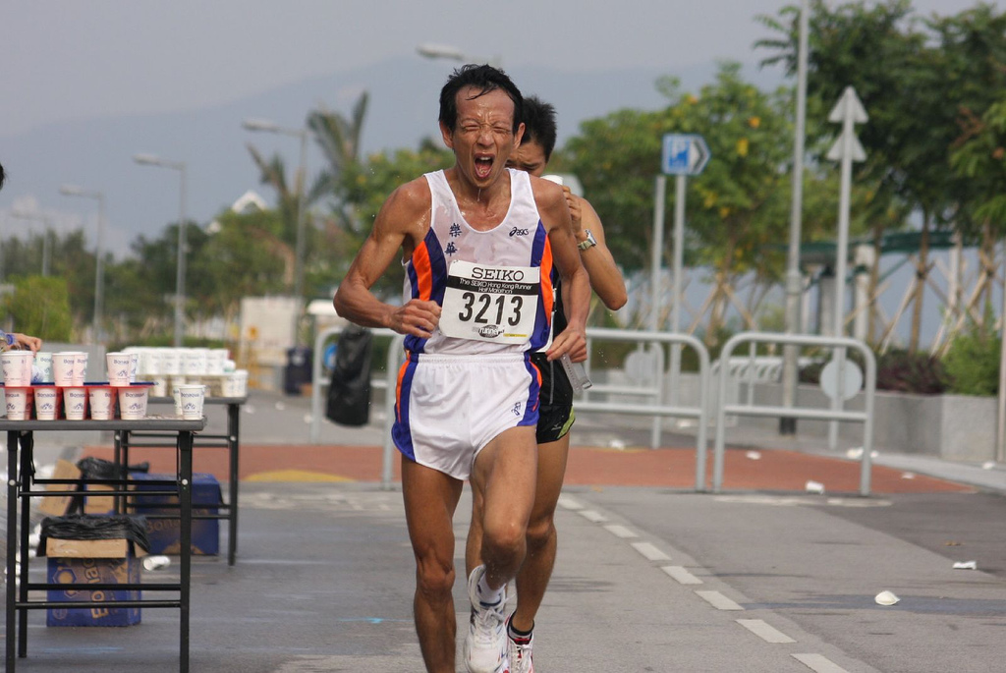
figure 1. States of flow in sport(©2007 Thomas Fan) and music (©2007 Beni Köhler)

I seek the nerves under your skin
The movement poem to be presented in this demonstration uses a piece of performance poetry by Patti Smith, during which she crescendos and accelerates to a climax. In the movement poem, this is simply linked to a tracking of speed of motion, if the listener does not continually accelerate, the poem starts to fade. This means that to hear the whole poem, they have to run faster and faster, constantly accelerating while the music crescendos in their ears. This movement itself requires a great deal of concentration, as it is physically challenging to run fast enough, and a mental challenge to navigate the local environment during this.
In experience, this piece plays directly on the synergy between the sweaty, exhausting experience of a brief but extreme sprint, and the feverish explosion of the poetry performance.

Anti-Funk
As well as this relatively straightforward responsive work, other poems using this technology are currently in development. The first one, titled ‘anti-funk’, takes a track deliberately chosen to encourage dancing and seeks to recontextualise it, by forcing the listener to become increasingly still, which unsurprisingly is quite difficult when your ears are surrounded by loud danceable music. This is a less extreme experience than “I seek the nerves under your skin” and is suitable for those wearing footwear that means they are unable to run.

The Technology
These pieces use a custom software platform, running on a repackaged mobile phone, which has a built in accelerometer allowing the detection of movement levels. The movement is fed into a Python script interpreter which creates and effects the audio outputs.

Technical Requirements
This piece is standalone, it requires a small table and a standard plug socket. The piece lasts typically between 1 and 3 minutes per participant, plus a short briefing. I will either run 1 or 2 sets of equipment depending on whether just “I seek the nerves under your skin” is run, or “Anti-funk” is run also.
For “I seek the nerves under your skin”, it is ideal if the table is near an external door, as participants will be moving quite fast, and it is vital to perform this in an outside environment.

Safety and Risk
From a safety point of view, the speed of “I seek the nerves under your skin” may be tuned in order to fit the environment in which the venue is set. “Anti-funk” has no risks other than potential theft of the hardware.
Organisers must provide insurance cover (or be willing to replace any lost/stolen/broken) for hardware (cost of hardware approx £300 per set), and be responsible for any risks / public liability – this may require insurance.
This is an active piece, and there is some inevitable risk involved. A disclaimer and safety information will be provided to all participants.

Acknowledgements
Thanks to Penny Munro for risking life and limb whilst running through our local woods during early tuning and testing of this system.

References
[1] Csíkszentmihályi, Mihály (1990). Flow: The Psychology of Optimal Experience'. New York: Harper and Row. ISBN 0-06-092043-2.
[2] Smith, Patti (1991) Babelogue

The details of the poem are deliberately not revealed here – in order to keep the experience a surprise to those who take part

