NEW at Gamestop!!!

From the makers of C.H.U.T.E. and PackTwins, comes the next big thing in computer game A.I.

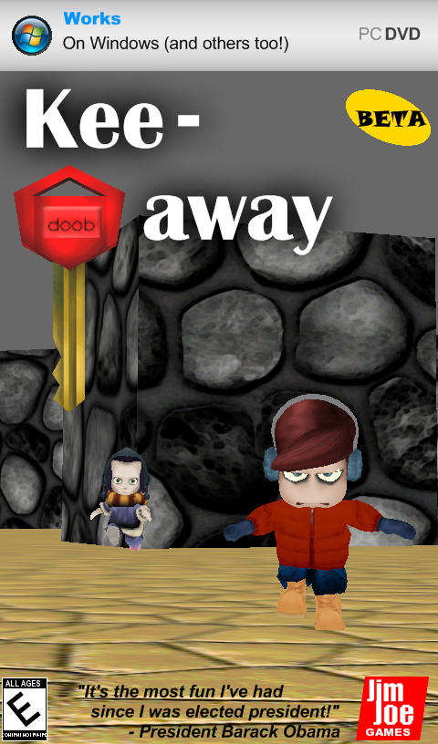

“Keepaway” is a puzzle-adventure game where you (Ralph) need to grab keys from each of the three rooms. But watch out, Eve is not your average enemy. She will use A\* pathfinding to superiorly navigate through the maze and *find you!!* When she does, you had better give her your key back. An advanced Finite State Machine will make sure she gets her key back, or else…

Line for pre-orders starts Monday, April 20, 2009 at 12:00 AM.