**PWS Background**

The Pacific herring fishery in Prince William Sound, Alaska declined by 75% from 1988 to 1993 and has yet to recover 27 years later. The Exxon Valdez oil spill affected most spawning grounds in PWS, exposing over 50% of embryos to damaging levels of oil in the Spring of 1989. Major disease outbreaks have cycled through the population since 1993.

Given a generation interval of 6 years (Feng et al 2017) and lifespan ~8 years (Hay 1985), we know that:

1. None of the pre-collapse samples collected in 1991 were exposed to oil as embryos.
2. A subset of the post-collapse samples collected in 1996 descended from oil spill survivors.
3. None of the post-collapse samples collected in 2007 and 2017 were directly exposed to oil.

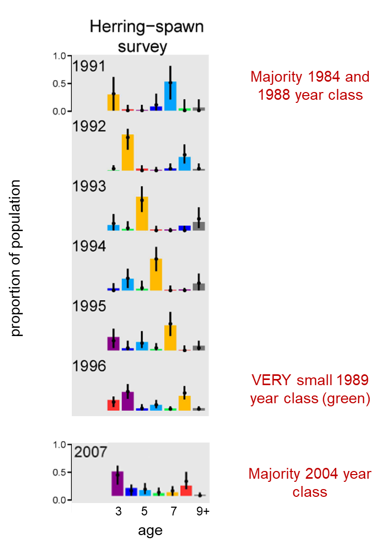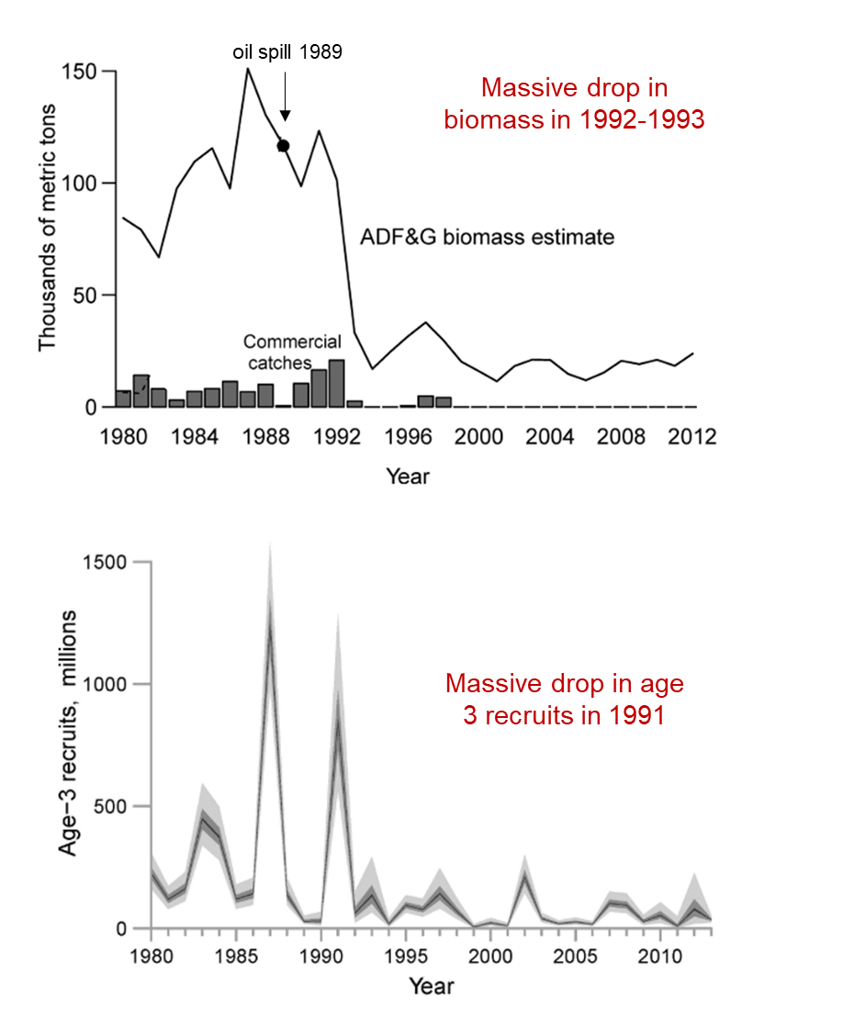

Muradian et al. 2017

**Togiak Bay and Sitka Sound**

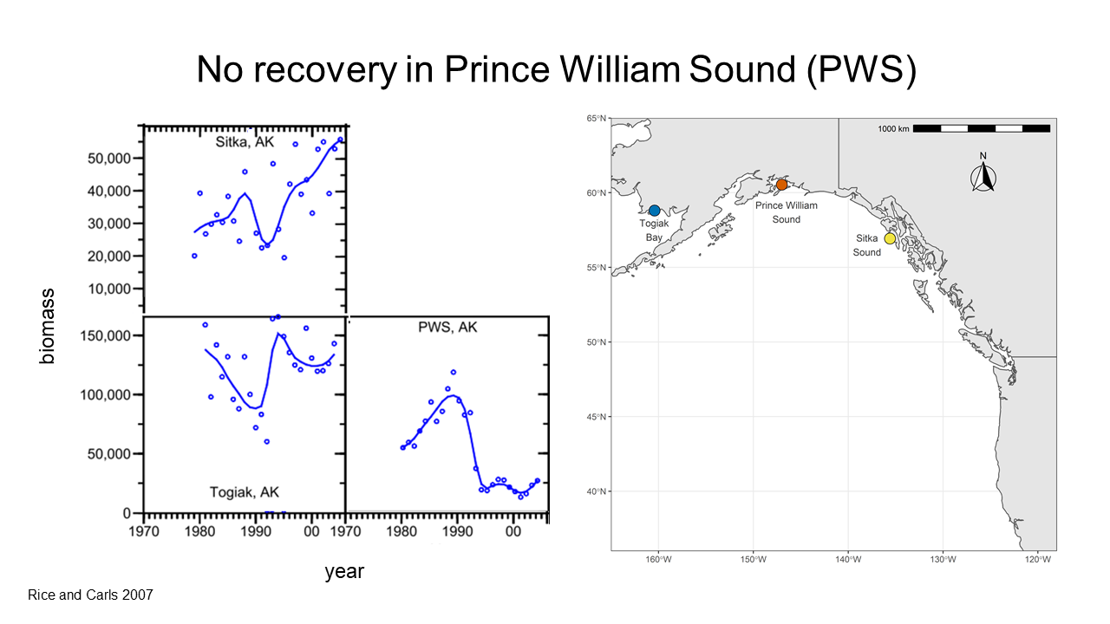

**Objectives**

We are interested in three main selection pressures influencing Prince William Sound, Sitka Sound, and Togiak Bay populations: pollution, disease, and warming oceans. The PWS population was impacted by oil exposure and experienced subsequent disease outbreaks. All three populations experienced convergent selection pressures related to climate change. Using whole-genome sequences from each population across four time points, we will measure 1) short-term effective population size, 2) temporal covariance in allele frequency change within populations, 3) replicate covariance in allele frequency change between populations, and 4) the acrsine transformed difference in allele frequency between sampling periods.

**Hypotheses:**

1. The decline in population size between 1991 and 1996 in PWS was proportionally larger than declines in TB and SS. Population size remained low in PWS through 2017, whereas population sizes increased in TB and SS. We expect that estimates of short-term effective population size using temporal changes in allele frequency (Ne = t / F) will show:
   1. A larger decline in Ne in PWS than TB between 1991 and 1996.
   2. Continued decline in Ne in PWS through 2017 as selection driven by disease outbreaks further reduced genetic diversity.
   3. A larger decline in Ne in PWS than TB and SS between 1996-2006 and 2006-2017.
2. We predict that the PWS population experienced a shift between two selection pressures over time. In 1989 during the oil spill, selection favored alleles conferring reduced sensitivity to embryonic oil exposure. Between 1993 and 2017, selection favored alleles conferring disease resistance. It is possible that alleles reducing sensitivity to pollutants also compromise immune function. We can understand how this shift in selection pressures influenced population recovery by measuring temporal covariance in allele frequency change in PWS. We predict:
   1. Temporal covariance will be negative in PWS, reflecting a change in selection pressure between 1991-1996 versus 1996-2007 and 2007-2017.
   2. Temporal covariance will be near zero or be positive in SS and TB where selection regimes have remained more stable.
3. We predict that all three populations experienced similar selection pressures related to climate change. However, PWS experienced unique selection pressures associated with pollution and disease. Furthermore, PWS and SS are more ecologically similar the Gulf of Alaska compared to Togiak Bay in the Bering Sea. By measuring replicate covariance in allele frequency change between populations, we might expect one of three patterns:
   1. Positive convergence covariance between all populations, reflecting similar selection pressures.
   2. Negative convergence covariance between PWS and the other populations, reflecting the unique history of pollution and disease.
   3. Convergence covariance near zero between TB and the other populations, reflecting the unique ecology of the Bering Sea.
4. By measuring allele frequency changes between sampling years in PWS, we expect that

allele frequencies

- increased between 91 and 96, decreased between 96 and 07, and continued to decrease between 07 and 17

- decreased between 91 and 96, increased between 96 and 07, and continued to increase between 07 and 17