S.NO INDEX Page No
1. INTRODUCTION

1.1 About the Project
1.2 Company Profile

2. SYSTEM STUDY

2.1. Existing System
2.2. Disadvantages of Existing System
2.3. Proposed System
2.4. Advantages of Proposed System
2.5. Problem Definition and Description

3. SYSTEM ANALYSIS

3.1. Resources Required (HW & SW)
3.2. Feasibility Study
3.3. Use Case Diagram
3.4. Data Flow Diagram

4. SYSTEM DESIGN
4.1. Architectural Design
4.2. I/O Form Design
4.3. Tables
4.4. Normalization

5. CODING & DEBUGGING

5.1. Functional Documentation
5.2. Special Features of Language / Utility
5.3. Pseudo code/ Algorithm

6. TESTING

6.1. Types of Testing Done

7. USER MANUAL

7.1. Hardware Requirements
7.2. Software Requirements
7.3. Installation Procedures
7.4. Sample I/O
7.5. Error Message

8. CONCLUSION

8.1. Summary of the Project
8.2. New Enhancements
8.3. Future Possibilities

BIBLIOGRAPHY

Article Bibliography

Book Bibliography

Websites References

1. INTRODUCTION

1.1 About the Project

The project entitled as “DONATION MANAGEMENT SYSTEM FOR DONATION COLLECTION” and it is an python application which is designed for VENBA INFORMATION TECHNOLOGIES(P) LTD which is situated in gowrivakkam,chennai. The application will be more useful for the outsource for all the donor,volunter data are stored and maintained by the administrative members or employees. The purpose of this application is to make the administrative facilities to be more easy and efficient to donate money.The application is designed in order to give proper user interface to the end user. The module describes about the administrative details of the employees,donor,volunter. It has 4 modules which describes about the staff,volunter,donor and details about the projects.

The staff module has the process of entering the project details such as project name, start date, end state and details like needed amount etc., the details entered by the staff will be stored in database and will be used for further use. The volunter module will be view the project details module and donate money with separte module then added to project fund raising module.

The volunter or donor module has the process of donating money toto the project with details fo donor name,address,mail_id and so on and then entered data will be used for future use. both volunter or donor module has the details of entering the some necessary information and the stored data will be used for many other modules if necessary. Finally application will give comfort to NGO especially for social welfare groups.

1.2 Company Profile

Company Name : Versions Software Solutions

Address : plot No:6,Rakshi Sai Building,
Buhavenswari Nagar,
Tamabram to Velachery Main Road,
Sai Baba Kovil Street,
Gowrivakkam,
Chennai -600023
Email:info@venbainfotech.com

External Guide Name : VENBA KANNAN (HEAD)

2. SYSTEM STUDY

System Study is used to deliver information about the donors in which describes about both the personal and company details of each donors. The details have to be entered by the staffs and those details will be stored in database and will be used for further use. The application is designed mainly for the administrative members in order to maintain the details of donors.

2.1 EXISTING SYSTEM
Existing System defines the system which is already exist anywhere and may have merits and demerits of the project. The existing project of this application is web application named “Web based System”. It is a web application in which the administrative details will be entered by the staffs. It is an only application where all the details of the donors,volunter will be entered and managed by the administrators. It may lead to a problem and it will be difficult for both staffs and donors and only support web based not developed by mobile based. Also the application may have bugs and errors.

2.2 DISADVANTAGES OF EXISTING SYSTEM

- Human Error
- Connectivity issues
- Less responsive
- Inaccuracy
- Time consumption
- Slow processing Speed
- Data inconsistency

2.3 PROPOSED SYSTEM

Proposed system refers to the system that enhances the existing features to the advanced level and makes the application more accuracy. Here the existing web application is designed in an python application as proposed system in order to give the clear user interface to the end user. The purpose of this application is to give an accuracy of data about the donors. The application will be more interactive. The application reduces the time and increases the performance while entering the data.

2.4 ADVANTAGES OF PROPOSED SYSTEM

- Easy to access
- High performance
- Accuracy of data
- User friendly Interface
- Retrieval of information
- Accurate results

2.5 PROBLEM DEFINITION AND DESCRIPTION

NGO staffs have to enter donor details in order to maintain the record of each and every staff. Not only the staff also the volunter and donor have to maintain the details and the work is done by the administrative members. The entered details are stored in database and will be used for further use.

For those purpose the application has been designed by using the following modules

- Staff
- Donor
- Volunter

3. SYSTEM ANALYSIS

3.1 RESOURCES REQUIRED

3.1.1 Hardware Requirements

Processor : ANY CORE PROCESSOR

RAM : 4 GB (Minimum)

Hard Disk : 320 GB (Minimum)

Other Devices : Android smart device (Smart phone, Tablet)

3.1.2 Software Requirements

Operating System : Windows 7 or Higher

Linux Ubuntu 16

3.1.3 CLIENT SIDE DEVELOPMENT

Pycharm version 18.1(python IDE)

Django version 1.2.11

Pip installer

3.1.4 SERVER SIDE DEVELOPMENT

Script : Python

Database : SQLITE3

Server : Apache http

3.2 FEASIBILITY STUDY

Feasibility is a system proposal according to its work ability, impact on the organization, ability to meet user and effective use of resources.

Three types of feasibility,

1. Technical feasibility.
2. Operational feasibility.
3. Economic feasibility.

Feasibility analysis is necessary to determine whether the proposed system is feasible considering the technical, operational and economic factors. By having detailed feasibility study the management will have clear-cut view of the proposed system with benefit and drawbacks.

3.2.1 Technical Feasibility
The proposed System is to be implemented with MySQL as a backend tool running under local server. Since the system is being developed in running in hand held devices, the system is easy-to-users. Thus the proposed system is technically feasible. The most important criteria for a system are that it must be technically feasible. The proposed system is going to be the part of much bigger system and hence its implementation are designed in such a way that it is going to be faster and efficient.

3.2.2 Operational Feasibility
The user friendly interface, which makes all operation easy to use and no extra training, is needed in this regard, the user doesn’t need extra thing and thus lots of time is saved. This makes the project operationally feasible.

3.2.3 Economic Feasibility

Since the proposed system deals with the mobiles and tablets, it is worth to purchase while needed. Thus the proposed system is economically feasible.

3.3 USE CASE DIAGRAM

The use case diagram at its simplest representation of a user's interaction with the system that shows the relationship between the user and the different use cases in which the user is involved. A use case diagram can identify the different types of users of a system and the different use cases and will often be accompanied by other types of diagrams as well.

Use case diagrams are used to gather the requirements of a system including internal and external influences. These requirements are mostly design requirements. So when a system is analysed to gather its functionalities use cases are prepared and actors are identified. Now when the initial task is complete use case diagrams are modelled to present the outside view.

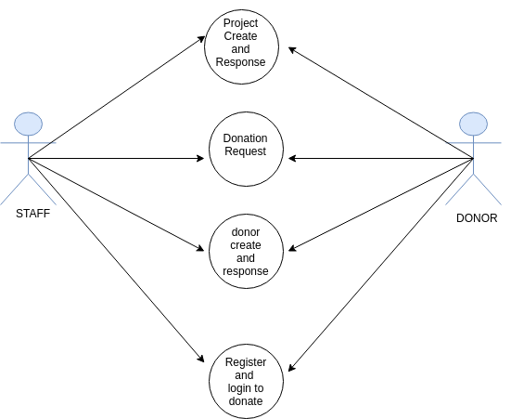
Fig:3.1 Use Case Diagram

3.4 DATA FLOW DIAGRAM

A Data Flow Diagram (DFD) is a graphical representation of the "flow" of data through an information system, modelling its process aspects. Often they are a preliminary step used to create an overview of the system which can later be elaborated. DFDs can also be used for the visualization of data processing (structured design).

A DFD shows what kinds of information will be input to and output from the system, where the data will come from and go to, and where the data will be stored. It does not show information about the timing of processes, or information about whether processes will operate in sequence or in parallel.

Data flow diagrams can be used to provide the end user with a physical idea of where the data they input ultimately has an effect upon the structure of the whole system from order to dispatch to report. How any system is developed can be determined through a data flow diagram model.

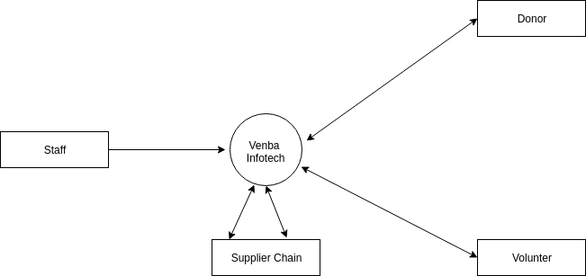
DATA FLOW DIAGRAM CONTEXT LEVEL
Fig.3.2 Context Level

4.SYSTEM DESIGN

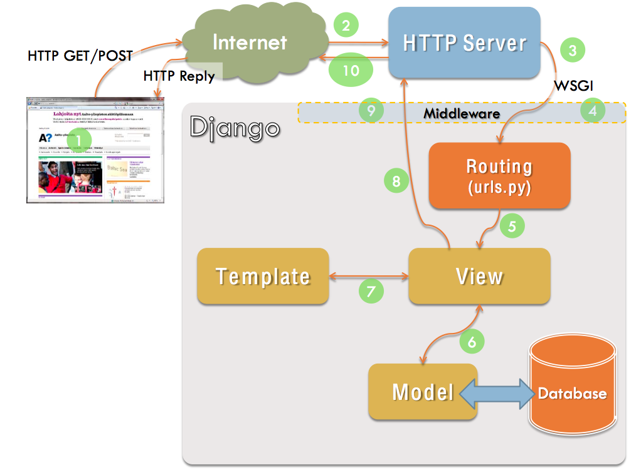
4.1 ARCHITECTURAL DESIGN
Fig 4.1:Architectural Design

4.2 INPUT/OUTPUT DESIGN

4.2.1 Input Design

The input data are collected into groups of similar data. While entering the input data the operators must know the space allocated for each field, the data types in which the data fields are entered. The input design is the link that ties information system into the world of its users. It consists of developing specification and procedure for data preparation. The inaccurate data won’t be accepted by this system. For example entering text in place of telephone number field is inappropriate. So this type of wrong input will not be allowed. In this manner the input design allows only valid and required relevant data to be stored.

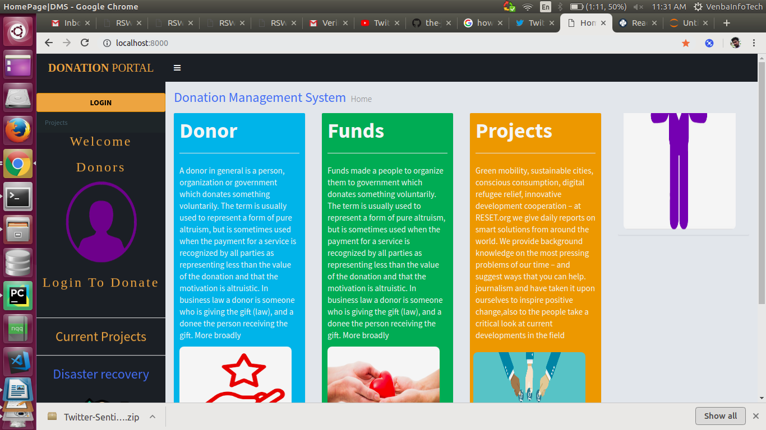

Fig:4.2 Home Page

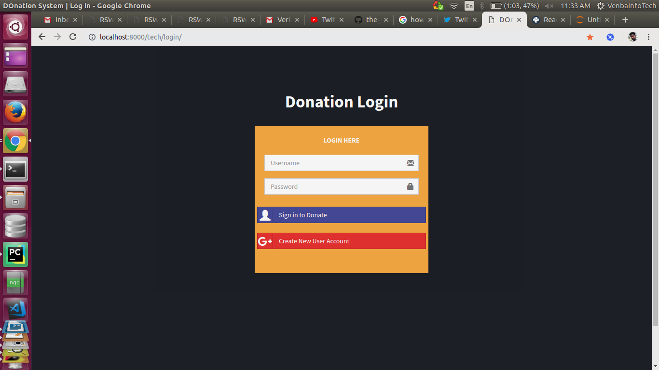

Fig:4.3 :Donation Login Page
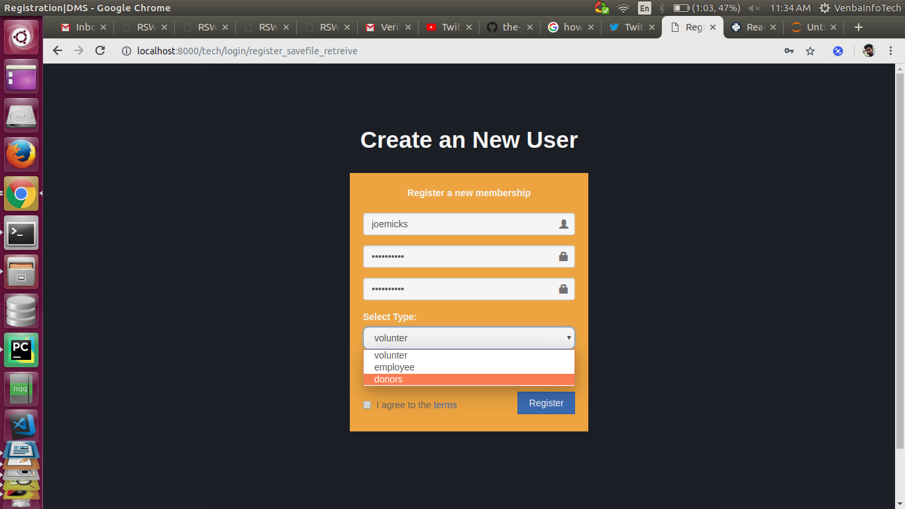

Fig 4.4 Registration Page

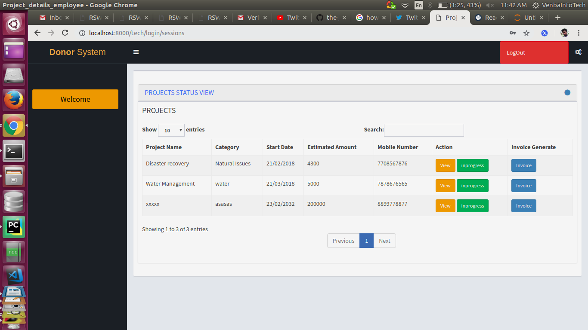

Fig 4.5 :Project View Page

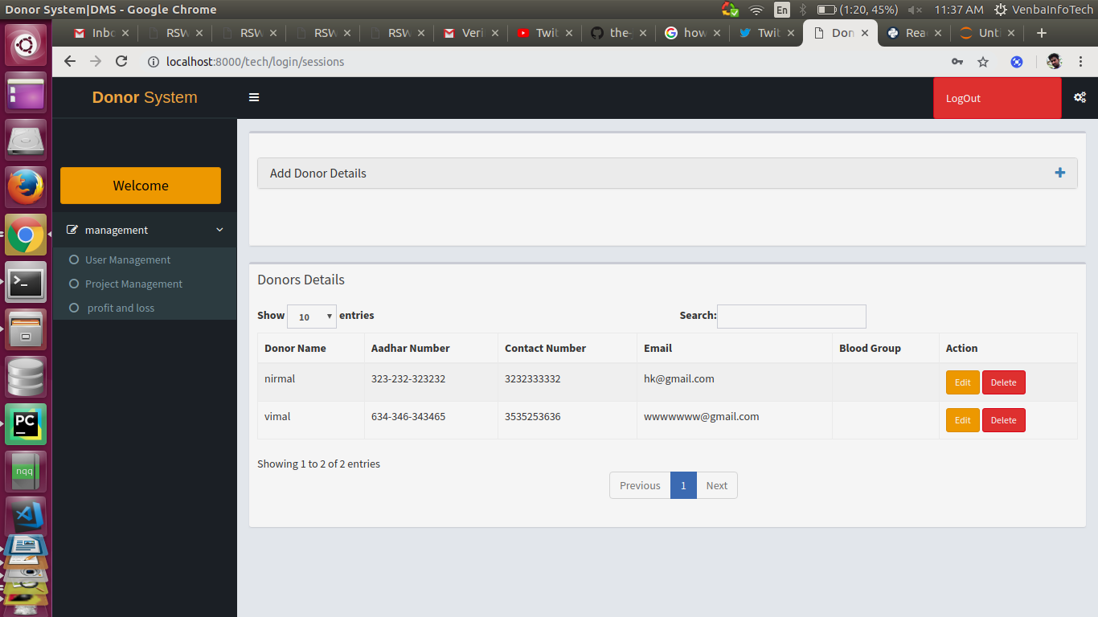
Fig 4.6 : Donor View Page

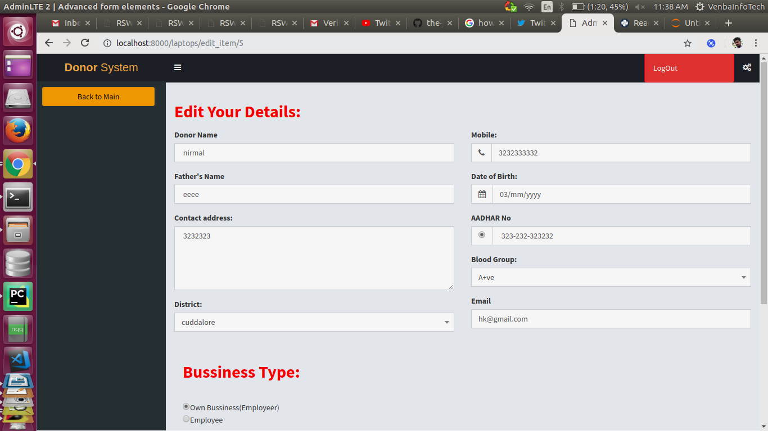
Fig 4.7 Edit Donor Details Page

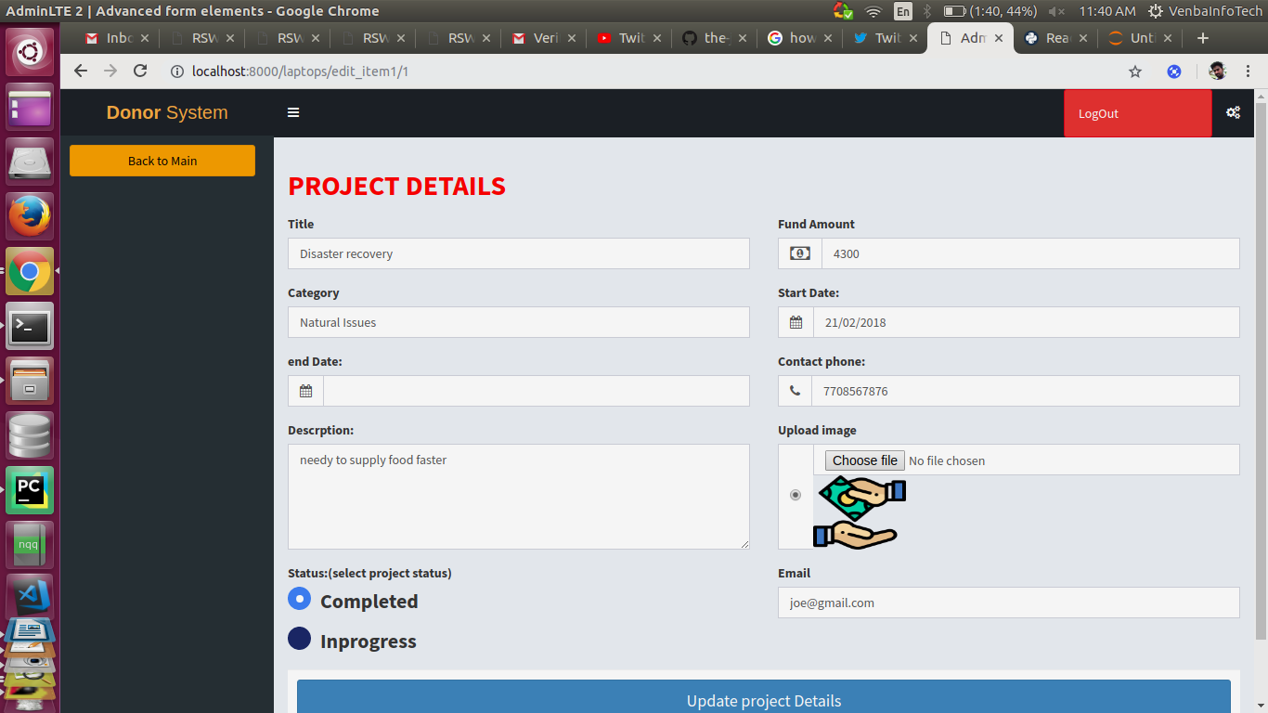
Fig 4.8: Edit project Details

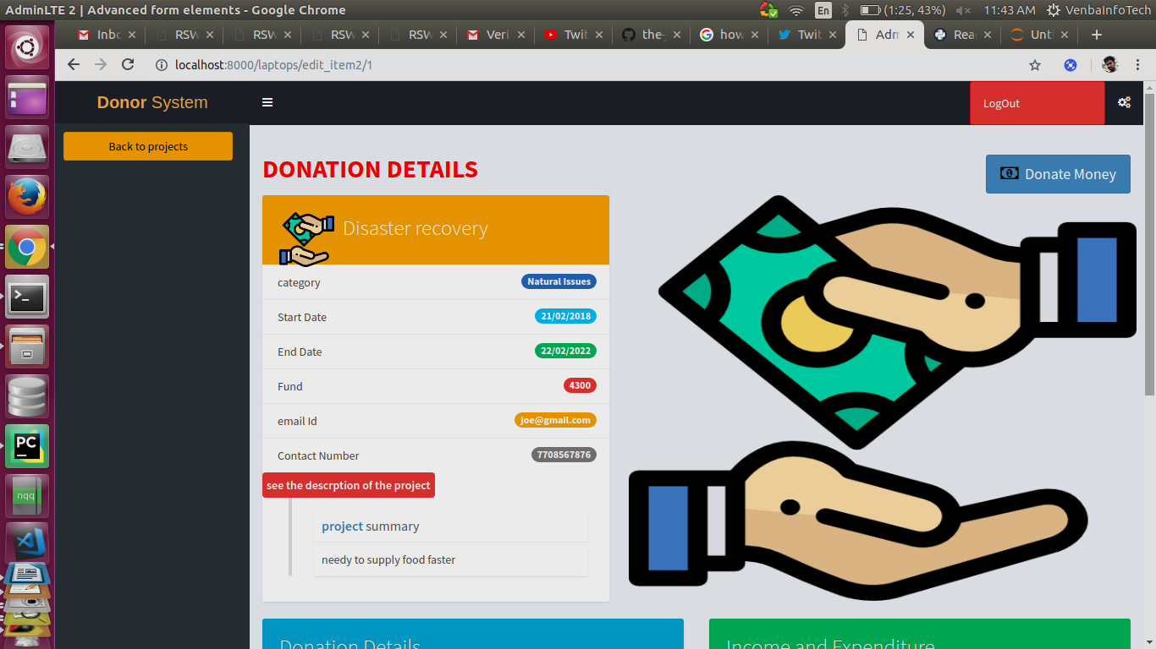
Fig 4.9 Donation _view page

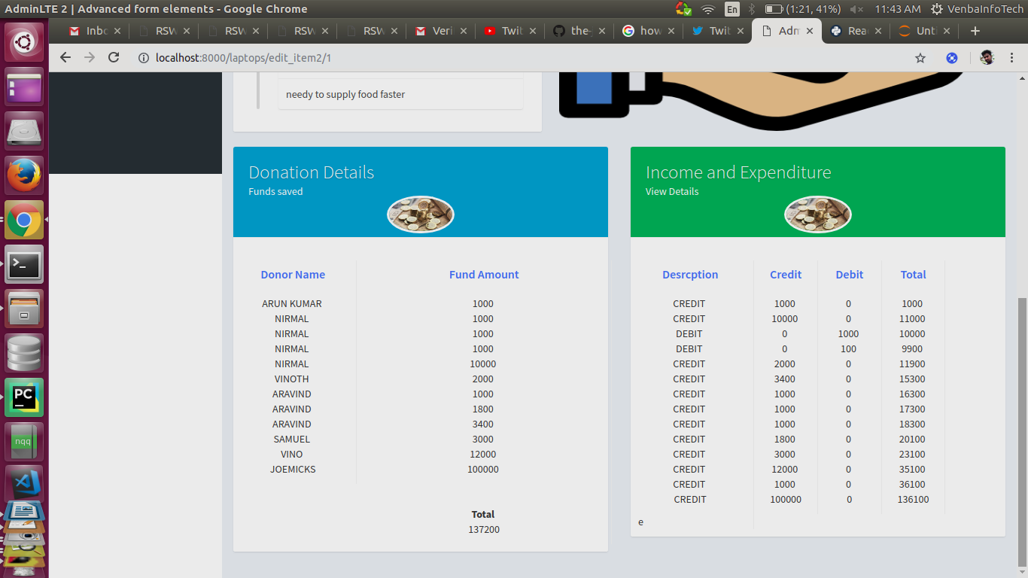
Fig :4.10 Donation view page 2

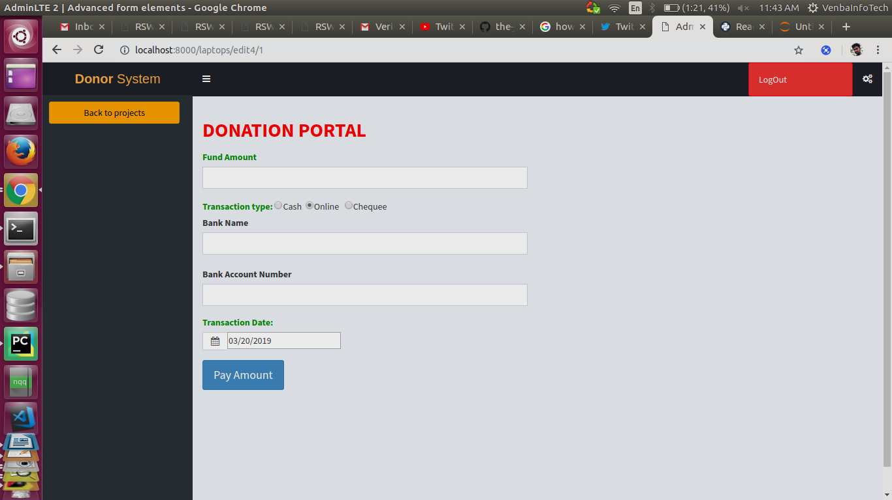
Fig 4.11 Donation Portal

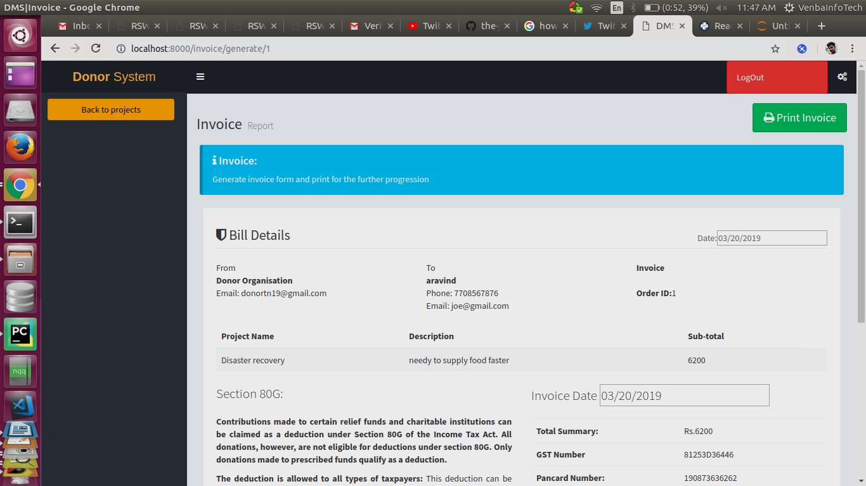
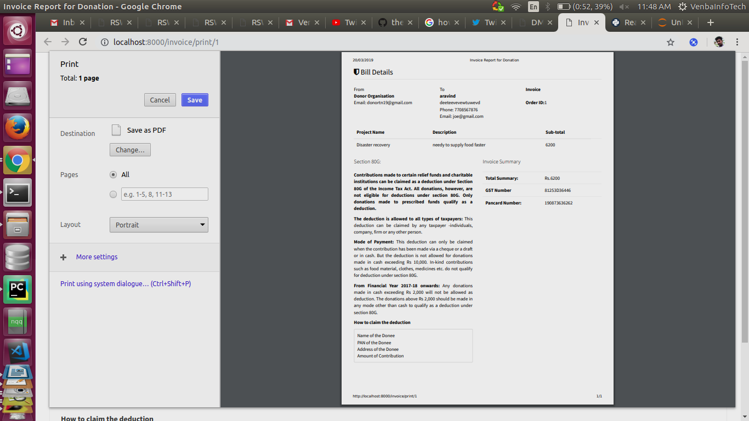
Fig 4.12 : Invoice Page

Fig 4.13 :Generate Invoice page

4.3 TABLE DESIGN

A table is a collection of related data held in a structured format within a database. It consists of columns, and rows. In relational databases and flat file databases, a table is a set of data elements using a model of vertical columns and horizontal rows, the cell being the unit where a row and column intersect. A table has a specified number of columns, but can have any number of rows. Each row is identified by one or more values appearing in a particular column subset. The columns subset which uniquely identifies a row is called the primary key

TABLE 4.3.1 :django_session

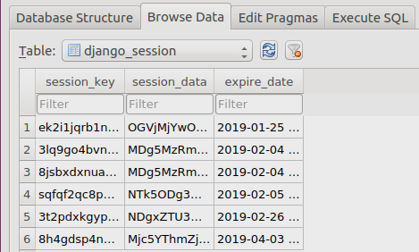

TABLE 4.3.2 :auth_user
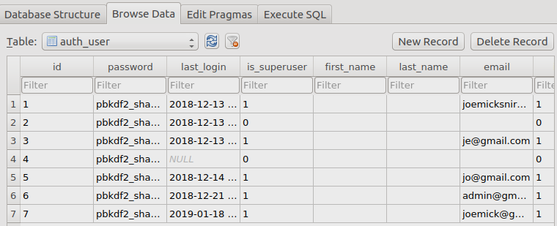

TABLE 4.3.3 :tech_districtmodel
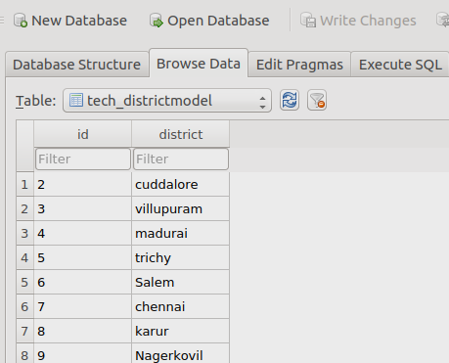

TABLE 4.3.4 :tech_bussinesstype
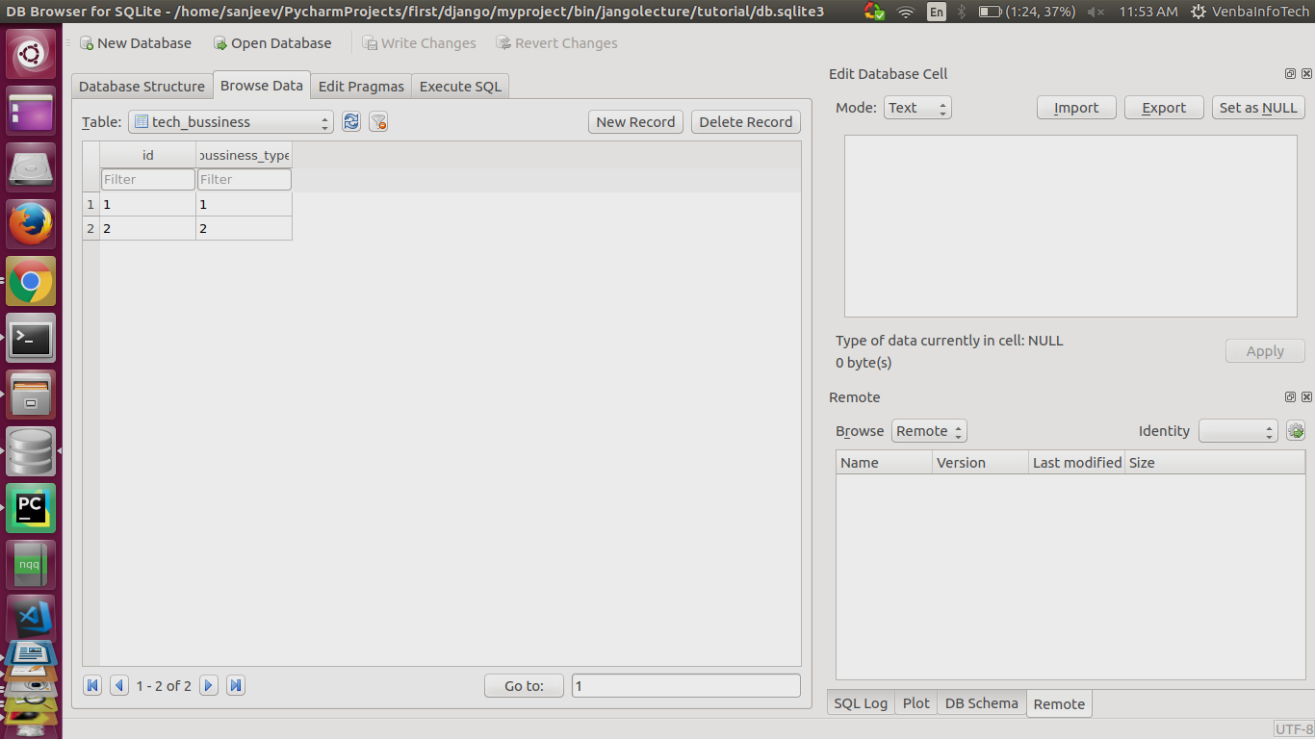

TABLE 4.3.5 :tech_dontation_portal
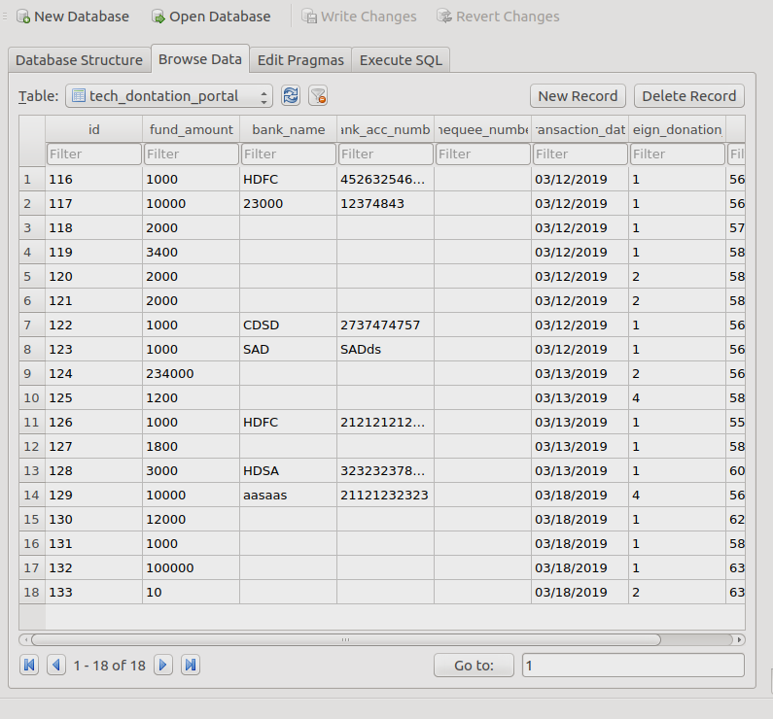

TABLE 4.3.6 :tech_profit_account
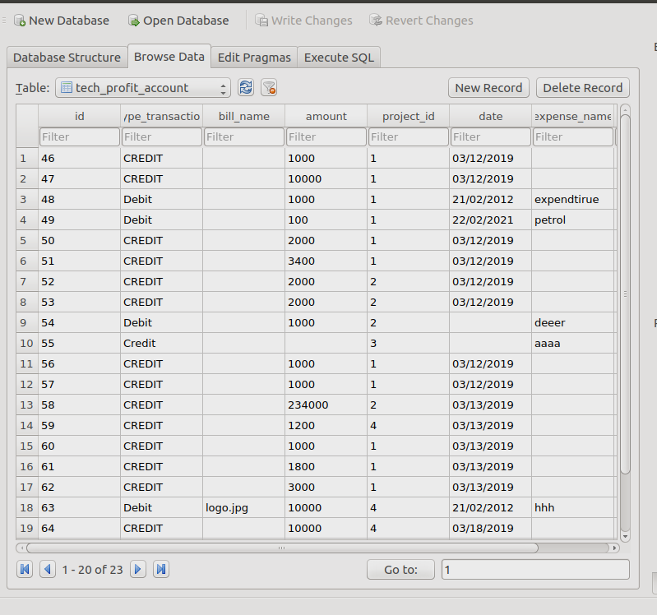

TABLE 4.3.7 :userprofilemodel
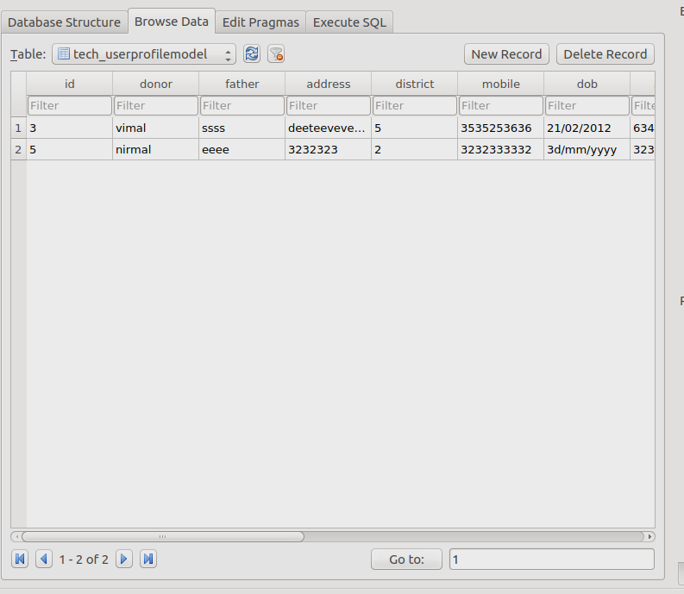

TABLE 4.3.8 :table structure
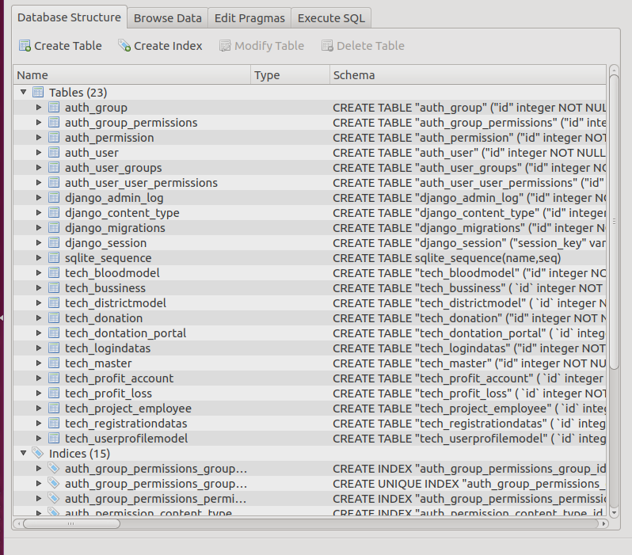

4.4. Normalization

Normalization is the process of efficiently organization data in a database. There are two goals of the normalization process: eliminating redundant data (for example, storing related data in more than one table) and ensuring data dependencies make sense (only storing related data in table). If the database design is not perfect, it may contain anomalies, which are like a bad dream for any database administrator. Managing a database with anomalies is next to impossible.

Update anomalies − If data items are scattered and are not linked to each other properly, then it could lead to strange situations.

For example, when we try to update one data item having its copies scattered over several places, a few instances get updated properly while a few others are left with old values. Such instances leave the database in an inconsistent state. Insert anomalies − we tried to insert data in a record that does not exist at all. Normalization is a method to remove all these anomalies and bring the database to a consistent state.

First Normal Form (1NF)
- Eliminate duplicative columns from the same table.

Second Normal Form (2NF)
- Meet all the requirement of the first normal form.
- Each group of related data and identify each row with a unique column or set of columns (the primary key). Diagram The class diagram is a static diagram. It represents the static view of an application.

5. CODING AND DEBUGGING

5.1 Functional Documentation

The system maintains all the administrative activities of all the donors, volunters and staff. The entered information will be stored in database and will be used for further use.

5.1.1 Staff
- New entry
- Report of staff details
      - Code wise
      - Name wise
      - project wise
      - Location wise
- Updating the details
- Password Validation

The module describes the details of all the donors. Staff members have to enter their own details and this will be similar to registration form. The details will be used for future use.

5.2 Special Features of Language / Utility

PYTHON

Python is an open source programming language . Python is a server side, user interactive, programming language, works nearly in on all platforms like Unix,Linux,Windows It is a general purpose scripting language. It can be embedded into html. Python is a server side scripting language that is embedded in HTML. It is used to manage dynamic content, databases, session tracking, even build entire e-commerce sites. It is integrated with a number of popular databases, including MySQL, PostgreSQL, Oracle, Sybase, Informix, and Microsoft SQL Server. The MySQL server, once started, executes even very complex queries with huge result sets in record-setting time. Also contains many server interfaces. Open source is one of the best specifications of Python.
Especially Web Based Developement it could be use for the django,flask framework more secured sites with cross platform accesibilty conjunction has made.python similary used for different fields of studies like machine learning,deep learning,data science Now a days python play an vital role in the computer fields.
DJANGO

Django is a free and open source web application framework written in Python. A framework is nothing more than a collection of modules that make development easier. They are grouped together, and allow you to create applications or websites from an existing source, instead of from scratch.
This is how websites - even simple ones designed by a single person - can still include advanced functionality like authentication support, management and admin panels, contact forms, comment boxes, file upload support, and more. In other words, if you were creating a website from scratch you would need to develop these components yourself. By using a framework instead, these components are already built, you just need to configure them properly to match your site.
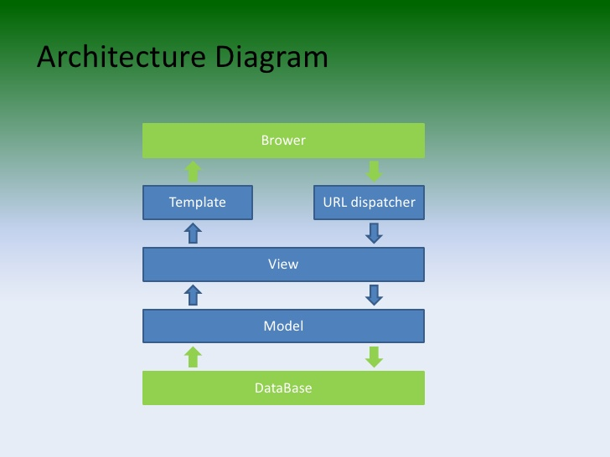
Application FrameWork:

5.3 Pseudo code / Algorithm

General

Step 1: Start

Step 2: Click the login button in the home page.

Step 3: insert data in the required fields in the form “login page”.

Step 4: login redirect based on id user can redirect .

Step 5: Also register a usertype can access the module differently.

Step 6: End

Donor/Volunter

Step 1: Start

Step 2: Click the view button in the page of redirection.

Step 3: view data in the projects also to donate.

Step 4: Access prohibited for create project/donor .

Step 5: Also generate invoice on a button on viewpage.

Step 6: End

Staff

Step 1: Start

Step 2: Click the Menubar in the page of redirection.

Step 3: create or manipulate data in the projects or donors details.

Step 4: Access project/donor .

Step 5: Also remove any details instantly.

Step 6: End

6. TESTING
6.1 DEFINITION

The importance of software testing and its impact on software cannot be underestimated. Software testing is a fundamental component of software quality assurance and represents a review of specification, design and coding. The greater visibility of software systems and the cost associated with failure are motivating factors for planning, through testing.

6.1.1. Types of Testing Done

The following are the different types have been carried out:

Integration Testing

Integration testing is the phase in software testing in which individual software modules are combined and tested as a group. It occurs after unit testing and before system testing. Integration testing takes as its input modules that have been unit tested, groups them in larger aggregates, applies tests defined in an integration test plan to those aggregates and delivers as its output the integrated system ready for system testing.

Validation Testing

Validation Testing can be defined in many ways, but a simple definition is that validation succeeds when the software functions in a manner that can reasonably expected by a customer. After validation test has been conducted, one of the following two possible conditions exists. The functions or performance characteristics confirm to specification and are accepted.

User Acceptance Testing

User acceptance of a system is a key factor of any system. The system under consideration is tested for the acceptance by constantly keeping in touch with the prospective system users at the same time of developing and marketing changes whenever required.

7. USER MANUAL
7.1 Hardware Requirements

Processor : ANY CORE PROCESSOR

RAM : 4 GB (Minimum)

Hard Disk : 320 GB (Minimum)

Other Devices : Android smart device (Smart phone, Tablet)

7.2 Software Requirements

Operating System : Windows 7 or Higher 7.3.

7.3 Installation Procedures

Install PyCharm

Setting up Pycharm IDE takes just a few clicks. (You should have already downloaded Pycharm) To installPycharm on Windows,Linux(use commands) proceed as follows:

Step 0: Pre-Installation Check List

1.Before that install python 2.7 or above version on the system

2.install python package Manager(pip installer)

3.install Django 1.0 or more on a system for the framework to access libraries

4.After the completion of the installments check it correctly installed or not

8. CONCLUSION

8.1 Summary of the Project

The overall application demonstrates the donation details of all the staff, volunters,donors who are all interrelated with this project. It is necessary to make entry for each and every one to place orders from the company or to supply the goods. The administrator maintains all the details of the donation and donors details. The process of insertion and Updation will be made through this application. The details entered by the user will be stored in database and will be used for further use.

8.2 New Enhancement

The system is enhanced from web application to python application with responsive support for mobile,tab and it has features of making entry and updating their own profile. By selecting the staff name and staff no the staff can update their details.

8.3 Future Possibilities

In future, the application will be designed in android and also the application will be further developed using new technology called Data Science(Data Analysis) and will be great impact for the company and also to the users.

BIBLIOGRAPHY

Web References

https://docs.djangoproject.com/en/2.1/
https://docs.djangoproject.com/en/dev/releases/2.2/

References

1. Dave Smith and Jeff Friesen, “Light Wieght Django”, Rakmo Press (P) Ltd, New Delhi, 2011.Computer Vision: Algorithms and Applications By Richard Szeliski.

2. Abraham Silberschatz, “ Database Systems”, McGraw Hill International, 1997. 3. Roger S Pressman, “Software Engineering”, McGraw Hill, International 6th Edn, New York, 2006.

