PROJECT – DATAWAREHOUSE AND ETL

MOHAMED JOUHARI

DATE : 2024-10-29

Contents

1. INTRODUCTION 4

1.A. DATA 4

1- Orders 4

2- Order_items 4

3- Order_payments 4

4- Customers 4

5- Sellers 4

6- Products 4

7- Product_category_name_translation 4

8- Geolocation 4

9- Order_reviews 4

1.B. TOOL 5

1.C. METHOD 5

2. STAGING DATABASE 6

2.A. Importing orders dataset 6

2.B. Other datasets 7

2.C. Creating SQL Staging database 8

2.D. Specificity for OrderReviews dataset 9

3. OPERATIONAL DATA STORE (ODS) 10

3.A. Extracting staging data 11

4. DATE WAREHOUSE 16

4.A. MODELING 16

4.B. Fact table 18

1) Total invoiced 18

2) Date keys 18

3) Order_id / Order_item_id 18

4.C. DIMENSION TABLES 19

1) Geolocation table 19

2) Date table 19

3) Other dimensions table 19

5. PIPELINE CONSTRUCTION 19

6. AUTOMATIZATION 20

7. USE CASES 22

7.A. 23

7.B. 24

7.C. 25

1. INTRODUCTION

This project is aimed to address a data warehouse modeling and ETL pipeline creation problem. We have at our disposal several data sources containing information about a south American e-commerce website. The dataset are in a CSV format. The objective is to create an automated data pipeline that will fetch those data sources and fill the relevant business data into a data warehouse. This data pipeline should be scheduled and work as a routine task to automate the solution for the business.

## 1.A. DATA

For this project, locally stored csv files will act as data sources. We have the following:

1. Orders

The orders data source is split into three different csv files: orders_2016.csv, orders_2017.csv, orders_2018.csv. They contain the columns:

* Order_id : This is a unique identifier for each order
* Customer_id : A unique identifier for the customer who made the order
* Order_status: The status of the order whether delivered, in process, etc…
* Order_purchase_timestamp: The date when the order was placed
* Order_approved_at: The date when the purchase was approved by the system
* Order_delivered_carrier_date: The date when the order was delivered to the carrier
* Order_delivered_customer_date: the date when the order was delivered to the customer
* Order_estimated_delivery_date: the estimated date for the order cycle until delivered to customer

1. Order_items

This data source is contained in the order_items_dataset.csv. It contains the following columns:

* Order_id : a unique identifier for each order
* Order_item_id: a unique identifier for the item in the specific order

Those two features work as a composite key together to select a specific item from an order.

* Product_id : a unique identifier for the product purchased
* Seller_id : a unique identifier for the seller of the product
* Shipping_limit_date: Latest date by which the order must be shipped
* Price : the price of the item
* Freight_value: the shipping cost of the item

1. Order_payments

This data source can be found in the order_payments_dataset.csv and it contains the following columns:

* Order_id: a unique identifier for the order
* Payment_sequential: sequential number of the payment made for an item
* Payment_type: type of payment used for the transaction (cash, credit card, etc)
* Payment_installments: number of installments used for the transaction
* Payment_value: total value of the payment in local currency

1. Customers

This data source is in customers_dataset.csv.

* Customer_id : a unique identifier for the customer
* Customer_unique_id: an anonymized unique identifier for the customer
* Customer_zip_code_prefix: ZIP code prefix of the customer
* Customer_city : city of the customer
* Customer_state: state of the customer

1. Sellers

This data source is located in sellers_dataset.csv.

* Seller_id : a unique identifier for the seller
* Seller_zip_code_prefix: zip code of the seller location
* Seller_city: city of the seller
* Seller_state: state where the seller is located

1. Products

This contains information about the products that customers can purchase. This data source is enclosed in the products_dataset.csv.

* product_id: Unique identifier for each product.
* product_category_name: Category of the product (e.g., "perfumaria").
* product_name_lenght: The length of the product name in characters.
* product_description_lenght: The length of the product description in characters.
* product_photos_qty: Number of photos associated with the product.
* product_weight_g: Weight of the product in grams.
* product_length_cm: Length of the product in centimeters.
* product_height_cm: Height of the product in centimeters.
* product_width_cm: Width of the product in centimeters.

1. Product_category_name_translation

This data source contains the translation of the original Portuguese names of the product categories in English, and it is found in the product_category_name_translation.csv dataset.

* Product_category_name: name of the product category in original Portuguese language
* Product_category_name_english: translation of the above

1. Geolocation

This contains general geolocation information with GPS coordinate.

* Geolocation_zip_code_prefix: zip code of the described location
* Geolocation_lat: latitutde
* Geolocation_lng: longitude
* Geolocation_city: city of the location
* Geolocation_state: state of the location

1. Order_reviews

This last data source contains information about order reviews made by customers on their order, including score, date, time, comment.

* review_id: Unique identifier for the review.
* order_id: Unique identifier for the order associated with the review.
* review_score: Numerical score of the review (e.g., 1-5).
* review_comment_title: Title of the review comment.
* review_comment_message: Message content of the review.
* review_creation_date: Date when the review was created.
* review_answer_timestamp: Timestamp when the review was answered or

processed.

## 1.B. TOOL

To address this project, several tools will be used. The working environment will be on windows server. We will work with SQL Server Management Studio 20 (version 20.2) and Visual studio enterprise 2022 (version 17.11.4).

SQL Server Management Studio: this software allows us to manage one or several databases, scheduling routine tasks, etc..

Visual Studio Enterprise: This software will be the main environment in which we work this project out. A specific addon of VS Enterprise will be used, that is SSIS – SQL Server Integration Services. This combination will allow us to build a data pipeline and specific ETL job for the final datawarehouse.

## 1.C. METHOD

The data will travel through several database layers which will serve the purpose of extracting transforming and loading the data into the final modeled datawarehouse. In order to do that, we will need three main databases:

* a staging database : to fetch/retrieve the source raw data as they are
* an ods (operational data store): to transform, clean and process the raw data
* a datawarehouse database: the final database that will be used in the business, sales and other teams feeding on the data.
* An extra database “admin”: that will serve to welcome the data that had technical or functional issues.

Using the tool mentioned above, we will address the project from the source data in csv format.

The project timeline and process is described below:

# 2. STAGING DATABASE

In this part, we discuss how we built the staging database. The objective of the staging part is to welcome all the source data in raw form for further process. The source can be website, app data, APIs, IoT, data files, databases, cloud data, etc… Therefore, to retrieve what is interesting for the business, we need to have the data ready, thus staged in the staging database.

In this project, the source data are all from data files in CSV format. Each datasets represent a type of data, except for orders datasets which are triple. We will to create one control flow for every dataset (and one slightly different for the orders dataset).

## 2.A. Importing orders dataset

To import orders dataset for the three years 2016, 2017 and 2018, we need to use a ‘Foreach Loop Container’ component in SSIS. This component allows to loop over data files and iterate over each of the set data files to retrieve its data and union them into a staging database “Orders” table.

In the container, we defined a data flow task in which we can set up a flat file connection.

We first set the foreach container into “… file enumerator” . We then set the folder where the files are stored and we give an expression name, in our case, orders_*.csv so that the container can fetch all the files that begins with orders_ and ends with .csv.

After setting this container, we create a ‘FilePath’ variable that we use in the flat file connection to indicate to the data flow task that the foreach loop will fetch the files.

Finally, we define in the flat file connection properties, a new “ConnectionString” property with the FilePath variable we created in the foreach loop container as an expression. That way, the data flow is set to fetch the designated files.

## 2.B. Other datasets

For other datasets, the data flow is easier, as there is only one of each dataset. Therefore, we need to fetch only one dataset for each data flow. A simple data flow with a flat file source component is enough. We set the flat file connection to fetch that specific file. We use a latin-1 (1252) encoding. After the data is retrieved, we need to load them into the staging databases.

To do that, we create an OLE DB Destination component where we will load all the data loaded from flat source file and we connect it to the right table in the staging database. We need to “map” the source file variables to the column in the database table.

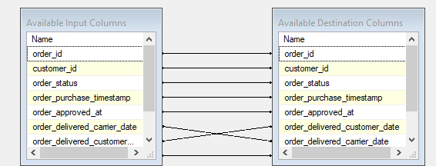

Thus why, the database table must exist before completing this step. (The step to create the table in the sql database is described in the next part).

## 2.C. Creating SQL Staging database

To connect the OLE Destination SSIS component to the SQL Server database, we first need to create the databases in SQL Server Management Studio. We create 4 databases named:

* S24_EXAM_STA
* S24_EXAM_ODS
* S24_EXAM_DWH
* S24_EXAM_ADMIN

Taking the Orders dataset as an example, in the S24_EXAM_STA, we use the following query to create the orders table that will contain the data from the orders dataset source files:

All the SQL Queries used to create the different tables can be found in appendix.

## 2.D. Specificity for OrderReviews dataset

This source dataset shows a singularity. In fact, in general for the project, we used a latin-1 encoding that can read most of latin language special characters. But for the specific orderreviews data, it cannot. Therefore, in the specific orderReviews data flow, we set up the flat file connection to encode in UTF-8. We also set all the variables for this dataset to WSTR,255 (instead of normal STR).

Therefore, we use a very specific SQL Query for this table in terms of ‘data type’.

We defined all the variables as nvarchar(255) which is equivalent to WSTR,255 in SSIS, that can contain UTF-8 encoded string. In fact, SSIS specific flat file connection only support the same encoding for all variables. We cannot define different encodings for different variables of the same data source.

The right data types will be set up right in the ODS database before loading them in the data warehouse.

The first lines of the result using a data viewer functionality in SSIS:

The first lines of the result directly in the staging database in the sql server:

# 3. OPERATIONAL DATA STORE (ODS)

This part of the pipeline aims to operate all the transformation, cleaning and processing of the data as we want them to be. Its output will be directly ready to be loaded into the data warehouse.

In this part of the project, we still require to have a control flow for every dataset.

The control flow begins with creating a data flow task that will contain all our extracting, loading, data transformation task, just like the staging part.

## 3.A. Extracting staging data

The data flow task for our Orders ODS table looks like this:

It begins with data extraction and finishes with data loading.

To extract the staging data, we now don’t need to fetch from the flat source file anymore. Instead, we work directly with the staging database we created previously. To extract the data from there, we use a ‘OLE DB Source’ SSIS component. This component allows to retrieve data from a specific table in the database.

One only needs to specify the database and the table:

Then, in the columns tab, we can review all the variables that can be imported from the database table. For our project, we decided to retrieve all columns except :

* Order_delivered_carrier_date
* Order_estimated_delivery_date

Those two variables, we won’t include them in the final model of the data warehouse as we decided them to be useless for our specific business needs. Therefore, they don’t need any transformation or extra steps.

After extracting the data, we converted the date from string to datetime format. We also resize all the variables to optimize the database. We use the minimal required size for every variables.

In the transformation process, we also considered the possible existence of technical issues with raw data that can conflicts with our process. For that purpose, we earlier created a STA Admin database that will welcome all the data that had a technical or a functional issue. In this specific data flow for Orders data, we create a derived column for every date conversion task and union them and load them to the staging admin database.

In each derived column, we defined 4 variables that are needed to assess where the problem comes from to be able to solve it later on.

* Rejects_Date: uses the expression GETDATE(). This will retrieve the date when this problem occurred.
* RejectPackageAndTask: retrieves system information about the package name and package task where the issue occurred
* RejectColumn: retrieves the specific column concerned with this problem
* RejectDescription: a short description of the technical problem.

The same derived column was created for all three conversion steps, then we merged them using a ‘UNION ALL’ SSIS component.

Note: the data tasks are set to ‘fail component’ by default, therefore, the data flow will stop if an error occurs. To redirect the errors to the sta admin database, we set up the conversion steps to redirect any errors to the derived columns first:

After uniting all the incoming eventual errors, we load them into the STA Admin : technical rejects database table.



Again, the database and the table need to exist before loading them. An SQL Query step is done before:

And then a mapping step from the incoming data in the pipeline and the SQL destination database table:

The successful transformed data are then sent to the destination ODS database.

As before, the database and the table must exist before this data task is created.

In this SQL query, we define the right data type for every variable. As we converted our dates into datetime format, we defined datetime data type in the sql query.

Now that the table exists, we can do the mapping between our transformed data and the destination variables in the sql table.

The ODS Orders table output looks like this:

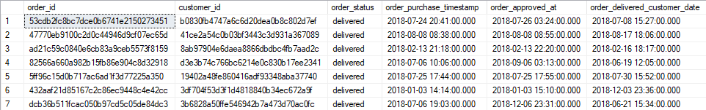

# 4. DATE WAREHOUSE

## 4.A. MODELING

In this section, we are addressing the date warehousing part. We first modeled the data warehousing on paper taking into account what would be interesting business wise.

In the model, we adopted a snowflake architecture for our data warehouse.

A central fact table that includes the following data :

* Order_id
* Oder_item_id

Those two previous variables act together as a composite key

* Customer_key (surrogate)
* Seller_key (surrogate)
* Product_key (surrogate)
* Review_key (surrogate)
* Order_status
* Order_purchase_date (surrogate key from dimension date table)
* Order_approved_date (surrogate key from dimension date table)
* Order_delivered_customer_date (surrogate key from dimension date table)
* Payment_type
* Total_invoiced (a manual calculation)

Around this fact table, articulates 7 dimension tables giving the context information of the observations in the fact table.

DimCustomer table:

* Customer_key (surrogate key incrementing integer)
* Customer_id (initial primary key of customer data)
* Customer_unique_id (anonymized unique id for customer)
* Geolocation_key (which is a surrogate key for another dimension table)

DimSeller table:

* Seller_key (surrogate)
* Seller_id
* Geolocation_key (which is a surrogate key for another dimension table)

DimProducts table:

* Product_key (surrogate)
* Product_id
* Product_category_name
* Product_category_name_english
* Product_photos_qty
* Product_weight_g
* Product_length_cm
* Product_height_cm
* Product_width_cm
* Price
* Freight_value

DimReviews:

* Review_key (surrogate)
* DateKey (surrogate for dimension date table)
* Review_id
* Review_comment_title
* Review_comment_message
* Review_score

The fact table first rows in the data warehouse looks like this:

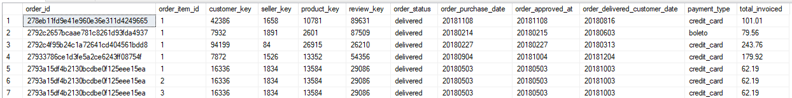

## 4.B. Fact table

1. Total invoiced

Regarding, the variable total_invoiced, this is a calculated column. In fact, in the original flat source files, we have access to the payment value by order, however an order can contain several items. Our granularity works at the order-item level, so we needed a way to obtain the price value per item. We can find from the order_item source file, the information about the price and freight value of each item. Those two values were summed together to get the total value per item. The final payment_value of the order is just the sum of the total_invoiced for every items contained in the order.

1. Date keys

Regarding date, we decided to work with date and not datetime. Meaning that during the creation of the datawarehouse in SQL database, we changed the data type for date columns to date unlike we did with ODS where we kept the datetime. Indeed, depending on business needs, we decided to keep the datetime format in the ODS database, meaning it will be less costly to impute changed to retrieve the time when the business needs it.

Also for the dimension date table, we worked with the table seen in class that supports only date (day) at most (the SQL query can be found in appendix). To work with datekeys and keeping time, the dimension date table must be changed to support time slices.

1. Order_id / Order_item_id

In the fact table, the primary key is a composite one, composed of the order_id and the order_item_id which is just a repeated integer. The combination of both variables is necessary and sufficient to uniquely identify a row in the fact table.

For example the row #10 and #11 share the same order_id but not the same order_item_id.

## 4.C. DIMENSION TABLES

1. Geolocation table

We created a geolocation dimension table that includes all the geolocation details for a specific geolocation_key. This table, as described in the snowflake architecture, is used to describe other dimension table (and not the fact table directly). For example, the customer dimension table includes the columns:



The geolocation_key points to a specific row in the geolocation dimension table where details about the customer location can be found. This geolocation key is also used for seller table to indicate the location of the seller through a geolocation key.

The advantage of this, is to normalize and increase the granularity of our data warehouse, making it more readable and logical. The inconvenient is a reduction in the performance as more joins will have to be used when queries about customer or seller location are made.

1. Date table

The date dimension table contains all the information of “time” that we might need, including month, week of the year, date in different format and a dateKey (surrogate key) that we reference in the other tables.

This table is also used to described other dimension table such as DimReview table as well as to describe directly the fact table.

1. Other dimensions table

All the context of a fact or an observation in the fact table can be found in the following dimension table:

* DimCustomer : table containing infos on customer
* DimSeller: seller informations
* DimProducts: product information (this contextualize the order_items)
* DimReviews: review information of an order. The reviews are made for every order and not product. Therefore, when several items were purchased in a unique order, a duplicate of this will be found in the fact table, as it references the same review.

# 5. PIPELINE CONSTRUCTION

The step before automatization of this process is to build the pipeline, in other words, to construct the links between every single step of the whole process. This is done directly in SSIS.

Instead of using data flow task as it was done before, we now use sequence container (SEQC). SEQC can contain several packages and link them together in a specific order. That way, the whole pipeline process can be started all together without starting every single package at a time. Also, it the pipeline will proceeds in the specific order of the package that was defined in the sequence container.

This is important especially at the data warehouse step where the fact table data flow can only work after the dimension tables have been created and populated. Therefore, the dimension tables package must start first and foremost in the DWH step.

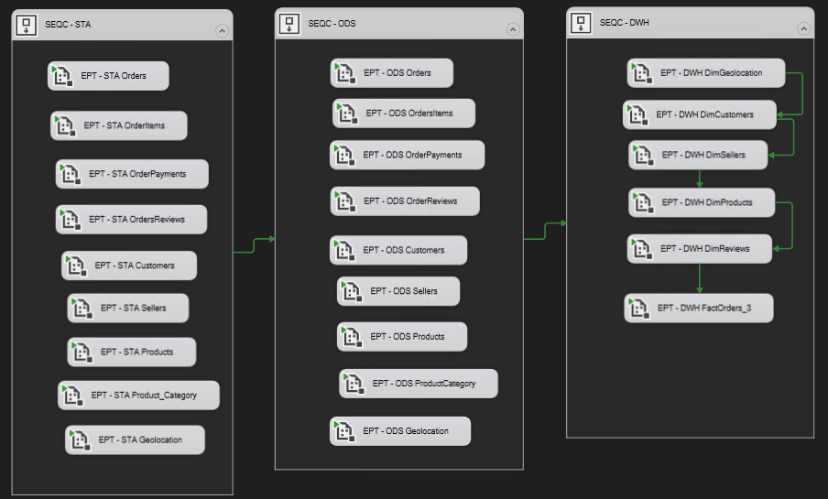

The sequence container have also more useful perks, such as working flow indication (failed, completed, success..) and more.

# 6. AUTOMATIZATION

The final step of the project is to create a routine job in SQL server that will launch the whole pipeline periodically at defined time periods.

To do that, we first deployed the project from Visual Studio solution explorer side page.

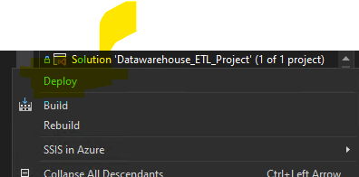

The deployment can be done with Azure, but in the scope of this project, we deployed the project directly to SQL server. We created a folder: S24_EXAM. After deploying to SQL server, in SQL Server management studio we can see the folder S24_EXAM in the integration services catalogs, SSISDB.

Once the project is deployed we can create job and schedule to implement the pipeline in a routine task.

We use for that, SQL server agent, we create a new job that we call S24_EXAM_ETL_PIPELINE and we select the package called ETL , that contains all the sequence container of all packages in the pipeline as described in previous section. We then create a new schedule in the Schedules tab

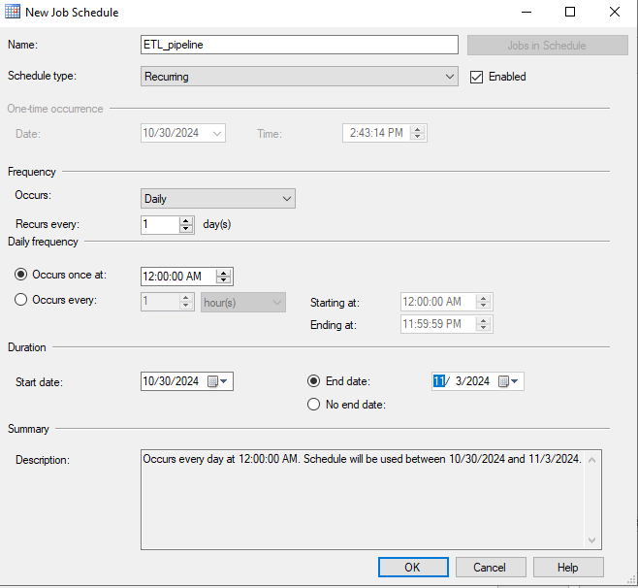

After this step is done, the project is completed and the pipeline will run every day at 12AM fetching the source file and proceeding to all the steps in the pipeline to filling the data warehouse.

# 7. USE CASES

Now that the data warehouse is ready to be used by business, we can do some analysis on the data. We will treat 3 use cases of the data warehouse.

## 7.A.

We would like to know which product categories have the highest or lowest customer satisfaction.

Using the DWH, we can query using the following SQL:

USE [S24_EXAM_DWH]

SELECT

dp.product_category_name_english,

AVG(dr.review_score) AS avg_review_score

FROM

FactOrders fo

JOIN

DimProducts dp ON fo.product_key = dp.product_key

JOIN

DimReviews dr ON fo.review_key = dr.review_key

GROUP BY

dp.product_category_name_english

ORDER BY

avg_review_score DESC;

This can provide a ranking of the different product categories according to their average customer review score.

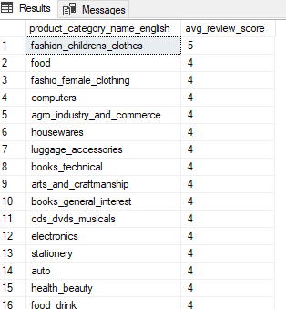

In the use cases, we are more interested in two specific categories, the top one and the last one. In that case, we can modify the query as such:

WITH RankedCategories AS (

SELECT

dp.product_category_name_english,

AVG(dr.review_score) AS avg_review_score,

ROW_NUMBER() OVER (ORDER BY AVG(dr.review_score) DESC) AS rn_desc,

ROW_NUMBER() OVER (ORDER BY AVG(dr.review_score) ASC) AS rn_asc

FROM

FactOrders fo

JOIN

DimProducts dp ON fo.product_key = dp.product_key

JOIN

DimReviews dr ON fo.review_key = dr.review_key

GROUP BY

dp.product_category_name_english

)

SELECT

product_category_name_english,

avg_review_score

FROM

RankedCategories

WHERE

rn_desc = 1 OR rn_asc = 1;

This query uses the ‘VIEW’ functionality in TSQL. The result of the query is :

So the category that had much customer satisfaction is ‘fashion_childrens_clothes’ and the one that had the least customer satisfaction is ‘home_comfort_2’.

## 7.B.

Another use case:

How do different payment methods impact order completion times ?

We can query the DWH as such:

USE [S24_EXAM_DWH]

SELECT

fo.Payment_type,

AVG(DATEDIFF(day, ddp.Date, ddd.Date)) AS avg_completion_time_days

FROM

FactOrders fo

JOIN

DimDate ddp ON fo.Order_purchase_date = ddp.DateKey

JOIN

DimDate ddd ON fo.Order_delivered_customer_date = ddd.DateKey

WHERE

fo.Order_status = 'Delivered'

GROUP BY

fo.Payment_type

ORDER BY

avg_completion_time_days;

That way we can get the average completion time depending on the payment type. Here is the result:

## 7.C.

A more broad use case is to investigate the factors that influence delivery delays. For such analysis, we investigated separately suspect factors and try to see if there are big differences in delivery delays between sub groups of those factors.

For example, the weight of the product can be an interesting factor to look at considering delivery delays.

SELECT

delays.product_weight_g,

AVG(delivery_delay_days) AS avg_delay_days,

ROUND(STDEV(delays.delivery_delay_days),2) AS stddev_delay_days

FROM

(SELECT

fo.Order_id,

fo.Order_item_id,

DATEDIFF(day, da.Date, dd.Date) AS delivery_delay_days,

dp.product_category_name_english,

dc.geolocation_key AS customer_location,

fo.payment_type,

dp.product_weight_g

FROM

FactOrders fo

JOIN

DimDate da ON fo.order_approved_at = da.DateKey

JOIN

DimDate dd ON fo.order_delivered_customer_date = dd.DateKey

JOIN

DimProducts dp ON fo.product_key = dp.product_key

JOIN

DimCustomers dc ON fo.customer_key = dc.customer_key

WHERE

DATEDIFF(day, da.Date, dd.Date) > 0) AS delays

GROUP BY

delays.product_weight_g

ORDER BY

avg_delay_days DESC;

GO

The result is a ranking of average delivery delays in descending order of the product_weight.

As analyst, we could plot this table as scatter plot to check for any linearity, or correlation between package weight and delivery delay. For such result, we see that the weight of the package has in fact no influence on the delivery delay.