Instructions for Conducting Multiple Linear Regression Analysis in SPSS
Multiple linear regression analysis is used to examine the relationship between two or more independent variables and one dependent variable. The independent variables can be measured at any level (i.e., nominal, ordinal, interval, or ratio). However, nominal or ordinal-level IVs that have more than two values or categories (e.g., race) must be recoded prior to conducting the analysis because linear regression procedures can only handle interval or ratio-level IVs, and nominal or ordinal-level IVs with a maximum of two values (i.e., dichotomous). The dependent variable MUST be measured at the interval- or ratio-level. In this demonstration we use base year standardized reading score (BY2XRSTD) as the dependent variable and socio-economic status (BYSES), family size (BYFAMSIZ), self-concept (BYCNCPT1), urban residence, (URBAN), rural residence (RURAL), and sex (GENDER) as independent variables. In order to conduct the analysis, we have to recode two variables from the original data set [i.e., urbanicity (G8URBAN) into urban residence (URBAN), and rural residence (RURAL), and sex (SEX) into sex (GENDER)]. We include instructions for this step as well. Although not used in the analysis, the data set also includes two identification variables [student ID (STU_ID) and school ID (SCH_ID)] and one weight variable (F2PNWLWT).
Copies of the data set and output are available on the companion website. The data set file is entitled, “REGRESSION.SAV”. The output file is entitled, “Multiple Linear Regression results.spv”.
The following instructions are divided into three sets of steps:
- Recode G8URBAN and SEX into new dichotomous variables (i.e., URBAN, RURAL, & GENDER)
- Conduct preliminary analyses
  - Examine descriptive statistics of the continuous variables
  - Check the normality assumption by examining histograms of the continuous variables
  - Check the linearity assumption by examining correlations between continuous variables and scatter diagrams of the dependent variable versus independent variables.
- Conduct multiple linear regression analysis
  - Run model with dependent and independent variables
  - Model Check
    - Examine collinearity diagnostics to check for multicollinearity
    - Examine residual plots to check error variance assumptions (i.e., normality and homogeneity of variance)
    - Examine influence diagnostics (residuals, dfbetas) to check for outliers
    - Examine significance of coefficient estimates to trim the model
  - Revise the model and rerun the analyses based on the results of steps i-iv.
  - Write the final regression equation and interpret the coefficient estimates.
To get started, open the SPSS data file entitled, REGRESSION.SAV.

STEP I: Recode SEX and G8URBAN into dichotomous variables
Run frequencies for SEX and G8URBAN. This will be helpful later for verifying that the dichotomous variables were created correctly. At the Analyze menu, select Descriptive Statistics. Click Frequencies. Click SEX and G8URBAN and move them to the Variables box. Click OK.
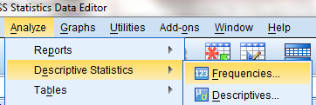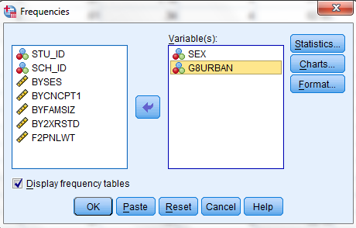
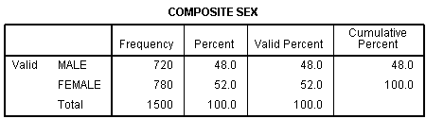
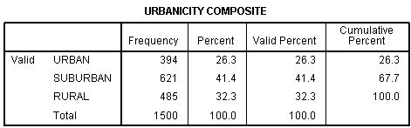
Prior to recoding SEX into a dichotomous variable, we need to determine what the numeric values are for Male and Female. To do this, click on SPSS variable view at the bottom left corner of your SPSS screen. Click the Values column for SEX variable. Click on the grey bar to reveal how Male and Female are coded. We see that Male is coded as “1” and Female is coded as “2”. Click Cancel.
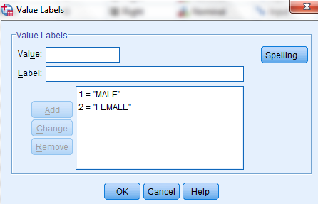
To run multiple regression analysis in SPSS, the values for the SEX variable need to be recoded from ‘1’ and ‘2’ to ‘0’ and ‘1’. Because the value for Male is already coded 1, we only need to re-code the value for Female, from ‘2’ to ‘0’. Open the Transform menu at the top of the SPSS menu bar. Select and click Recode into Different Variables.
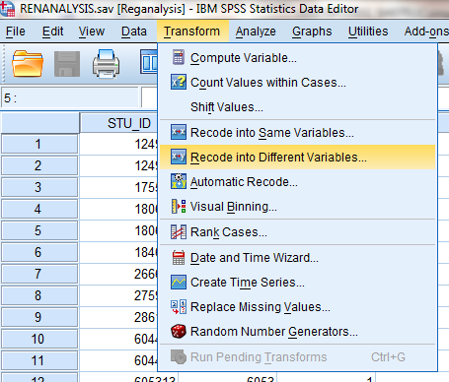
On the variables list in the box on the left, click SEX and move it to center box.
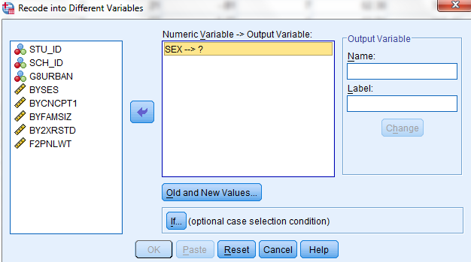
Within the Output variable Name type ‘GENDER’ to rename the SEX variable. Click Change.
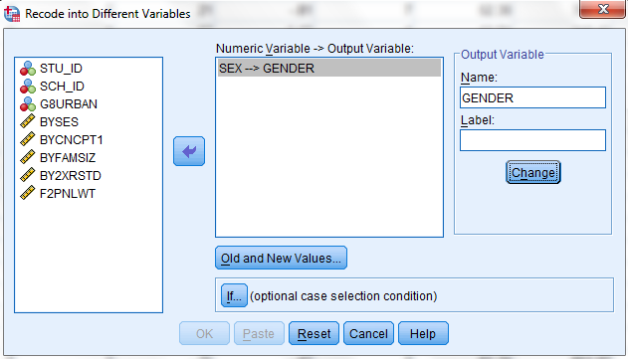
Click Old and New Values. The "Old Value" is the value for the level of the categorical variable (SEX) to be changed. The "New Value" is the value for the level on the recoded variable (GENDER).
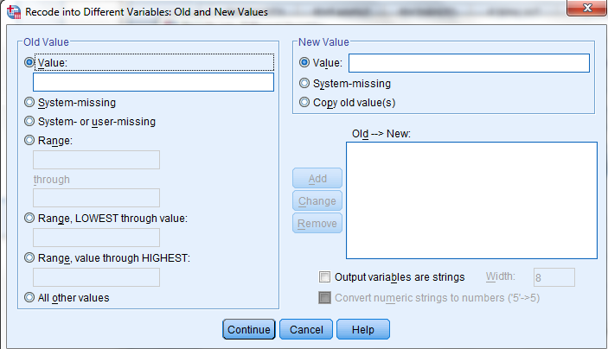
The value for Male is “1” on both SEX and GENDER. Type “1” in the Old Value box; type “1” in the New Value box. Click Add. The value for Female is recoded from “2” on SEX to “0” on GENDER. Type “2” in the Old Value box; type “0” in the New Value box. Click Add.
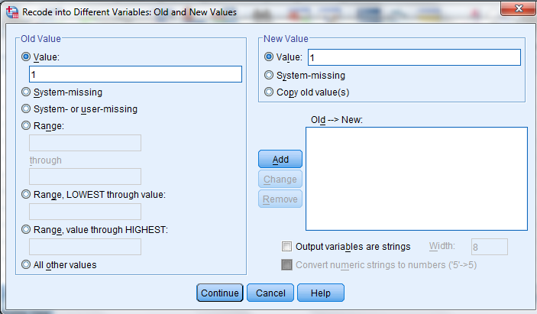
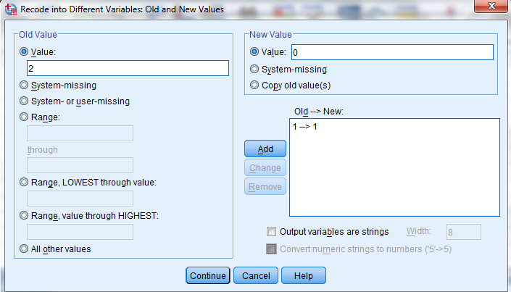
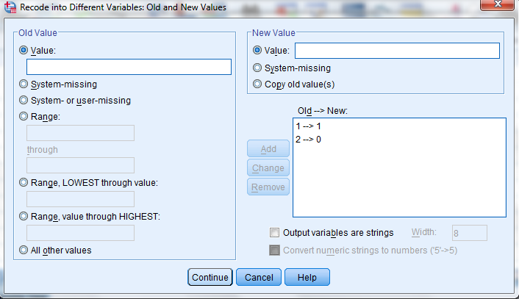
Click Continue. Click OK
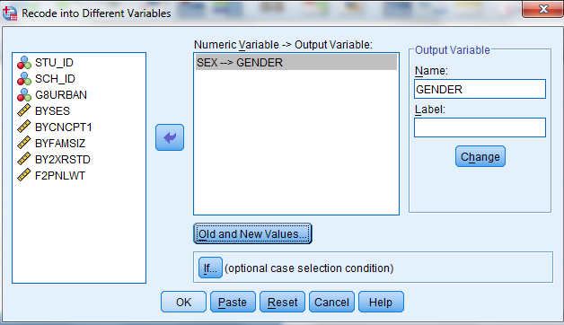
The variable GENDER will be added to the dataset.
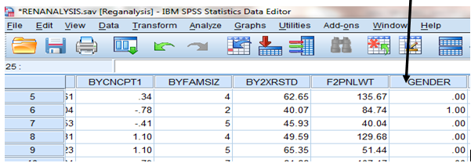
Next we label the values for the GENDER categories (Male and Female). Click Variable View on bottom left corner of the data spread sheet.
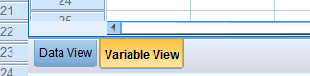
Click the grey bar on the Values column for GENDER
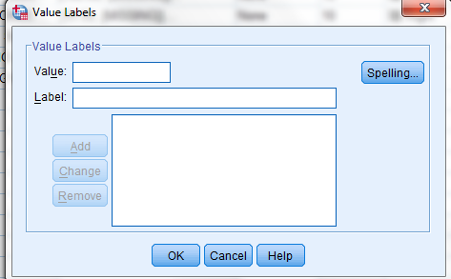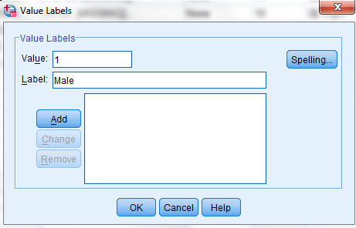
Type “1” into the Value box; type “Male” into the Label box. Click Add. Type “0” into the Value box; type “Female” into the Label Box. Click Add. Click OK.
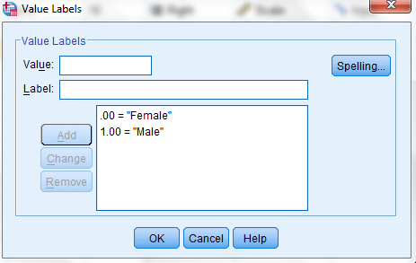
To determine whether GENDER was created correctly, run a frequency on the newly created GENDER variable.
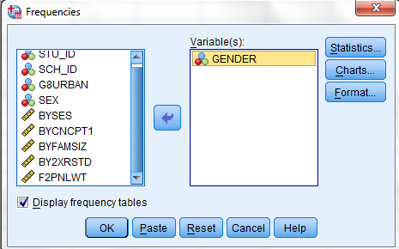
The values for Males and Females should match those in the SEX variable.
We now need to examine G8URBAN to determine its categories and how it should be recoded. Click on SPSS variable view. Click the Values column for G8URBAN variable. Click on the grey bar to reveal how G8URBAN categories are coded. We see that G8URBAN has three categories.

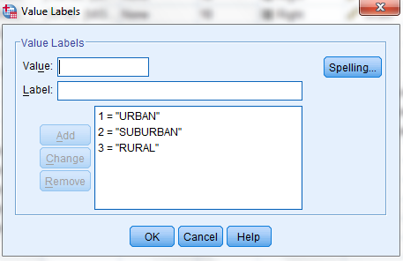
Recall that in multiple regression analysis, independent variables must be measured as either interval/ratio or nominal/ordinal with only two values (i.e., dichotomous). Thus, we need to recode G8URBAN. A rule of thumb in creating dichotomous variables is that for categorical independent variables with more than two categories (i.e., k), we create k minus 1 dichotomous variables. In this case, G8URBAN has 3 categories, thus, we will create 2 dichotomous variables (3 – 1 = 2). The category that is not included in the dichotomous variables is referred to as the reference category. In this example, SUBURBAN is the reference category. The two new dichotomous variables are named URBAN and RURAL. The recoding is done in the same way that we recoded SEX. The following table shows the values of the old variable (i.e., G8URBAN) and values for each of the new dichotomous variables (URBAN and RURAL):
Variables | Values
 | Urban | Suburban | Rural
Old: G8URBAN | 1 | 2 | 3
New: URBAN | 1 | Reference Category | 0
New: RURAL | 0 | Reference Category | 1

To create URBAN from G8URBAN, open the Transform menu at the top of the SPSS menu bar. Select and click Recode into Different Variables.
If necessary, click Reset to clear previous selections. On the variables list in the box on the left, click G8URBAN and move it to center box. Within the Output variable Name type URBAN. Click Change.
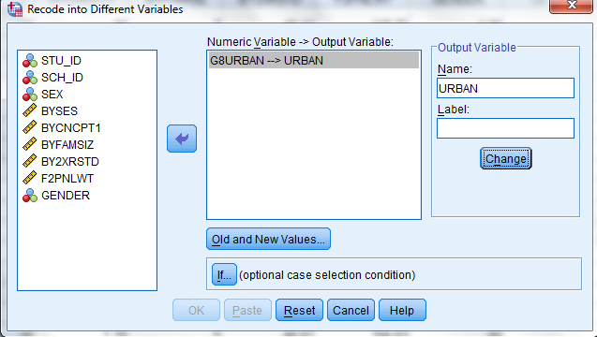
Click Old and New Values. Type “1” in the Old Value box; type “1” in the New Value box. Click Add. Type “2” in the Old Value box; type “0” in the New Value box. Click Add. Type “3” in the Old Value box; type “0” in the New Value box. Click Add. Click Continue.
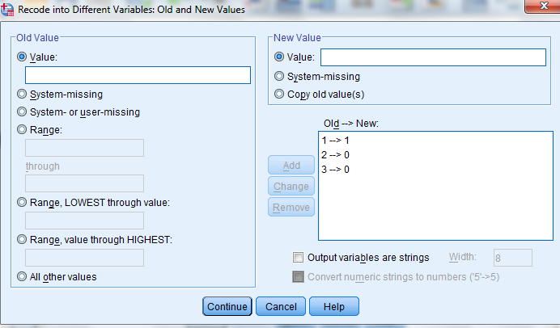
Click OK.
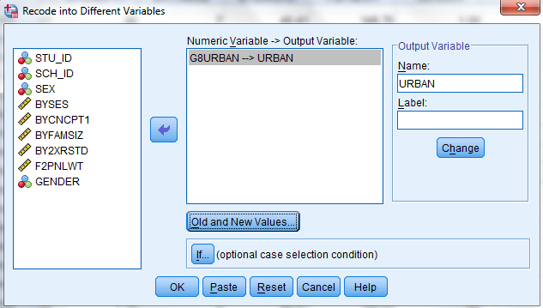
A new variable URBAN will be added to the dataset. Run frequencies on URBAN to verify that the number of 1’s in the URBAN category matches the number of URBAN in the original G8URBAN variable.
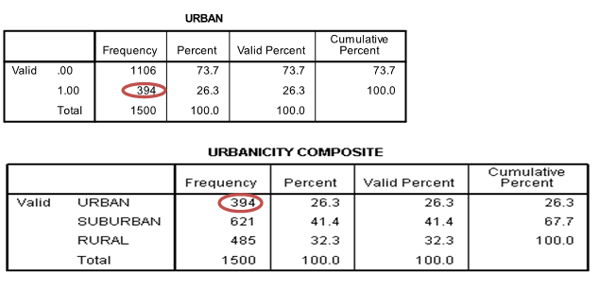
To create RURAL from G8URBAN, open the Transform menu at the top of the SPSS menu bar. Select and click Recode into Different Variables.
Click Reset to clear the previous selections. On the variables list in the box on the left, click G8URBAN and move it to center box. Within the Output variable Name type RURAL. Click Change.
Click Old and New Values. Type “1” in the Old Value box; type “0” in the New Value box. Click Add. Type “2” in the Old Value box; type “0” in the New Value box. Click Add. Type “3” in the Old Value box; type “1” in the New Value box. Click Add. Click Continue.
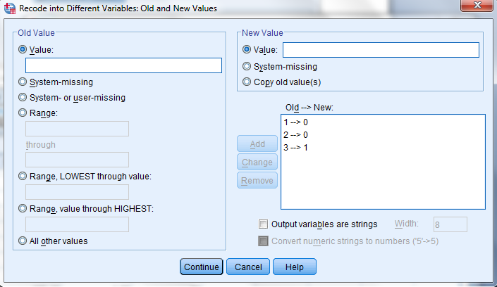
Click OK.
A new variable RURAL will be added to the dataset. Run frequencies on RURAL to verify that the number of 1’s in the RURAL category matches the number of RURAL in the original G8URBAN variable.
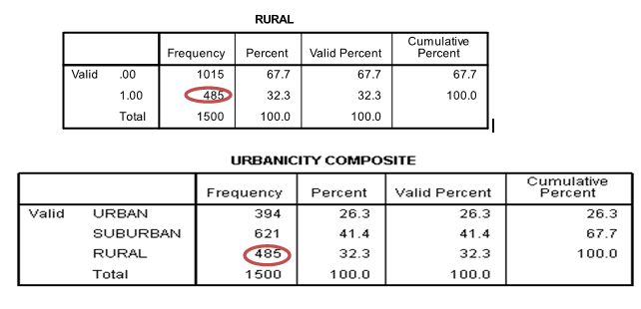
STEP II: PRELIMINARY ANALYSES
Dependent Variable: BY2XRSTD
Independent Variables: BYSES, BYFAMSIZ, BYCNCPT1, GENDER, URBAN, RURAL
***NOTE: The list of independent variables does not include SEX and G8URBAN variables. This is because we replaced them with the recoded and dichotomous variables***
Examine Descriptive Statistics
In conducting preliminary analyses, the first step is to examine various descriptive statistics of the continuous variables (i.e., BY2XRSTD, BYSES, BYFAMSIZ, and BYCNCPT1). On Analyze menu, select Descriptive Statistics. Click Descriptives. Click on BY2XRSTD, BYSES, BYFAMSIZ, and BYCNCPT1, one at a time, and click to add them to the Variables box. Click Options. Check Mean, Std. deviation, Minimum, Maximum, Kurtosis, and Skewness. Click Continue. Click OK.

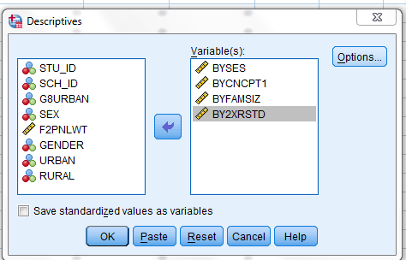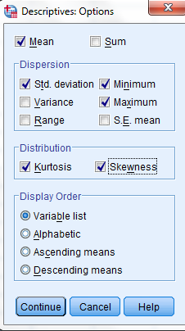
The values for Skewness and the Kurtosis indices are very small which indicates that the variables most likely do not include influential cases or outliers.
Check Normality Assumption
We examine the distribution of the independent variables measured at the interval/ratio-levels and dependent variables to check the normality assumption as the second step. To check BYSES, click Graphs menu. Select Legacy Dialogs. Click Histograms. Click and move BYSES to the Variable box. Check Display normal curve. Click OK.
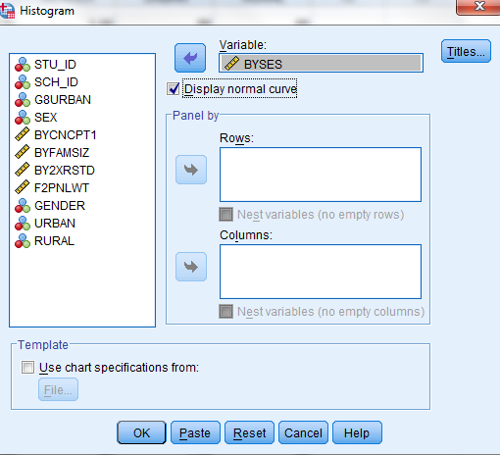
As the graph shows, BYSES is normally distributed.
To check BYFAMSIZ, click Graphs menu. Select Legacy Dialogs. Click Histograms. Click Reset to clear the variable box. Click and move BYFAMSIZ to the Variable box. Check Display normal curve. Click OK.
Although BYFAMSIZ is slightly skewed in a positive direction, the normality assumption is not violated.
To check BYCNPT1, click Graphs menu. Select Legacy Dialogs. Click Histograms. Click Reset to clear the variable box. Click and move BYCNCPT1 to the Variable box. Check Display normal curve. Click OK.

Sometimes the way in which SPSS determines the number of intervals for histograms results in the creation of a histogram with a shape that is difficult to interpret (as in the preceding histogram for self concept). When this happens, we can manually adjust the number of intervals to improve interpretation. Between 15 and 20 intervals is recommended for a data set with more than 250 cases. The following revised histogram includes 15 intervals.
As the graph indicates, self concept is negatively skewed. The distribution of self-concept scores is not normal and thus violates the normality assumption.
To check BY2XRSTD, click Graphs menu. Select Legacy Dialogs. Click Histograms. Click Reset to clear the variable box. Click and move BY2XRSTD to the Variable box. Check Display normal curve. Click OK. The number of intervals for this histogram has also been adjusted to 15 using the same procedure as self concept.
Reading Standardized score is slightly skewed in a positive direction but not enough to violate the normality assumption.
Check Linearity Assumption:
Another linear regression assumption is that the relationship between the dependent and independent variables is linear. We can check this assumption by examining scatterplots of the dependent and independent variables. First, we calculate Pearson correlation coefficients to examine relationships between the DV and the IVs measured at the interval/ratio-levels to check an indication of the magnitude of the relationship between variable pairs. Click Analyze. Select Correlate. Click Bivariate. Click and move the dependent and the continuous independent variables to the Variables box. Check Pearson. Select Two-tailed significance. Check Flag significant correlations. Click OK.
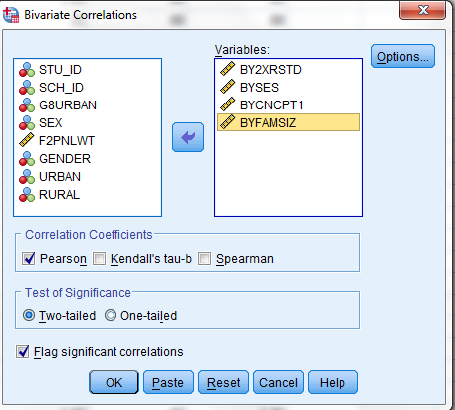
The results indicate a moderate positive correlation between socio economic status and reading scores; a weak positive correlation between self concept and reading scores, and a weak negative correlation between family size and reading scores.
To create a scatter diagram of BY2XRSTD by BYSES, click Graphs menu. Select Legacy Dialogs. Click Scatter/Dots. Select Simple scatter. Click Define. Click and move BY2XRSTD to the Y Axis. Click and move BYSES to the X Axis. Click OK.
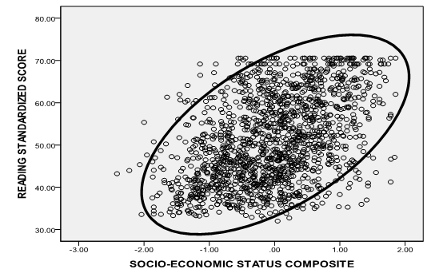
The graph shows a positive linear relationship between reading scores and socio economic status. The correlation between the two variables is significant so we can conclude that there is a linear relationship between BY2XRSTD and BYSES, thus not violating the linearity assumption.
To create a scatter diagram of BY2XRSTD by BYCNPT1, click Graphs menu. Select Legacy Dialogs. Click Scatter/Dots. Select Simple scatter. Click Define. Click Reset to clear the axes boxes. Click and move BY2XRSTD to the Y Axis. Click and move BYCNCPT1 to the X Axis. Click OK.
Although this graph suggests that the linearity assumption may be violated here, we will keep self concept in the model because its correlation with reading scores is significant. However, this violation must be noted as a limitation of the model.
To create a scatter diagram of BY2XRSTD by BYFAMSIZ, click Graphs menu. Select Legacy Dialogs. Click Scatter/Dots. Select Simple scatter. Click Define. Click Reset to clear the axes boxes. Click and move BY2XRSTD to the Y Axis. Click and move BYFAMSIZ to the X Axis. Click OK.
This graph suggests that the linearity assumption may be violated here as well. In fact, the graph shows similar reading scores among students in families with two to seven family members. The reading scores of students from families with more than seven members appear to be lower. We could recode family size to a dichotomous variable (0= less than 8 family members, 1=8 or more family members) as an alternative way to evaluate its impact. This violation must also be noted as a limitation of the model.
Based on the outcome of this assessment, we retain all continuous independent variables in the model because they are significantly correlated with the dependent variable.
STEP III: MULTIPLE LINEAR REGRESSION ANALYSIS
Dependent Variable: BY2XRSTD
Independent Variables: BYSES, BYFAMSIZ, BYCNCPT1, GENDER, URBAN, RURAL
***NOTE: The list of independent variables does not include SEX and G8URBAN variables. This is because we replaced them with the recoded and dichotomous variables***
In addition to providing instructions for running the multiple regression analysis, we also include instructions for checking model requirements (i.e., outliers and influential cases and multicollinearity among the continuous independent variables) and the homogeneity of variance assumption. Recall that outliers and influential cases can negatively affect the fit of the model or the parameter estimates. We calculate residuals and dfbetas using the Influence Diagnostics procedure to check for outliers and influential cases. We calculate the Variance Inflation Factor (VIF) and Tolerance statistics to check for multicollinearity. Finally, we create homogeneity of error variance plots to check the homogeneity of variance. The dataset used to conduct these analyses is included on the companion website. It is entitled, REGRESSION.SAV.
The first step is to enter the dependent and independent variables into the SPSS model. Click on Analyze in the menu bar at the top of the data view screen. A drop down menu will appear. Move your cursor to Regression. Another drop down menu will appear to the right of the first menu. Click on Linear to open the Linear Regression dialog box.

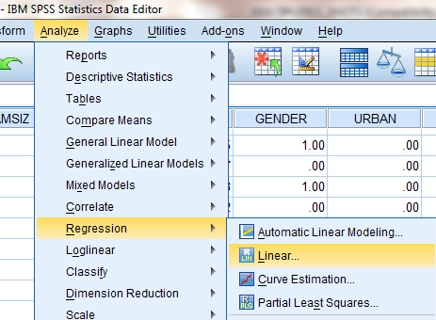

Click to highlight BY2XRSTD in the box on the left side. Click the top arrow to move it to the Dependent box. Click to highlight BYSES, BYFAMSIZ, BYCNCPT1, GENDER, URBAN, and RURAL and move each of them one at a time to the Independent(s) box.
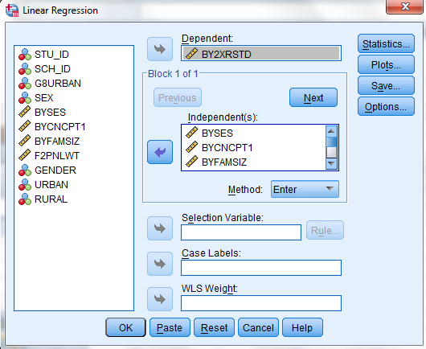
Next, we program SPSS to provide a check for multicollinearity. Click Statistics in the upper right corner to open the Linear Regression: Statistics dialogue box. Make sure that Estimates, Model fit and Collinearity Diagnostics are checked. Click Continue to return to the Linear Regression dialogue box.

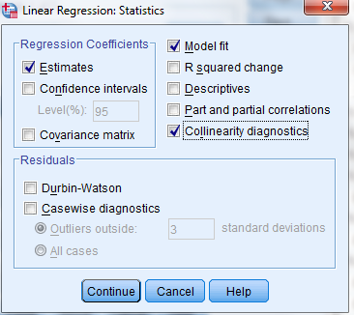
To create residual plots to check the homogeneity of variance and normality assumptions, click Plots just below Statistics to open the Linear Regression: Plots dialogue box. Click and move “*ZRESID” to the Y box. Click and move “*ZPRED” to the X box. Check “Histogram”. Click Continue to return to the Linear Regression dialogue box.

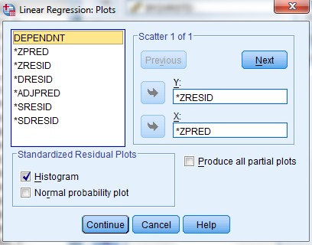
To check for outliers and influential cases, click Save just below Plots to open the Linear Regression: Save dialogue box. Under Residuals, check “Standardized”. Under Influence Statistics, check “Standardized DfBetas”. Click Continue to return to the Linear Regression dialogue box.
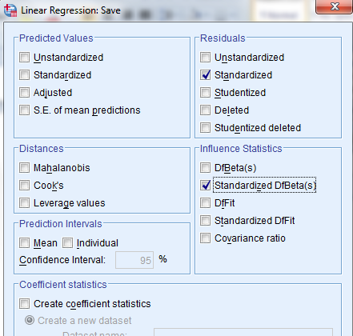
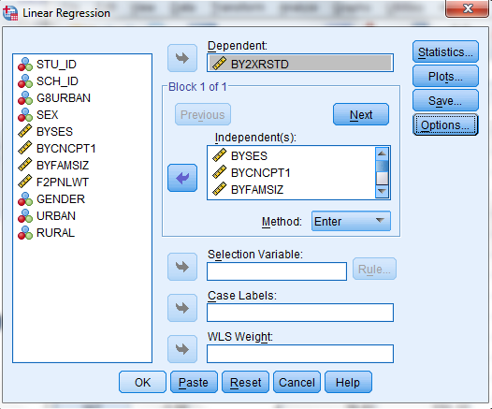
Click OK at the bottom of the Linear Regression dialogue box to run the multiple linear regression analysis.
We now examine the output, including findings with regard to multicollinearity, whether the model should be trimmed (i.e., removing insignificant predictors), violation of homogeneity of variance and normality assumptions, and outliers and influential cases.
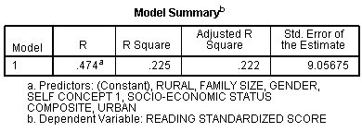
The R² is .225. This means that the independent variables explain 22.5% of the variation in the dependent variable.
The p value for the F statistic is < .05. This means that at least one of the independent variables is a significant predictor of the DV (standardized reading scores). The “Sig.” column in the Coefficients table shows which variables are significant.
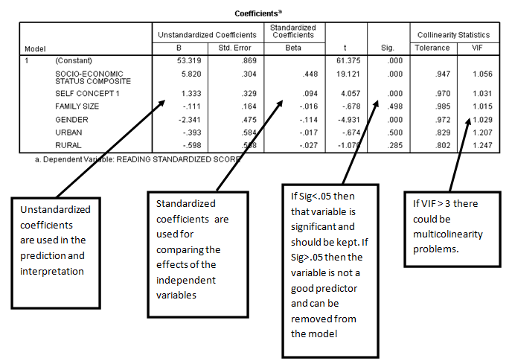It appears multicollinearity is not a concern because the VIF scores are less than 3.
In terms of model trimming, the results also show that BYFAMSIZ, URBAN, RURAL are not significant predictors of the standardized reading scores. We will remove these variables from the model and rerun the analysis.
The histogram of residuals allows us to check the extent to which the residuals are normally distributed. The residuals histogram shows a fairly normal distribution. Thus, based on these results, the normality of residuals assumption is satisfied.
We examine a scatter plot of the residuals against the predicted values to evaluate whether the homogeneity of variance assumption is met. If it is met, there should be no pattern to the residuals plotted against the predicted values. In the following scatter plot, we see a slanting pattern, which suggests heteroscedasticity, (i.e., violation of the homogeneity of variance assumption).
Finally, we examine the values of the standardized DfBetas and standardized residual values to identify outliers and influential cases. Large values suggest outliers or influential cases. Note that the results thus far (histograms and scatter plots of the continuous variables and residuals) showed no data point(s) that stood out as outliers. Thus, it is unlikely that we will find large standardized DfBetas or standardized residual values. Nonetheless, the standardized DfBeta values can verify this. The values of the standardized DfBetas have been added as seven additional variables in the data set (SDB0_1 – SDB6_1). Outliers or influential cases have large (< -2 or >2) standardized DfBetas. Instead of manually scrolling through the values of each variable to check this, we can calculate maximum and minimum values.
Click Analyze in the menu bar at the top of the data view screen. A drop down menu will appear. Move your cursor to Descriptive Statistics. Another drop down menu will appear to the right of the first menu. Click on Descriptives to open the Descriptives dialog box. Highlight the seven SDB variables and move them to the Variables box. Click OK.
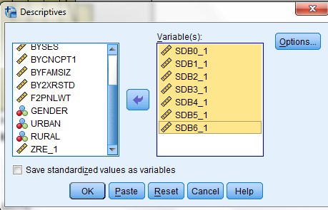
The results show no standardized Dfbeta values < -2 or > 2. We can conclude that the dataset does not include outliers or influential cases. 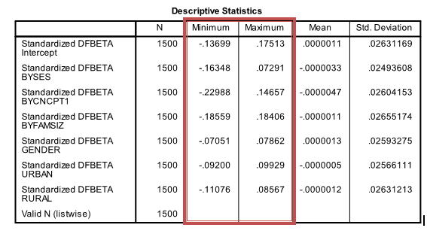
A copy of the output for the analyses we just conducted is provided on the companion website. It is entitled, Multiple Linear Regression Results_prelim.spv.
Fitting a Final Model
Given that BYFAMSIZ, URBAN, RURAL are not significant we remove them from the analysis and refit the model. The revised list variables are:
Dependent Variable: BY2XRSTD
Independent Variables: BYSES, BYCNCPT1, GENDER
First, we must delete the Residual and DfBeta variables from the dataset. This can easily be done by highlighting them, right clicking your mouse, and then clicking Clear.
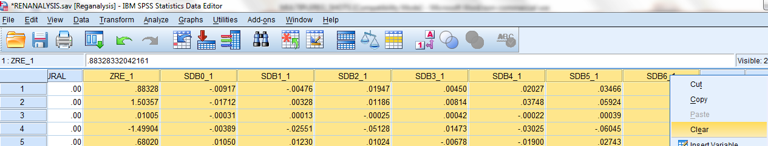
Next, we rerun the model following the same steps used in conducting the preliminary analyses. Click Analyze in the menu bar at the top of the data view screen. A drop down menu will appear. Move your cursor to Regression. Another drop down menu will appear to the right of the first menu. Click Linear to open the Linear Regression dialog box. Click to highlight BY2XRSTD in the box on the left side. Click the top arrow to move it to the Dependent box. Click to highlight BYSES, BYCNCPT1, and GENDER and move each of them one at a time to the Independent(s) box.
Click Statistics in the upper right corner to open the Linear Regression: Statistics dialogue box. Make sure that Estimates and Model fit are checked. Click Continue to return to the Linear Regression dialogue box.
To check the homogeneity of variance and normality assumptions, click Plots just below Statistics to open the Linear Regression: Plots dialogue box. Click and move “*ZRESID” to the Y box. Click and move “*ZPRED” to the X box. Check “Histogram”. Click Continue to return to the Linear Regression dialogue box.
Click OK at the bottom of the Linear Regression dialogue box to run the revised analyses. The output is provided as follows:

The R² = .224. This means that the independent variables explain 22.4% of the variation in the dependent variable. This value almost the same as the R² value from the preliminary model. This confirms that the variables removed from the preliminary model were useless in predicting reading scores.
The p value for F statistic is < .05. This means that at least one independent variable is a significant predictor of reading scores. The Sig. column in the Coefficients table shows which variables are significant.
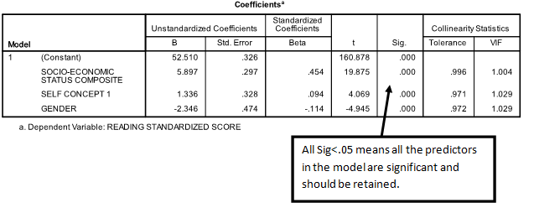
Plots of residuals and homogeneity of error variance look identical to the plots from the preliminary model, indicating that the normality of residuals assumption is met but the homogeneity of variance assumption is not met.
We examine the coefficients table to examine and interpret the results. The prediction equation is based on the unstandardized coefficients, as follows:
BY2XRSTD_{i} = 52.51 + 5.897 BYSES_{i} + 1.336 BYCNCPT1_{i} – 2.346 GENDER_{i} , where
i=1….1500 and GENDER= 1 for Males and 0 for Females.
We can use the unstandardized coefficients to interpret the results.
- The Constant is the predicted value of the dependent variable when all of the independent variables have a value of zero. In the context of this analysis, the predicted reading score for females with zero self-concept and zero socio-economic status score is 52.51.
- The slope of socio-economic status (BYSES) is 5.897. This means that for every one unit increase in socio economic status, predicted reading scores increase by 5.897 units, after controlling for self concept and gender.
- The slope of self concept (BYCNCPT1) is 1.336. This means that for every one unit increase in self concept, predicted reading scores increase by 1.336, after controlling for socio-economic status and gender.
- The slope of gender (GENDER) is -2.346. This means that, on average, predicted reading scores for males are 2.346 points lower than for females, after controlling for socio-economic status and self concept.

