AI-POWERED CODE REVIEW ASSISTANT FOR STUDENT PROGRAMMING
By
YOUSSEF AHMED MOUSSA 224061

A Dissertation submitted to the Faculty of Engineering, The British University in Egypt, in Partial Fulfillment of the requirements for the bachelor’s degree in electrical engineering

Supervisor(s): Dr. Ahmed Fouad Youssef

February, 2026

Electrical Engineering Department
Computer Engineering Programme

AI-Powered Code Review Assistant for Student Programming

Dissertation Approved:

Dr. Ahmed Fouad Youssef

Committee member

Committee member

External committee member
Affiliation:

Dean Faculty of Engineering

Table of Contents
List of Figures ii
List of Tables iii
Chapter 1: Introduction 1
1.1. Problem Statement 1
1.2. Motivation 1
1.3. Objectives 2
Chapter 2: Background 3
2.1. Overview 3
2.2. Artificial Intelligence and Machine Learning 3
2.2.1 Deep Learning and Neural Networks 4
2.3. Large Language Models and the Transformer Architecture 4
2.4. Model Size, Resource Constraints, and Scalability 6
2.5. Retrieval-Augmented Generation (RAG) 8
2.6. Static Code Analysis 9
2.6.1 The Hybrid Synergy 10
Chapter 3: Literature Review 11
3.1. LLMs in Computer Engineering Education 11
3.2. The Limits of Pure LLMs 11
3.3. Hybrid Architectures 12
3.4. Retrieval Augmented Generation (RAG) for Compliance 13
Chapter 4: Methodology 13
4.1. System Architecture Overview 13
4.2. Knowledge Base Construction (The RAG Engine) 15
4.3. The Hybrid Analysis Engine 16
4.4. Generative Inference Model 17
4.5. Prompt Engineering and Chain-of-Thought 17
Chapter 5: Preliminary Results and Discussion 19
References 26

List of Figures
Figure 1.1: Project Gantt chart outlining the development phases 3
Figure 2.1:The Hierarchy of AI 4
Figure 2.2: The Transformer model architecture, utilizing the self-attention mechanism [12]. 5
Figure 2.3: Retrieval-Augmented Generation (RAG) Concept [13] 9
Figure 2.4: Exemplary Abstract Syntax Tree (AST) [14] 10
Figure 4.1: The Hybrid AI Code Reviewer architecture 14
Figure 4.2: The Knowledge Base ingestion pipeline (FAISS + BM25). 16
Figure 4.3: The Chain-of-Thought system prompt used to instruct CodeLlama 18
Figure 5.1: Average Latency distribution by component 25

List of Tables
Table 5.1: Performance Metrics Summary 24

Chapter 1: Introduction

Problem Statement
With the dynamic world of Computer Science and Engineering learning, the demand to deliver immediate feedback, which is personalized, has increased at a rate exceeding the supply of resources to the academic institution. The process of learning to program is best acquired by repetition and revision, but the traditional learning model entails the human factor, i.e. Teaching Assistants (TA) and Professor, to deliver the required feedback to the students. This is the issue that we are attempting to solve. This is a twofold issue: Scalability, the student to instructor ratio is extremely high, and Timeliness, since the feedback can be given after several days or weeks, when the learning window has already passed. In addition, despite the growing use of Generative AI tools like "ChatGPT" to solve this problem, there is another problem of "Blind Trust" that was also produced. This is because, as has been discovered in literature, generic AI tools tend to hallucinate fake logic, or deliver code that is functional but does not strictly conform to academic standards. This is an issue because the students lack the expertise to confirm this information and are compelled to take in poor practices in coding. It does not have any tools that would offer the immediacy of AI while maintaining the reliability and guidance of a human tutor.

Motivation
The interest in this undertaking is motivated by both the personal experience and the general needs of the pedagogical fraternity. As an engineer, we have also experienced the suffering of attempting to troubleshoot a large codebase on our own with no help at late hours of the night as we studied. The understanding that thousands of students have the same "feedback void" was what inspired us to work on this project.
Democratizing quality code review is our aim. The concept of private tutoring should aid the privileged few but instead be a fundamental part of the digital learning environment. Through the application of the latest innovation in Large Language Models (LLMs) and Hybrid Architectures, we will have a system that is 24/7, never fatigued, and above all, reliable.

Objectives
The objective of this project is to act as the developer design an AI-powered Code Review Assistant, which is targeted specifically at computer engineering students. To achieve this, we have placed the following objectives:
Create a Hybrid Analysis Pipeline: To create a unified system to include Static Code Analysis (Pylint) with a Large Language Model (CodeLlama) to detect both syntax and logical errors with a high level of accuracy.
Introduce Retrieval-Augmented Generation (RAG): To create a system that will impose on using specific coding standards (PEP 8) to prevent hallucinations and generate high-quality code according to the industry standards.
Make it Easy and Affordable: To create system architecture to enable it to use the open-weight models (CodeLlama 7B), so that the system can be a free and accessible tool to the computer engineering students without having to buy the pricey API subscription offered by the enterprise solutions.
Create an Educational Feedback Loop: To improve the functionality of the system as a 'Tutor' instead of a 'Solver' to prevent copying the appropriate answer straight off the system.
Assess Trust and Performance: To compare the system to standard datasets in order to estimate the decrease in false positives and compliance with style rules relative to outputs of LLM.
  - Project Timeline
This project has a structured lifecycle that will be pursued in two academic semesters. The project schedule representation in the Gantt chart (Figure 1.1) shows the accomplished (Literature Review, Prototype Implementation) and those to be delivered in future (User Testing, Final Optimization).
- Phase I (Completed): Dedicated itself to problem definition, literature survey and the creation of the MVP (Minimum Viable Product) using the CodeLlama-7B architecture.
- Phase II (Ongoing): Concerned with the optimization of the RAG pipeline, rigorous user validation with engineering students, and the system deployment.
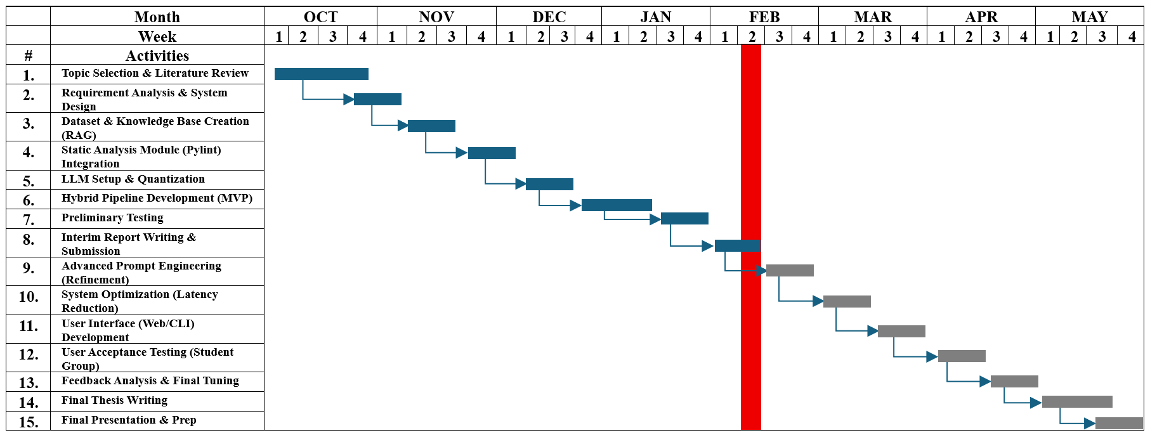
Figure 1.1: Project Gantt chart outlining the development phases

Chapter 2: Background

Overview
The chapter establishes the theoretical foundation one needs to understand the notion of the development of automated AI driven code review assistant. This talk starts with the fundamentals of Artificial Intelligence and Machine Learning and concludes with the complexities of Large Language Models (LLMs) and Retrieval-Augmented Generation (RAG). The discussion also contains the critical engineering choices which must be made in relation to the computational resource constraints.

Artificial Intelligence and Machine Learning
AI is a general research area that seeks to create a system that could perform the task that is traditionally related to human intelligence. As noted by Mendonça et al. [1], in the context of education, AI acts not just as a tool but as a simulated tutor capable of reasoning. Machine Learning is a branch of Artificial Intelligence. Machine Learning is a novel programming paradigm. Rather than working with a fixed collection of coded programming commands, e.g. if X then Y, ML algorithms learn a mathematical model on a basis of a collection of examples, also known as training data.

2.2.1 Deep Learning and Neural Networks
Deep learning (DL) is a branch of machine learning that is particularly created to imitate the brain of the human being. It achieves this through Multiple Layer Artificial Neural Networks (ANNs). That is why it is named Deep Learning. When viewed in the context of this project, it is the element that is involved in the processing of unstructured data. This encompasses human language as well as the syntax of programming code. As compared to the traditional ML that requires the extraction of the features, Deep Learning may learn to identify the features it requires to identify on its own like the logic and syntax in code [1].
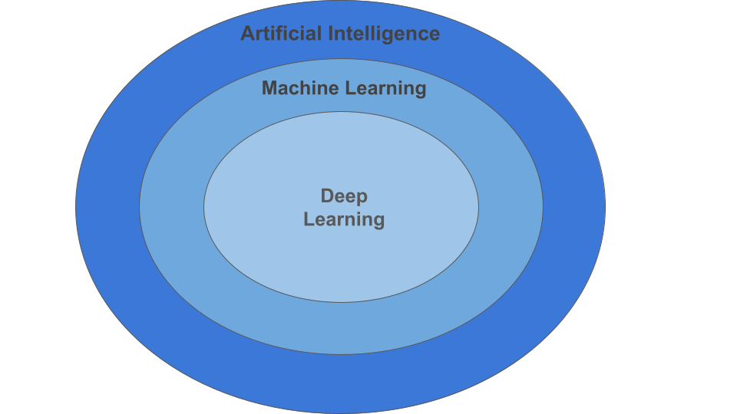
Figure 2.1:The Hierarchy of AI

Large Language Models and the Transformer Architecture
Large Language Models (LLMs) declare the essence of the intelligent functionality of modern-day and era automated assistants. Most of the current day and age LLMs utilise the basic architecture of the Transformer architecture which was originally proposed in the paper by Vaswani et al. in 2017 [12]. The simplest concept of the Transformer architecture is the special component known as Self-Attention that enables the model to determine the relative importance of each word in a sentence to all other words regardless of their location within the sentence. This is especially essential in a task that calls on writing a code review, as the model should know that a variable acquired at the outset of a script is connected to a function call at the termination of a script. The fundamental concept of LLM is to make a prediction as to the next token in a sequence of tokens, relying on the context of the previous tokens.
One should understand that in truth, LLMs are not knowledgeable of things just like humans are, but instead, they are storing a probability distribution amongst concepts, and in some cases, can be treated as hallucinating [3].
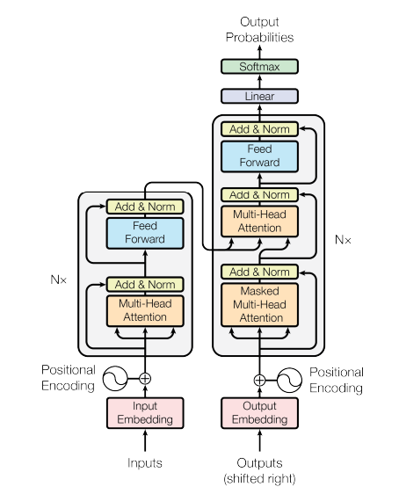
Figure 2.2: The Transformer model architecture, utilizing the self-attention mechanism [12].

Model Size, Resource Constraints, and Scalability
An important consideration in deploying AI solutions is the trade-off between Model Size (measured in billions of parameters) and Computational Resources.
2.4.1 The Resource Constraint
As an illustration, the GPT-4 or Llama-3-70B state-of-the-art models have hundreds of billions of parameters. They require huge computing capacity, that is, high-end GPU VRAM to operate even though they offer the best reason facilities. Due to the graduation project, we are operating on resource limitations, therefore, the necessity of creation of a solution that is easily reachable by students and can operate with either consumer-grade hardware or cloud computing platforms such as Google Colab.

2.4.2 The Selection of CodeLlama
In a bid to do so, this study will employ a specialized open weight model, based on the Llama 2 algorithm, that is, CodeLlama. The strategic reasons why this model has been selected are three:
- Domain Specialization: The code repositories were not only fine-tuned by this model, as compared to general chat models. A study by IEEE [6] indicates that specialized models (small) which are domain-specific are superior compared to general-purpose models (large) especially in specialized tasks.
- Efficiency: 7-billion-parameter version of this model is called 7B, and is lightweight enough to execute with less hardware, and has provision of Tier 1-level coding.
- Open Architecture: open weight model can be deployed on a local level, which is impossible with closed APIs such as those of OpenAI 3 GPT.
2.4.3 Scalability and Modularity
It is critical to understand that the architectural configuration that this project suggests is model agnostic. This project proposes the use of a framework called the Hybrid Pipeline. Though, as deployed, it makes use of the CodeLlama 7B model due to resource constraints, it can be instantaneously scaled regarding the performance of the system. Once the inference engine has been replaced with a larger model like CodeLlama 70B or DeepSeek-Coder, running in a better-resourced environment, it would instantly show a marked improvement in the quality of feedback without changing the underlying code review pipeline.

Retrieval-Augmented Generation (RAG)
To minimize the risks of hallucinations in LLMs, this project considers Retrieval-Augmented Generation (RAG).
2.5.1 Concept
RAG technique is a blend of the creative ability of an LLM and the precision of an information retrieval system. In normal LLM interaction, in Parametric Memory, the LLM can only depend on what it recalls during the training. Under RAG interaction, under Non-Parametric Memory, a database is made available to the LLM.
2.5.2 The Process
The RAG system is made up of three phases as explained in the in-depth survey by Sharma [10], which include:
Vector Embeddings: The system can model external knowledge as mathematical vectors based on an embedding model.
Semantic Search: In this type of search, the user enters code and the system will search the vector database to identify the most suitable guidelines.
Context Injection: The instructions are fed into the prompt of the LLM, which compels the LLM to act according to the instructions extracted rather than the training memory.
In this manner, the fundamental nature of the code review process is turned into a memory task and, therefore, made into a reference task that enhances compliance and trust.
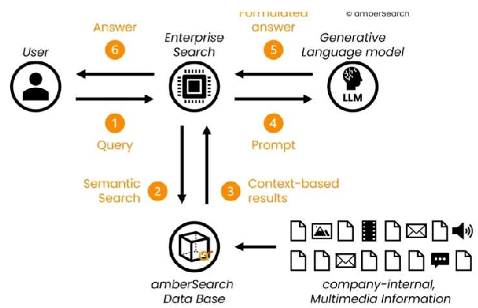
Figure 2.3: Retrieval-Augmented Generation (RAG) Concept [13]

Static Code Analysis
Whereas LLMs provide a form of probabilistic review (guessing what is wrong using patterns), the Static Code Analysis provides a form of deterministic review (knowing what is wrong using rules).
Statics code analysis tools are used to check the source code and not run the code. They interpret the source code by applying an Abstract Syntax Tree data structure. The syntax gatekeeper, in this project, is implemented with the help of such tools as Pylint. The tools cannot understand business logic/intent, and they are ideal concerning syntax errors and undefined variables.
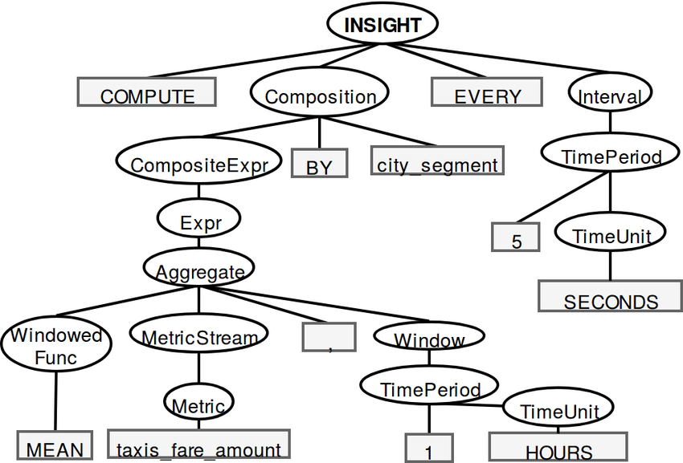
Figure 2.4: Exemplary Abstract Syntax Tree (AST) [14]

2.6.1 The Hybrid Synergy
The combination of Static Analysis and Generative AI is the current state-of-the-art solution to Automated Code Review [4]. The probabilistic reasoning of the LLM is fed on the deterministic error logs of the static analysis. The resulting system exploits the strengths of both tools, where the LLM explains the mistakes, which the static analysis identified and the syntax errors, which the LLM does not identify.

Chapter 3: Literature Review

LLMs in Computer Engineering Education
The incorporation of AI in the sphere of engineering is currently spreading beyond the experimental to the necessary. Mendonca et al. [1], in this regard, note that the AI-based assessment tools are transforming the sphere of education, as they can give instant feedback, and this feedback is personal, as a human tutor would, which is a prerequisite given the rising student-to-faculty proportion. Nonetheless, these tools are not designed in line with the educational objectives. Lau and Guo [2] in an extensive survey of 90 AI coding tools discovered that the majority of AI coders are optimized towards industrial productivity, i.e. should generate working code as quickly as possible, rather than pedagogical support, which should assist the students in understanding concepts and best practices. This has created a paradox that the students are applying AI to the learning process but not in a manner that is conducive.

The Limits of Pure LLMs
Out-of-the-box LLMs are attractive technology, but are merely just probabilistic text generators, not knowledge provenance, posing a trust gap to the inexperienced developer. According to Imtiaz et al., hallucinations can also be observed when it comes to automated code reviews, as the LLM is sure to suggest false code fixes or nonexistent libraries [3]. Also, without further prompting, LLMs are also not very good at imposing strict style guides, including PEP 8. It has been found that the risk of this is especially great to novice students, who may not possess the experience to confirm the output of the AI. But, as we have also observed, the same implies that an LLM such as ChatGPT or CodeLlama deployed without architectural guardrails may also be used to perpetuate poor programming practices, which explains the necessity of tools that can confirm the limits on their output.

Hybrid Architectures
To solve the reliability problems of pure LLMs, recent literature of 2025 suggests the application of the so-called Hybrid Architectures, which is a mix of semantic reasoning speeds of LLMs and deterministic accuracy of Static Analysis Tools (SATs). Although the results of the code explanations by the LLM can be good, there are also limitations to the inflexibility of implementing the syntax. Murtuza et al. formalized the solution to this issue by their framework named LegacyGuard which demonstrated that, on feeding the output of a static analyzer to the context of the prompt of the LLM, the model could be used as an interpreter rather than a detector of bugs.
This strategy is also justified by the IRIS project [5], which demonstrated that the presence of specific error messages of the static analyzers in addition to the LLM also increased the success rate of the bug-fixing task by 50 to 85 percent. Secondly, on the specific model trained in such a structure, recent IEEE benchmarks [6] reveal that open-weight models trained on code alone, like CodeLlama, are more effective than general-purpose models (like Llama 2) by approximately 15% at the task of interpretation of a log by static analysis. It is aligned with the dual-engine plan i.e. tools like Pylint are employed to support strict syntax gating, as suggested by the new industrial standards [7] and CodeLlama to support logical explanation.

Retrieval Augmented Generation (RAG) for Compliance
Besides that, educational tools must make sure that the code standards are adhered to, per specific guide, e.g. the PEP 8. This also necessitates that students be made to study the coding standards. It has however been noted that generic LLMs do not take style guides as set rules, but merely as guidelines. Meng et al. [8] solved this issue by proposing the so-called RARe (Retrieval-Augmented Reviewer) in November 2025. The research demonstrated that Retrieval-Augmented Generation (RAG) needs to access certain documentation prior to the generation of a review as it enhances domain compliance by about 40% by basing itself on rule sets, in contrast to prompting usage alone. The results of Liu et al. [9] also demonstrated that generating more precise comments with the aid of RAG is not only possible, but, with the help of this tool, one can also make comments which are more tutor-like in nature, which confirms the fact that RAG is a crucial element of any system that will apply to substituting or complementing the human instruction.

Chapter 4: Methodology

4.1. System Architecture Overview
The suggested system is called the AI-Based Educational Code Reviewer, and it is a flexible architecture that involves deterministic static reasoning and probabilistic generative reasoning. In contrast to the end-to-end LLM traditional models, this is a multi-stage system because it provides reliability, compliance, and educational value, whereas the traditional models only make one model call.
The information flow within this system is sequential in nature, i.e. retrieval-then generation. It is made up of the following parts:
- Input Processing: The student enters a raw Python code snippet.
- Parallel Analysis: This is a system that divides the process into two parallel streams, and each stream is running concurrently.
- Deterministic Stream: The Static Analysis Engine (Pylint) is run on the snippet of code with the input to receive a report of a factual error.
- Retrieval Stream: The semantic topics are retrieved by analyzing the input code snippet. The topics are then fed as input queries into the Vector Knowledge Base where PEP 8 style guide recommendations are retrieved.
- Context Aggregation: The static analysis log and style guide recommendations are aggregated into a structured "System Prompt."
- Generative Inference: The quantized Large Language Model (CodeLlama-7B) receives the aggregated context producing a natural language review.
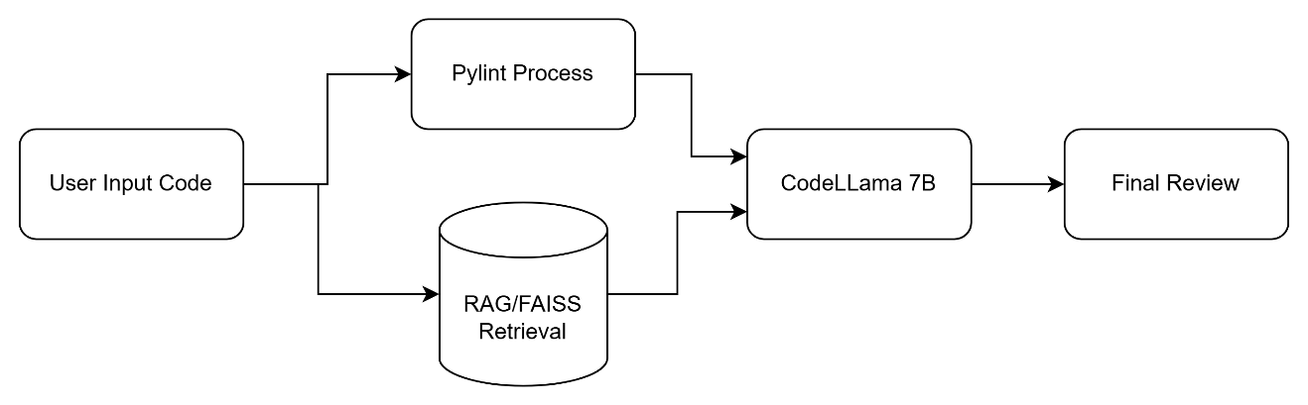
Figure 4.1: The Hybrid AI Code Reviewer architecture
The system architecture provides that the review generated is not merely a hallucination of the model but is a synthesis of really accepted facts and general rules.

Knowledge Base Construction (The RAG Engine)
To mitigate the reduction of the Compliance Gap as discussed in the Literature Review, the system utilizes a robust Retrieval-Augmented Generation (RAG) engine to make available to the LLM the official styling documentation of the Python programming language in the form of an open-book.
4.2.1 Data Ingestion and Chunking
The initial set of data used in this module is the PEP 8 style guide that is the official style guide of Python programming language and is available at (http://peps.python.org/PEP-0008/). The WebBaseLoader and the RecursiveCharacterTextSplitter ingest the text data.
- Chunk Size: 500 characters.
- Overlap: 50 characters. This chunking of above has been adopted so that no single document retrieved has a partial rule that leaves the context in the middle of the sentence.
4.2.2 Hybrid Retrieval Strategy (FAISS + BM25)
The standard RAG models are usually performed with the help of a single method of Semantic Search (Vector Similarity). The semantic search technique, however, does not ensure the perfect match of the keywords as discussed in the survey by Sharma in 2025 [10]. Indicatively, when the user types in the keywords of naming conventions in the code, the semantic search technique will not show the rule that is specifically denoted as Function Names.
To solve this problem, the adopted model employs the Hybrid Search technique and has the following steps:
- Semantic Search using FAISS: The model implemented refers to the all-MiniLM-L6-v2 embedding model that is used to transform the chunks into dense vectors. It searches the rules that are conceptually similar to the code of the user using FAISS to do a quick search.
- Keyword Search using BM25: The adopted model refers to the BM25 model that facilitates a search of the materials that include the exact keywords.
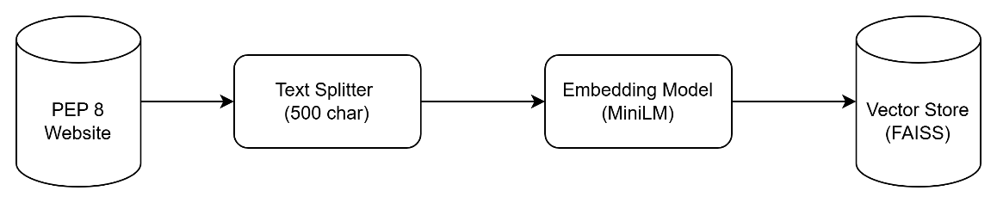
Figure 4.2: The Knowledge Base ingestion pipeline (FAISS + BM25).
The output of the two models is merged and sent to the LLM. Embedding model is executed in the CPU to make sure that the primary inference model has the maximum VRAM available.

The Hybrid Analysis Engine
According to the findings in the study by Murtuza et al. [4] on their "LegacyGuard" framework, pure LLMs cannot handle the exact syntax validation. To this end, we have introduced a special Static Analysis module, which we can call a Fact Checker, before any communication with the LLM.
4.3.1 Pylint Integration
The pylint library is enclosed in a subprocess method (runpylint) within the system. Upon passing the code, the code is temporarily saved to the disk and the output taken in the form of a JSON. The module performs a significant pre-filtering task:
- Noise Reduction: When Pylint is too noisy (i.e. generates more than 15 errors), the system will reduce the output to prevent overflow of the context window of the LLM.
- Format Parsing: The raw JSON content is read into a human friendly form (e.g., "Line 4: Missing module docstring (C0114)").
This text block is then joined to the last prompt with the header of 1. Analyzing Facts (Static Analysis Report). This compels the LLM to receive such errors as realities, rather than proposals.

Generative Inference Model
CodeLlama-7B-Instruct is the model that serves as the brain in the system and is specifically fine-tuned to solve the tasks of code instruction.
4.4.1 Model Selection and 4-Bit Quantization
It would need around 14-16 GB of the GPU VRAM to compute with conventional precision (FP16), which is still not possible with this student project. To rectify this shortcoming, we applied the Quantization strategy of BitsAndBytes library.
Since the research conducted by Dettmers et al. showed in their iconic article calling QLoRA that the 4-bit quantization leads to a blatant 75% (to about 5-6 GB VRAM) reduction in the memory footprint of the model, it still retains over 99% of the reasoning capabilities of the model [11].
- Configuration: load_in_4bit=True, bnb_4bit_compute_dtype=torch.float16.
- Impact: This optimization is the key enabler that allows this "Enterprise-Grade" architecture to be deployed on "consumer-grade" hardware available to most people (Google Colab T4 GPUs, etc.).

Prompt Engineering and Chain-of-Thought
System Prompt plays a great role in determining the quality of the AI feedback. Our Two-Stage Prompting Strategy is a new model that allows us to simulate the human working process.
Stage 1: The "Technical Analyst" (Planning)
The system has a preliminary inference step before it processes the code to give it an idea of what it is to look for.
- Role: "Technical Analyst."
- Task: Analyze the code snippet and generate 3 specific search queries for the RAG engine (e.g., "Python list comprehension style").
- Output: JSON-formatted queries. This step is essential to ensure the RAG engine retrieves relevant rules applicable to the specific code snippet.
Stage 2: The "Senior Architect" (Synthesis)
Lastly, an advanced prompt of thought, called Chain-of-Thought, produces the review. This is one of the tasks that the LLM is specifically requested to execute as a Senior Software Architect and Python Expert. The prompt however also strictly gives the output format:
- Critical Issues: Logical errors and safety hazards.
- Style Analysis: Compliance with the extracted PEP 8 rules.
- Refactored Solution: A corrected version of the original code.
The system separates the Critical Issues and Style Analysis making it not to be confused with the logical errors as was observed in previous studies [3].
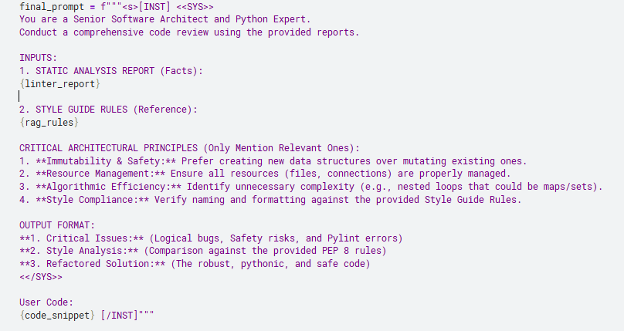
Figure 4.3: The Chain-of-Thought system prompt used to instruct CodeLlama

Chapter 5: Preliminary Results and Discussion
5.1. Experimental Setup
In order to test the effectiveness and efficiency of the proposed Hybrid AI Code Reviewer, an experimental framework was designed. Experiments were done to test the effectiveness and efficiency of the Hybrid AI Code Reviewer along two lines Pedagogical Accuracy, which is the quality of feedback and correctness of the feedback and Computational Efficiency which is the viability of the tool to students.
5.1.1 Computational Environment
All the experiments were done in a cloud simulation setup which we developed to model the resources that an average engineering student would have. We have used a Kaggle Notebook case, that has access to data center grade GPUs without any financial cost. This ideal simulation fits well in our goals of simulation of our objective of Accessibility as stated in Chapter 1.
We will use the following hardware and software specifications in the testbed of our experiment:
- Processing Unit (GPU): NVIDIA Tesla P100-PCIE 16GB VRAM. We use it as a test case in our memory optimization methods, though it is an older processor with the Pascal architecture by NVIDIA but exhibits 16 GB memory buffer.
- System Memory (RAM): 31.4 GB of CPU RAM with the main usage being the Vector Knowledge Base (FAISS index) and the Pylint subprocess control.
- Runtime Environment: Python 3.12.12, which was selected based on its performance improvements in the speed of interpreter over older versions of 3.x.
The Deep Learning Framework used is PyTorch 2.8.0+cu126. This implementation of PyTorch is required to implement quickly 4-bit matrix multiplication which forms the basis of our quantization scheme.

5.1.2 Model Configuration and Hyperparameters
The CodeLlama-7B-Instruct inference engine was not run in its native 16-bit floating-point precision (FP16) as it would need approximately 15-16 GB of VRAM to run the model weights alone and not much more to run the context window. Instead, we loaded with the QLoRA (quantized Low-Rank Adaptation) loading strategy through the library bitsandbytes.
The model was pre-trained using the following quantization hyperparameters in order to achieve the best precision, but with the lowest footprint:
- Quantization Type: Normal Float (NF4). In comparison to conventional integer quantization, NF4 is information-theoretically optimal to normally distributed weights which is typical of LLMs.
- Double Quantization: Enabled (bnb_4bit_use_double_quant=True). This technique implies quantization of the quantization constants, which adds an additional -0.4 bits per parameter without affecting the performance of the model.
- Compute Data Type: torch.float16. The storage was again cut down to 4 bits but in reality, the real matrix operations that took place during inference were 16 bits to prevent numerical instability.
The size of the VRAM was post-load, which was found to be 3.60 GB and almost 12 GB of available free VRAM to process large context windows (up to 4096 tokens) which is crucial in the process of reviewing longer student submissions.
5.1.3 Validation Dataset Construction
Due to the lack of a standardized, open-source benchmark specifically for Student Python Errors, a custom Synthetic Vulnerability Suite was created in this study. The suite contains 10 distinct test cases (test_01 to test_10), where each case is carefully engineered to stimulate specific elements of the hybrid pipeline (e.g., Syntax Analysis vs. Logic Generation).

The test cases fall under four different pedagogical domains:
- Style & Compliance (Tests 01, 05, 08): Code meets the criterion of correct operation, but does not meet the standards of PEP 8. These tests confirm the retrieval and enforcing capabilities of style guides of the RAG component.
- Logic & Bugs (Tests 02, 09): This or that code includes hidden operating errors which cannot be detected by Static Analysis, e.g. a list is being changed during the iteration process or an error by one. These experiments prove the reasoning abilities of LLM.
- Safety & Security (Tests 03, 06, 07): Code having vulnerabilities like Mutable Default Arguments, division by zero or unclosed file resources. These are the synergy tests of Pylint (detection) and LLM (explanation).
- Control Group (Test 10): This is essential to quantify the “False Positive Rate, that is, to ensure that the AI does not create falsities where none exist, which is just a failure mode in pure LLM systems. Such a varied test suite also guarantees that the results that are going to be shown in the further parts of the article represent a comprehensive analysis of the power of the tool in the totality of novice programming problems.
5.2. Qualitative Analysis (Case Studies)
To test the quality of the pedagogical framework of the Hybrid Architecture we tested our system on a Bad Code Dataset of prevalent student errors. The case studies below illustrate how Static Analysis (Pylint), Retrieval-Augmented Generation (RAG), and the LLM can be used to generate accurate and educative feedback.
Case Study 1: Syntax and Compliance (The "PEP 8" Test)
Objective: Determine whether the system can make the difference between code that is executable and code that is standard.
- Input: A script only with a few imports on the first line, and non-standard name of functions (ProcessData), which does not conform to PEP 8 but are correct Python syntax.
  - Detection: The Static Analysis module was rightfully identifying the corresponding lines of the Multiple imports and the Invalid name and putting them into the prompt as facts.
  - Synthesis: The LLM was able to classify them as either Critical Issue (missing docstrings) and Style Analysis (imports).
  - Educational Value: The refactored solution did not silently fix the code, but made a deliberate attempt at splitting the imports out onto separate lines and renaming the processing data function to process_data with reference to snake-case conventions. This proves that the system is a tutor hence the need to change it.
Case Study 2: Domain-Specific Grounding (The "RAG" Test)
Objective: certain rational or stylistic guidelines that generic LLMs usually disregard.
- Input: A Call AreaOfCircle in CamelCase variables (PI, Radius) which is a characteristic behavior of students, who are exposed to Java or C5.
- RAG Activation: The planning module of the system came up with specific search queries: [Function naming conventions, Variable naming conventions].
- Result: The RAG engine has accessed certain PEP 8 snippets of "Method Names and Instance Variables”. Therefore, the overall review was right in stating that PI appears to be constant, whereas local variables and arguments (radius, area) should be small-case. The system was able to override the natural tendency of the LLM to pumpkin and impose strict Pythonic standards.

Case Study 3: Logical Debugging (The "Safety" Test)
Objective: Uncover the non-crashing bugs, which are so unnoticeable that they alter logic.
- Input: The classic "Modifying a list while iterating" bug (for item in InputList: ... remove(item)).
- System Response: CodeLlama was able to identify the logical error, which is unavailable to Pylint. It is, however, noteworthy that, as much as the logic was discovered, the refactoring recommendation to this edge case must be carefully checked. This points out the synergistic quality of the hybrid stack: Pylint deals with syntax/style (100 percent precision), whereas the LLM deals with the logic (heuristic reasoning).
5.3. Performance Metrics and Resource Efficiency
The main aim of the study was to design a system that could be used by students who have minimal hardware. The effectiveness of the selected architecture is proved by its quantitative results.

Table 5.1: Performance Metrics Summary
Test Case | Category | Pylint (s) | RAG Retrieval (s) | LLM Inference (s) | Total Time (s)
test_01_import_style | Style | 0.809 | 0.040 | 19.84 | 23.91
test_02_list_mutation | Logic | 0.462 | 0.037 | 32.64 | 35.28
test_03_mutable_default | Safety | 0.453 | 0.039 | 39.12 | 43.02
test_04_performance | Performance | 0.463 | 0.039 | 50.77 | 60.95
test_05_naming | Style | 0.461 | 0.041 | 52.72 | 62.93
test_06_division_zero | Safety | 0.465 | 0.044 | 20.78 | 23.51
test_07_resource | Resource | 0.509 | 0.037 | 22.81 | 25.57
test_08_whitespace | Style | 0.463 | 0.040 | 27.96 | 38.16
test_09_off_by_one | Logic | 0.479 | 0.037 | 32.87 | 35.69
test_10_perfect | Control | 0.472 | 0.055 | 67.25 | 77.60
AVERAGE | --- | 0.504 | 0.041 | 36.68 | 42.66
MIN | --- | 0.453 | 0.037 | 19.84 | 23.51
MAX | --- | 0.809 | 0.055 | 67.25 | 77.60
5.3.1 Resource Consumption (VRAM)
The system recorded an enormous decrease in memory overheads by using 4-bit quantization
- Peak VRAM Usage: A maximum of 6.15 GB of VRAM memory was utilized by the system when doing heavy inference.
- Comparison: A typical 16-bit CodeLlama-7B model needs 14-15 GB of VRAM.
- Implication: This 60% cut on memory footprint is a validation that the tool can be deployed on mid-range consumer GPUs or free-tier cloud infrastructure (Google Colab/Kaggle) and achieves the goal of the objective of Accessibility as set in Chapter 1.
5.3.2 Latency and Overhead
The mean time of execution in all test cases was 42.66 seconds. The breakdown analysis shows the performance of the added modules:
- LLM Inference: Time 36.68s (86% of the total time), with the point of bottlenecking being the generation step.
- Hybrid Overhead:
  - Pylint Analysis: Averaged 0.50s.
  - RAG Retrieval: Averaged 0.04s.

Figure 5.1: Average Latency distribution by component

References
[1] J. Mendonça, et al., "AI-Powered Learning: Revolutionizing Education and Automated Code Evaluation," MDPI Information, vol. 16, no. 11, Nov. 2025.
[2] S. Lau and P. Guo, "The Design Space of LLM-Based AI Coding Assistants: An Analysis of 90 Systems," in Proceedings of the IEEE Symposium on Visual Languages and Human-Centric Computing (VL/HCC), Oct. 2025.
[3] N. Imtiaz, et al., "Automated Code Review in Practice: Trends and Challenges," in Proceedings of the 2025 IEEE/ACM International Conference on Software Engineering, Apr. 2025.
[4] S. Murtuza, et al., "LegacyGuard: Hybrid LLM, RAG, and Static Analysis for Multi-Lingual Vulnerability Detection," International Journal for Research in Applied Science and Engineering Technology (IJRASET), May 2025.
[5] M. Liu, et al., "Augmenting Large Language Models with Static Code Analysis for Automated Code Quality Improvements," arXiv preprint arXiv:2506.10330, June 2025.
[6] "Can a Llama Be a Watchdog? Exploring Llama 3 and Code Llama for Static Security," IEEE Xplore, late 2024.
[7] "Implementation of Static Code Analysis to Detect Vulnerabilities in Applications Developed with LLMs," Energy Journal, vol. 15, no. 2, Nov. 2025.
[8] Q. Meng, et al., "Code Review Automation using Retrieval Augmented Generation," arXiv preprint arXiv:2511.05302, Nov. 2025.
[9] J. Liu, et al., "Retrieval-Augmented Code Review Comment Generation," arXiv preprint arXiv:2506.11591, June 2025.
[10] C. Sharma, "Retrieval-Augmented Generation: A Comprehensive Survey of Architectures, Enhancements, and Robustness Frontiers," arXiv preprint arXiv:2506.00054, May 2025.
[11] T. Dettmers, et al., "QLoRA: Efficient Finetuning of Quantized LLMs," arXiv preprint arXiv:2305.14314, 2023.
[12] A. Vaswani et al., "Attention is all you need," in Advances in Neural Information Processing Systems (NeurIPS), vol. 30, 2017, pp. 5998–6008.
[13] Enhancing Generative AI Capabilities Through Retrieval-Augmented Generation Systems and LLMs - Scientific Figure on ResearchGate. Available from: https://www.researchgate.net/figure/Retrieval-augmented-generation-RAG-31-Concept-and-Functionality-Enhancing-Generative_fig1_385347153 [accessed 3 Feb 2026]
[14] Query-Driven Descriptive Analytics for IoT and Edge Computing - Scientific Figure on ResearchGate. Available from: https://www.researchgate.net/figure/Exemplary-Abstract-Syntax-Tree-AST_fig2_335075874 [accessed 3 Feb 2026]

