COURSE NAME: Descriptive Statistics
ASSIGNMENT REPORT
GROUP MEMBERS:
- Joseph MUTANGANA 29061
- MBONYINKWIYE Burumbuke Frank 28745
- Ushimirwa ingabire Benitha 28747
- Kubananayo Ismael 28920
- Uwase Rubagumya Joseé ID:29181
- Nyirahabinshuti Marlene 28884

$$ACTIVITY 1$$

$$Q1. By using Extended Grouped Frequency Distribution Table$$
$$Step 1: Find Total Number (N)$$
$$N = 62$$
$$Step 2: Find the number of class interval K$$
$$K = 1 + 3.322 * log10\left(N\right), K = 1 + 3.322 * log10\left(62\right), K = 6$$
$$Step 3: Find the length of class width C$$
$$C = (Maximum value – Minimum Value) / K$$
$$Max value = 96, Min value = 2, C =\frac{\left(96 – 2\right)}{6}, C = 16$$

$$Step 4: Find starting number and ending number of group 1$$
$$Step 5: Find midpoint, fi, and cfi$$
$$mi = (b + a) / 2$$
$$First mi will be (17 + 1)/2 = 18/2 = 9$$

$$i$$ | $$a-b$$ | $$mi$$ | $$fi$$ | $$cfi$$
$$1$$ | $$1 - 17$$ | $$9$$ | $$8$$ | $$8$$
$$2$$ | $$17 - 33$$ | $$25$$ | $$11$$ | $$19$$
$$3$$ | $$33 - 49$$ | $$41$$ | $$21$$ | $$40$$
$$4$$ | $$49 - 65$$ | $$57$$ | $$12$$ | $$52$$
$$5$$ | $$65 - 81$$ | $$73$$ | $$6$$ | $$58$$
$$6$$ | $$81 - 97$$ | $$89$$ | $$4$$ | $$62$$
$$\sum_{i=1}^{6}{ }$$ |  |  | $$62$$
The reason why we choose Extended group frequency is that Since the octane values are in decimals, making a distinct table would be long and messy. Using an extended grouped frequency distribution helps us organize the data into clear intervals, making it easier to read and analyze

$$Q2. By using Extended Grouped Frequency Distribution$$
$$N = 14$$
$$K = 1 + 3.322 * log10\left(14\right)=>K = 1 + 3.322 * 1.14$$
$$K = 1 + 3.80K => 4.80K = 4.80, k≥6, k≤12,$$
$$C = (95.3 - 84.2) / 6=>C = 1.88 ≅2$$
$$Let (a) start from 84 then b will be (a + c) = 84 + 2 = 86$$

$$i$$ | $$a-b$$ | $$mi$$ | $$fi$$ | $$cfi$$
$$1$$ | $$84-86$$ | $$85$$ | $$1$$ | $$1$$
$$2$$ | $$86-88$$ | $$87$$ | $$3$$ | $$4$$
$$3$$ | $$88-90$$ | $$89$$ | $$2$$ | $$6$$
$$4$$ | $$90-92$$ | $$91$$ | $$4$$ | $$10$$
$$5$$ | $$92-94$$ | $$93$$ | $$2$$ | $$12$$
$$6$$ | $$94-96$$ | $$96$$ | $$2$$ | $$14$$
$$\sum_{i=1}^{6}{ }$$ |  |  | $$14$$

Q3. By using Frequency Distribution
xi | 6 | 7 | 8 | 9 | 10 | 11 | 12 | 13 | 14 | 16
fi | 1 | 1 | 4 | 5 | 5 | 9 | 3 | 3 | 2 | 2

ACTIVITY 2
$$Q4$$
i | xi | fi | xi.fi
1 | 5 | 4 | 20
2 | 10 | 6 | 60
3 | 15 | 8 | 120
4 | 20 | 7 | 140
5 | 25 | 3 | 75
6 | 30 | 2 | 60
$$\sum_{i=1}^{6}{ }$$ |  | 30 | 475

$$Total marks (passed)=6860-475=6385$$

$$Average Marks of Passed Students$$
$$Average=\frac{6385}{100-30}≈91.21$$

$$Total failed student=30$$

$$Total marks of failed student=475$$
$Total marks \left(all\right)=68.6×100=6860$

$$Q5$$
xi | fi | cf
0 | 1 | 1
1 | 3 | 4
2 | 10 | 14
3 | 7 | 21
4 | 4 | 25
5 | 2 | 27
6 | 2 | 29
7 | 1 | 30

$$Bar Chat$$
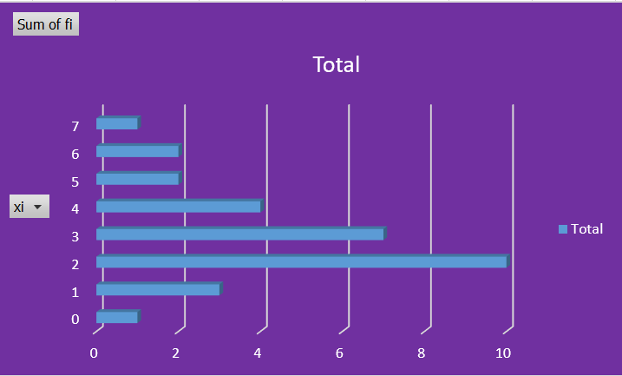

$$Cumulative frequency chart$$

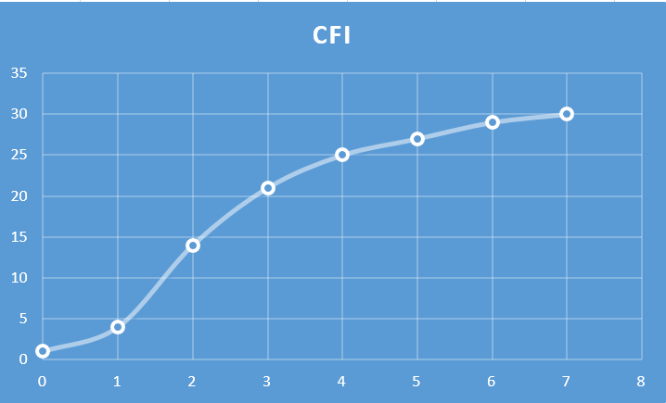

Q6
$$N = 40$$
$$K = 1 + 3.322 * log10\left(40\right)=>K = 1 + 3.322 * 1.6=>K = 1 + 5.3=>K = 5.3 ≅5$$
$$C = (59 - 10) / 6=>C = 8.1 ≅1$$

$$i$$ | $$a-b$$ | $$mi$$ | $$fi$$ | $$cfi$$
$$1$$ | $$10-20$$ | $$15$$ | $$8$$ | $$8$$
$$2$$ | $$20-30$$ | $$25$$ | $$9$$ | $$17$$
$$3$$ | $$30-40$$ | $$35$$ | $$14$$ | $$31$$
$$4$$ | $$40-50$$ | $$45$$ | $$11$$ | $$42$$
$$5$$ | $$50-60$$ | $$55$$ | $$8$$ | $$50$$
$$\sum_{i=1}^{6}{ }$$ |  |  | 50

Histogram
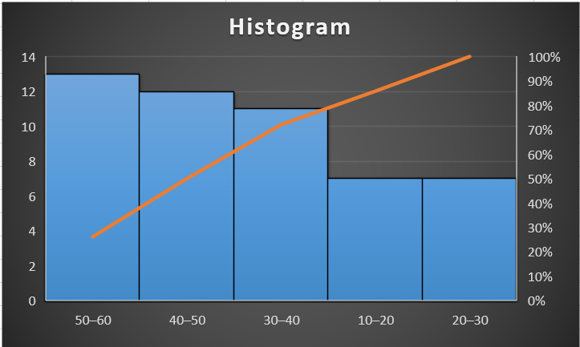

Ogives/Cumulative frequency
