Assignment 4 Report – Software Engineering

Group 1 Members:
- 1. Isaro Rubagumya Roxane (28762)
- 2. Ishimwe Billy Joshua (28455)
- 3. Mutangana Joseph (29061)
- 4. Rebeka Patience (26277)
- 5. Nsengiyumva George (28491)

Section A

1. Differences between Finite State Machine (FSM) and Petri Net
A Finite State Machine (FSM) represents systems as a set of finite states and transitions triggered by events. It is mainly used for sequential control and deterministic systems.
In contrast, a Petri Net models systems using places, transitions, and tokens, allowing representation of concurrency and synchronization. FSMs are limited to linear state transitions, while Petri Nets can represent multiple events occurring simultaneously.
FSMs are commonly used in digital circuits and communication protocols, whereas Petri Nets are used in workflow, distributed, and manufacturing systems.

2. Concurrency and Synchronization in Petri Nets vs FSMs
Petri Nets naturally support concurrency and synchronization using tokens flowing through transitions. Multiple transitions can fire simultaneously if their input places have tokens, representing concurrent events.
FSMs, on the other hand, transition from one state to another sequentially, making it difficult to model concurrent activities.
For example, in a manufacturing process, two machines can operate concurrently using Petri Nets, but FSMs would require multiple independent machines modeled separately.

3. Limitations of FSMs in Modeling Complex Systems
FSMs struggle with scalability when modeling systems with numerous interacting states. As complexity grows, the number of states increases exponentially, leading to the state explosion problem.
This makes FSMs less effective for complex systems such as communication networks or manufacturing processes where multiple events occur concurrently. They also lack constructs for representing parallelism or synchronization.

4. Deterministic vs Non-Deterministic FSMs
A Deterministic FSM (DFSM) has exactly one transition for each input from any given state, ensuring predictable behavior. A Non-Deterministic FSM (NFSM) allows multiple transitions for the same input, representing uncertainty or multiple possible paths.
NFSMs are more appropriate for systems involving unpredictable user behavior or decision-making, such as interactive software or AI-driven decision systems.

5. Petri Nets as Graphical and Mathematical Tools
Petri Nets are both graphical and mathematical tools. The graphical aspect provides an intuitive visual representation of processes through places, transitions, and tokens.
The mathematical aspect allows formal analysis using reachability, boundedness, and liveness properties. Together, they enable both visualization and rigorous analysis of complex system behavior.

Section B

Question 1: Automated Parking Gate System (FSM)
1. States: Idle, VehicleDetected, CardValidation, GateOpen, GateClose.
Events: Vehicle arrival, Card insertion, Card validation, Vehicle passes.
Actions: Open gate, Close gate, Display invalid message.
2. State Transition Diagram (FSM)
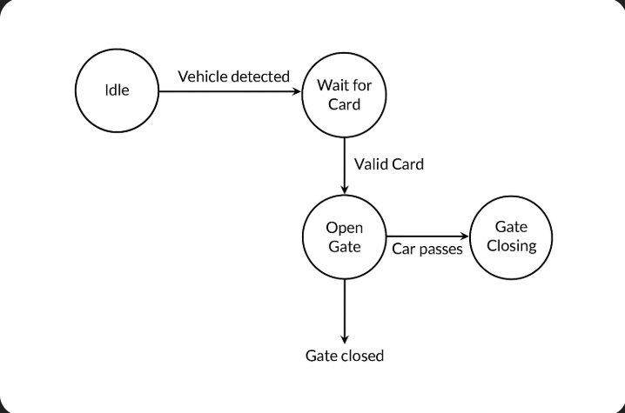

3. Automated Parking Gate System – State Transition Table
Current State | Input / Event | Condition | Next State | Output / Action
Idle | Vehicle detected | — | VehicleDetected | Activate sensor, wait for card
VehicleDetected | Card inserted | Card valid | GateOpen | Open gate
VehicleDetected | Card inserted | Card invalid | Idle | Display “Invalid Card” message
GateOpen | Vehicle passes sensor | — | GateClosing | Start closing gate
GateClosing | Gate fully closed | — | Idle | Return to idle state
4. The FSM ensures safety and reliability by validating inputs before actions occur (e.g., the gate opens only after a valid card) and by returning to the idle state to await the next vehicle.

Question 2: Vending Machine System (Petri Net)
1. Places: Idle, CoinInserted, CoinVerified, ProductSelected, ProductDispensed.
Transitions: InsertCoin, VerifyCoin, SelectProduct, DispenseProduct, ReturnChange.
Tokens represent the current system state, and concurrency is shown when multiple processes (e.g., verifying coin and waiting for selection) happen simultaneously.
2. Petri Net diagram representing the process
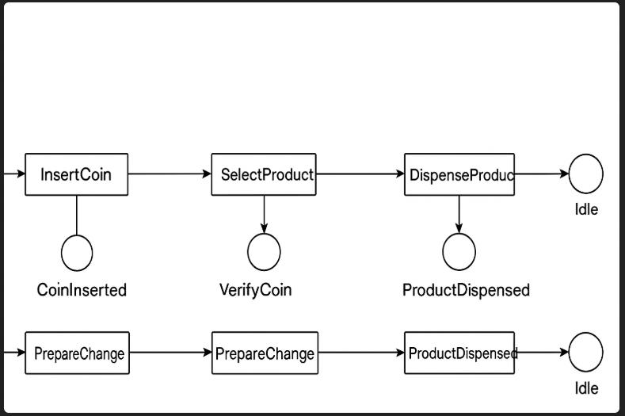
3. Concurrency:
After a user inserts a valid coin (token placed in CoinVerified), the system can simultaneously allow:
  - Product selection (SelectProduct transition), and
  - Preparation for dispensing change (PrepareChange transition).
These transitions operate independently and can occur concurrently, reflecting how multiple internal operations can proceed in parallel.
Synchronization:
The DispenseProduct transition requires both conditions to be met:
  - The coin must be verified (CoinVerified place has a token), and
  - A product must be selected (ProductSelected place has a token).
Only when both tokens are present does the DispenseProduct transition fire.
4. Petri Nets handle concurrent activities more effectively than FSMs, allowing simultaneous verification and product selection, making them better suited for modeling such systems.

Question 3: University Database (ER Model)
Entities: Student(StudentID, Name, Email), Course(CourseID, Title, Credits), Instructor(InstructorID, Name, Department).
Relationships:
- Student registers for Course (many-to-many).
- Instructor teaches Course (one-to-many).
2. ER diagram
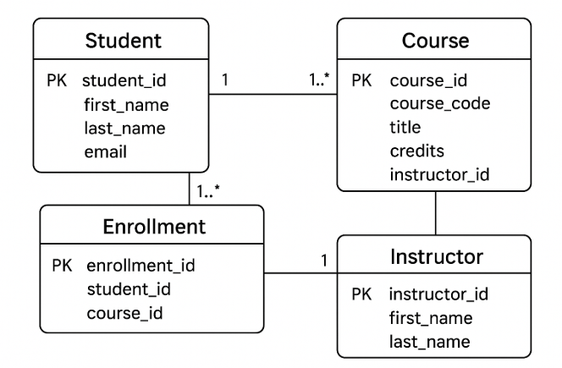
3.Primary Keys: StudentID, CourseID, InstructorID.
Foreign Keys: CourseID in Registration, InstructorID in Course.
4.The 3NF schema:
STUDENT(StudentID, Name, Email)
COURSE(CourseID, Title, Credits, InstructorID)
INSTRUCTOR(InstructorID, Name, Department)
REGISTRATION(StudentID, CourseID)

Question 4:

1. Modified ER
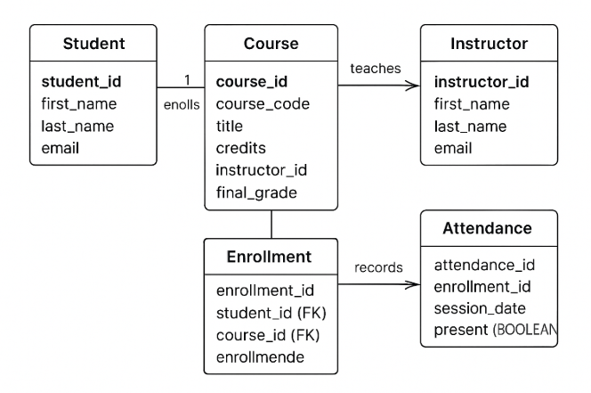

3. Relational Schema (with keys and constraints)

STUDENT SCHEMA
STUDENT(
student_id INT PRIMARY KEY,
first_name VARCHAR(50),
last_name VARCHAR(50),
email VARCHAR(100)
)

INSTRUCTOR SCHEMA
INSTRUCTOR(
instructor_id INT PRIMARY KEY,
first_name VARCHAR(50),
last_name VARCHAR(50),
email VARCHAR(100)
)

COURSE SCHEMA
COURSE(
course_id INT PRIMARY KEY,
course_code VARCHAR(10) UNIQUE,
title VARCHAR(100),
credits INT,
instructor_id INT,
FOREIGN KEY (instructor_id) REFERENCES INSTRUCTOR(instructor_id)
)

ENROLLMENT SCHEMA
ENROLLMENT(
enrollment_id INT PRIMARY KEY,
student_id INT,
course_id INT,
enrollment_date DATE,
final_grade CHAR(2),
FOREIGN KEY (student_id) REFERENCES STUDENT(student_id),
FOREIGN KEY (course_id) REFERENCES COURSE(course_id),
CONSTRAINT uq_enrollment UNIQUE (student_id, course_id)
)

ATTENDANCE SCHEMA
ATTENDANCE(
attendance_id INT PRIMARY KEY,
enrollment_id INT,
session_date DATE,
present BOOLEAN,
FOREIGN KEY (enrollment_id) REFERENCES ENROLLMENT(enrollment_id)
)

3. How this model supports Business Intelligence & Analytics
- Student Performance Tracking
  - final_grade in ENROLLMENT allows analytics on:
    - Average grade per course, department, or instructor
    - GPA trends per student or cohort
- Attendance Analytics
  - The ATTENDANCE table enables:
    - Correlation between attendance rate and grades
    - Identification of at-risk students with poor attendance patterns
- Instructor and Course Effectiveness
  - Join COURSE, ENROLLMENT, and INSTRUCTOR tables to:
    - Evaluate instructor performance based on student outcomes
    - Compare grade distributions across courses
- Operational Reporting
  - Analyze:
    - Enrollment trends over semesters
    - Course popularity
    - Resource planning (e.g., class sizes, instructor workload)
- Predictive Analytics Foundation
  - Historical grades + attendance data can feed ML models for:
    - Predicting student success or dropout risk
    - Optimizing course scheduling and teaching assignments

References
- Murata, T. (1989). Petri Nets: Properties, Analysis and Applications. Proceedings of the IEEE.
- Hopcroft, J. E., Motwani, R., & Ullman, J. D. (2001). Introduction to Automata Theory, Languages, and Computation.
- Elmasri, R., & Navathe, S. B. (2016). Fundamentals of Database Systems (7th ed.). Pearson.

