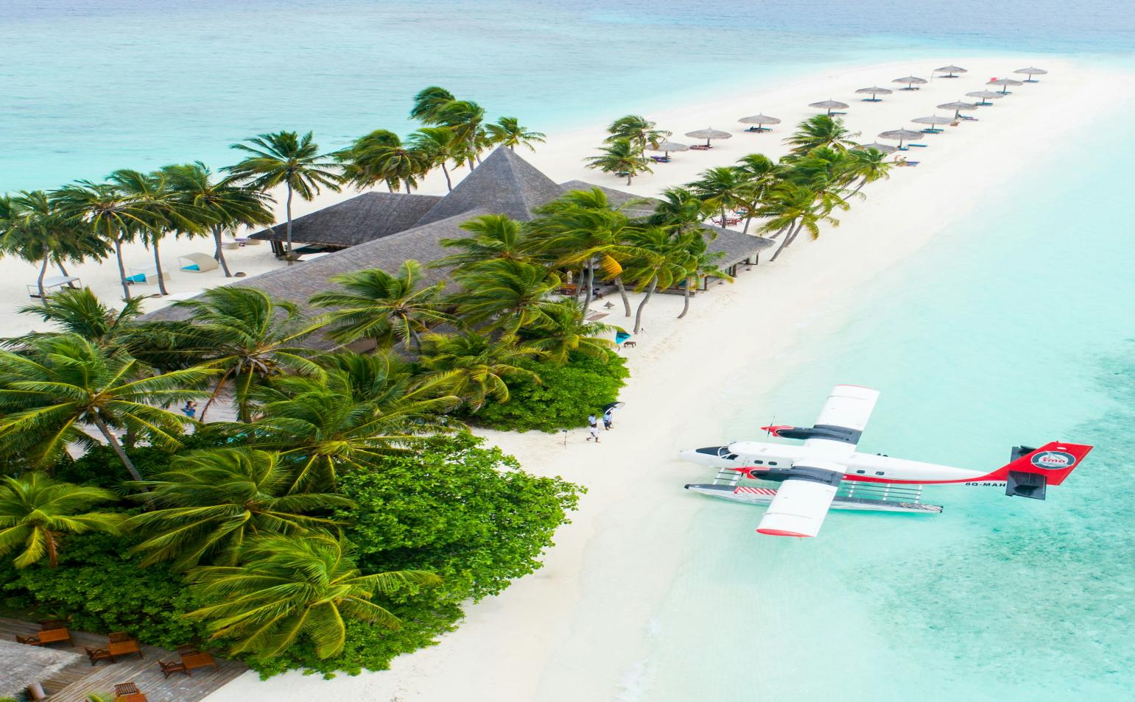
COME ON
TRAVEL IS AN ART
A RARE RELAXATION

EXCUSES THAT DON'T TRAVEL TO DIFFERENT THERE IS NO EXTRA ENERGY AND TIVE, INSUFFICIENT EXPENSESIN TRAVEL TOTAL FOREST

TRAVEL IS ALSO THE PROCESS OF CONTINU OUS LEARNINGTRAVEL, FREE, NO CUMBER SOME PLANSTHERE IS NO HEAVY BURDEN. ONLY THE PUREST ATTITUDE
BLUE SKY
CLEAR WATER

TRAVEL IS AN ART OF LIFE ALLOCATION IT SHOULD BE SEPARATED FOR 10 DAYS
IN THE RUTIAN BOUNDARYINTHE ENGUSH EDWARD I HAVE LIVED
FOR MORE INFORMATION, CONTACT US : 343-678-897-634
BLUE OCEAN

TOGETHER

TRAVEL

COME TOGETHER

EVERYONE TRAVELS FOR THEIR OWN REASON, EACH JOURNEY HAVING ITS OWN DEFINITION.
I DON’T WANT TO BE TRAPPED IN THE CYCLE OF ROUTINE, BUT INSTEAD, TO EMBRACE
THE FREEDOM OF A TRUE ADVENTURE—ONE THAT ALLOWS ME TO EXPLORE, LIVE, AND GROW. SO, WE TRAVEL.

