

INSY8314 WEB DESIGN
(AttendPro)
Student Attendance Management System

Student Name: Joseph MUTANGANA
Student ID: 29061
Course Name: Web Design
Group: A
Lecturer Name: Eric BYIRINGIRO
Report: Individual Assignment
Submission Date: 5th Aug 2026

Table Of Contents
Project Title 3
Background 3
Objectives 3
Technologies 3
System Features 4
Database Design 4
Screenshots of the application 4
Testing Process and results 9
Discussion of results 9
Challenges 10
Possible Improvements 10
Conclusion 10

Project Title
Student Attendance Management System

Background
Many school attendances are taken using manual hand writing in registers and some are still recorded using spreadsheets which is time consuming, this process lead to errors in recording attendance. The AttendPro as student attendance management web application, designed to solve the challenges faced during manual attendance tracking bringing the easy and efficient attendance management system where administrators are able to record the and update the attendance.

Objectives
- Develop a web-based application for attendance management system
- Store attendance records securely
- Reduce time spent during manual attendance recording
- Improve the attendance accuracy
- Easy updating the attendance
- Generate attendance report
- Reduce attendance errors
- Easy attendance record
- Easy to track student’s status efficiently

Technologies
- XAMPP: The local web development that used to run the application during development. It provided the APACHE web server, PHP environment, and MYSQL database, allowing the system to be tested locally before deployment.

- Apache: was used as the local web server to host the application. It processes users requests through a web browser and served the web pages, enabling the interaction between user and attendance management system.

- PHP: was used as the server-side scripting language. It handled the application’s business logic, processed form submissions, validated user input, communicated with database, and generated dynamic web pages.

- MySQL: was used as database management system to store and manage application data. It stored information such as lecturers, students, and attendance records.

- HTML: was used to create the structurer of the web pages. It defined elements such as forms, table, buttons, navigation menus, and other content displayed to users.

- CSS: was used to style the application’s interface. It controlled the layout, colors, fonts, spacing, and overall appearance to make the system looking and easy to use.

System Features
- Lecturer Registration: Allows new lecturers to create an account and access the system.
- User Login: Authenticates the lecturers before granting access to the application.
- Logout: Allows the lecturer to logout their account from the system.
- Dashboard: Displays an overview of attendance information and quick access to system functions such as taking attendance.
- Student Management: Enables lecturer to view the list of student and add new student.
- Student Search: Allows users to quickly search for students using their name or registration number.
- Attendance Recording: Enables lecturers to record and update student’s attendance.
- Attendance Reports: Generated reports for recorded attendance.
- Report Exporting: Allows reports to be printed or exported as PDF or Excel files.

Database Design
The system used the relational database consisting three tables such as lecturers, students, and attendance. The attendance table and students has the relationship showing that students can have more than one attendance records.
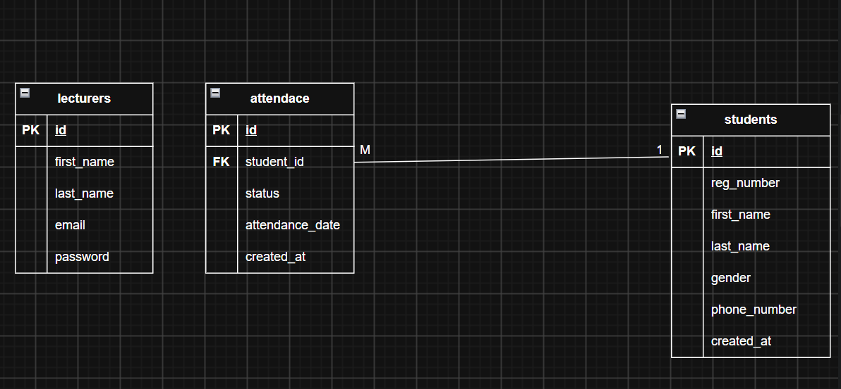

Screenshots of the application
Figure 1: Home
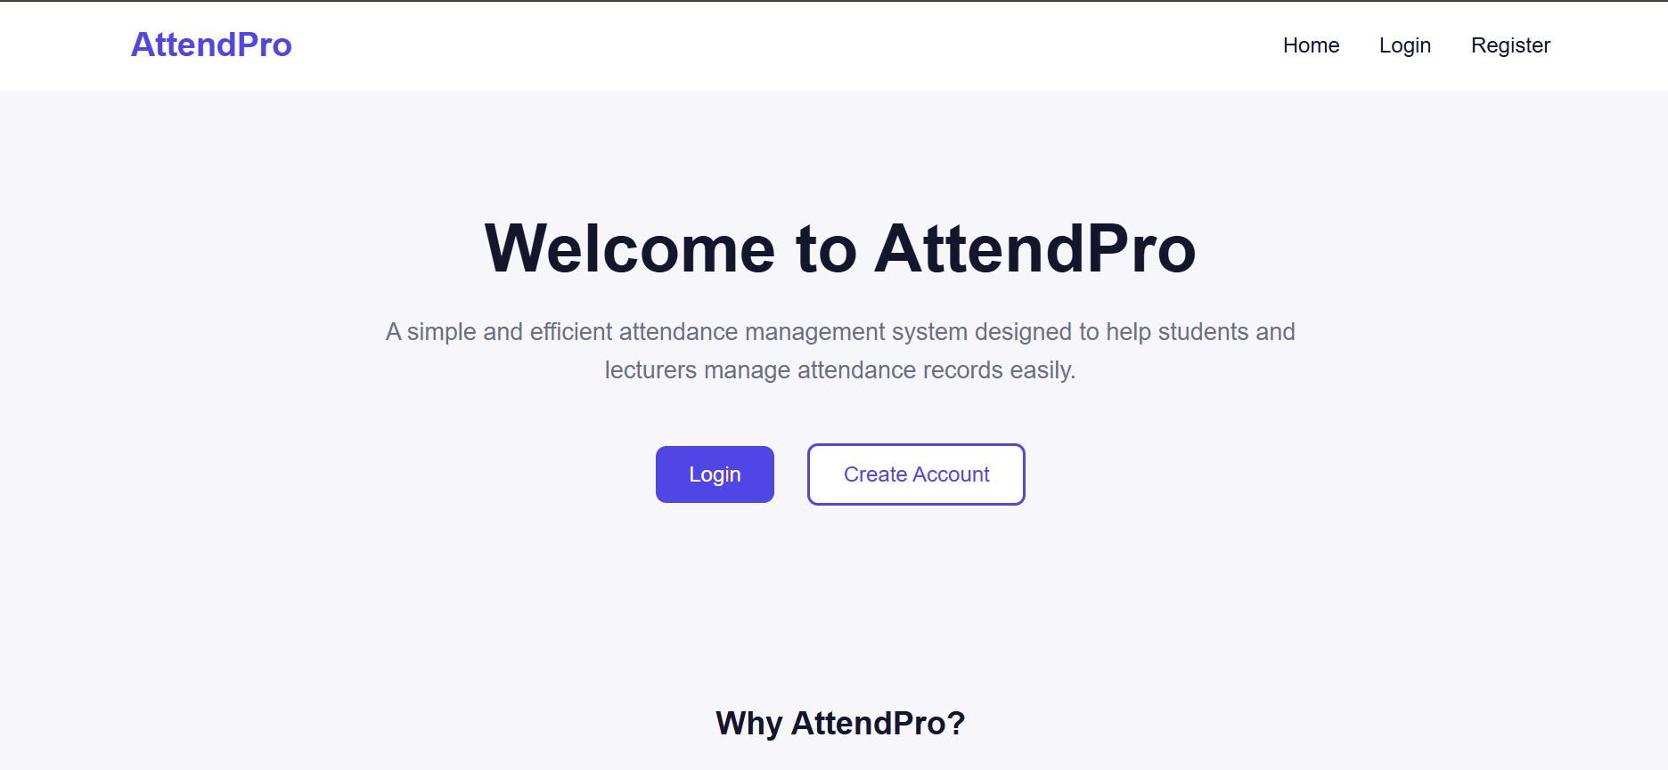
Figure 2: Lecturer Registration
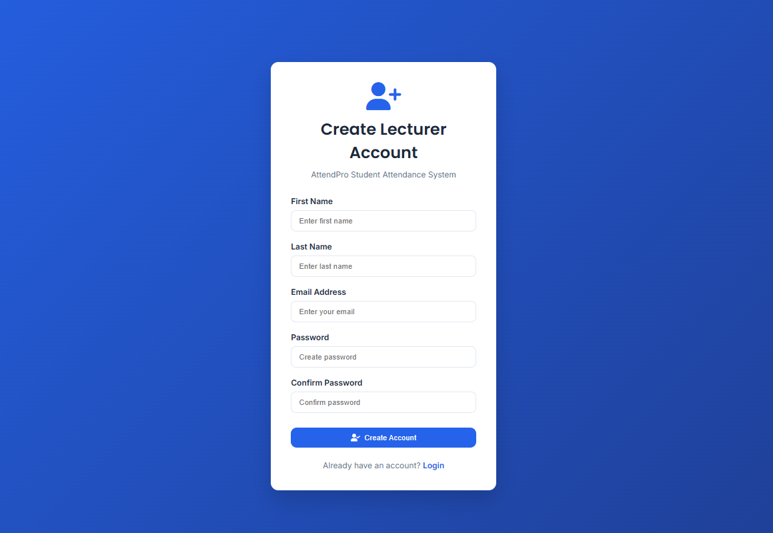
Figure 3: Lecturer login
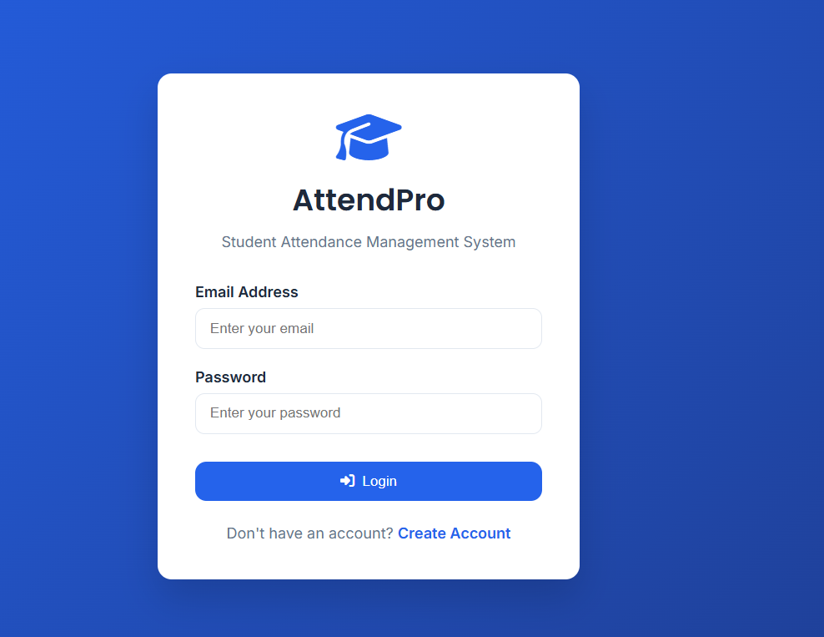 Figure 4: Dashboard
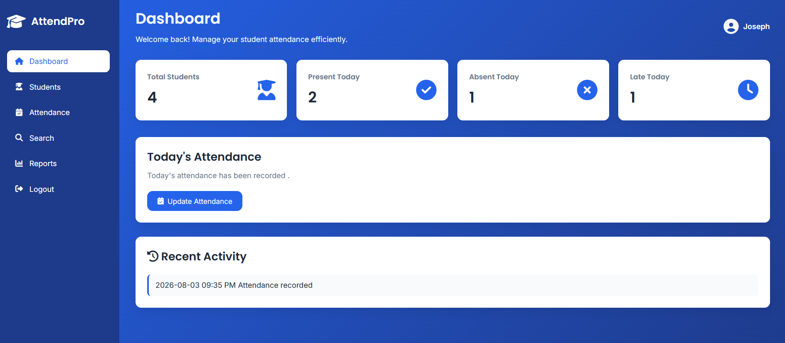
Figure 5: Students List and Add student form
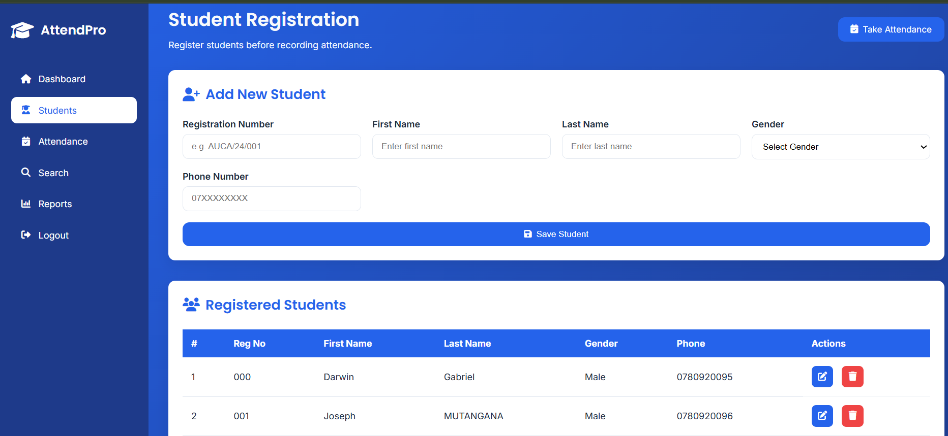
Figure 6: Attendance
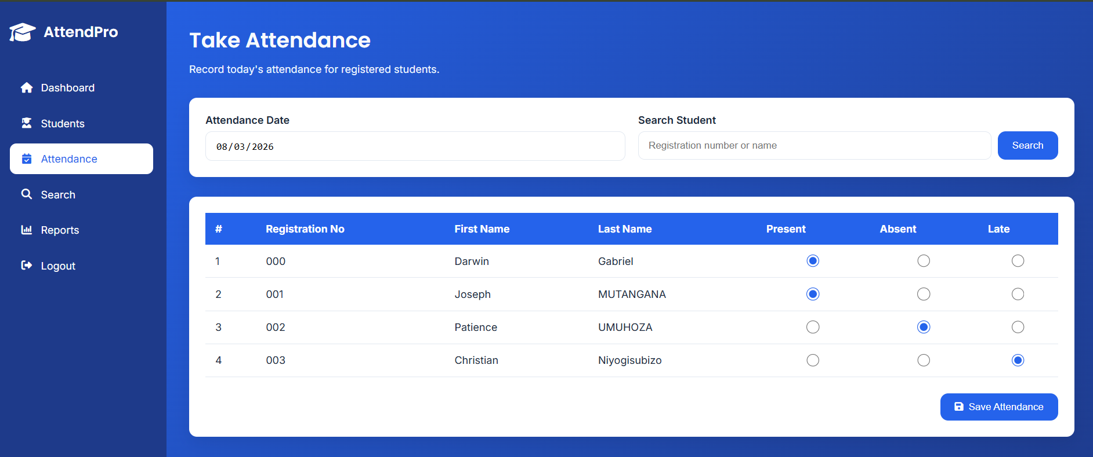
Figure 7: Search Student
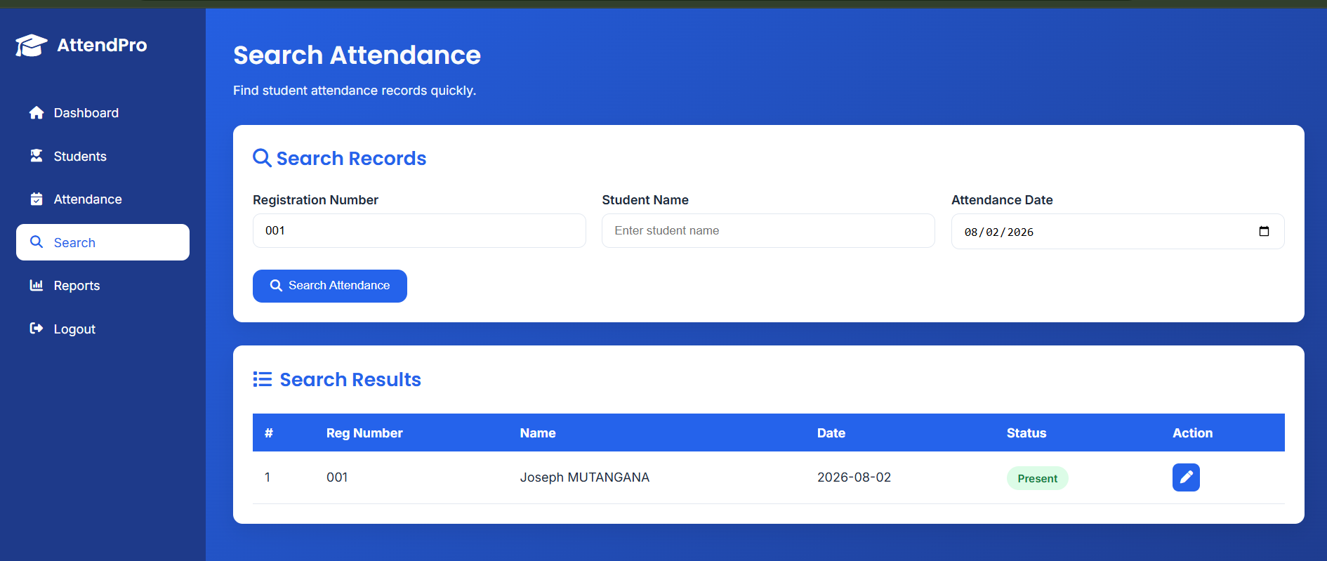
Figure 8: Reports
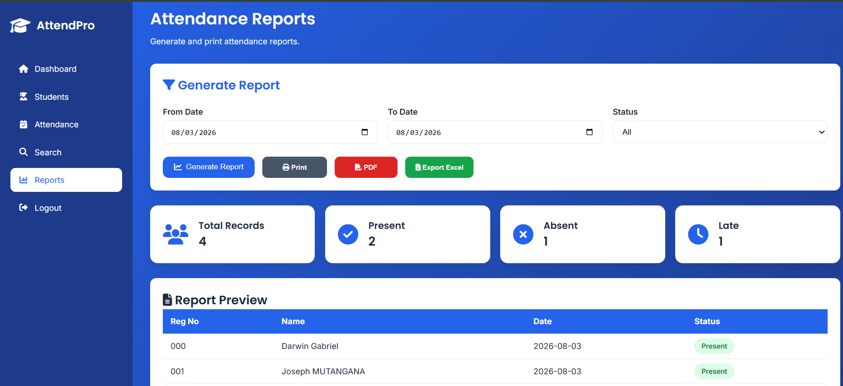

Testing Process and results
The application was tested using functional testing to verify that each major feature performed as expected. Each function was tested using valid and invalid input data, and results were compared with the expected outcomes to determine whether the feature operated correctly.
Test Case | Test Data | Expected Result | Actual Result | Status
Lecturer Registration | First Name: Joseph, Last Name: Mutangana, Email: josephmuta@example.com, Password: lecturer123 | Lecturer account is created successfully and redirected to the login page. | Account was created and redirected to the login page. | Pass
Login | josephmuta@example.com / lecturer123 | Lecturer logs into the system and accesses the dashboard. | Login successful and dashboard displayed. | Pass
Add Student | Reg No: 002, Name: Patience UMUHOZA | Student is saved in the database and displayed in the student list. | Student added successfully. | Pass
Search Student | 001 | Student record is displayed. | Correct student record displayed. | Pass
Record Attendance | Student: 001, Status: Present | Attendance record is saved successfully. | Attendance recorded successfully. | Pass
Export PDF | Attendance report | PDF report is generated. | PDF generated correctly. | Pass
Export Excel | Attendance report | Excel report is generated. | Excel file generated correctly. | Pass
Edit Student | Student 001 | Student information is updated. | Feature not fully implemented. | Fail
Delete Student | Student 001 | Student record is removed. | Feature not fully implemented. | Fail

Discussion of results
The testing showed that the core functions of the system work as expected. Lecturer can create account and log into their account which contains the authentication to allow valid lecturer to access actual system feature and prevent invalid lecturer credential from accessing them core featured of the system.

Attendance recording was successfully tested, and attendance record was correctly saved in database and again retrieved as saved to generate report. The modules to generate reports was successfully doing intended work, helps to generate report and repost can be exported as PDF or Excel file.
However, some features, including editing and deleting the students record were not implemented in testing. These indicate that there are areas need improvement and testing in future versions of the system.

Overall, the result demonstrated that the system achieved primary objectives of providing the tools for managing the attendance management system solution that reduce the need for manual attendance.

Challenges
- Handling the relationships between database tables.
- Implementing attendance reporting and exporting PDF and Excel.
- Managing user authentication
- Implementing edit and delete functional

Possible Improvements
- Complete the edit and delete features
- Add role-based access control
- Associate students and attendance records with the lecturer who created or managed them.
- Improve the user interface and responsiveness
- Add attendance analytics and charts

Conclusion
The AttendPro Attendance Management System was successfully developed to provide a digital solution for recording and managing student attendance. The system showed the challenges related to manual attendance recording by providing lectures with an efficient platform for registering students, recording attendance, searching student records, and generating attendance reports.
The project achieved its primary objectives by implementing essential features such as lecturer registration and login, student management, attendance recording, and reports generation in printable, PDF and Excel formats. Testing confirmed that these functionalities operate as expected.
Although, some features, including editing and deleting the students record were not implemented in testing. These indicate that there are areas need improvement and testing in future versions of the system.
In conclusion, attendPro demonstrates how web technologies can simplify attendance management, improve data accuracy, and reduce the time required to manage records

