CHAPTER I
BACKGROUND OF THE STUDY

Introduction

Higher education institutions are mandated not only to provide instruction and conduct research but also to deliver meaningful extension services to communities. Extension programs serve as a bridge between the university and society, allowing academic knowledge, research outputs, and technical expertise to be shared with partner communities and local government units. Through extension and training services, universities provide opportunities for community members, local organizations, and government units to benefit from academic knowledge, technical assistance, and capacity-building initiatives. These programs often include skills training, technology transfer, community development activities, and other forms of outreach that aim to address real societal needs (Commission on Higher Education [CHED], 2020).

Isabela State University (ISU) actively implements extension and training programs aligned with its institutional vision and mission. These programs are designed to promote sustainable development, community empowerment, and inclusive participation. The extension services are intended to be more practical and responsive to the real needs of communities, particularly those in the poorest local government units and rural areas. Through these initiatives, the University seeks to reach out and work closely with these communities to help strengthen their capacities, enabling them to become more self-reliant and empowered in addressing their own development needs. At the same time, the University envisions creating effective extension approaches and strategies that place strong emphasis on social mobilization, while also promoting sustainable science and technology initiatives and supporting the growth of viable rural-based enterprises (Extension Services Manual of Operations, 2021).

The ISU Cabagan campus plays a vital role in delivering these services to its adopted communities and stakeholders. It embraces the university’s extension thrusts namely Adopt-A-Barangay Volunteerism Program, Adopt-A-School Program, LGU Strengthening and Capability Building, Gender and Development, Scaling Up Agriculture and Fishery Extension (AFE) Innovations, and Community Outreach and Support Services. These programs serve as the foundation of the university’s community engagement efforts. As ISU Cabagan continues to strengthen its commitment to community engagement, the effective management of extension and training programs has become increasingly important (Lirazan, T. P., 2025).

Extension and training activities involve several stages such as proposal preparation and submission, review and approval, implementation, monitoring, documentation, and reporting. These processes require coordination among faculty extensionists, extension coordinators, administrators, and community partners. However, despite the importance of these activities, many extension offices still rely on manual procedures, paper-based documentation, or fragmented digital tools. As a result, information related to extension projects and training activities is often scattered across different files, offices, or individuals. This situation may lead to difficulties in tracking project progress, consolidating reports, and accessing historical data needed for planning and evaluation (Almeida & Monteiro, 2021).

With the increasing use of digital technologies in institutional management, universities are beginning to explore ways to improve their processes through integrated digital solutions. Digital platforms can help streamline workflows, improve record keeping, and support better coordination among stakeholders. More importantly, they can provide reliable data that can guide decision-making and support continuous improvement of extension services (Laudon & Laudon, 2022).

A digital ecosystem refers to an interconnected digital environment where people, processes, and technologies interact to support a common set of services or functions. In the context of extension and training services, a digital ecosystem can bring together various components such as proposal management, project monitoring, documentation of activities, and client feedback collection. By integrating these functions within a single platform, the system can facilitate information sharing, improve transparency in program implementation, and provide a more organized repository of extension-related data (Senyo, P. K. et al., 2021; Gong, Y. et al., 2023).

Despite the recognized importance of digital systems in institutional operations, the management of extension and training services in many universities remains largely decentralized or partially digitized. Without a digital ecosystem at the campus level, monitoring ongoing projects, managing and documenting program outcomes can become time-consuming tasks. Furthermore, generating timely reports and evaluating the overall impact of extension programs may become difficult when data are not systematically organized (Sarker et al., 2021).

In response to these challenges, this study proposes the design and development of a digital ecosystem intended to support the management of campus extension and training services. The system is designed to serve as a centralized platform for submitting extension proposals, tracking the progress of approved projects, and securely managing project documentation. In addition, the platform seeks to support the collection of feedback from beneficiaries and generate relevant reports that can assist administrators in decision making.

Statement of Objectives
The study aims to design, develop, and evaluate a digital ecosystem that supports the management of extension and training services of the Isabela State University Cabagan campus.
Specifically, the study aims to:
- Develop an online platform for the campus Extension and Training Services with the following features:
a. Extension and Training Services Information Portal
b. Extension Project Proposal Submission and Monitoring
c. Client Satisfaction and Feedback
d. Reporting and Analytics Dashboard
e. User and Access Management

- Evaluate the platform based on the following ISO/IEC 25010 software quality standards:
a. Functional Suitability
b. Usability
c. Reliability
d. Security
- Assess the readiness of the faculty and staff in using the online platform.

Scope and Limitation
This study focuses on the development of a web-based information system designed to support the extension services of Isabela State University Cabagan Campus. The system will provide accessible and organized web pages displaying information on extension services, programs, projects, organizational structures, announcements, online CREST publications, downloadable forms, manuals, and online inquiry options. Its primary aim is to enhance information dissemination to students, faculty, beneficiaries, and partner organizations.
The system will also facilitate the online submission of project proposals, including the uploading of supporting documents, tracking of submission status, and submission of progress and terminal reports. This feature is intended to streamline administrative processes and reduce the reliance on physical documentation, thereby improving efficiency and record-keeping within the extension office.
Additionally, the system will incorporate online feedback forms for participants, beneficiaries, and partner organizations. These forms will allow for the collection of feedback and the generation of graphs and charts to visualize satisfaction trends. This function aims to help the extension office assess the effectiveness and impact of their programs and guide decision-making for future initiatives.

A statistical dashboard will also be included, showing real-time data on the number of projects, number of beneficiaries served, faculty participation, and project mapping. This component provides an overview of the university’s extension activities, enabling administrators to monitor performance and identify areas for improvement.
To ensure security and proper access control, the system will feature secure login and authentication with role-based access. Specific access levels will be provided for the extension director, faculty extensionists, staff, and external users, ensuring that sensitive information is protected and only authorized personnel can perform administrative or data entry tasks. Despite its broad capabilities, the system will be limited to online functionalities and statistical reporting, and it will not replace all offline processes such as field validation or in-person project assessments.
However, the system is limited to managing and presenting information related to extension programs of Isabela State University Cabagan Campus only. It will depend on internet connectivity for access and operation, which may affect usability in areas with unstable connections. The system will also rely on users to provide accurate and complete information when submitting documents and feedback. Additionally, the system will not cover financial management, field monitoring, or full project implementation processes, as these activities may still require manual or external institutional procedures.
The developed system will undergo evaluation to assess its functionality, usability, reliability, and overall performance in supporting the extension services of Isabela State University Cabagan Campus. The evaluation will involve selected users such as the extension director, faculty extensionists, staff members, and other authorized users who will test the system based on its implemented features. A structured evaluation instrument will be used to gather feedback regarding the system’s effectiveness in information dissemination, project proposal submission, feedback collection, and statistical reporting. The results of the evaluation will help determine whether the system meets the intended objectives and user requirements. Additionally, the feedback collected from the evaluators will serve as a basis for identifying possible improvements and enhancements to further optimize the system’s functionality and usability.

Significance of the Study
The results of the study will be of great benefit to the following:

University Administration. The system will provide a centralized platform for monitoring extension programs, projects, and faculty participation. The statistical dashboards and organized records will help administrators easily track accomplishments, analyze data, and support decision-making for future extension initiatives.

Extension Director and Extension Office Staff. The system will simplify the management of extension-related documents and reports. Features such as online submission of project proposals, status tracking, and digital storage of supporting documents will help reduce manual work, improve record organization, and increase efficiency in handling extension activities.

Faculty Extensionists. The system will make it easier to submit proposals, upload supporting documents, and submit progress and terminal reports through an online platform. This will save time and effort compared to traditional paper-based processes and allow them to monitor the status of their submissions more conveniently.

Participants, Beneficiaries, and Partner Organizations. The system will provide easy access to information about extension services, programs, and announcements. The online feedback forms will also allow them to share their experiences and suggestions, helping the university improve the quality and impact of its extension programs.

Future Researchers. The study may serve as a reference for developing similar web-based systems related to extension services, program management, or institutional information systems. The findings and system design may provide useful insights for further studies and improvements in extension management and digital information systems.

CHAPTER II
REVIEW OF RELATED LITERATURE

Extension and Training Services in Higher Education Institutions
Training and extension services are essential components of higher education institutions (HEIs), as they facilitate knowledge transfer, skill development, and community engagement. According to Malik et al. (2023), structured training programs significantly enhance the competencies of both trainers and beneficiaries by combining theoretical learning with practical application. Their study highlights that well-designed training initiatives improve knowledge dissemination and strengthen community engagement, particularly in institutional. Similarly, Brion and Reginaldo (2021) emphasized that extension and training programs especially those institutionalized through initiatives such as Gender and Development (GAD) contribute to inclusive development by improving implementation efficiency, strengthening organizational systems, and ensuring sustainability.
Supporting this, Angco (2026) emphasized that extension services are fundamental functions of HEIs alongside instruction and research, as they promote knowledge sharing, capacity building, and community empowerment. The study highlighted that universities act as catalysts for social transformation by bridging academic knowledge with real-world applications, particularly in underserved communities. In relation to training effectiveness, Labayo (2022) evaluated a teacher-training extension program using the Kirkpatrick evaluation model and found that training programs significantly improve participant engagement and satisfaction. However, the study pointed out that long-term outcomes such as behavioral change and skill retention must be assessed to ensure sustainability. Likewise, Mekheimer (2025) found that hands-on and context-based training programs enhance professional development, particularly in improving teaching practices and technology integration, emphasizing the need for relevance and practicality in training design.
In addition, Panes and Mejos (2019) stressed the importance of organized training management systems in delivering effective extension services. Their findings showed that proper planning, needs assessment, scheduling, and monitoring are crucial to ensure that training programs address the specific needs of beneficiaries. The integration of information systems further improves efficiency, accessibility, and service delivery. Meanwhile, Corpuz, Time, and Afalla (2022) emphasized that extension services play a vital role in community empowerment by addressing societal needs such as literacy, health awareness, and livelihood development. Their study revealed that participatory and needs-based programs lead to higher engagement and improved quality of life, while also strengthening institutional social responsibility.
Moreover, Sierto and Navarro (2023) examined faculty engagement in extension services and found that faculty participation is driven not only by institutional requirements but also by a commitment to sustainable community development. Their study revealed that factors such as experience, years of service, and level of involvement influence faculty commitment, which in turn enhances program implementation and community partnerships. Similarly, Mani and Zulueta (2018) highlighted that extension and training services contribute to institutional development by improving research productivity and strengthening community involvement, demonstrating the interconnected role of instruction, research, and extension in HEIs.

Digital Transformation in Extension and Training Services
Digital transformation has significantly improved the delivery of extension and training services in educational institutions. Salsabella, Bakhtiar, and Ibrahim (2024) found that digital technologies enhance accessibility, communication, and coordination in extension systems. Their study highlights that web-based platforms enable efficient program management, monitoring, and reporting, improving transparency and service delivery. Similarly, Enaldo and Trinidad (2025) demonstrated that implementing a SMART extension management system enhances efficiency and accessibility. Their findings revealed that performance expectancy and effort expectancy are key factors influencing user adoption, while institutional support and training are necessary to overcome challenges such as system integration and data migration.
Furthermore, Pawar (2022) emphasized that digital transformation improves connectivity, information dissemination, and organizational performance. The study also pointed out that disparities in digital infrastructure can create a digital divide, affecting adoption and effectiveness. In the context of higher education, Halkhoree et al. (2024) found that digital transformation supports flexible learning environments, improves access to resources, and enhances decision-making processes. However, challenges such as resistance to change and limited infrastructure remain significant barriers. Similarly, Carmo et al. (2025) highlighted that digital transformation requires not only technological adoption but also organizational restructuring and strategic alignment.
Additionally, Mabotha and Ngcamu (2025) emphasized that digital transformation improves institutional performance by modernizing systems and enhancing communication, although challenges such as limited funding and low digital literacy persist. Li (2022) further explained that digital transformation is a dynamic process that enhances competitiveness and sustainability but depends on an organization’s ability to adapt to changing environments. Meanwhile, Wintersberg and Pittich (2025) focused on digital transformation in training, highlighting that digital tools improve flexibility, accessibility, and learner engagement, although they require adjustments in instructional design and organizational processes.

Software Quality Standards and Evaluation
Software quality evaluation is essential in ensuring the effectiveness and reliability of digital systems. Pratama and Mutiara (2021) emphasized the importance of the ISO/IEC 25010:2011 model, which provides standardized criteria such as functional suitability, usability, reliability, and security for assessing software quality. Their study demonstrated that applying ISO standards enables systematic evaluation and identification of areas for improvement. Similarly, Fadel, El Bishouty, and El Dahshan (2020) highlighted that web-based systems must be evaluated based on usability, response time, navigation, and reliability, as these factors significantly influence user satisfaction and system effectiveness.
Kokol (2022) further emphasized that software quality is a fundamental component of digital transformation, as reliable systems are essential for sustaining digital infrastructures. The study identified trends such as advanced testing techniques and the use of machine learning in quality assurance. Meanwhile, Thongtanunam and Hassan (2020) demonstrated that collaborative code review processes significantly improve software quality by reducing defects and enhancing decision-making in development.
In addition, Lytra et al. (2020) highlighted the importance of quality attributes in software architecture, emphasizing that decisions related to performance, maintainability, and usability directly affect system effectiveness. Jayasree and Ravindran (2019) contributed by showing how advanced systems, such as sensor networks, improve real-time monitoring and operational reliability. Furthermore, Husereau et al. (2022) stressed the importance of standardized evaluation frameworks in ensuring transparency and consistency in assessments, while Humphries et al. (2021) demonstrated how standardized guidelines improve reliability and comparability in laboratory evaluations.

Technology Adoption
Technology adoption plays a crucial role in the successful implementation of digital systems. Abdou and Jasimuddin (2020) applied the UTAUT model and found that performance expectancy, effort expectancy, and social influence significantly affect users’ intention to adopt e-learning systems, with performance expectancy being the strongest predictor. Similarly, Al-Rahmi et al. (2021) found that system quality, information quality, and service quality influence students’ use of social media in education, leading to improved academic performance and satisfaction.
Al-Emran and Griffy-Brown (2023) emphasized that technology adoption supports sustainable development but is influenced by both enabling factors (efficiency, innovation) and barriers (cost, complexity, lack of skills). Meanwhile, Škare and Soriano (2021) highlighted that globalization accelerates technology adoption by facilitating knowledge transfer and innovation across countries.
Furthermore, Wang, Olivier, and Chen (2020) emphasized that organizational readiness comprising commitment, efficacy, and shared beliefs is essential for successful implementation of new systems. Similarly, Miake-Lye et al. (2020) found that readiness involves both willingness and capability, influenced by leadership, communication, and resource availability. Uren and Edwards (2022) extended this by emphasizing the importance of readiness across people, processes, and data, while Sharma and Venkatraman (2023) highlighted that lack of organizational readiness is a primary cause of failure in technology adoption.

CHAPTER III
METHODOLOGY
This chapter presents the research design and methods employed in the development and evaluation of the web-based Extension and Training Services Management System for Isabela State University Cabagan Campus (ISUC). It outlines the procedures and techniques used to design and develop the system, evaluate its quality based on ISO/IEC 25010:2023 standards, and assess user acceptance through the Technology Acceptance Model (TAM).

Research Design
This study employ a descriptive and developmental research design. The developmental aspect involves the design, creation, and implementation of a web-based system intended to enhance the management of extension and training services at ISUC. The system incorporates features such as extension service information management, project proposal submission and monitoring, documentation, reporting, and user access management. This phase focuses on developing a functional and efficient platform that supports the needs of the Extension Director, faculty extensionists, staff, and authorized users in managing extension-related activities.
The descriptive aspect focuses on evaluating the system’s quality and assessing user acceptance. Surveys using structured questionnaires will be conducted to gather numerical data. Users’ perceptions will be examined based on the ISO/IEC 25010:2023 software quality standards, specifically functional suitability, interaction capability, reliability, and security. Additionally, the Technology Acceptance Model (TAM) will be employed to assess perceived usefulness, perceived ease of use, and intention to use the system, providing insights into user acceptance and satisfaction.
The participants of the study will include the Extension Director, faculty extensionists, staff, and authorized system users of Isabela State University, Cabagan (ISUC). Respondents will be selected using convenience sampling, focusing on individuals who are readily available and directly involved in extension and training service activities, ensuring relevant stakeholder representation and efficient data collection
Data will be collected through survey questionnaires which will be distributed to the selected participants after testing the developed system. The study will ensure that all participants will be voluntarily provided with informed consent and will be fully briefed about the purpose of the research. Participants’ identities and responses will be kept confidential, and data will be used solely for research purposes. The study will also ensure that no participant experiences harm or discomfort, and participants are allowed to withdraw at any time without consequences.
Responses will be organized, tabulated, and analyzed using weighted means and percentages. A five-point Likert scale will be employed as shown in Table 1, where 1 corresponds to Strongly Disagree and 5 corresponds to Strongly Agree, providing a standardized measure of participants’ perceptions and determining the overall effectiveness and acceptance of the developed system.

Table 1. Likert Scale
Scale Range Descriptive Equivalent
5 4.21 – 5.00 Strongly Agree (SA)
4 3.41 – 4.40 Agree (A)
3 2.61 – 3.40 Neither Agree nor Disagree (N)
2 1.81 – 2.60 Disagree (D)
1 1.00 – 1.80 Strongly Disagree (SD)

Software Development Model
The study will use the Agile Web Development Process model (Agile Alliance, n.d.) to develop the system in phases. It is composed of six phases: requirements gathering, design, development, testing, deployment, and review as shown in Figure 1.
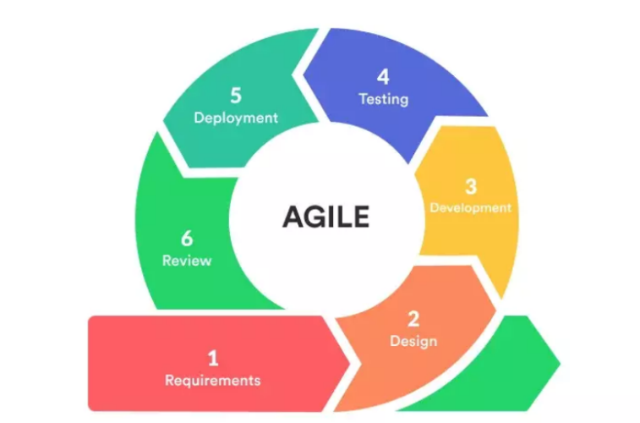

Figure 1. Agile Software Development Cycle
The Agile Web Development Process Model is iterative and incremental, meaning the system will be developed step by step while continuously improving based on feedback from users. Agile is appropriate for this study because it supports flexibility, user involvement, and continuous system improvement. This model will allow the researchers to quickly respond to feedback from Extension Director, faculty extensionists, staff, and authorized users. It will also ensure that the system meets the actual needs of the institution.
A. Requirements Gathering
The first phase focuses on identifying the problems and needs related to the current extension and training services management process. Data were gathered through interviews and observations with the Extension Director, faculty extensionists, and staff. This phase identified several issues, such as manual handling of extension proposals, delays in monitoring and reporting, and difficulty in organizing and retrieving documents. Based on these findings, the system requirements were defined, including features such as online proposal submission, project monitoring, feedback collection, and report generation. A flow of the current process was also analyzed using process flowchart to understand how evaluation data moves within the institution and to identify areas that need improvement.
B. Design
After gathering the requirements, the next phase focuses on designing the system. This includes creating the system layout, interface design, and overall structure of the platform. The system was designed to be user-friendly for Extension Director, faculty extensionists, staff, and authorized users, and report interfaces were planned to ensure easy navigation and accessibility. A Use Case Diagram was also developed to show how users interact with the system. This helped ensure that each user role has appropriate access and functions within the system.
C. Development
In this phase, the system will be developed into a functional web-based application. The backend will be developed using PHP and MySQL to manage data securely, while the frontend will be developed using HTML, CSS, and JavaScript to create an interactive and user-friendly interface.
D. Testing
Testing will be conducted to ensure that the system functions properly and meets user requirements. It includes unit testing and system testing.
Unit testing involves examining each individual component of the system separately. Features such as online proposal submission, project monitoring, feedback collection, reporting, user management, and analytics dashboard will be tested independently to verify that they worked correctly and produced accurate outputs. Errors or bugs detected during this stage will be corrected immediately, ensuring that each module performed as intended.
Following unit testing, system testing will be conducted to evaluate the integrated system as a whole. This ensures that all modules worked together seamlessly, that data flows correctly between components, and that the overall system meets the intended functional and technical requirements. System performance will be tested under different scenarios to identify and address issues such as processing errors, interface inconsistencies, and potential security vulnerabilities.
E. Deployment
After testing and improvements, the system will be deployed for actual use. The system will be made accessible to selected respondents within the institution. Users will be guided on how to use the system, including submitting evaluations, viewing reports, and accessing analytics features. This phase allows the system to be used in a real environment.
F. Review
After deployment, evaluation will be conducted based on ISO/IEC 25010:2023 software quality standards, as well as user acceptance using the Technology Acceptance Model (TAM), focusing on perceived usefulness, perceived ease of use, and intention to use.

References

Abdou, D., & Jasimuddin, S. M. (2020). The use of the UTAUT model in the adoption of e-learning technologies: An empirical study in France-based banks. Journal of Global Information Management, 28(4), 38–51.
Agile Alliance. (n.d.). About Agile Alliance. https://agilealliance.org/the-alliance/
Al-Emran, M., & Griffy-Brown, C. (2023). The role of technology adoption in sustainable development: Overview, opportunities, challenges, and future research agendas. Technology in Society, 73, 102240. https://doi.org/10.1016/j.techsoc.2023.102240
Almeida, F. (2021). The impact of digital transformation on organizational performance. Applied Sciences, 11(3), 1–15. https://www.mdpi.com/2076-3417/11/3/1109
Al-Rahmi, A. M., Shamsuddin, A., Alturki, U., Aldraiweesh, A., Yusof, F. M., Al-Rahmi, W. M., & Aljeraiwi, A. A. (2021). The influence of information system success and technology acceptance model on social media factors in education. Sustainability, 13(14), 7770. https://doi.org/10.3390/su13147770
Angco, R. J. N. (2026). Higher education extension programs in the Philippines: A meta-synthesis. Frontiers in Education.
https://doi.org/10.3389/feduc.2026.1764682
Brion, R. B., & Reginaldo, A. L. (2021). Institutionalization of gender and development in extension and training services programs. International Journal of Educational Management and Development Studies.
Carmo, J. E. S., Lacerda, D. P., Klingenberg, C. O., & Piran, F. A. S. (2025). Digital transformation in the management of higher education institutions. Sustainable Futures, 9, 100692.https://doi.org/10.1016/j.sftr.2025.100692
Commission on Higher Education. (2020). Guidelines on extension programs and community engagement in higher education institutions. https://ched.gov.ph
Corpuz, D. A., Time, M. J. C., & Afalla, B. T. (2022). Empowering the community through the extension services of a teacher education institution in the Philippines. Cogent Education, 9(1).https://doi.org/10.1080/2331186X.2022.2149225
Enaldo, M. A., & Trinidad, G. A. (2025). Digital transformation in university extension services: Evaluating UTAUT constructs in the adoption of a SMART extension management system. New Educational Review. https://doi.org/10.15804/tner.2025.79.1.09
Fadel, J., El Bishouty, A., & El-Dahshan, N. (2020). Quality evaluation of web-based systems. Journal of Physics: Conference Series, 1529(2), 022004.https://iopscience.iop.org/article/10.1088/1742-6596/1529/2/022004/meta
Halkhoree, R., Santally, M., Gukhool, O., & Murdan, A. P. (2024). Analyzing the landscape of digital transformation in higher education institutions. In 2024 1st International Conference on Smart Energy Systems and Artificial Intelligence (SESAI) (pp. 1–6). IEEE.https://doi.org/10.1109/SESAI61023.2024.10599412
https://doi.org/10.4018/JGIM.2020100103
https://iiari.org/wp-content/uploads/IJEMDS-Vol-2-Issue-3-September-2021.pdf
Humphries, R., Bobenchik, A. M., Hindler, J. A., & Schuetz, A. N. (2021). Overview of changes to the Clinical and Laboratory Standards Institute performance standards for antimicrobial susceptibility testing, M100, 31st edition. Journal of Clinical Microbiology, 59(12), e00213-21.https://journals.asm.org/doi/full/10.1128/jcm.00213-21
Husereau, D., Drummond, M., Augustovski, F., de Bekker-Grob, E., Briggs, A. H., Carswell, C., Caulley, L., Chaiyakunapruk, N., Greenberg, D., Loder, E., Mauskopf, J., Mullins, C. D., Petrou, S., Pwu, R. F., & Staniszewska, S. (2022). Consolidated Health Economic Evaluation Reporting Standards 2022 (CHEERS 2022) statement: Updated reporting guidance for health economic evaluations. MDM Policy & Practice, 7(1).https://journals.sagepub.com/doi/full/10.1177/23814683211061097
Jayasree, R., & Ravindran, B. (2019). Recent trends in sensor network applications: design, technology, and use cases. IET Smart Cities, 1(1), 3–13.https://ietresearch.onlinelibrary.wiley.com/doi/full/10.1049/iet-sen.2018.5446
Kokol, P. (2022). Software quality: How much does it matter? Electronics, 11(16), 2485. https://doi.org/10.3390/electronics11162485
Labayo, C. P. (2022). Evaluation of a teacher-training extension program using the Kirkpatrick model. The Normal Lights Journal.
https://doi.org/10.56278/tnl.v16i1.1713
Laudon, K. C., & Laudon, J. P. (2022). Management Information Systems: Managing the Digital Firm (17th ed.). Pearson. https://books.jgu.edu.in/bib/3090679?utm_source
Li, L. (2022). Digital transformation and sustainable performance: The moderating role of market turbulence. Industrial Marketing Management, 104, 28–37. https://doi.org/10.1016/j.indmarman.2022.04.007
Lirazan, T.P., (2025). Livelihood extension program administration, stakeholder engagement, and organizational performance of selected SUCs in NCR.
International Journal of Research and Scientific Innovation.
https://doi.org/10.51244/IJRSI.2025.12120020
Lytra, I., Carrillo Sánchez, C., Capilla, R., & Zdun, U. (2020). Quality attributes use in architecture design decision methods: research and practice. Computing, 102(2), 551–572.https://link.springer.com/article/10.1007/s00607-019-00758-9
Mabotha, P. A. P., & Ngcamu, B. S. (2025). Digital transformation in the higher education sector: A systematic literature review. Administrative Sciences, 16(1), 1. https://doi.org/10.3390/admsci16010001
Malik, S., Kaur, J., Saini, K., Kumar, A., Yadav, K. K., Dhingra, A., Abhilash, & Malik, R. (2023). Exploring the impact of training programs on agricultural extension services from trainer's perspective. International Journal of Education and Management Studies. https://iahrw.org/our-services/journals/international-journal-of-education-and-management-studies/
Mani, M. C., & Zulueta, D. P. (2018). The research, development, extension and training experiences of Marinduque State College, Philippines: Basis for excellence in education. International Journal of Engineering Technologies and Management Research, 5(3), 44–58. https://doi.org/10.29121/ijetmr.v5.i3.2018.176
Mekheimer, M. A. (2025). Professional development and training in higher education: A mixed-methods study. Education and Information Technologies.
https://link.springer.com/article/10.1007/s10639-025-13750-y
Miake-Lye, I. M., Delevan, D. M., Ganz, D. A., Mittman, B. S., & Finley, E. P. (2020). Unpacking organizational readiness for change: An updated systematic review and content analysis of assessments. BMC Health Services Research, 20(1), 106. https://doi.org/10.1186/s12913-020-4926-z
Panes, W. D., & Mejos, R. S. (2019). TrainME: A web-based training needs assessment and management system. International Journal of Science and Management Studies.https://www.ijsmsjournal.org/2019/volume-2%20issue-2/ijsms-v2i2p106.pdf
Pawar, P. S. (2022). A comparative study of digital transformation among the emerging economies in Asia and Africa during 2001–2020. WVSU Research Journal, 11(1), 18–35.https://doi.org/10.59460/wvsurjvol11iss1pp18-35
Pratama, A. A., & Mutiara, A. B. (2021). Software quality analysis for Halodoc application using ISO/IEC 25010:2011. International Journal of Advanced Computer Science and Applications, 12(8), 383–392.https://doi.org/10.14569/IJACSA.2021.0120844
Salsabella, I. H., Bakhtiar, A., & Ibrahim, J. T. (2024). The role of extension workers in digital transformation. AGROMIX, 15(2), 255–261.https://doi.org/10.35891/agx.v15i2.4098
Sarker, I. H., Kayes, A. S. M., Badsha, S., Alqahtani, H., Watters, P., & Ng, A. (2020). Cybersecurity data science: An overview from machine learning perspective. Journal of Big Data, 7(41).https://link.springer.com/article/10.1186/s40537-020-00318-5
Senyo, P.K., Effah, J., &Addae, E. (2021). Digital platforms and ecosystems: A review of emerging research and future directions.
International Journal of Information Management, 60, 102358.
https://doi.org/10.1016/j.ijinfomgt.2021.102358
Sharma, A., & Venkatraman, S. (2023). Towards a standard framework for organizational readiness for technology adoption. In Advances in Digital Manufacturing Systems. Springer. https://doi.org/10.1007/978-981-19-7071-9_10
Sierto, M. E., & Navarro, R. J. (2023). Status of engagement and commitment of faculty members in extension services in BulSU external campuses: Basis for an action plan. International Journal of Multidisciplinary: Applied Business and Education Research, 4(10), 3559–3571.https://doi.org/10.11594/ijmaber.04.10.13
Škare, M., & Ribeiro Soriano, D. (2021). How globalization is changing digital technology adoption: An international perspective. Journal of Innovation & Knowledge, 6(4), 222–233. https://doi.org/10.1016/j.jik.2021.04.001
Thongtanunam, P., & Hassan, A. E. (2020). Review dynamics and their impact on software quality. IEEE Transactions on Software Engineering, 47(12), 2698–2712.https://doi.org/10.1109/TSE.2020.2964660
Uren, V., & Edwards, J. S. (2022). Technology readiness and the organizational journey towards AI adoption: An empirical study. International Journal of Information Management, 68, 102588. https://doi.org/10.1016/j.ijinfomgt.2022.102588
Wang, T., Olivier, D. F., & Chen, P. (2020). Creating individual and organizational readiness for change: Conceptualization of system readiness for change in school education. International Journal of Leadership in Education, 26(6), 1037–1061. https://doi.org/10.1080/13603124.2020.1818131
Wintersberg, L., & Pittich, D. (2025). Digital transformation of corporate technical education and training: A case study on instructional designers’ perceptions. Vocations and Learning. https://doi.org/10.1007/s12186-025-09360-x

Analysis Modeling

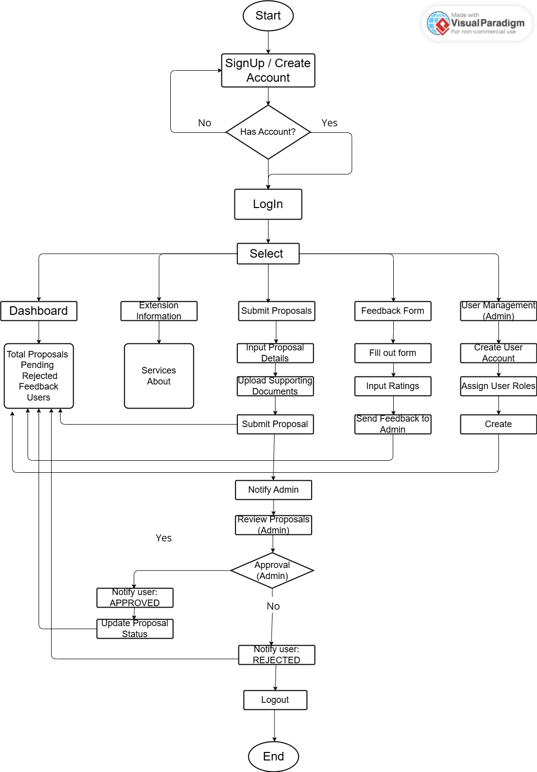

Figure 2. Flowchart Diagram for Digital Ecosystem for Campus Extension and Training Services

Design Modeling

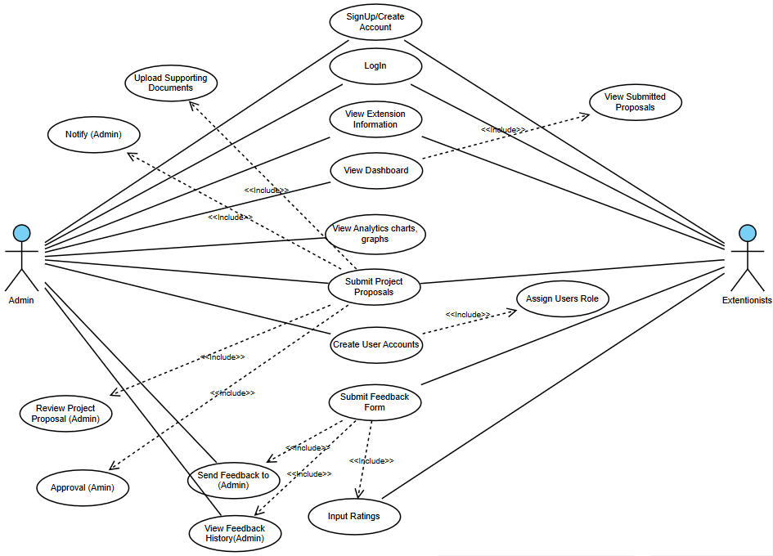

Figure 3. Use Case Diagram for Digital Ecosystem for Campus Extension and Training Services

