# Title page

# Table of contents

*URL -----------------------------------------------------------------------------------------*

*Summary -----------------------------------------------------------------------------------*

*Logical Design -----------------------------------------------------------------------------*

*List of Applications------------------------------------------------------------------------*

*User’s Guide -------------------------------------------------------------------------------*

*Contents of Tables -------------------------------------------------------------------------*

*Implementation code ----------------------------------------------------------------------*

*Conclusion - --------------------------------------------------------------------------------*

## URL

### Project Repository:

[*https://bitbucket.org/joenelsong/wcs_dj_db/overview*](https://bitbucket.org/joenelsong/wcs_dj_db/overview)

* *Access was made private so no one deletes my final project. But as you see below I’ve forwarded you both access.*

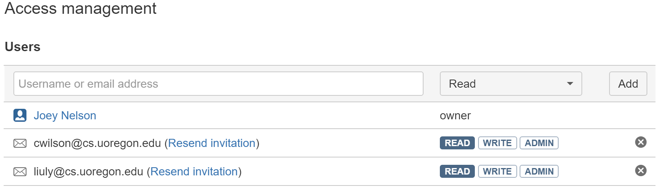

### Web Application:

<http://ix.cs.uoregon.edu/~jnelson/wcs_dj_db/db.html>

## Conclusion

Things that still need to be done are the following:

1. Write more scripts to automatically collect information available online.
2. Write a script to go through the Track table and fill in missing fields that are not being logged from their primary point of acquisition.
3. Include more Radio, DJ, and Top X lists to create a more diverse database
4. Include more than just West coast Swing radio stations (Because West Coast Swing is itself very eclectic, so it would be nice to contain many different sources of music (blues, pop, r&b, hiphop, jazz, etc.)
5. Allow more sophisticated querying from users
6. Give registers DJ’s extensive access to the database, and other users limited, or pay to use
7. Also the front end could be build up to look nice, now it is extremely rudimentary
   1. Ideally this would contain my own custom views
      1. Average BPM histogram for Playlists
      2. Genre distributions, Duration, Key, time Signatures, etc.
   2. Also it would allow for logged in users to have their own custom views (maybe)
   3. Users could save Queries they’ve ran before
8. I’d also want to include an Event’s Table which would show which event each Source came from.