**@Description**

The is an e-commerce website project for IERG4210 and built with create-react-app(react.js 腳手架),material-ui(a front-end UI-framework for react),redux(state container of js),react-icons(an icon library of react).

**@npm and library setup**

For enabling project properly to run, Node Package Manager (npm) is a must, i.e.

1.for Linux, you may install npm by **“sudo apt install npm” OR**

2.go to <https://nodejs.org/en/> and download the recommended version of node.js. Or click Other Downloads for other OS

After installation of node.js, npm will be enabled.

Type **“npm install”** under the path ‘/client’, i.e.



That will install all the library/framework dependency for the project according to ‘package.json’ file into a folder call “node_modules”,

Note that the folder may be very large, around 1.1GB, so that the installation may take a while and required space. You may ignore the warning during installation.

**@startup procedure**

after “node_modules” installed,you may type “npm start” to start up the project,i.e.



That will start the project in [development] mode, and also that will take a while,

After successfully start, you may see

If the browser didn’t automatically open, you may view the page by typing the URL into browser.

**Note: As the project still in development mode, it keeps tracking with any change to the project and that may exhaust computer resources. i.e.it works smooth in my local computer but little lag in VM.**

**The situation will become better after deployment in production mode in the future.**

**@file structure**

Under folder [client],

[public] store all the public info, usually image

[src] store all the react code for this project

Under folder [src],

[components] store all the components for this project. With applying create-react-app, the webpage is separated into different component, i.e. Header,Footer,Home etc..

[pages] also store components, but those are displayed by routing, i.e. change of URL

[redux] responsible to store configuration and operation of Redux, that is while component are embedded inside component and hence it’s really hard to pass data and update all of them. Redux can provided an external state management that all components only need to access Redux for the data, i.e. in this project, accessing the cart in different component.

[route] store the routing rules of the url

{App.js} define the content of the whole web page,i.e. constantly display Header and Footer, and content are display between them by routing.

{index.js} trigger the rendering of App.js

{sampleData.js} store fabricated data for currently displayed purpose,after backend server settle up, this file will be removed.

Under folder [component]

[Footer] store all the code for footer



[Header] store all the code for header



[HomeProductList] store code for displaying product list in home page

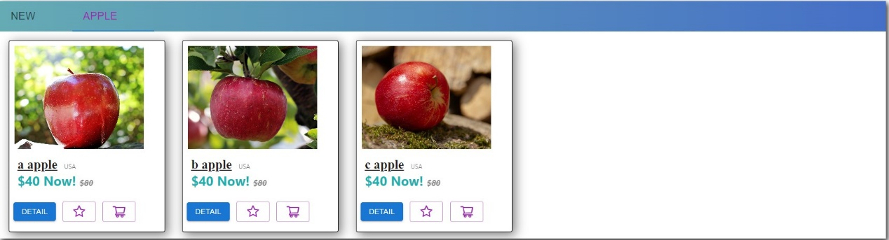

[ProductDetail] store the dialog design that is shown after clicking “Detail” button/image/item name on any item’s card

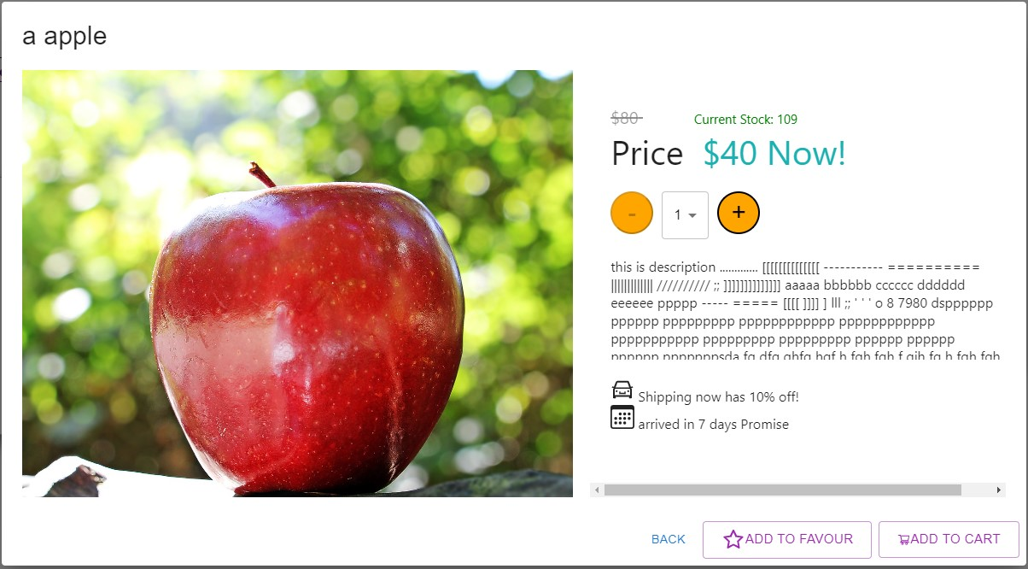

[ProductList] store the display list in routing page of Subnavigation,that is the [HomeProductList] also use this component for displaying items

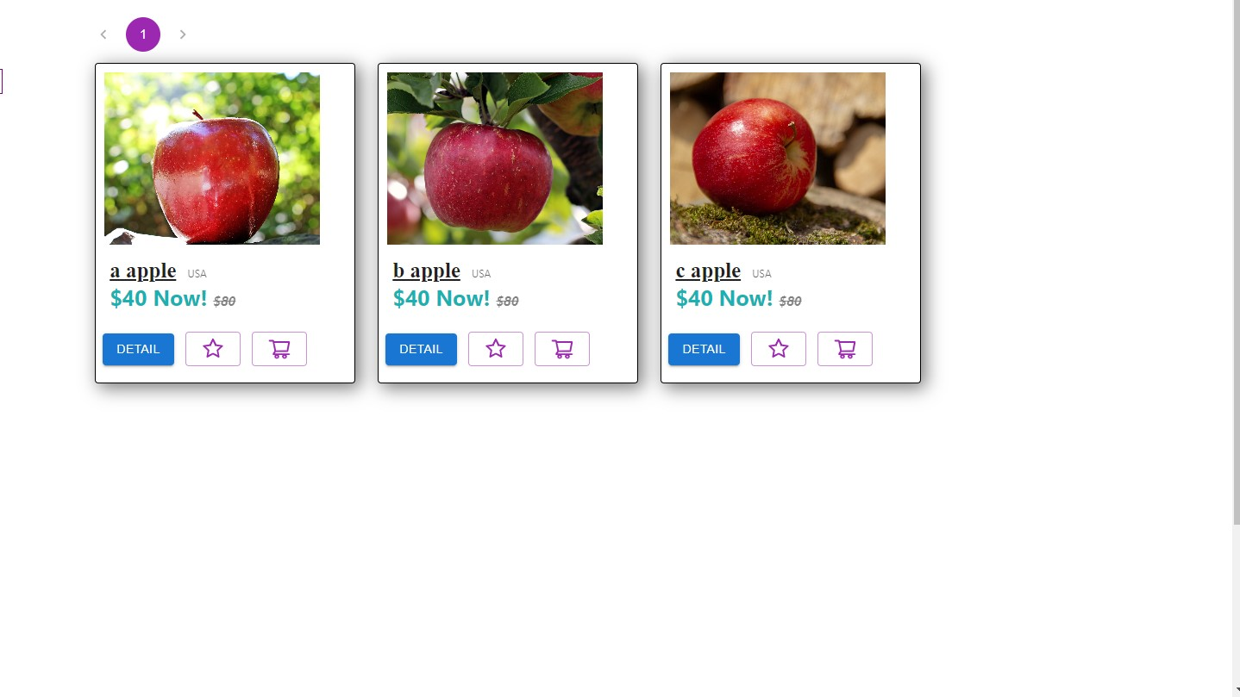

Under Folder[pages]

[Home] store the design of home page, including the image and the list

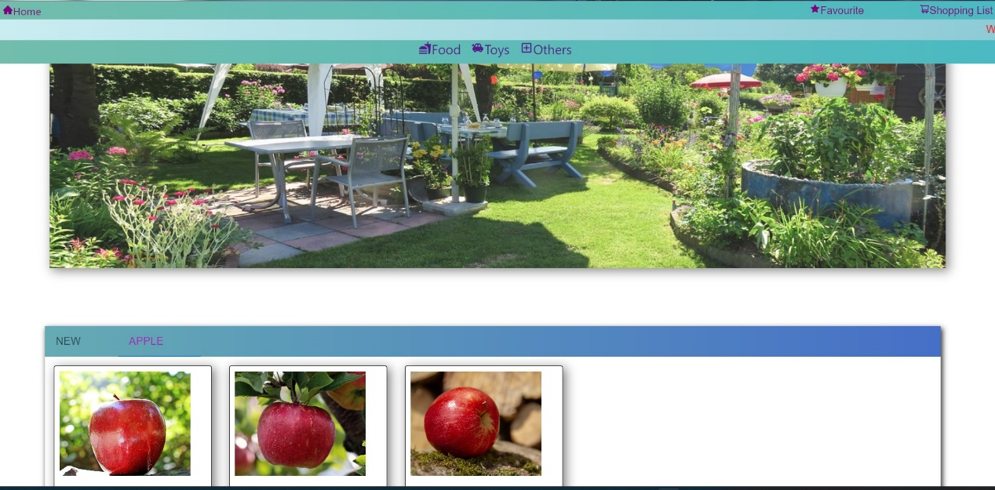

[SubNavigation] store the design of navigation page after click the navigation bar in header, including the left side sub Navigation bar, the right side pagination and product list.

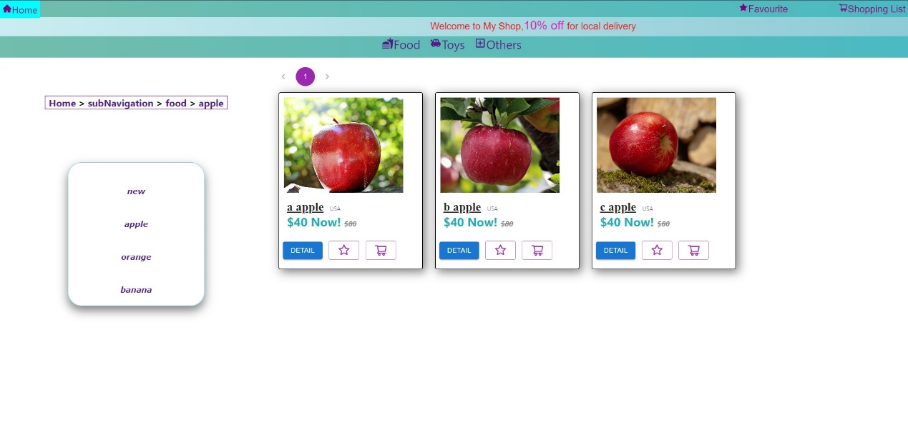

**@Specification for IERG4210 assignment1 requirement**

1. HTML: Make good use of semantic HTML throughout the whole assignment

In component Footer, apply <footer>



In component Header,apply <header>

Note: 1. In react,All the component is required to be wrapped by a root component, usually a <div> will be used in that cased.2.Some of the tag are not refer to html tags, instead it might be other components, components from material-ui or react-icons

1. CSS: Clean separation of HTML, CSS and JS code and files throughout the whole assignment.

In this react project, HTML and JS will be packed into a .jsx file while css is a separated file.

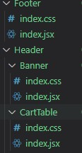

But note that some of the component from material-ui/react-icons provided API for styling that is inline CSS, i.e. 

That the Button is from material-ui where variant/size/color is styling the button

1. Main page demonstrates the use of “CSS table-less” product list

To view the effect of table-less, you may select “Others” in navigation bar of header, then select chopper in the left sidebar that contain >10 items.

In my computer with full screen,it display 4 item in a row

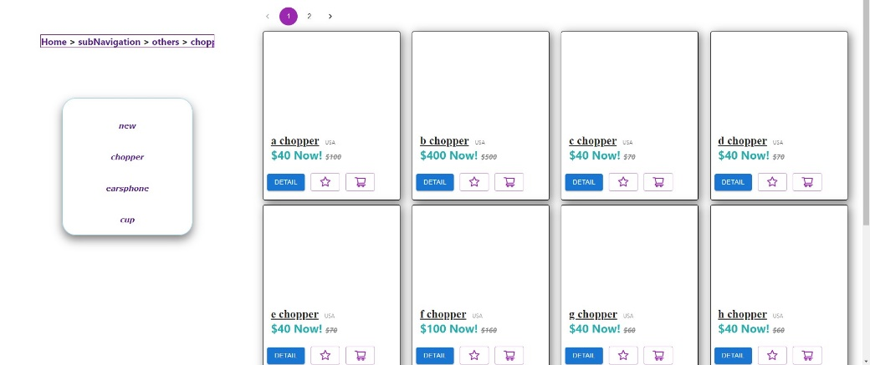

Or after shrink the size

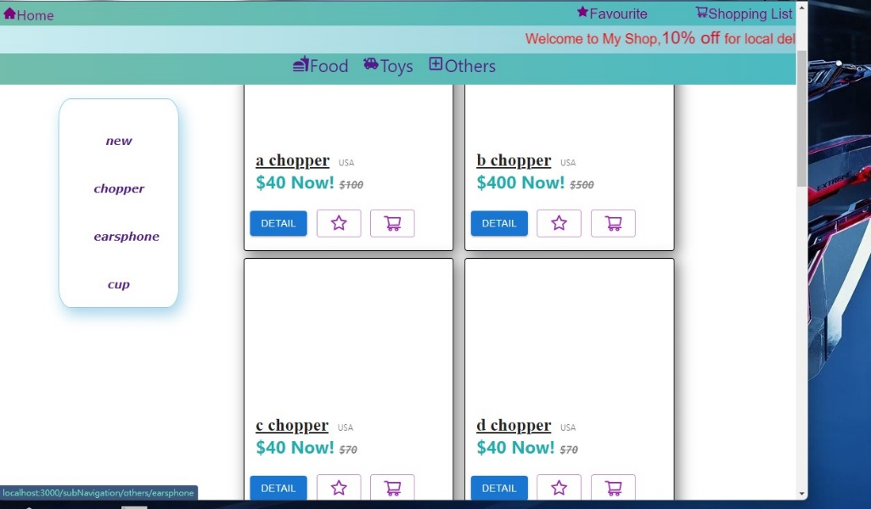

You can also view the detail by clicking the image/name/detail button

1. Main page demonstrates the use of “CSS hover” shopping list

The header is stick at any page and the cart is manage by Redux, that means you can access the cart in any page. For the “CSS hover” opening the cart,we may use onmouseenter event to trigger it.

After trigger, a Drawer displayed and cover all the element behind.

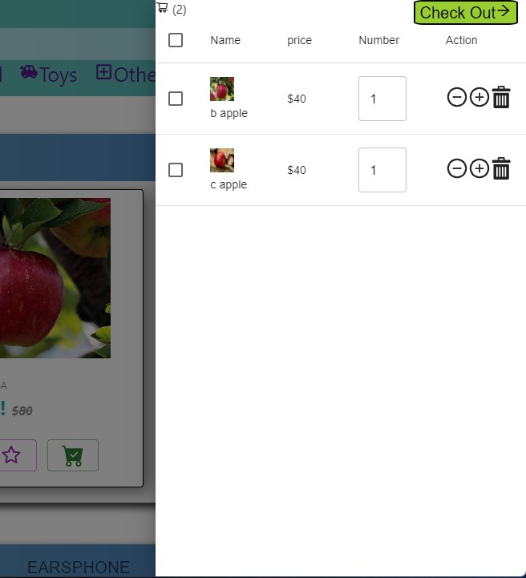

There is a check out button at top right corner.

There is an input field for the Number of item, note that I set a limit number in 1<x<100

There is minus/add button for add/minus 1 purpose and a garbage for deleting.

There is also a selected checkbox for deleting all the selected items in a time

**Note: The input box only allows number input, that’s mean you cann’t empty the field, i.e. if you want to change from 1 to 9, you need to input a 9 to make it become 19, then remove the 1.**

1. Product page provides product details

Instead of creating a new page, I create a dialog for displaying detail, including product name, price, stock etc…

If you click outside the dialog, it close.

For the number of items you want to order, you may press minus/add button or directly select the number by selector that contain options 1-99

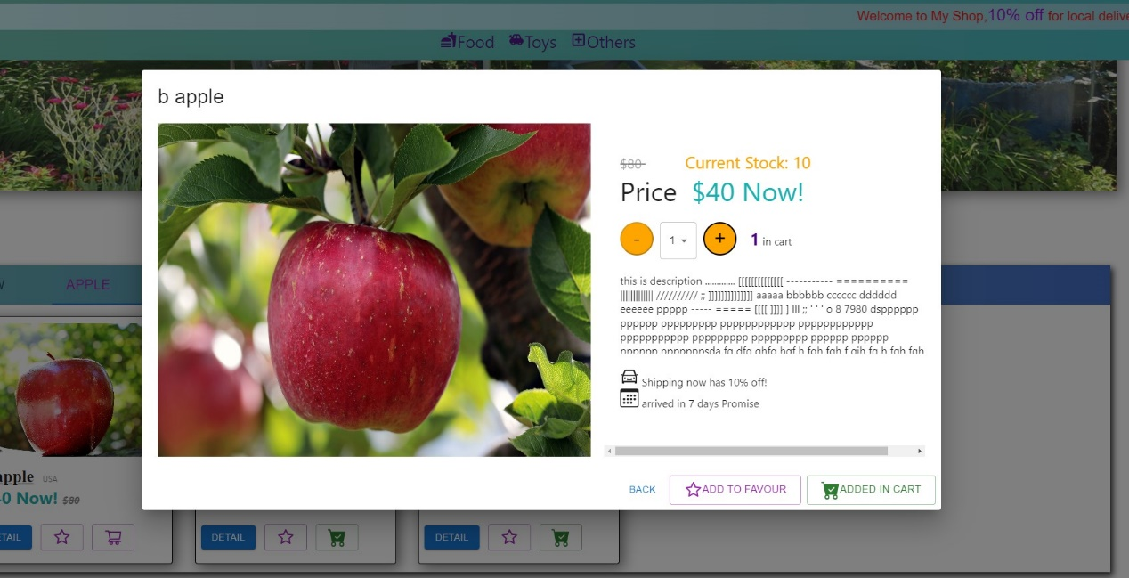

In case inventory less than 3, a red message “only x left” is displayed

Note that only image for apples is prepared, others should display not found message, and the description is not gibberish instead it just some random typing.

1. Both main and product pages should include a hierarchical navigation menu

For navigation part, you may perform it by clicking on the header as the header is stick at all the page.

Or in sub Navigation page, link is provided

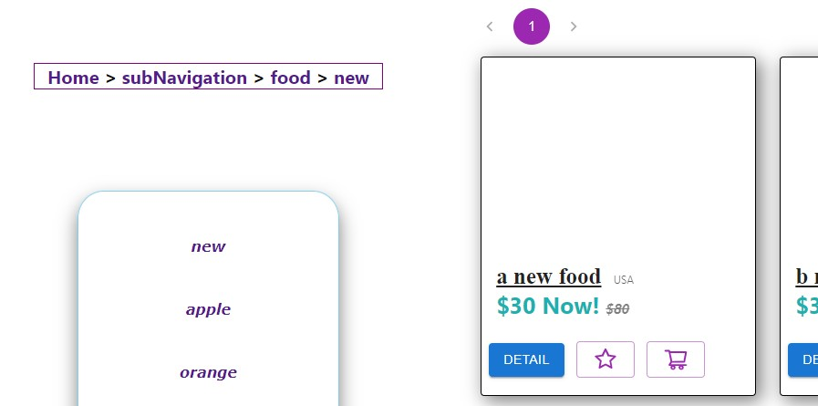

**@Extra note**

1.You may also view the code in <https://github.com/joeng0001/e-commerce>

2.All the images are free and open to use

3.you may see some warning in terminal, that is only warning by ‘eslint’ to remind me proper styling the code, i.e., imported something but didn’t used. It’s harmless and no effect that you may ignore it.