MY DOCKER ASSIGNMENT
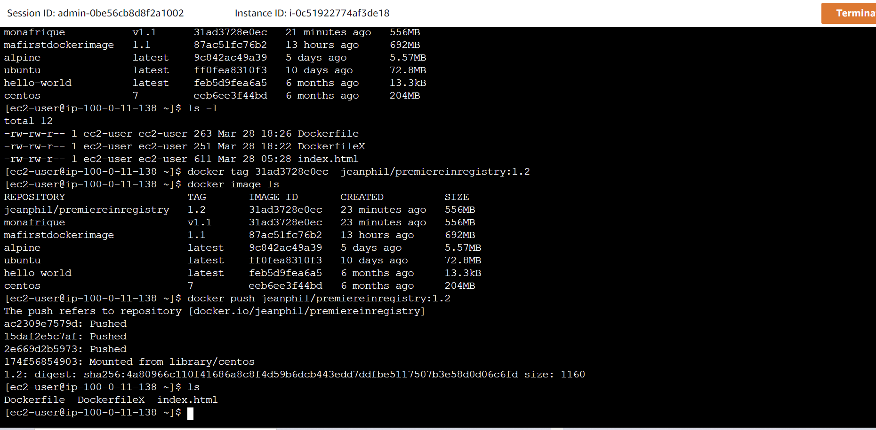
My images
We do either docker image ls or docker images
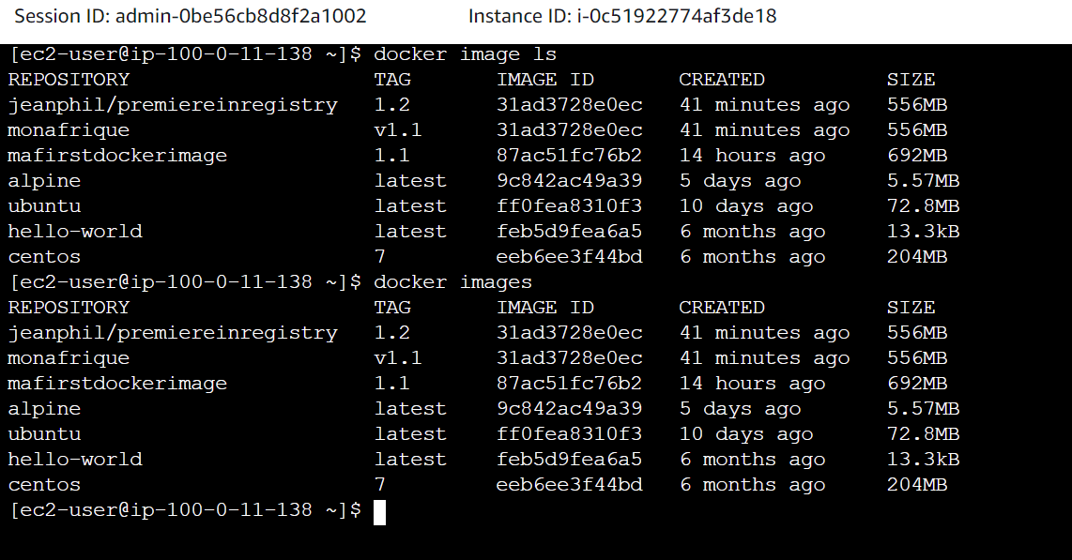
Let’s see my containers
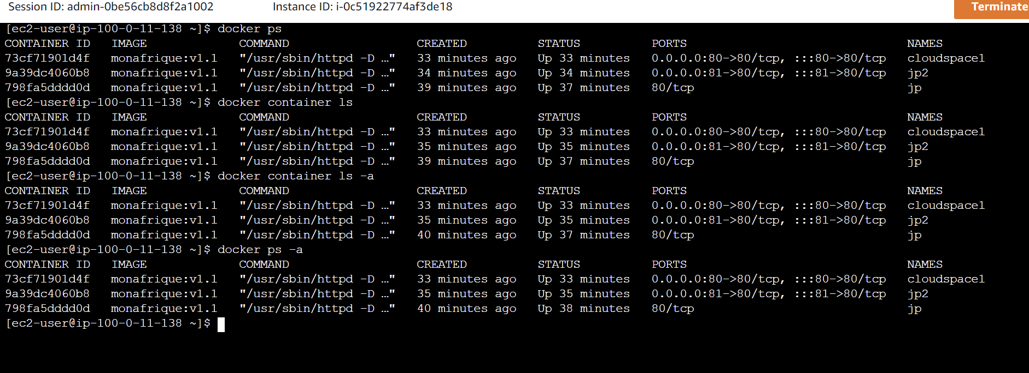
This is the my image pushed in the Docker Registry in my Docker hub account
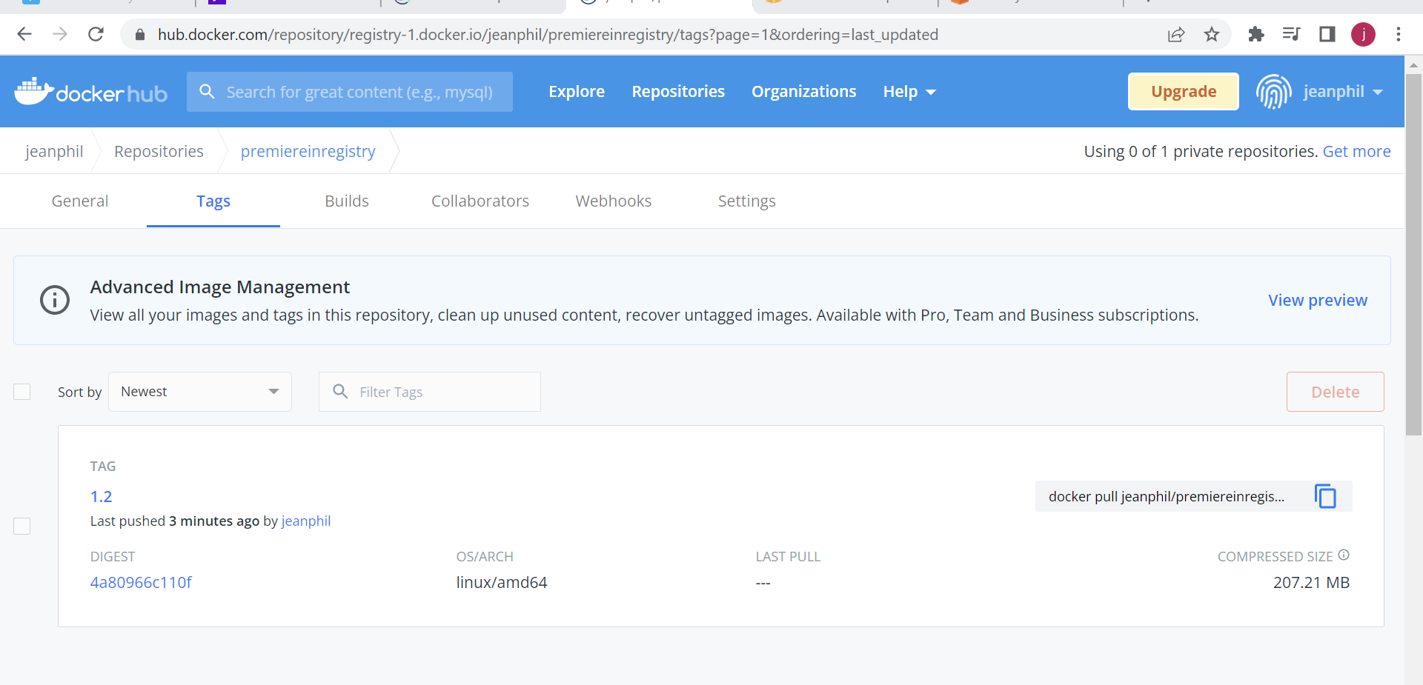
Other

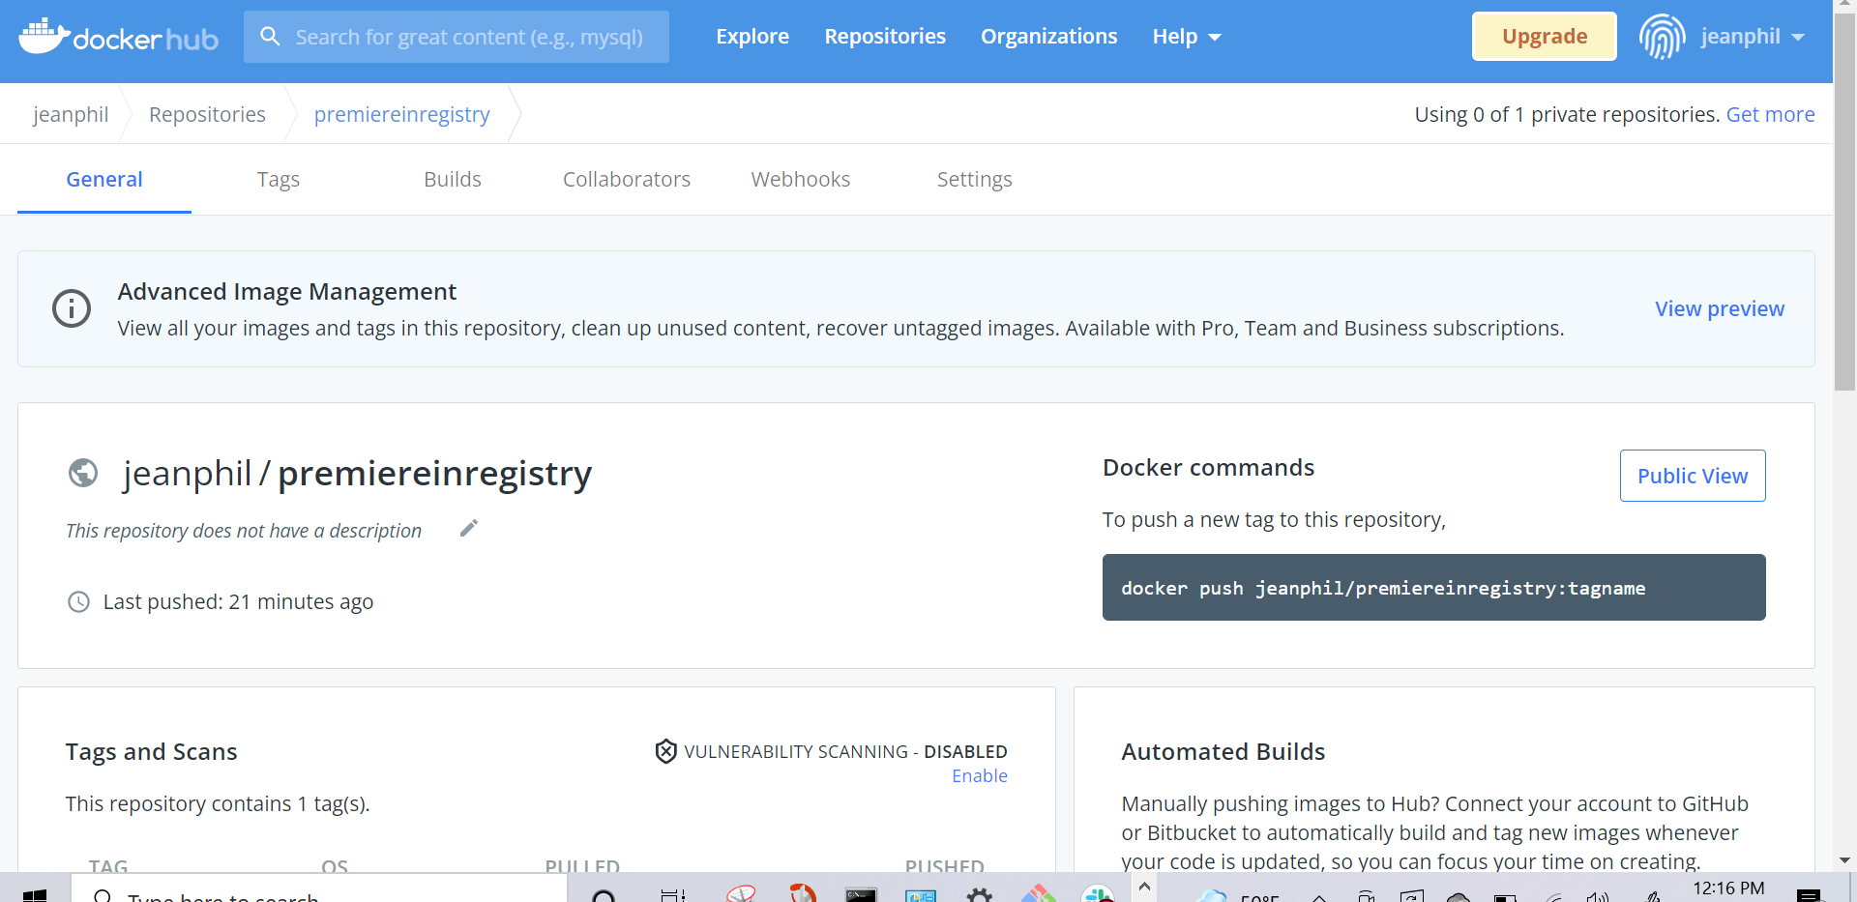
Other
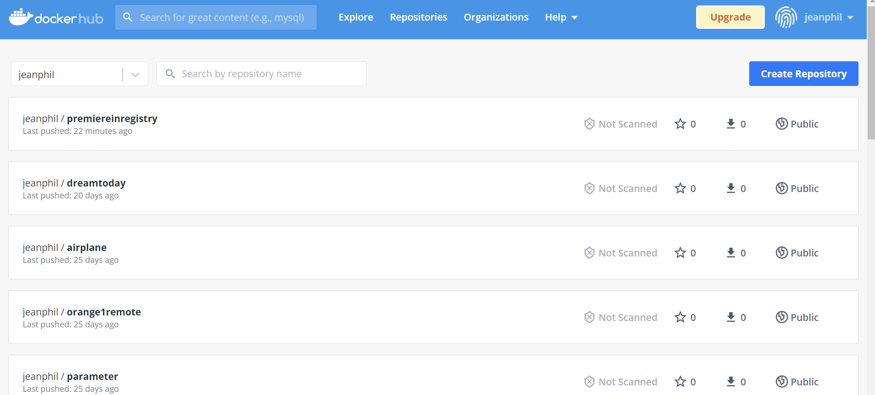

THIS the PULL of my image from another partner
The pull cmd from Docker Hub is --- docker pull jeanphil/premiereinregistry:1.2

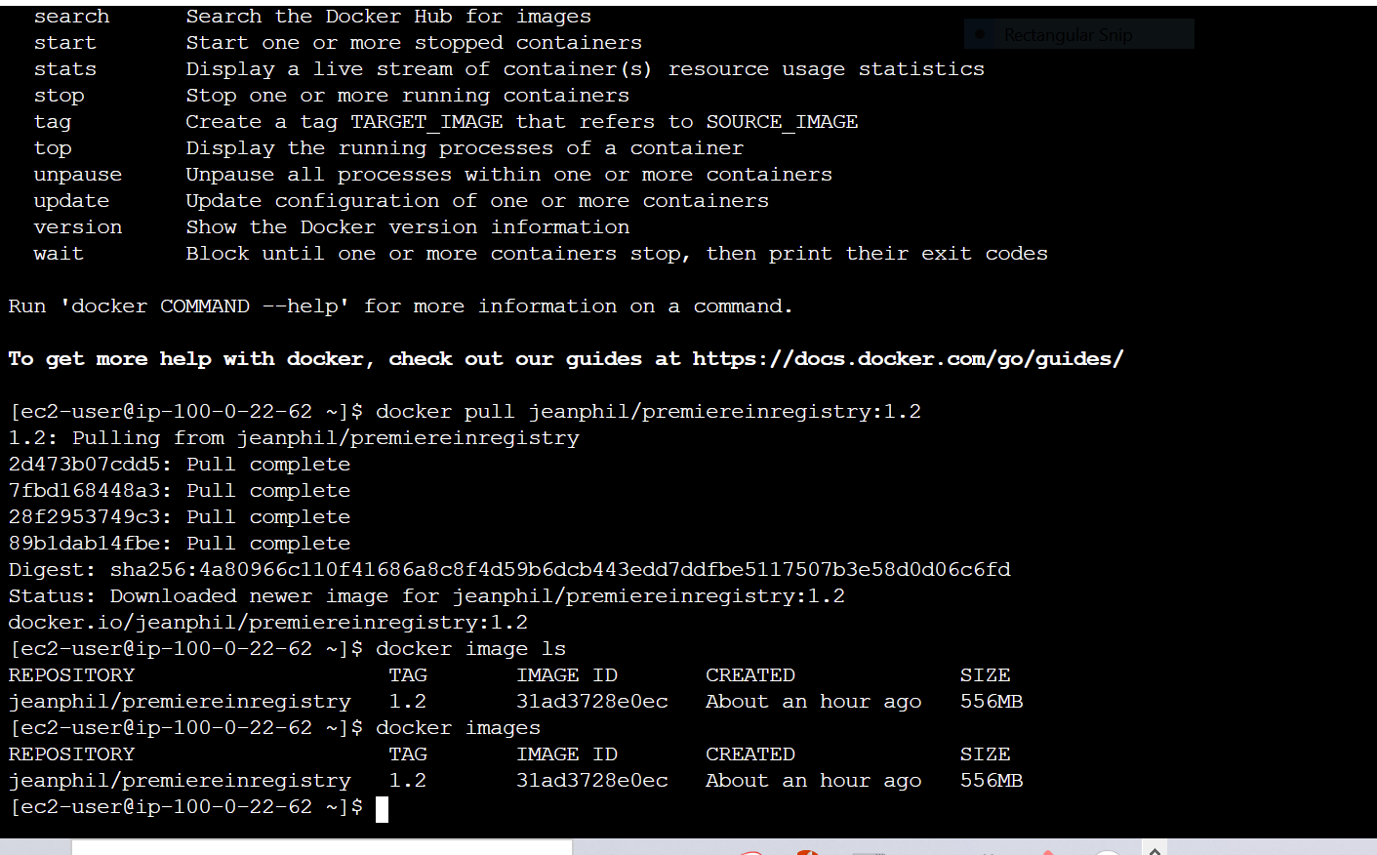
Lastly this is our website that we get whenever we browse the HOST IP on port 80 for http traffic

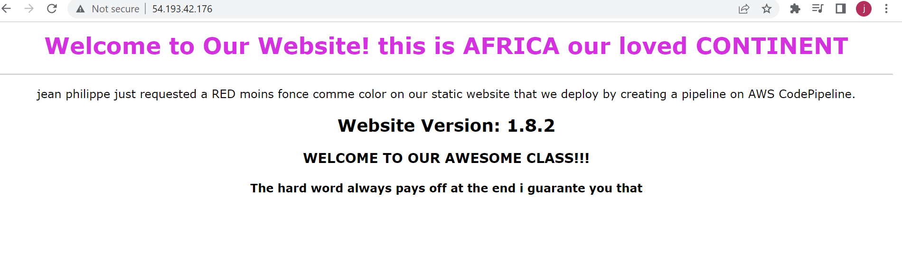
THANK YOU SO MUCH CLAUDIO, NARCISSE AND IDRISS THE GREAT JOB THAT WE ARE DOING.

