Joseph Prado

10 March 2020

## IT FDN 100 B

Assignment 06

**Modifying a program to increase the use of functions.**

# Introduction

In this assignment, I will do several things.

1. Modify a script to use functions as directed by the TODO lines provided by the instructor in the script.
2. Add docstrings to additional functions that I create in the program.
3. Verify the script functions in Spyder and in the Terminal.
4. Upload my script and knowledge document into GitHub.

# Reviewing and modifying the script

**To accomplish this assignment, I will start by going to the main (while) loop in the second half of the sample code, and determine locations where the TODO says I should move the code into a function.**

**We first run into a TODO at Section 3.3.1 in the sample code. This code requests user input for a new CD to be added to the inventory.**

**Since per the annotation, this code “asks user for new ID, CD Title and Aritst”, I’ll move these lines of code to a function I’ll create under class “IO”. Classes give us a way to group functions with common charateristics together.**[1] **Under IO, we’re grouping functions that are responsible for the collection and return of data together. Before the function, I place the word @staticmethod above it for reasons we are not required to understand right now.**[2]

1. @staticmethod
2. **def** input_new_cd():

**I make no changes to how the code request input from the user, except that I change the name of the variables to make it clear that they are local and limited to the scope of the function. By doing this, I create local variables that cannot be accessed by any other function or code outside of this scope.**[3]

1. cdID = input('Enter ID: ').strip()
2. title = input('What is the CD\'s title? ').strip()
3. artist = input('What is the Artist\'s name? ').strip()

**I then need to return this code to the main while loop. I can only return multiple return values as a collection**[4]**, so I group them together separated by commas, creating a tuple.**

1. **return** cdID, title, artist

**Then once I am back in the while loop at 3.3.1, I need to call this function and unpack this tuple into the three variables I need to work with, as demonstrated by the instructor.**[5] **I do this with the following line of code**

        strID, strTitle, strArtist = input_new_cd()

**OK, I’m getting an error in the code: “Undefined name”. Aha, I need to mention the class that the function is grouped under. Since this is part of the class IO, I need to invoke it using dot notation.** [6]

        strID, strTitle, strArtist = IO.input_new_cd()

**Now, let’s work on the moving the next bit of code in 3.3.2 into a function.**

**This is processing code, so I will move it under the Class DataProcessor. I’ll create the function add_cd**

1. @staticmethod
2. **def** add_cd():

**I initially move the code with no modifications under the function I created. A second, thought…one of the lines of code calls the function IO.show_inventory(lstTbl). Probably not good to have a function call another function. I’m going to pull that out and put it back in the main while Loop.**

**Now, I need to modify the function so that it will accept the return values from the previous function that I worked that I unpacked into variables. To do that, let’s create positional parameters**[7] **for this function.**

1. **﻿**     **def** add_cd(cdID, title, artist, row, table):

**I’ll also need to make sure the I change the name of the variables in the function to ones that match the parameters:**

1. intID = int(cdID)
2. row = {'ID': intID, 'Title': title, 'Artist': artist}
3. table.append(row)

**Now, we need to go back to the while loop at 3.3.2 and reference this function. ﻿**

        DataProcessor.add_cd(strID, strTitle, strArtist, dicRow, lstTbl)

**In this line of code, the arguments come from the return values of the previous function that I unpacked, and the list and dictionary (lstTbl and dicRow) defined at the beginning at the beginning of the program.**

**The next TODO is at 3.5.2, where we will move the processing code to delete a CD from the table to the top of the program as a function under the class DataProcessor.**

**I will name the function the delete_cd**

1. @staticmethod
2. **def** delete_cd()

**I will need to provide the function the ID for the CD that the user would like to delete, so we’ll give the function parameters.**

1. **def** delete_cd(selectID, table):

**The rest of the code I will modify to match the parameters I selected to use.**

1. intRowNr = -1
2. blnCDRemoved = False
3. **for** row **in** table:
4. intRowNr += 1
5. **if** row['ID'] == selectID:
6. **del** table[intRowNr]
7. blnCDRemoved = True
8. **break**
9. **if** blnCDRemoved:
10. **print**('The CD was removed')
11. **else**:
12. **print**('Could not find this CD!')

**Now, I need to go back to while loop at 3.5.2 and call the function, using the CD I that the user would like to delete as one of the arguments.**

        DataProcessor.delete_cd(intIDDel, lstTbl)

**The last bit of code with a TODO is at 3.6.2.1. Here we will move the processing code to save inventory to file as a function under the class FileProcessor. Here the function is predefined as write_file with parameters file_name and table.**

1. @staticmethod
2. **def** write_file(file_name, table):

**Matching the variables to the parameter names gives us the following:**

1. objFile = open(file_name, 'w')
2. **for** row **in** table:
3. lstValues = list(row.values())
4. lstValues[0] = str(lstValues[0])
5. objFile.write(','.join(lstValues) + '\n')
6. objFile.close()

# Adding docstrings

For each of the functions, I created, I will describe it using a docstring. The docstring is a triple quoted string that [describes what the code does](https://www.datacamp.com/community/tutorials/docstrings-python).[8] The docstring can consist of single line as demonstrated in the textbook[9], or consist of multiple parts (such as Google format) with sections devoted to a more detailed description, the arguments that feed into the function, what the function returns, and raises.[10]

Following the example for the Google format provided by the instructor, I created docstrings for remaining functions.

# Running the script

Running the script in Spyder results in the following:

(see next page)

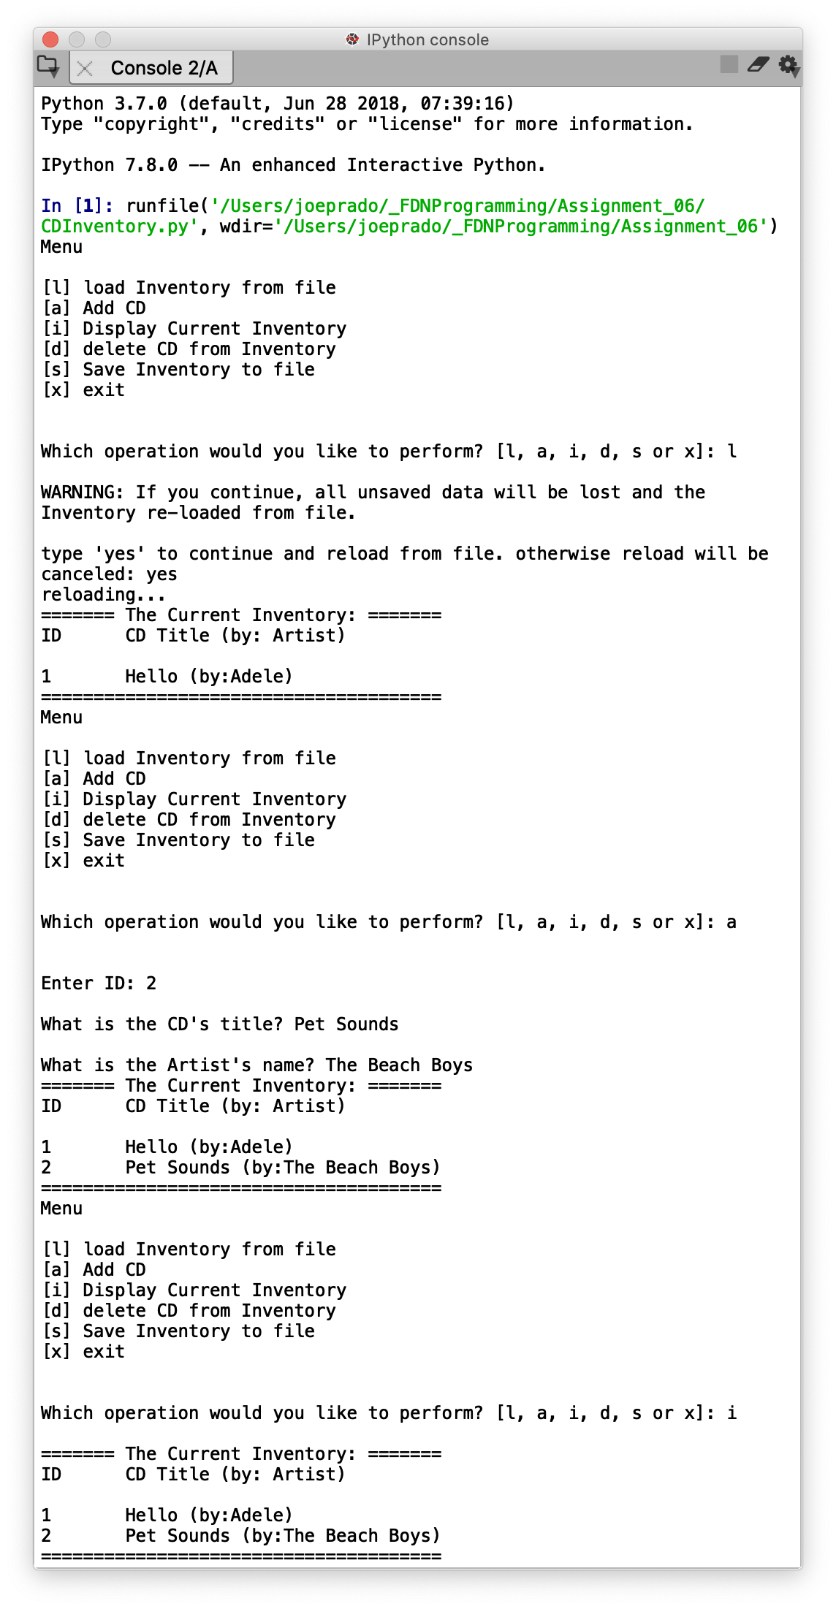 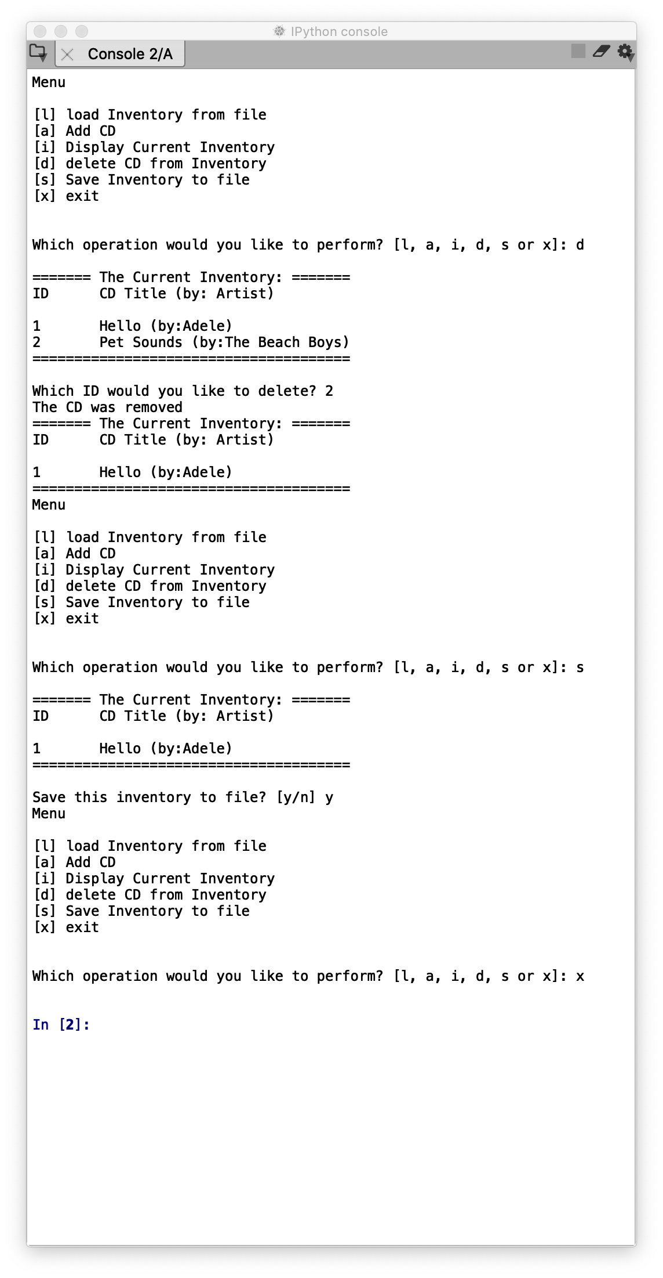

*Figure 1 – Output from Spyder*

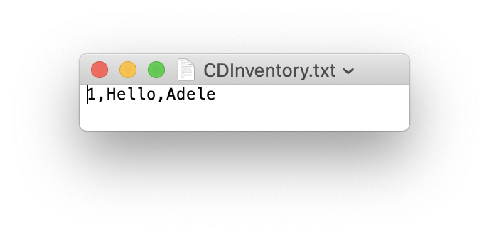

*Figure 2 – CDInventory.txt as written to by Spyder*

Running the script in the Terminal results in the following:

# 

# *Figure 2 – Output from Terminal*

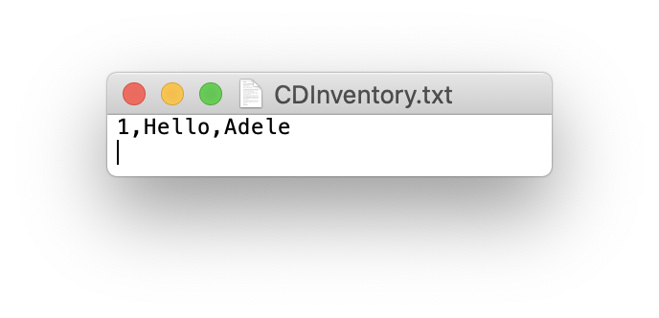

*Figure 3 – CDInventory.txt as written to by the Terminal.*

Link to GitHub

<https://github.com/joeprado/Assignment_06>

Summary

In this assignment, I took an existing script and:

1. Modified a script to add additional functions as directed by the TODO lines provided by the instructor in the script.
2. Added docstrings to the additional functions that I created in the script.
3. Verified the script functions in Spyder and in the Terminal.
4. Uploaded my script and knowledge document into GitHub.

# Appendix

## Listing CDInventory.py

1. #------------------------------------------#
2. # Title: CDInventory.py
3. # Desc: Working with classes and functions.
4. # Change Log: (Who, When, What)
5. # DBiesinger, 2030-Jan-01, Created File
6. # joeprado, 2020-Mar-09, Began modifying Script
7. # joeprado, 2020-Mar-10, Added docstrings.
8. # joeprado, 2020-Mar-10, Finished script modifications
9. #------------------------------------------#
11. # -- DATA -- #
12. strChoice = '' # User input
13. lstTbl = []  # list of lists to hold data
14. dicRow = {}  # list of data row
15. strFileName = 'CDInventory.txt'  # data storage file
16. objFile = None  # file object

19. # -- PROCESSING -- #
20. **class** DataProcessor:
21. @staticmethod
22. **def** add_cd(cdID, title, artist, row, table):
23. """Adding user data for new CD to a table.
25. Takes user input fed into the function via parameters,formats it as a set key:value pairs in a
26. dictionary, and then appends that dictionary as row nested inside a list.
28. Args:
29. cdID (string): ID number of CD as entered by the user
30. title (string): Title of CD as entered by the user
31. artist (string): Artist name for the CD as entered by the user
32. row (dictionary): empty data row in the form of dictionary
33. table (list of dict): list of dictionaries that holds our data in volatile memory
35. Returns:
36. None.
37. """
38. intID = int(cdID)
39. row = {'ID': intID, 'Title': title, 'Artist': artist}
40. table.append(row)
42. @staticmethod
43. **def** delete_cd(selectID, table):
44. """Delete a CD selected by user based on ID.
46. Takes user input for the ID number of a CD the user would like to delete, searches for the row (dictionary) the ID is in,
47. then deletes that row (dictionary) in the table (list).
49. Args:
50. selectID (integer): user selection for CD ID number the user would like to delete.
51. table (list of dict): list of dictionaries that holds our data in volatile memory
53. Returns:
54. None.
55. """
56. intRowNr = -1
57. blnCDRemoved = False
58. **for** row **in** table:
59. intRowNr += 1
60. **if** row['ID'] == selectID:
61. **del** table[intRowNr]
62. blnCDRemoved = True
63. **break**
64. **if** blnCDRemoved:
65. **print**('The CD was removed')
66. **else**:
67. **print**('Could not find this CD!')

70. **class** FileProcessor:
71. """Processing the data to and from text file"""
73. @staticmethod
74. **def** read_file(file_name, table):
75. """Function to manage data ingestion from file to a list of dictionaries.
77. Reads the data from file identified by file_name into a 2D table
78. (list of dicts) table one line in the file represents one dictionary row in table.
80. Args:
81. file_name (string): name of file used to read the data from
82. table (list of dict): 2D data structure (list of dicts) that holds the data during runtime
84. Returns:
85. None.
86. """
87. table.clear()  # this clears existing data and allows to load data from file
88. objFile = open(file_name, 'r')
89. **for** line **in** objFile:
90. data = line.strip().split(',')
91. dicRow = {'ID': int(data[0]), 'Title': data[1], 'Artist': data[2]}
92. table.append(dicRow)
93. objFile.close()
95. @staticmethod
96. **def** write_file(file_name, table):
97. """Function to save the contents of CD Inventory in volatile memory into a text file.
99. Takes the list of dictionaries identified by table and saves it into text file
100. identified by file_name.

103. Args:
104. file_name (string): name of file used to save data to.
105. table (list of dict): 2D data structure (list of dicts) that holds the data during runtime
107. Returns:
108. None
109. """
110. objFile = open(file_name, 'w')
111. **for** row **in** table:
112. lstValues = list(row.values())
113. lstValues[0] = str(lstValues[0])
114. objFile.write(','.join(lstValues) + '\n')
115. objFile.close()

118. # -- PRESENTATION (Input/Output) -- #
120. **class** IO:
121. """Handling Input / Output"""
123. @staticmethod
124. **def** print_menu():
125. """Displays a menu of choices to the user
127. Args:
128. None.
130. Returns:
131. None.
132. """
134. **print**('Menu\n\n[l] load Inventory from file\n[a] Add CD\n[i] Display Current Inventory')
135. **print**('[d] delete CD from Inventory\n[s] Save Inventory to file\n[x] exit\n')
137. @staticmethod
138. **def** menu_choice():
139. """Gets user input for menu selection
141. Args:
142. None.
144. Returns:
145. choice (string): a lower case sting of the users input out of the choices l, a, i, d, s or x
147. """
148. choice = ' '
149. **while** choice **not** **in** ['l', 'a', 'i', 'd', 's', 'x']:
150. choice = input('Which operation would you like to perform? [l, a, i, d, s or x]: ').lower().strip()
151. **print**()  # Add extra space for layout
152. **return** choice
154. @staticmethod
155. **def** show_inventory(table):
156. """Displays current inventory table

159. Args:
160. table (list of dict): 2D data structure (list of dicts) that holds the data during runtime.
162. Returns:
163. None.
164. """
165. **print**('======= The Current Inventory: =======')
166. **print**('ID\tCD Title (by: Artist)\n')
167. **for** row **in** table:
168. **print**('{}\t{} (by:{})'.format(*row.values()))
169. **print**('======================================')
171. @staticmethod
172. **def** input_new_cd():
173. """Function that collects user input for a new CD to be added to inventory.
175. Args:
176. None.
178. Returns:
179. cdID (string): string representing ID number user entered for CD
180. title (string): string representing CD title entered by user
181. artist (string): string representing artist name entered by user
182. """
183. cdID = input('Enter ID: ').strip()
184. title = input('What is the CD\'s title? ').strip()
185. artist = input('What is the Artist\'s name? ').strip()
186. **return** cdID, title, artist

189. # 1. When program starts, calls function that reads in the currently saved Inventory
190. FileProcessor.read_file(strFileName, lstTbl)
192. # 2. start main loop
193. **while** True:
194. # 2.1 Display Menu to user and get choice
195. IO.print_menu()
196. strChoice = IO.menu_choice()
198. # 3. Process menu selection
199. # 3.1 process exit first
200. **if** strChoice == 'x':
201. **break**
202. # 3.2 process load inventory
203. **if** strChoice == 'l':
204. **print**('WARNING: If you continue, all unsaved data will be lost and the Inventory re-loaded from file.')
205. strYesNo = input('type \'yes\' to continue and reload from file. otherwise reload will be canceled: ')
206. **if** strYesNo.lower() == 'yes':
207. **print**('reloading...')
208. FileProcessor.read_file(strFileName, lstTbl) #Calls function that loads text file containing CD inventory into runtime.
209. IO.show_inventory(lstTbl) #Calls function that displays inventory to user
210. **else**:
211. input('canceling... Inventory data NOT reloaded. Press [ENTER] to continue to the menu.')
212. IO.show_inventory(lstTbl) #Calls function that displays inventory to user
213. **continue**  # start loop back at top.
214. # 3.3 process add a CD
215. **elif** strChoice == 'a':
216. # 3.3.1 Calls function that asks user for new ID, CD Title and Artist
217. strID, strTitle, strArtist = IO.input_new_cd()
218. # 3.3.2 Calls the function that adds item to the table
219. DataProcessor.add_cd(strID, strTitle, strArtist, dicRow, lstTbl)
220. #Calls function that displays inventory with added CD
221. IO.show_inventory(lstTbl)
222. **continue**  # start loop back at top.
223. # 3.4 process display current inventory
224. **elif** strChoice == 'i':
225. IO.show_inventory(lstTbl) # Calls function that displays current inventory
226. **continue**  # start loop back at top.
227. # 3.5 process delete a CD
228. **elif** strChoice == 'd':
229. # 3.5.1 get Userinput for which CD to delete
230. # 3.5.1.1 Calls function that displays inventory to user
231. IO.show_inventory(lstTbl)
232. # 3.5.1.2 ask user which ID to remove
233. intIDDel = int(input('Which ID would you like to delete? ').strip())
234. # 3.5.2 Calls function that searches thru table and deletes CD
235. DataProcessor.delete_cd(intIDDel, lstTbl)
236. IO.show_inventory(lstTbl) #Calls function that displays inventory to user
237. **continue**  # start loop back at top.
238. # 3.6 process save inventory to file
239. **elif** strChoice == 's':
240. # 3.6.1 Calls function that displays current inventory.
241. IO.show_inventory(lstTbl)
242. strYesNo = input('Save this inventory to file? [y/n] ').strip().lower() #asks user for confirmation to save
243. # 3.6.2 Process choice
244. **if** strYesNo == 'y':
245. # 3.6.2.1 Calls function that saves data
246. FileProcessor.write_file(strFileName, lstTbl)
247. **else**:
248. input('The inventory was NOT saved to file. Press [ENTER] to return to the menu.')
249. **continue**  # start loop back at top.
250. # 3.7 catch-all should not be possible, as user choice gets vetted in IO, but to be save:
251. **else**:
252. **print**('General Error')

1. Module 06, Page 21
2. Module 06, Page 21
3. Page 172, Python Programming for the absolute beginner, Third Edition.
4. Module 06, Page 06
5. Module 06, Page 07
6. Page 222, Python Programming for the absolute beginner, Third Edition.
7. Page 168, Python Programming for the absolute beginner, Third Edition.
8. Accessed 10 March 2020
9. Page 161, Python Programming for the absolute beginner, Third Edition.
10. Module 06, Page 19