
kpmg.com
KPMG. Make the Difference.
May 2026
AI Driven Accrual Matching
A unified approach to proactively identify accrual candidates, improve period-end close accuracy, and reduce financial misstatement risk.

Contents
1. Document control 3
1.1 Change record 3
1.2 Reviewers 3
1.3 Approvals 3
2. Solution overview 4
2.1 Key Features & Solution Highlights 5
3. Target operating model 6
3.1 Use case impacts on the design layer of the TOM 6
3.2 TOM layer details: AI Driven Accrual Matching 6
3.3 KPMG leading practices and design decisions – Details 7
4. Implementation and SAP best practice 8
4.1 Configuration and SAP best practice 8
5. Demo script 9
5.1 Demo script overview 9
5.2 Approach 9
5.3 Demo steps 9
6. Deployment approach 10
7. Further information 11
7.1 Future development roadmap 11
7.2 Primary enhancements 11
7.3 Operational efficiency enhancements 11
Contact us 12

The information contained herein is of a general nature and is not intended to address the circumstances of any particular individual or entity. Although we endeavor to provide accurate and timely information, there can be no guarantee that such information is accurate as of the date it is received or that it will continue to be accurate in the future. No one should act on such information without appropriate professional advice after a thorough examination of the particular situation.

Document control

Change record
Version | Author | Date | Revision
1.0 | Martin Seo | May 27, 2026 | Initial version

Reviewers
This document has been reviewed by:
 | Reviewer | Date reviewed
<Sr.No.> | <Reviewer Name> | < Review Date>
<Sr.No.> | <Reviewer Name> | < Review Date>
<Sr.No.> | <Reviewer Name> | < Review Date>
<Sr.No.> | <Reviewer Name> | < Review Date>

Approvals
This document has been approved by:
 | Name | Signature | Date approved
<Sr.No.> | <Approver Name> | <Approver’s Signature> | <Approval Date>
<Sr.No.> | <Approver Name> | <Approver’s Signature> | <Approval Date>
<Sr.No.> | <Approver Name> | <Approver’s Signature> | <Approval Date>
<Sr.No.> | <Approver Name> | <Approver’s Signature> | <Approval Date>

Solution overview
The AI Driven Accrual Matching solution is designed to transform the period-end close from a reactive, judgment-based process into a proactive, intelligence-driven capability. The core challenge it addresses is the lack of real-time visibility into accrual exposure, which leads to financial misstatement risk and manual effort at month-end.
The solution delivers unified Accrual Intelligence on a cohesive SAP Business Data Cloud (BDC) landscape, moving organizations from siloed, spreadsheet-driven accrual reviews to a centralized, real-time worklist of accrual candidates ranked by ML confidence score and financial exposure across five company codes.
Predictive Accrual Identification is a core capability, utilizing a trained XGBoost classifier (F1 = 0.93) to surface accrual candidates from GR/IR gaps, GL history, and vendor delay signals before the month-end close. This enables finance teams to shift from reactive journal entry reviews to proactive exception management.
By empowering finance teams with a ranked accrual worklist and automated root-cause narratives, the solution fundamentally shifts the close process from manual identification to strategic, data-driven accrual management across $12.75M in tracked GR/IR exposure.
Lower
Close Accuracy
Increased Efficiency
Enhanced Visibility
The solution is designed to improve period-end close accuracy and reduce financial misstatement risk.
ML-ranked accrual worklists increase team efficiency by focusing effort on high-exposure items and automating root-cause analysis narratives per accrual candidate.
The solution provides a single source of truth for GR/IR exposure across all company codes and enhances CFO oversight of period-end accrual risk.

Key Features & Solution Highlights
The AI Driven Accrual Matching architecture is designed to fundamentally optimize the Record-to-Report close cycle through a medallion intelligence approach (Bronze→Silver→Gold) built natively on SAP Business Data Cloud.
94%
- Machine Learning Payment Forecasting: The system applies ML pattern recognition across GL history, GR/IR gaps, and vendor delay signals to surface likely accrual candidates before month-end, using an XGBoost classifier with 94.2% precision and 91.7% recall.
- Prioritized Accrual Worklist: Rather than relying on static aging buckets, the solution automatically generates daily, dynamically prioritized task lists for collection agents based on the highest calculated risk of default.
- Automated Root-Cause Narratives: Built within SAP Analytics Cloud, the interface allows users to perform interactive drill-downs—moving from aggregate regional KPIs to specific customer behaviors and disputed document types in seconds.
of CFOs and CIOs report increased collaboration due to AI, their responsibilities often remain separate.
The AI Driven Accrual Matching solution acts as a vital orchestration layer that bridges this gap. By delivering a shared, real-time accrual intelligence layer built on BDC, it enables CFOs and Financial Controllers to make close decisions with the same granular GR/IR and invoice data their accounting teams use daily.
- Conversational Accrual Queries (Joule): The integration of AI assistants empowers business users to interact with their data conversationally. Users can ask questions like "Show me top overdue customers in EMEA" and receive instant, auto-generated charts.
- Quantifiable Business Impact: When fully deployed, these integrated features drive significant operational improvements, including a significant reduction in manual analytical effort and a measurable improvement in overall Days Sales Outstanding (DSO).

- Operational Efficiency: Automating these insights minimizes manual analysis time, drastically reducing reliance on IT for ad-hoc reporting.
The AI Driven Accrual Matching solution empowers finance teams with the forward-looking insights needed to anticipate accrual exposure, accelerate the period-end close, and drive meaningful improvements to close accuracy and audit readiness.

Target operating model
The KPMG Target Operating Model (TOM) is a holistic framework that defines how an organization operates and delivers value. It shapes business transformation across every layer of the enterprise, providing a proven, future-ready solution set built on KPMG’s functional and industry-leading practices. Comprising six distinct design layers, the TOM ensures that strategic changes are seamlessly codified and implemented across the entire organization.
Velocity works hand-in-hand with the Target Operating Model (TOM) to translate strategic design into execution. By combining global TOM designs and tailored value stream blueprints - spanning various industries, sectors, and technologies - with Velocity’s pre-configured journeys, enablers, and automation, organizations can significantly accelerate their transformation. This integration ensures that strategic design and technical delivery remain seamlessly connected, presenting users with the exact TOM enablers required for their specific platform, sector, or functional journey.

Use case impacts on the design layer of the TOM
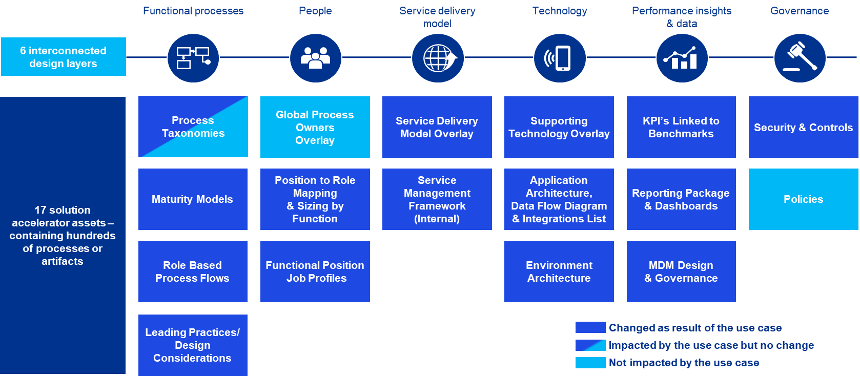

TOM layer details: AI Driven Accrual Matching
The AI Driven Accrual Matching solution is structured through the Target Operating Model (TOM) framework. It outlines six distinct operating model layers — Functional Processes, People, Service Delivery, Technology, Performance Insights, and Governance — and describes the specific capabilities the solution delivers within each layer. The overarching theme is a fundamental shift from reactive period-end close to proactive, automated accrual management.
The solution empowers distinct user groups. For the People layer, it provides CFOs and Financial Controllers with strategic accrual exposure oversight and Accounting Managers with a detailed, ML-prioritized accrual worklist, reducing their dependency on IT for standard reporting and ad-hoc queries. This model ensures all stakeholders work from the same real-time accrual data across all five company codes.reducing their dependency on IT for standard reporting and ad-hoc queries. This model ensures that actionable intelligence is readily available to those who need it.
The Technology layer is built on a unified cloud architecture using the SAP Business Data Cloud. This ecosystem leverages SAP Datasphere for data integration and a governed semantic layer, SAP Databricks for developing and hosting the machine learning models, and SAP Analytics Cloud as the interactive front-end for dashboards and analytics. This robust architecture provides a single source of truth for all AR data, delivering real-time KPIs, predictive insights, and operational data with drill-down capabilities. Finally, the Governance layer is embedded via the SAP Datasphere semantic layer, which guarantees consistent data definitions, standardized KPIs, and trusted, reusable analytics across the enterprise.

KPMG leading practices and design decisions – Details
The leading practices are centered on transforming accrual management from a reactive, spreadsheet-driven process into a proactive, predictive capability. This involves shifting from period-end manual reviews to continuous, real-time accrual intelligence by leveraging the full power of SAP Business Data Cloud, with a clean separation between SAP Datasphere (governed semantic layer) and SAP Databricks (XGBoost ML execution) via zero-copy Delta Share.
The specific design considerations detail how these leading practices are implemented. The process is built around ML-Prioritized Workflows, where collection activities are designed around a dynamic worklist prioritized by ML-driven risk scores from SAP Databricks, fundamentally shifting the focus from static aging to predictive risk. It also incorporates natural language queries like "Just Ask" and "Smart Insights" through Joule on SAC stories. Technologically, the architecture is built on a suite of SAP products: pulling AR data directly from S/4HANA Data Products, using SAP Datasphere to build a centralized and governed semantic layer, leveraging SAP Databricks to develop ML models with secure, zero-copy Delta Sharing, and using SAP Analytics Cloud as a live-connected, interactive front-end.
Ultimately, these design choices result in significant benefits. They create a Scalable Architecture with a clean separation between data warehousing and advanced analytics, ensuring the solution can grow with the business. They enforce Strong Governance by creating a single version of the truth through the semantic layer, which guarantees data consistency and reliability. Finally, the solution delivers Real-Time Insights, providing immediate, decision-ready data through live connections, which empowers the organization to act with speed and confidence.

Transitioning to technical execution
To successfully operationalize these Target Operating Model layers, a structured configuration approach must be followed. The following section outlines the critical configuration activities and SAP best practices required to transition these theoretical TOM layers into functional technical realities.

Implementation and SAP best practice

Configuration and SAP best practice
AI Driven Accrual Matching configuration activities:
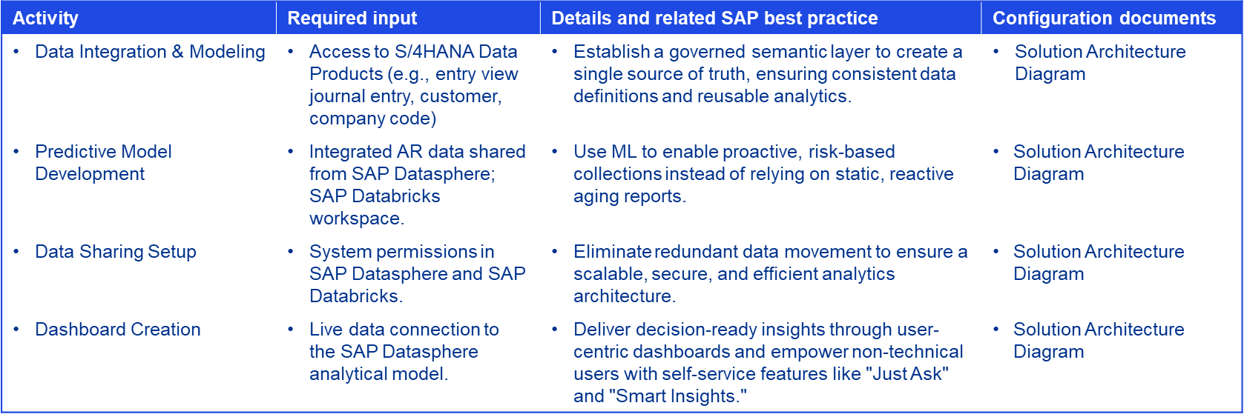

Demo script
This demonstration is structured as a “Day-in-the-Life” journey. It begins with the CFO reviewing high-level accrual exposure and drills down to the Accounting Manager taking action on specific GR/IR gaps — all within a single, unified SAC environment powered by BDC.

Demo script overview
The AI Driven Accrual Matching demo illustrates the solution’s capacity to transition finance organizations from reactive, manual accrual identification to a proactive, ML-driven close model. The script is tailored for two primary personas: the CFO/Financial Controller (high-level exposure oversight) and the Accounting Manager (detailed GR/IR investigation).
To ensure a seamless presentation, several technical prerequisites must be met: the SAP Datasphere model must be refreshed, the SAP Databricks ML models must be run to generate current predictions, and the SAP Analytics Cloud (SAC) environment must be opened to the main dashboard.

Approach
The demo employs a “top-down” narrative, starting with an executive-level accrual exposure view and drilling down into GR/IR gaps and vendor-level details. Each step highlights a specific capability, from high-level KPI analysis to individual purchase order action.

Demo steps
The demonstration workflow is conducted through four sequential phases:
- Phase 1: Dashboard KPI Review. The session begins with an examination of critical accrual metrics (Total Accrual Exposure $12.75M, 87 open items, variance distribution by type, and company code breakdown), establishing the business context and urgency for the solution.
- Phase 2: Overdue Balance Investigation. The presenter analyzes the drivers behind late payments, highlighting SAC’s ability to automatically identify and visualize the top contributing customers or document types without manual data manipulation.
- Phase 3: Self-Service Ad-hoc Analysis. The demo highlights user empowerment with the “Just Ask” natural language query tool, showing how users can input conversational questions to instantly generate visual insights and explore data.
- Phase 4: Proactive Collections Action. The focus shifts to operational execution by reviewing the ML-prioritized accrual worklist. This demonstrates how the XGBoost classifier translates confidence scores into actionable POST / REVIEW / OBSERVE decisions, enabling the Accounting Manager to process high-exposure items in minutes rather than hours.

Deployment approach
The implementation of the AI Driven Accrual Matching solution follows a rapid, structured hack-to-build deployment methodology. This framework ensures strict alignment between business objectives and technical execution while minimizing time-to-value. The delivery model is organized into three sequential phases, culminating in a 5-week Build Phase timeline.
Phase 1: Discover & Design
The initial phase is dedicated to establishing project alignment, gathering accrual business requirements, and designing the medallion data architecture (Bronze→Silver→Gold). This foundational work ensures all subsequent technical activities are grounded in validated finance team needs and SAP S/4HANA Data Product availability.
- Key Activities: The project commences with a formal use case Kick-Off, followed by detailed requirements gathering and solution design. During this period, the technical architecture is established, and specific KPIs and dashboard visualizations are defined in collaboration with key stakeholders.
- Milestones & Deliverables: Progression to the next phase is contingent upon the completion of key deliverables, including the project Kick-Off Deck, a formalized Technical Architecture document, and officially Signed-off Functional Specifications that serve as the blueprint for development.
Phase 2: Build & Test
The core technical development and system validation occur during this intensive phase.
- Key Activities: Technical teams execute system configuration across SAP Business Technology Platform (BTP) and SAP Databricks. This is followed by complex data integration and modeling, the development of the machine learning predictive models, and the iterative build of the SAP Analytics Cloud (SAC) dashboards. The phase concludes with rigorous User Acceptance Testing (UAT) to validate system accuracy and usability.
- Milestones & Deliverables: Critical milestones validating the success of this phase include the readiness of the BTP environment, successful data extraction to the Business Data Cloud (BDC), the delivery of the fully built dashboard, and a completed Test Plan accompanied by formal UAT sign-off.
Phase 3: Deploy & Support
The final phase focuses on organizational enablement, transitioning the accrual intelligence solution into the KPMG Velocity environment, and establishing a framework for ongoing support and continuous improvement.
- Key Activities: Activities are centered on conducting comprehensive end-user training sessions, finalizing go-live preparations, and providing dedicated "hypercare" support immediately following the launch to quickly address any operational issues.
- Milestones & Deliverables: The project is officially concluded upon the delivery of finalized Training Materials, the execution of the formal Go-Live Plan, and the acquisition of Final Sign-off from project sponsors, marking the transition to standard operational support.

Further information

Future development roadmap
The future development roadmap for the AI Driven Accrual Matching solution is focused on introducing new intelligence layers that further enhance accrual coverage, operational efficiency, and predictive accuracy. These planned enhancements are designed to expand the solution’s value and provide even deeper, more proactive insights for the finance organization.

Primary enhancements
A primary focus of future enhancements is on expanding predictive accrual coverage. This will be achieved by incorporating Credit Limit Breach Indicators to surface vendor risk signals, identifying High Write-Off scenarios based on historical GR/IR dispute patterns, and integrating external commodity price feeds to improve Price Variance root-cause detection.

Operational efficiency enhancements
To improve operational efficiency, an automated S/4HANA accrual postback feature is a key planned enhancement for approved POST-action items. Additional roadmap items include multi-currency exposure normalization, predictive close date estimation based on historical variance resolution patterns, and Unapplied Cash Monitoring for the Record-to-Report process.


Next Steps
Schedule a Discovery Workshop: Contact our team to schedule a 1-hour scoping session where we can map your specific accrual management challenges to the solution’s capabilities and define a clear path to deployment within your SAP BDC landscape.

Contact us

Martin Seo
Platforms - SAP
T: +1 (408) [210 4797]
E: martinseo@kpmg.com

Siva Vankayalapati
Finance & EPM
T: +1 (346) [387 2103]
E: sivavankayalapati@KPMG.com

Parag Shrivastava
Platforms - SAP
T: +1 (347) [491 9382]
E: paragshrivastava1@KPMG.com

Some or all of the services described herein may not be permissible for KPMG audit clients and their affiliates or related entities.
kpmg.com



The information contained herein is of a general nature and is not intended to address the circumstances of any particular individual or entity. Although we endeavor to provide accurate and timely information, there can be no guarantee that
such information is accurate as of the date it is received or that it will continue to be accurate in the future. No one should act on such information without appropriate professional advice after a thorough examination of the particular situation.
© 2026 Copyright owned by one or more of the KPMG International entities. KPMG International entities provide no services to clients. All rights reserved.
KPMG refers to the global organization or to one or more of the member firms of KPMG International Limited (“KPMG International”), each of which is a separate legal entity. KPMG International Limited is a private English company limited by
guarantee and does not provide services to clients. For more details about our structure please visit kpmg.com/governance.
The KPMG name and logo are trademarks used under license by the independent member firms of the KPMG global organization.
Throughout this document, “we”, “KPMG”, “us” and “our” refers to the KPMG global organization, to KPMG International Limited (“KPMG International”), and/or to one or more of the member firms of KPMG International, each of which is a
separate legal entity.
KPMG’s participation and contribution in this regard is not an endorsement, sponsorship or implied backing of any company’s products or services.

