# **Heating of a homogeneous volume**

**Geometry**: one single fully saturated hexahedron, 1 m edge, origin at 0,0,0 and developing towards positive axis.

**Coordinates of nodes/vertices**:

* Bottom face: (1,0,0); (1,1,0); (0,1,0); (0,0,0);
* Top face: (1,0,1); (1,1,1); (0,1,1); (0,0,1).

**To be solved:** liquid pressure, temperature, stress, deformation, displacement.

**Temporal discretization:** 0 ‒ 100 days; maximum time step allowed 0.5 days

**Initial conditions:** defined by volume

* Temperature = 20 oC
* Liquid pressure = 2 MPa
* Initial porosity = 0.1
* Isotropic initial stress: Sxx = Syy = Szz = -2 MPa; Sxy = Sxz = Syz = 0 MPa

**Boundary conditions:**

* **Mechanical:** 
  + Zero displacement ux at vertical planes x = 0 and x = 1;
  + Zero displacement uy at vertical planes y = 0 and y = 1;
  + Zero displacement uz at horizontal planes z = 0 and z = 1.
* **Thermal (*prescribed at the volume*):** linear temperature increment of 10 oC for 100 days (i.e., T(t=0d) = 20 oC and T(t=100d) = 30 oC).

**Thermomechanical elasticity:**

$∆ε_{v}=\frac{∆p^{'}}{K}+α_{vT}∆T$ (bulk); $∆ε_{sv}=c_{s}∆p+α_{svT}∆T=\frac{∆p}{K_{s}}+α_{svT}∆T$ (solid phase)

( $α_{svT}=3α_{sT}$ and $α_{vT}=3α_{T}$; compression negative)

**Parameters:**

* **Mechanical elasticity:**
  + Young’s modulus, E = 1000 MPa (constant, i.e., no variation with porosity);
  + Poisson’s ratio, ν = 0.35;
  + Bulk modulus, K = 1111.11 MPa (K = E/3(1-2ν), and rock compressibility = 9.0×10-4 MPa-1 (inverse of bulk modulus).
* **Hydraulic:**
  + Permeability, k = 3.5×10-20 m2 (isotropic, constant).
* **Thermo-mechanical:**
  + Thermal conductivity λsat = 1.2 W/mK (constant);
  + Axial or linear thermal expansion coefficient (not volumetric), αT = αVT/3 = 3.0×10-6 oC-1.
* **Solid phase properties:** 
  + Solid phase specific heat = 800 J/kgK (constant)
  + Solid phase density: $ρ_{s}=ρ_{s0}\exp{({‒c}_{s}dp{-α}_{svT}dT)}; ρ_{s0}$ = 2500 kg/m3;
  + Axial or linear thermal expansion coefficient for grains (not volumetric; this does not produce thermal expansion of the medium): = 3×10-6 oC-1;
  + Reference temperature for thermal expansion = 20 oC;
  + Compressibility of solid phase against mean stress changes, = 3.5×10-5 MPa-1;
  + Reference pressure for solid compressibility = 0.1 MPa.
* **Liquid phase properties:**
  + Density variation with pressure and temperature:
    - Exponential variation: ρL = ρL0exp(β(pL- pL0)+αT) ;
    - Reference density ρL0 = 1002.6 kg/m3;
    - Liquid compressibility β = 4.5×10-4 MPa-1;
    - Reference pressure pL0 = 0.1 MPa;
    - Volumetric thermal expansion coefficient for water α = -2.0×10-4 oC-1 (constant);
    - If the exponential law is not implemented in acode, then please use the same law used in the calculations of Task 1.
  + Dynamic viscosity:
    - Exponential variation μ = A exp(B/(273.15+T));
    - A = 2.1×10-12 MPa⋅s;
    - B = 1808.5 K;
    - If the exponential law is not implemented in acode, then please use the same law used in the calculations of Task 1.
* **Others:** gravity = 0 in all directions.

**Requested outputs: *following the template supplied by the TF (Template_SingleElement.xlsx; please indicate units at headers)*,** temporal evolution at point (0.5, 0.5, 0.5) of:

* temperature,
* liquid saturation,
* liquid pressure,
* liquid density,
* liquid viscosity,
* the three components of the conductive thermal flux,
* the three components of the dispersive thermal flux (if any),
* the three components of the advective flux of liquid phase,
* the three components of the displacement vector,
* the six components of the total stress tensor,
* the six components of the strain tensor.

**Deadline:**

* for amendments to specifications, latest December 21st, 2022.
* for simulations, latest January 9th, 2023.

# **1D axisymmetric problem**

**Geometry**: 1D along x-axis of the 3D model at the central section of one of the heaters (horizontal and perpendicular to the longitudinal axis of the FE tunnel). Dimensions: same as in the 3D model (see original specifications document). Thickness of the axisymmetric slice 1 m (Figure 1).

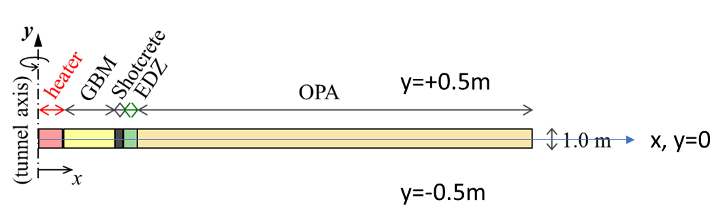

Figure . Geometry of the 1D axisymmetric problem (modified from UPC proposal).

The extent of the elements is xmax = 0.525 m (heater), xmax = 1.4 m (GBM), xmax = 1.6 m (shotcrete), xmax = 1.8 m (EDZ), xmax = 50 m (Opalinus clay),

**To be solved:** liquid pressure, gas pressure, temperature, stress, deformation, displacement.

**Temporal discretization and model phases:** as in the 3D model, including excavation and emplacement (depends on the model being solved; see below).

**Spatial discretization:** The table below displays the required discretization for each material (see file *Mesh_Axisymmetric.xlsx*).

|  |  |  |  |
| --- | --- | --- | --- |
| **Element** | **x** | **Number of elements (squares/rectangles)** | **dX (m)** |
| **Heater** | (0,0.525) | 10 | 0.0525 |
| **GBM** | (0.525,1.4) | 40 | 0.021875 |
| **Shotcrete** | (1.4,1.6) | 20 | 0.01 |
| **EDZ** | (1.6,1.8) | 20 | 0.01 |
| **OPA near field** | (1.8,5.0) | 50 | 0.1 |
| **OPA “mid” field** | (5,25) | 40 | 0.5 |
| **OPA far field** | (25,50) | 25 | 1 |

If a code cannot read an external mesh, the Modelling Team is requested to define the mesh in such a way that the control points stated below are nodes of the mesh.

**Control points:** Table 1 displays the required control points for each material. See also the Figure 2 displaying the suggested mesh and the control points.

Table . Location of control points.

|  |  |  |
| --- | --- | --- |
| **Element** | **x, (y = 0 m all)** | **Code (please use strict naming)** |
| **Heater** | 0.1575  0.42 | H1  H2 |
| **GBM** | 0.590625  0.9625  1.35625 | GBM1  GBM2  GBM3 |
| **Shotcrete** | 1.43  1.5  1.58 | SC1  SC2  SC3 |
| **EDZ** | 1.63  1.7  1.78 | EDZ1  EDZ2  EDZ3 |
| **OPA** | 1.83  2  5  20  30  40  50 | OPA1  OPA2  OPA3  OPA4  OPA5  OPA6  OPA7 |

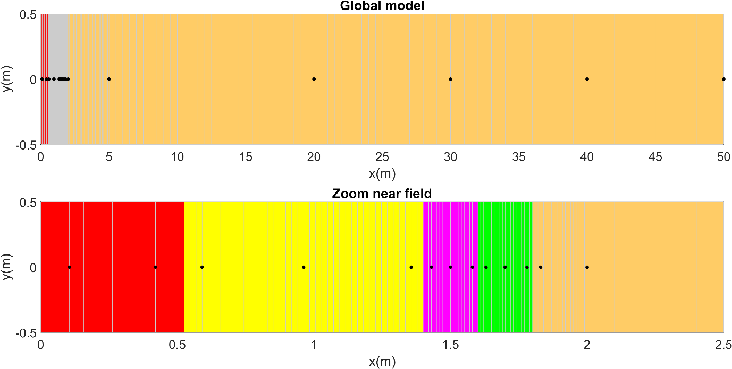

Figure 2. Schematic layout of the 1D axisymmetric model mesh discretization details with proposed control points.

**Initial conditions at t=-1000 d:**

* properties of all elements are those of Opalinus clay,
* initial temperature T(t=0d) =17 °C,
* initial liquid pressure pL (t=0d) =2 MPa,
* initial stress as in the latest version of the specifications document:
  + The maximum principal total stress S1 is vertical(along z axis), S1 = 6 MPa.
  + The intermediate principal total stress S2 is perpendicular to the axis of the FE tunnel, S2 = 4.5 MPa. Thus, S2 is oriented along the x axis.
  + The minimum principal total stress S3 is parallel to the y axis, S3 = 2.5 MPa.

**Initial conditions after emplacement of GBM and shotcrete:** please, refer to the specifications document.

**Boundary and initial conditions:** as in the 3D model, but using constant power of heater = 3×1350/23 = 176.1 W/m, where 1350 W is the power of each heater and 23 m is the length of the test section.

**Materials:** as in the 3D model (last set of specifications). Two cases depending on the entry pressure of the shotcrete are considered p0 = 1 MPa and p0 = 10 MPa. Anisotropy ignored. Isotropic values to be assigned are as follows:

* Young modulus OPA = 6000 MPa
* Poisson ratio OPA = 0.3
* Intrinsic permeability EDZ and OPA = 3⋅10-20 m2
* Thermalconductivity EDZ and OPA = 1.9 W/mK (both saturated and dry, i.e., constant)

**Model runs:**

1. Model_1_THM: assume that all materials but the heater are Opalinus Clay. Thus, excavation, ventilation and emplacement are not modelled and only the heating phase is simulated.
2. Model_2_THM: assume that there is no shotcrete and there is no EDZ, i.e., materials are Heater, GBM and OPA. Excavation, ventilation and emplacement are not modelled and only the heating phase is simulated.
3. Model_3-1_THM: assume that there is no EDZ, i.e., materials are Heater, GBM, shotcrete and OPA. Entry pressure of shotcrete is p0 = 1 MPa. Excavation, ventilation and emplacement are not modelled and only the heating phase is simulated.
4. Model_3-2_THM: assume that there is no EDZ, i.e., materials are Heater, GBM, shotcrete and OPA. Entry pressure of shotcrete is p0 = 10 MPa. Excavation, ventilation and emplacement are not modelled and only the heating phase is simulated.
5. Model_4-1_TH: all materials and model phases considered. Entry pressure of shotcrete is p0 = 1 MPa. Ignore mechanical problem.
6. Model_4-1_THM: all materials and model phases considered. Entry pressure of shotcrete is p0 = 1 MPa. Consider mechanical problem.
7. Model_4-2_TH: all materials and model phases considered. Entry pressure of shotcrete is p0 = 10 MPa. Ignore mechanical problem.
8. Model_4-2_THM: all materials and model phases considered. Entry pressure of shotcrete is p0 = 10 MPa. Consider mechanical problem.
9. Model_5-1_THM: all materials, only heating phase considered. Entry pressure of shotcrete is p0 = 1 MPa. Consider mechanical problem.
10. Model_5-2_THM: all materials, only heating phase considered. Entry pressure of shotcrete is p0 = 10 MPa. Consider mechanical problem.

**Model outputs:** ***following the template supplied by the TF (Template_Axisymmetric.xlsx; please indicate units at headers). One single Excel file, with sheets named according to code of control point.* Please, rename the Excel file according to the corresponding model run.** Temporal evolution at control points of:

* temperature,
* liquid saturation,
* relative humidity,
* liquid pressure,
* liquid density,
* liquid viscosity,
* gas pressure,
* the two components of the conductive thermal flux,
* the two components of the dispersive thermal flux (if any),
* the two components of the advective flux of liquid phase,
* the two components of the advective heat flux,
* the two components of the displacement vector,
* the six components of the stress tensor,
* the six components of the strain tensor,
* relative permeability (liquid),
* relative permeability (gas),
* hydraulic conductivity (liquid),
* hydraulic conductivity (gas),
* specific storage,
* thermal conductivity,
* heat capacity,
* porosity, and
* mass balance (liquid and gas) and energy balance at the interfaces between materials. Please, specify sign convention.

***In a separate Excel file, please provide the retention and relative permeability curves for the different materials.***

**Deadline:**

* for amendments to specifications, latest December 21st, 2022.
* for Models 9 and 10, latest January 16th, 2023. A quick feedback will be given by the TF latest January 18th, 2023.
* for Models 1 and 8, latest January 23th, 2023.