**Word Add-on**

**Display Tabs:**

Here only three tabs (TEXXTOOR, Insert, Semantic) are visible same as blog.

1. TEXXTOOR:

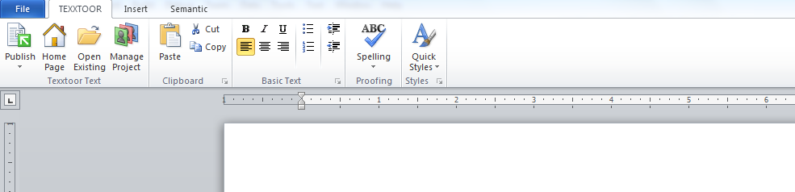

1. Insert:

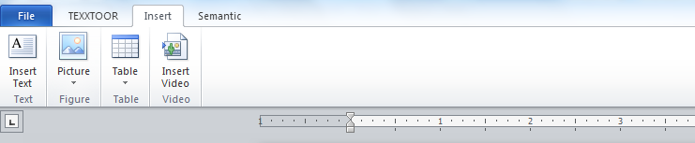

1. Semantic:

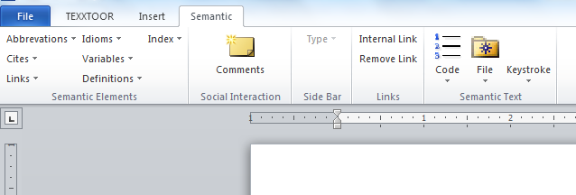

**TEXXTOOR Functions:**

1. **Copy :**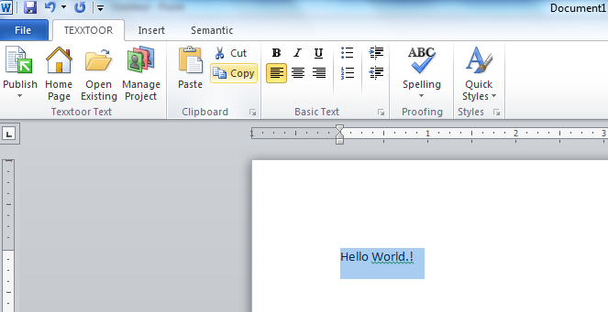
2. Paste:

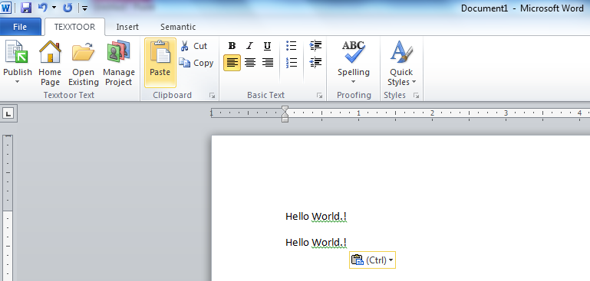

1. Cut:

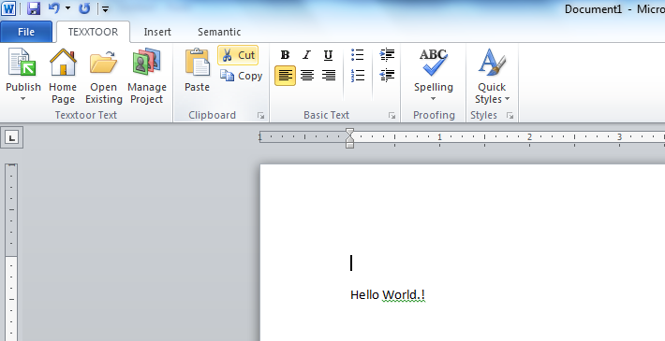

1. Bold:

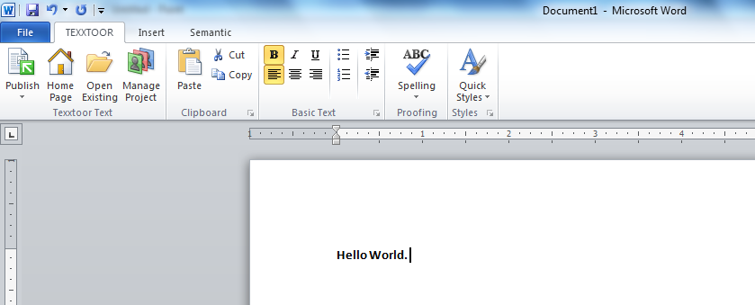

1. Italic:

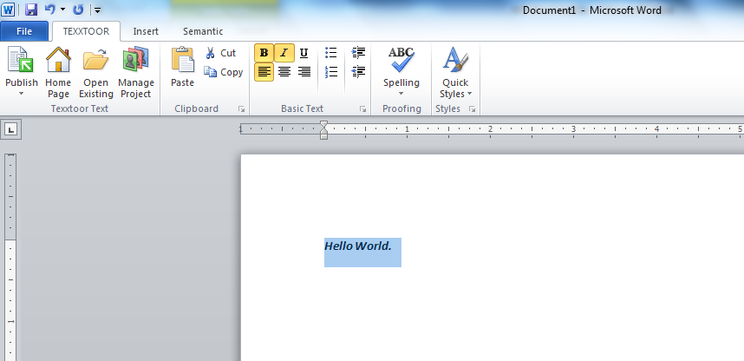

1. Underline:

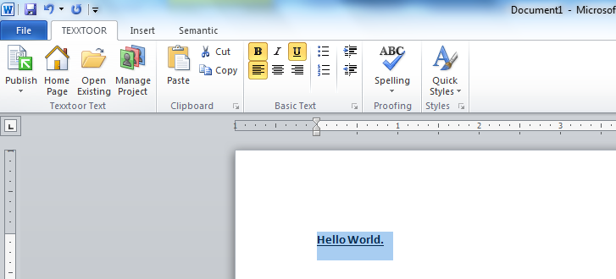

1. Left Alignment:

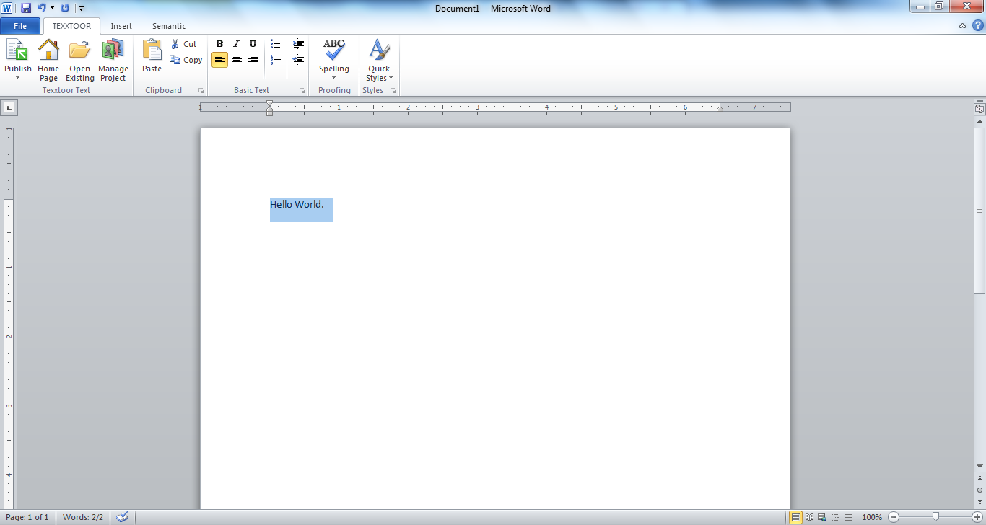

1. Center Alignment:

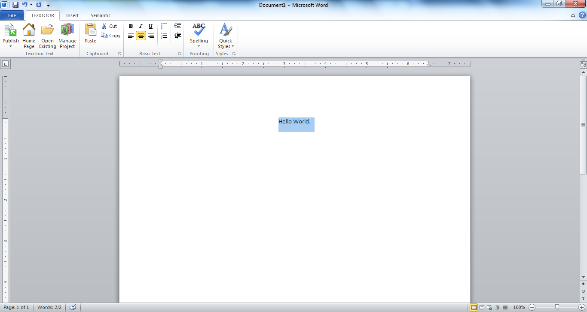

1. Right Alignment:

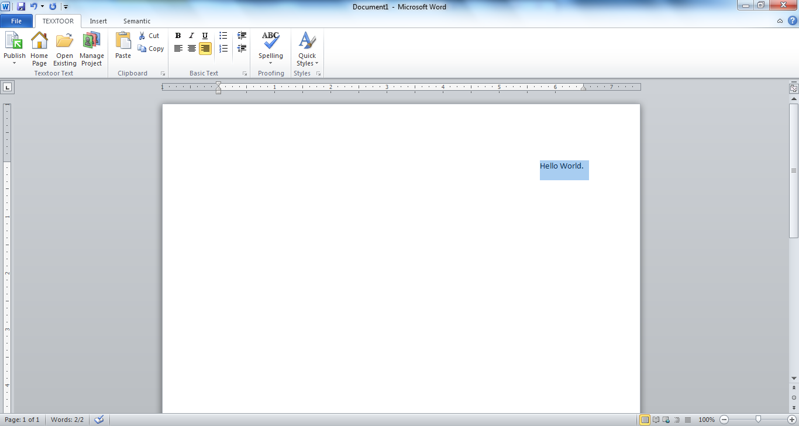

1. Bullets:

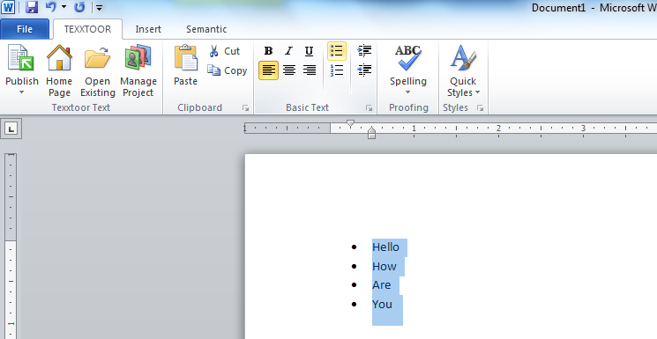

1. Numbers:

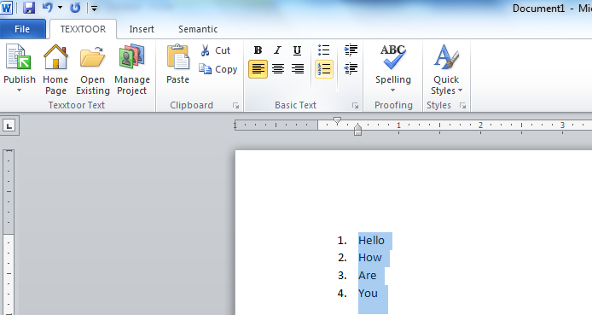

1. Indent: It works only for the Works only if in a bulleted or numbered list

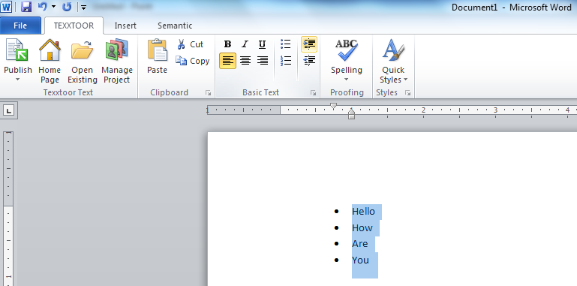

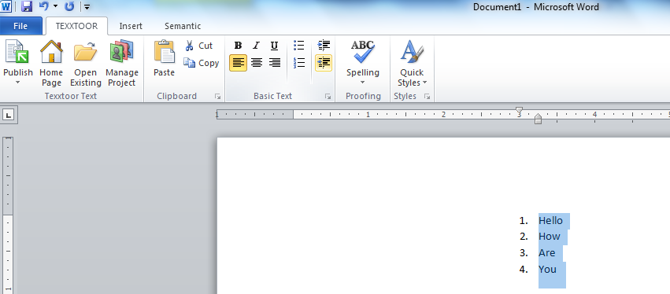

**INSERT Functions:**

1. **Insert Text:**

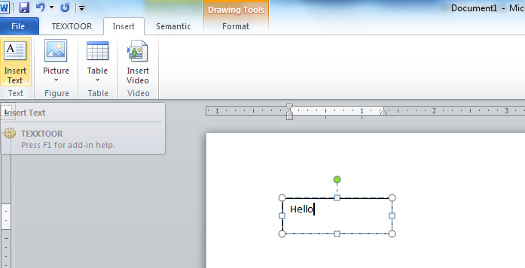

1. **Insert Picture:**

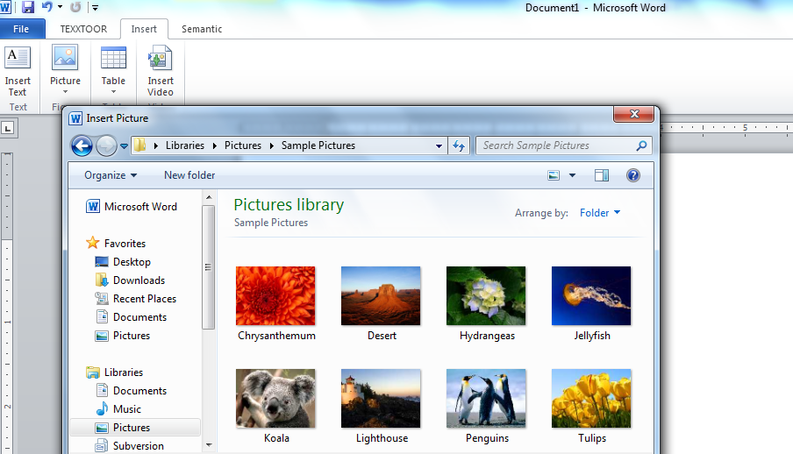

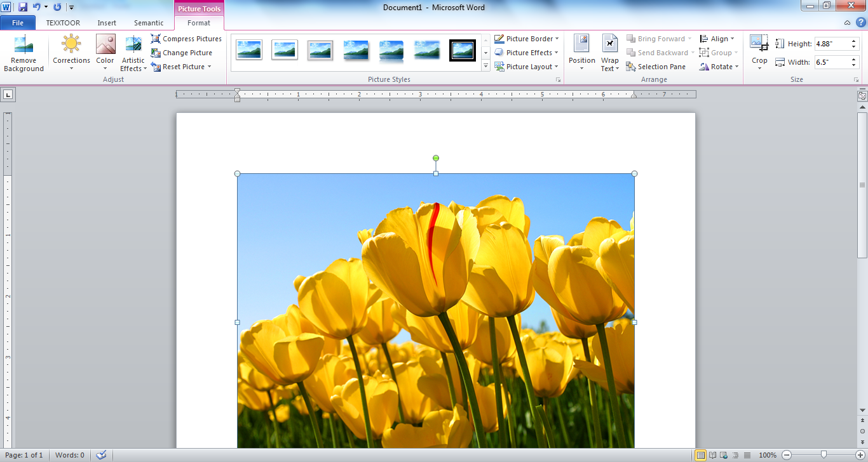

1. **Insert Table:**

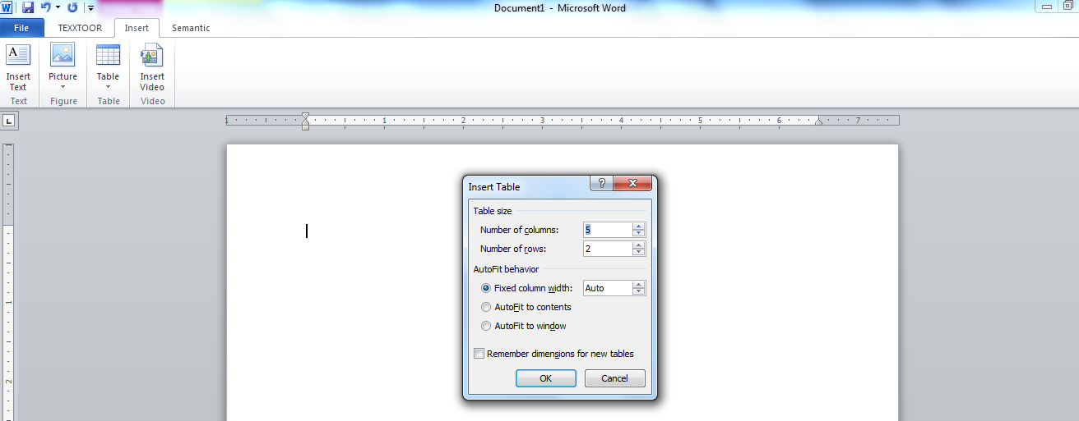

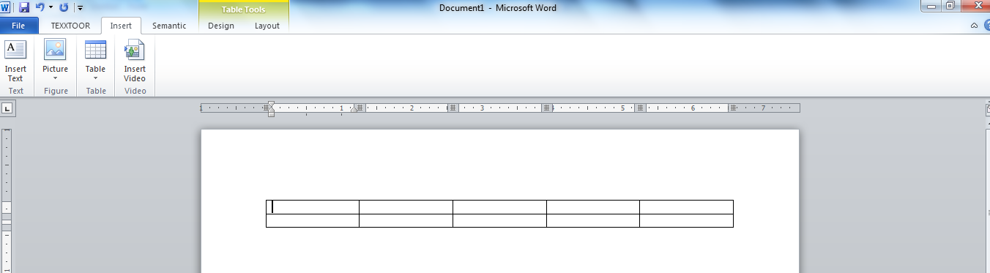

1. **Insert Video:**

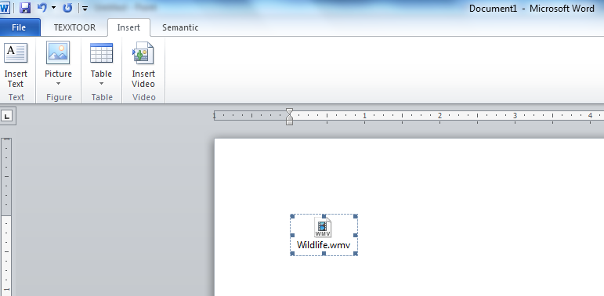

**Playing Video:**

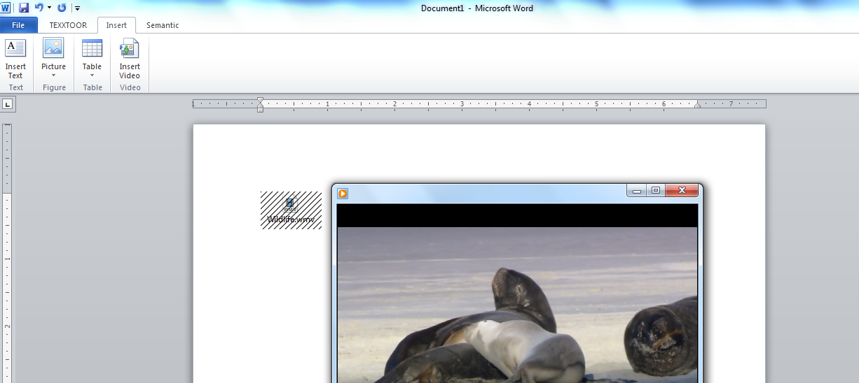

**SEMANTIC Tab Functions:**

1. **Comments:** Display the task panel at the right side of the application,

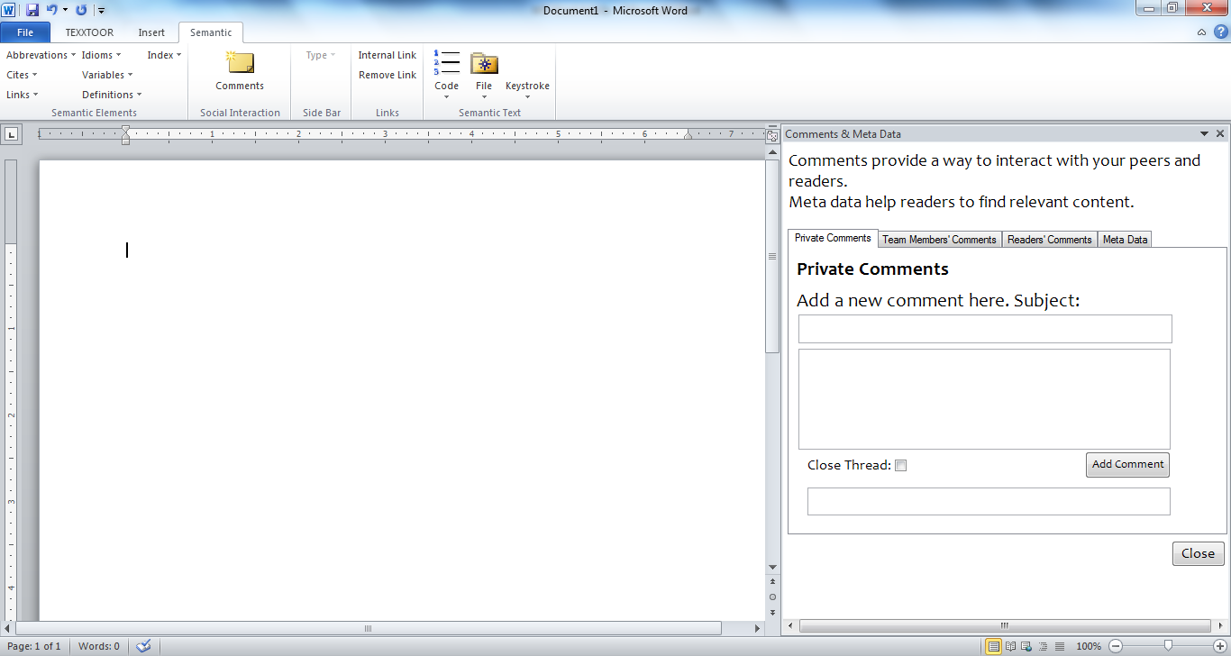

1. **Links Task Panel:** Display the task panel at the right side of the application,

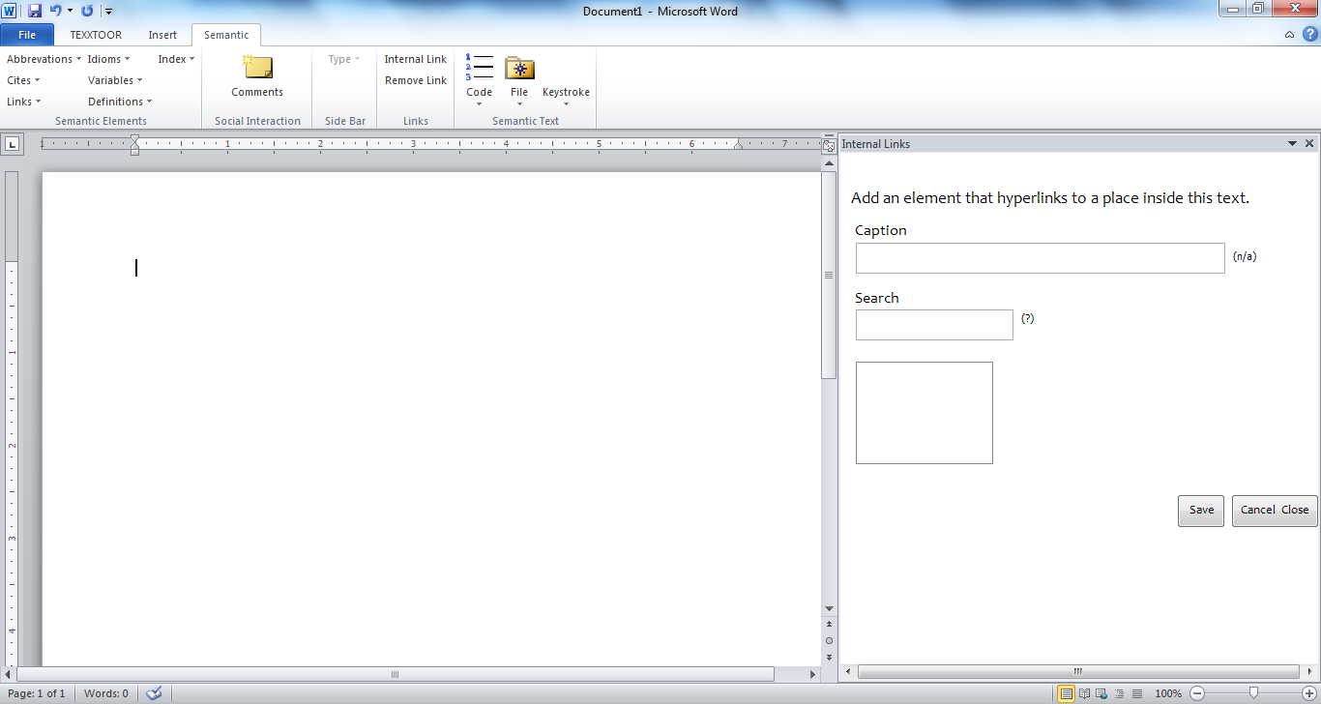

1. **At the same time two panels are displayed**

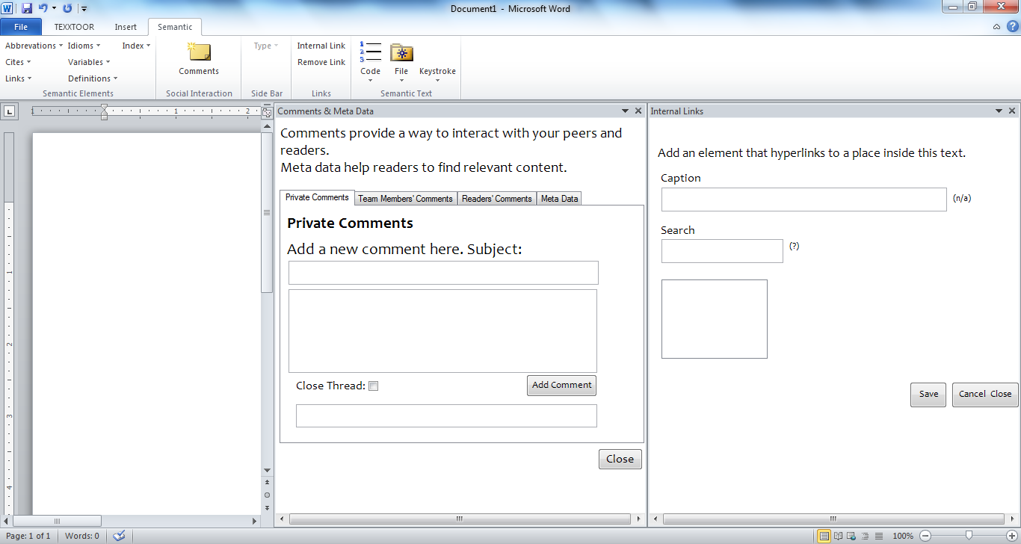

Except services based functionalities, remaining all functionalities are almost completed. Let me know any changes required in up to what we have done.

Thank You.