Bjørnar’s assignment in Gretl

John Doe

Jane Smith

[Bjørnar’s assignment](https://hiof.instructure.com/courses/9596/files/folder/Assignment?preview=1695176)

## Exercise 1

Inline equations $θ=2+2$

## Exercise 2

*Model 1*

$$price_{i}=β_{0}+β_{1}Age_{i}+u_{i}$$

a. a. a. a. a.

## Exercise 3

*Model 2* $$ price_i = _0 + _1Age_i + _2WinterRain_i +_3temp_i + _3HarvestRain_i + u_i \ c a. a. a.

## Exercise 4

*Model 3*

$$price_{i}=β_{0}+β_{1}Dheavyraint_{i}+β_{2}tempt_{i}+β_{3}temp_{i}·Dheavyrain_{i}+u_{i}$$

## Exercise 5

## Tips til kode

Legger til txt fil fra Gretl

Mean Median S.D. Min Max  
price 1405,8 1079,8 1027,2 495,17 4883,9  
WinterRain 608,41 600,00 129,03 376,00 830,00  
temp 16,478 16,417 0,65919 14,983 17,650  
HarvestRain 144,81 123,00 73,066 38,000 292,00  
Age 16,185 16,000 8,2464 3,0000 31,000

Legger til png fra Gretl

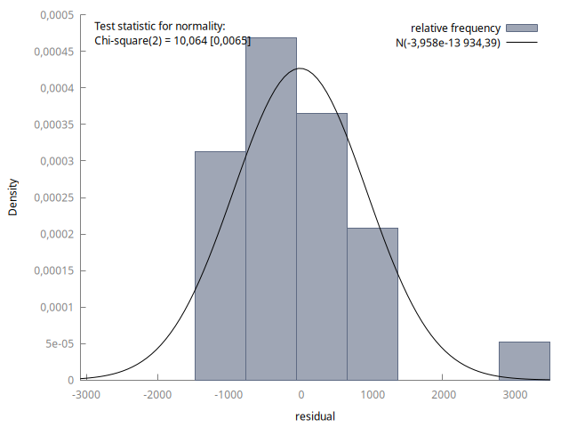

Png of residualta