test

Abc
text goes here….

Exercise 1

a

b

c

Exercise 2

Exercise 3

a
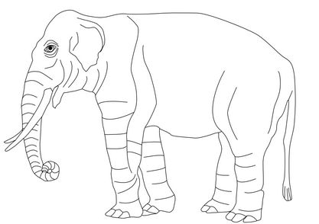
Caption
accepts html code
addf
$$x=f\left(N,K\right)$$
in this case the shourt run prouction function is $x=f\left(N\right)$
Right | Left | Default | Center
12 | 12 | 12 | 12
123 | 123 | 123 | 123
1 | 1 | 1 | 1

