**This setup is from** [**https://www.bezkoder.com/vue-3-firebase/**](https://www.bezkoder.com/vue-3-firebase/) **by Bezkoder**

**1 - Setup the Firebase Project**

Go to [Firebase Console](https://console.firebase.google.com/), login with your Google Account, then click on Add Project.

You will see the window like this:

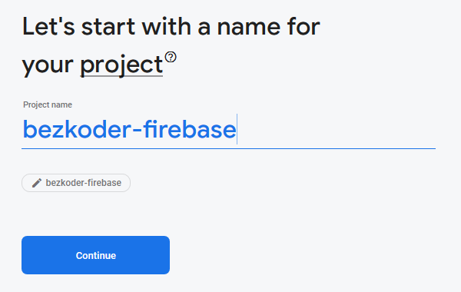

Enter Project name, set Project Id and click on **Continue**.  
Turn off *Enable Google Analytics for this project*, then click **Create Project**.

Now, browser turns into following view:



If you don’t see it, just choose Project **Overview**.  
Click on **Web App**, you will see:

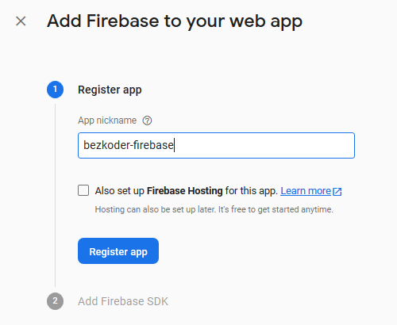

Set the nickname and choose **Register App** for next step.

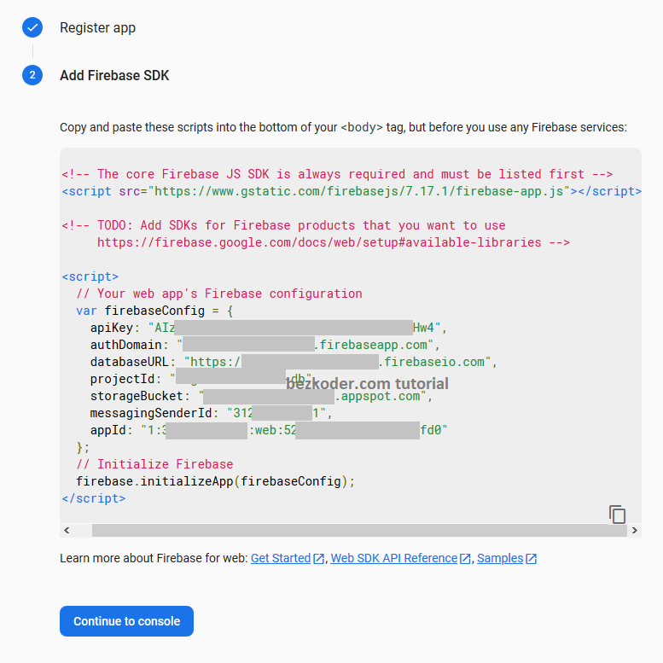

Copy the script for later use.

Choose Database in the left (list of Firebase features) -> Realtime Database -> **Create Database**.

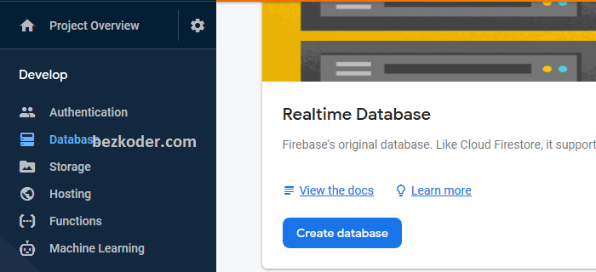

In this tutorial, we don’t implement Authentication, so let’s choose **test mode**:

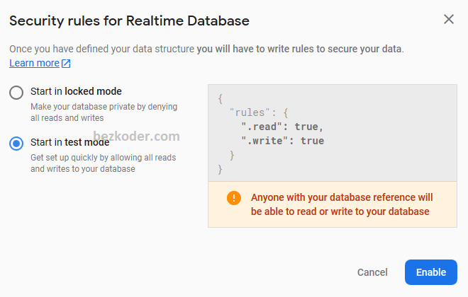

Or if you come from another situation, just open Tab **Rules**, then change .read and .write values to true