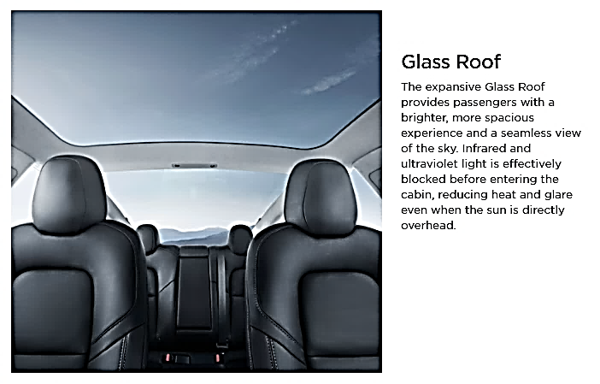
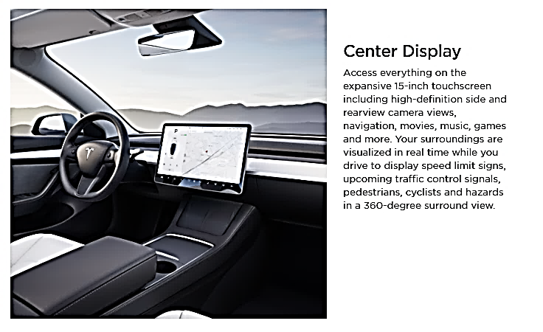
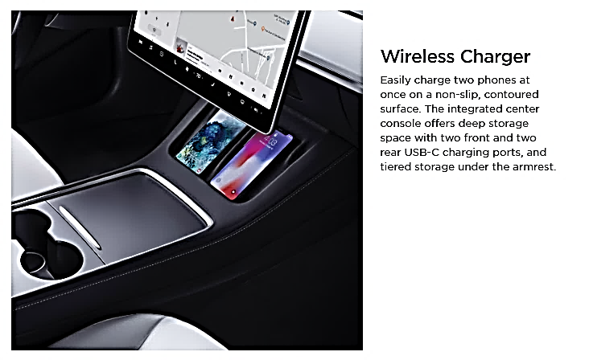
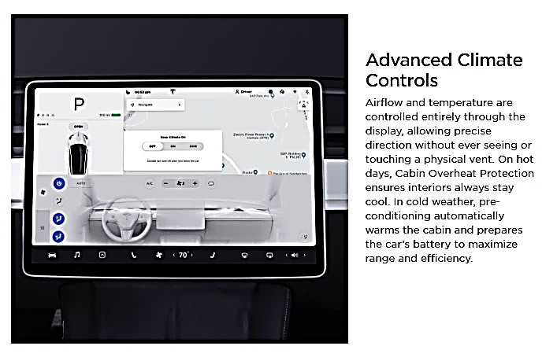
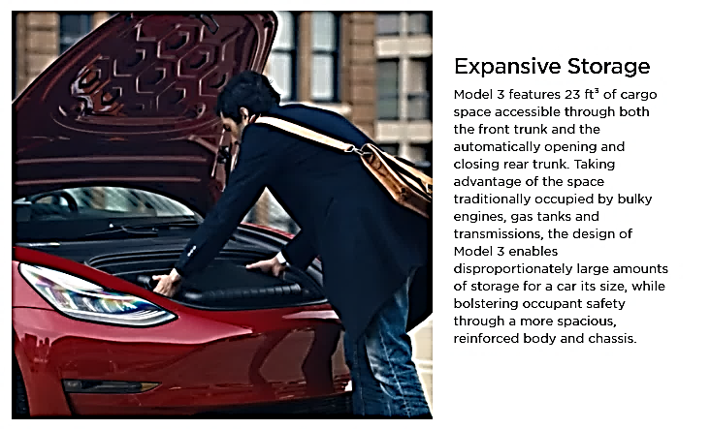
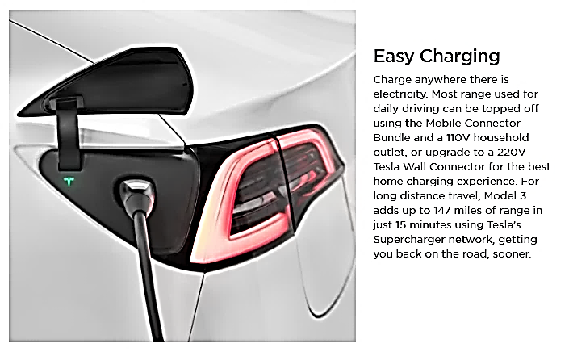

Interior Features
Audio and Media
- Upgraded audio - immersive sound
- Music and media over Bluetooth
- USB-A port in the glovebox with a 128GB portable storage device included
Comfort
- Power adjustable heated front seats
- Heated front and rear seats
- Heated steering wheel
- Tinted glass roof with ultraviolet and infrared protection
Convenience
- Power folding, auto-dimming, heated side mirrors
- Custom driver profiles
- Center console with storage, 4 USB-C ports and wireless charging for 2 smartphones
=============================================================================

