Model 3 Standard
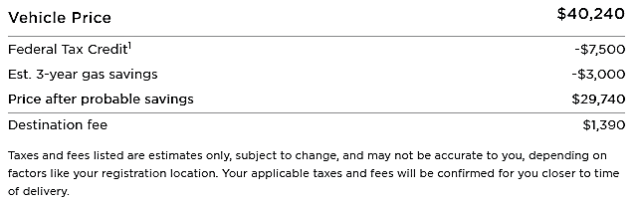
Model 3 Long Range
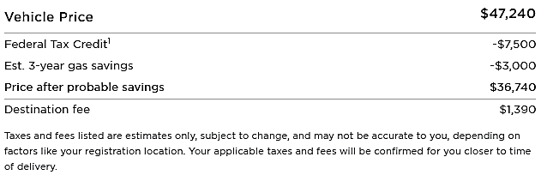
Model 3 Performance
