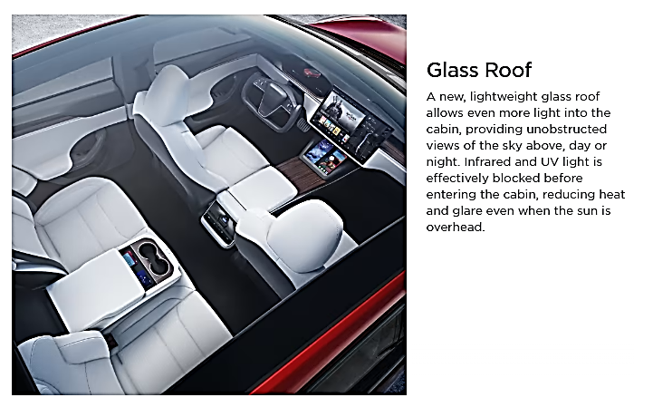

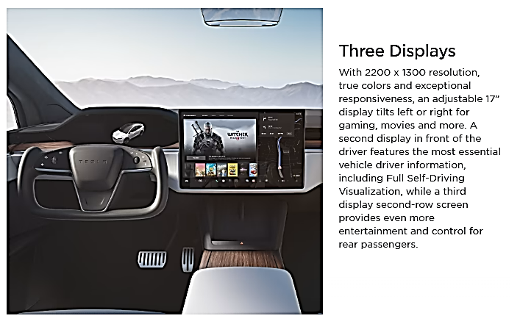
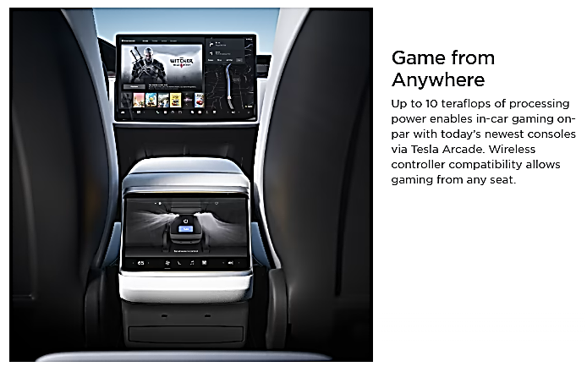
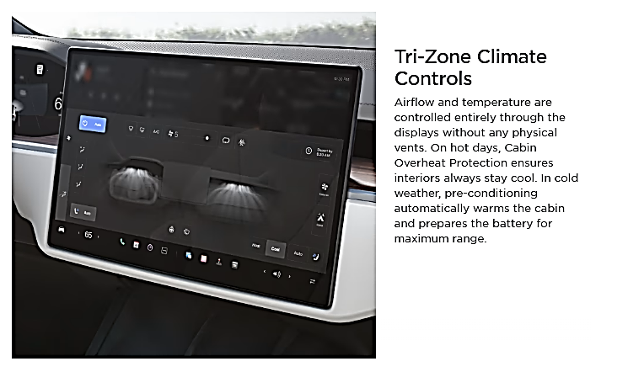
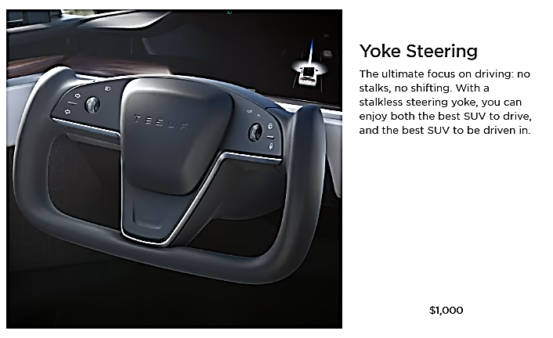
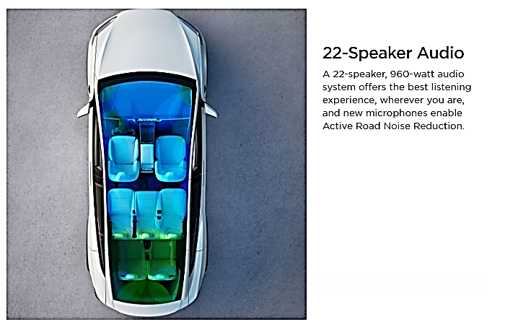

=============================================================================

Interior Features

Audio and Media
- Premium 22-speaker audio with Active Road Noise Reduction
- Multi-device music and media over Bluetooth
- FM Radio, SiriusXM and Internet Streaming Radio
- Tilting 17" center display, 12.3" driver’s display, and 9.4" second row display
- Gaming computer with 10 teraflops of processing power
- Wireless controller compatibility

Comfort
- Heated seats for every passenger, heated steering and heated windshield
- Ventilated front seating
- Tri-zone Airwave cabin conditioning
- HEPA air filtration system
- Custom driver profiles with automatic easy-entry and exit
- Ambient lighting
- Tinted glass roof
- Ultraviolet and infrared protection on all glass

Convenience
- Front center console with sliding cup holders and storage
- Second row stowable center armrest with integrated storage and wireless charging
- Automatic opening and closing rear liftgate
- Auto dimming, power folding, heated side mirrors
- 28 ft of cargo space and secure front trunk
- Wireless and USB-C fast charging for every passenger
- Location-aware automatic garage door opener
- Phone Key
=============================================================================

Plaid Upgrades
Included

- Quickest accelerating car in production today
- 0-60 mph: 1.99s
- 1/4 mile: 9.23@155 mph trap speed
- 1,020 horsepower
- Three high performance motors with carbon-sleeved rotors
- Torque vectoring
- Higher thermal capability brake pads
- Carbon fiber spoiler
=============================================================================

