Model S Standard
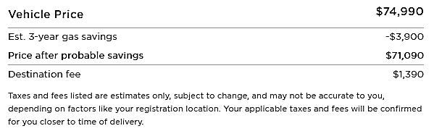
Model S Plaid
