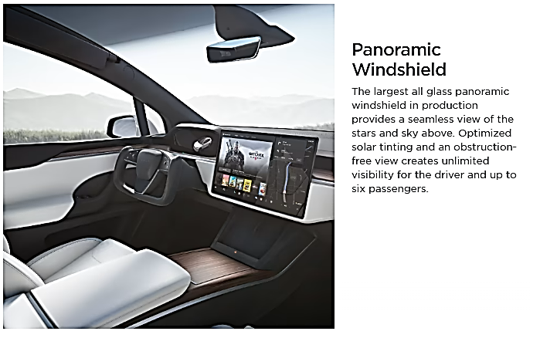
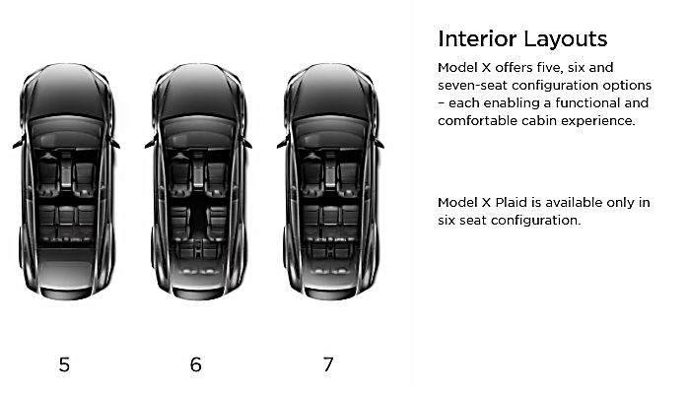
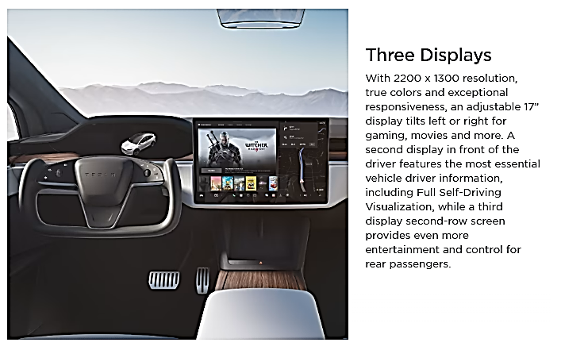
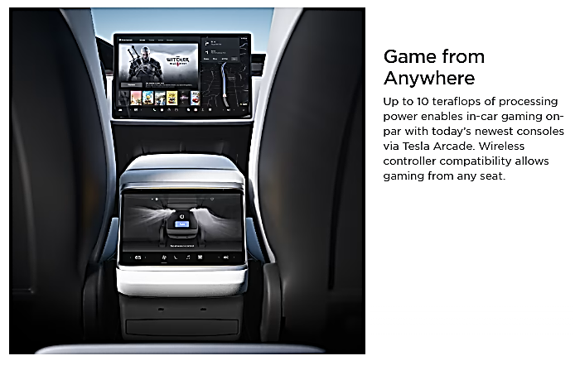
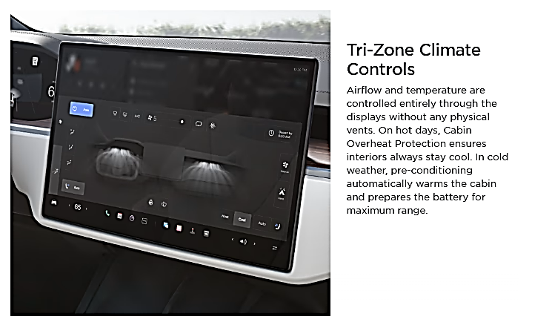
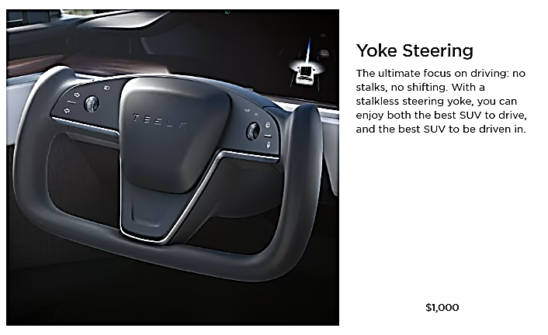
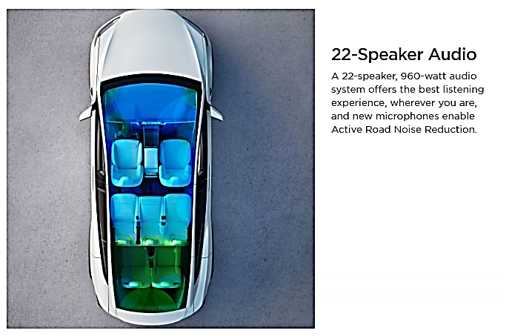

=============================================================================

Interior Features

- Audio and Media
- Premium 22-speaker audio with active noise cancelling
- Multi-device music and media over Bluetooth
- FM Radio, SiriusXM and Internet Streaming Radio
- Tilting 17" center display, 12.3" driver's display, and 8" second row display
- Gaming computer with 10 teraflops of processing power
- Wireless controller compatibility
- Comfort
- Panoramic windshield
- Ultraviolet and infrared protection on all glass
- Heated seats for every passenger, heated steering and heated windshield
- Ventilated front seating
- Tri-zone Airwave cabin conditioning
- HEPA air filtration system
- Custom driver profiles with automatic easy-entry and exit
- Ambient lighting
- Convenience
- Automatic opening and closing front doors
- Front center console with sliding cup holders and storage
- Automatic opening and closing rear liftgate
- Auto dimming, power folding, heated side mirrors
- 92 ft of cargo space including a secure front trunk
- Wireless and USB-C fast charging
- Location-aware automatic garage door opener
- Phone Key
=============================================================================

