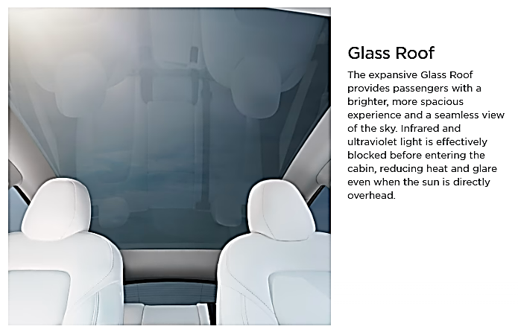
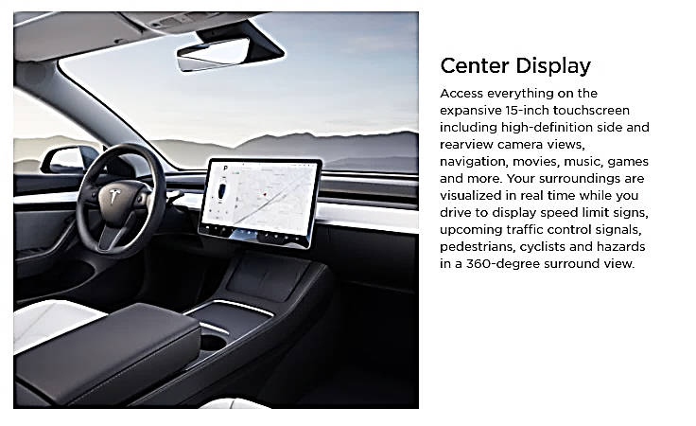
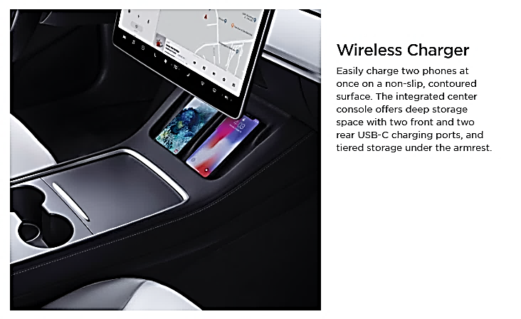
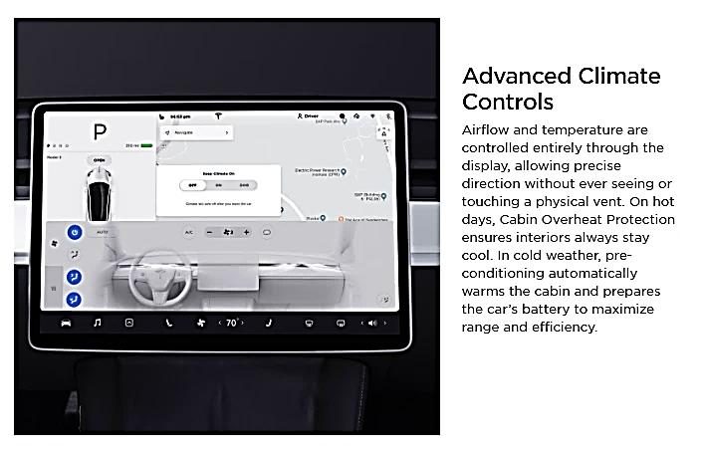
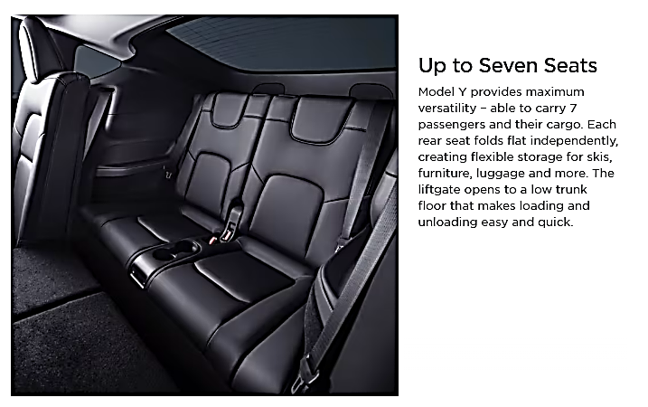
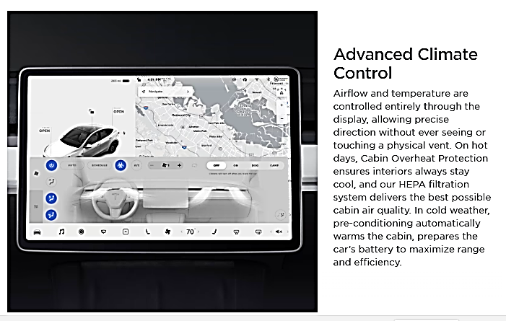

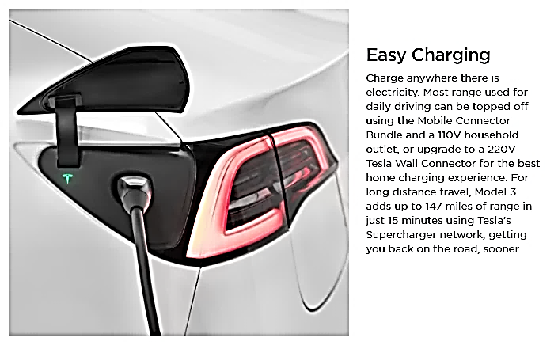

Interior Features
- Audio and Media
- Premium audio - 13 speakers, 1 subwoofer, 2 amps, and immersive sound
- Music and media over Bluetooth
- USB-A port in the glovebox with a 128GB portable storage device included
- Comfort
- Power adjustable front seats
- Heated front and rear seats
- Heated steering wheel
- HEPA air filtration system
- Tinted glass roof with ultraviolet and infrared protection
- Independent flat-fold rear seats
- Interior floor mats
- Convenience
- LED fog lamps
- Power folding, auto-dimming, heated side mirrors
- Custom driver profiles
- Center console with storage, 4 USB-C ports and wireless charging for 2 smartphones
=============================================================================
Model Y Performance Upgrades
- Increased top speed from 135mph to 155mph
- 21" Uberturbine Wheels
- Performance Brakes
- Lowered suspension
- Aluminum alloy pedals
- Carbon fiber spoiler
=============================================================================

