Model Y Standard
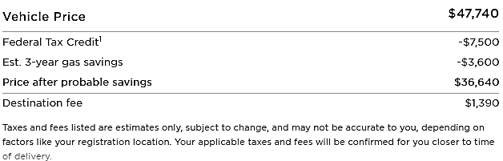
Model Y Long Range
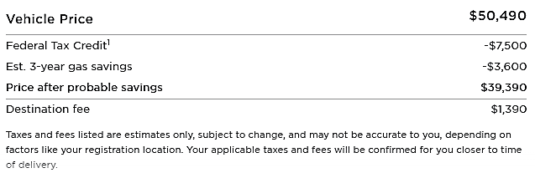
Model Y Performance
