* 2DLs
* Tuvok
* Tasker
* Jasker
* ToDo
* 2do
* udo
* mydo
* idoes
* jdoes
* joes
* jodo
* workit
* pasker

Tuvok is a work flow manager that has hierarchical tasks ending with work items.

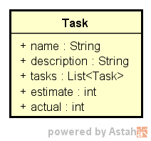

Features

* Personal Estimation Metrics – These metrics relate how well you are estimating your tasks.
  + Estimation Factor – Do you want to estimate more accurately? Keep thinking the same way, but multiply that number by this factor before telling others.
  + Estimation Consistency – Are some of your estimates just wildly incorrect while most others are spot on?