JChart Software Description Document

# Purpose

This document shall serve as guidance for create and maintenance of the JChart library and application.

# Definitions

* Chart – the collection of items drawn that include axes, gridlines, the legend, titles, labels, and plots.
* Dataset – an array of series, each with the same number of data points associated with a resource. The resource may be read-only such as the clipboard.
* Series – an array of single data points.
* Plot – a plot data instance and drawing properties.
* Plot Data – a set of x/y pairs. May or may not be created by two series.

# Use Cases

1. Read data in and plot. Zoom in on single data points. Observe values for hover highlighted points.
2. Select points and replace with:
   1. Nothing (delete/hide/mark for deletion)
   2. “NaN”
   3. “999999999.999999999”
   4. a custom sentinel value

# Requirements

## Main Interface

1. Opens files (see 4.7 Input Formats) as Datasets via one of the following methods. When data is being plotted, the cursor changes to the busy cursor, then back when finished.
   1. drag-n-drop files of different types for plotting. The control key signifies that the file is to be added if held down during a drag-n-drop operation.
   2. an add data button on the main toolbar.
   3. a recent file dropdown on the main toolbar.
   4. an open button in the File menu.
   5. an open button in the Recent Files menu in the File menu.
2. Saves files (see 4.8 Output Formats):
   1. all Datasets and Plots and options loaded in the current session to a JChartLib session file.
   2. the entire or user selected data from a single Dataset.
   3. the entire or user selected data from all Datasets. Use a progress bar to let the user know that the software is not locked up. For each file the user should be presented with the following options for saving:
      1. the original file name
      2. a generated file name
      3. all original
      4. all generated
      5. rename field
      6. skip
      7. cancel
   4. an image of the chart in
      1. PNG format.
      2. SVG format.
      3. JPEG format.
   5. the chart configuration with no data.
   6. a plot configuration with no data.
3. navigate through the list of series within a dataset with next/previous buttons.
4. navigate to the next/previous dataset series if at the end/beginning of a dataset.
5. reorder plots.
6. apply a function to each point in a series.
7. apply a filter to a series.

## Chart Interface

1. remove data points by
   1. selecting with right-click drag, then pressing the delete key.
   2. going to the data table, selecting the points, then pressing the delete key.
2. zoom the chart via scroll-wheel (up for zoom-in and down for zoom-out); which additionally supports:
   1. zooming in both axes (no keys pressed).
   2. zooming in the domain only (control key pressed).
   3. zooming in the range only (shift key pressed).
   4. fine control zooming (in either both axes, domain only, or range only) using the ALT key:
      1. ALT = fine both
      2. ALT+CTRL = fine domain only
      3. ALT+SHIFT = fine range only
3. moving the plot at the current chart bounds via middle-click and drag.
4. observe crosshairs that track the cursor movement to the edges of the plot.
5. clear all plots

### Toolbar

1. A save button to save images.
2. A copy button to copy a plot image to the clipboard.
3. Two buttons to zoom-in and zoom-out the chart.
4. Four buttons to pan the chart up, down, left, and right.

### Right-Click Menu

1. Zoom
2. Stats
3. Chart Properties

## Data Interface

1. add/remove/edit data

## Editable Properties

1. the entire chart; which will enable the user to:
2. set the title and all text properties and choose to show/hide.
3. set the subtitle and all text properties and choose to show/hide.
4. set the top/bottom text and all properties and choose to show/hide.
5. set the top, left, bottom, and right spacing from the edge of the canvas to the first chart component.
6. set the background color of the chart.
7. set the exact size of the plot in either inches, centimeters, or pixels.
8. turn on/off object anti-aliasing.
9. turn on/off text anti-aliasing.
10. turn on/off horizontal gridlines.
11. turn on/off vertical gridlines.
12. turn on/off horizontal minor ticks.
13. turn on/off vertical minor ticks.
14. the legend; which will enable the user to
15. show/hide the legend.
16. set the border:
    * 1. visibility.
      2. thickness.
      3. color.
17. set the side on which the legend appears.
18. set the background color of the legend.
19. each axis (primary and secondary domain/range); which will enable the user to
    1. set the title and all text properties and choose to show/hide.
    2. set the subtitle and all text properties and choose to show/hide.
    3. manually set the bounds for the axis.
    4. set tick spacing to auto or define as:
       1. tick start
       2. tick end
       3. tick width
    5. set ticks to include zero if auto
20. plots; which will enable the user to reorder all available plots.
21. each plot; which will enable the user to:
    1. change the plot name.
    2. show/hide the plot.
    3. assign the plots x-values to primary or secondary domain.
    4. assign the plots y-values to the primary or secondary range.
    5. edit the marker properties:
       1. show/hide the marker.
       2. choose the marker shape (Circle, Diamond, Square, X, Plus).
       3. choose the marker size.
       4. choose the marker color.
    6. edit the connecting line properties:
       1. show/hide the line.
       2. choose the line style (dashed/solid).
       3. choose the line weight.
       4. choose the line color.

## Data Table User Interface

1. show
   1. all points.
   2. visible points only.
   3. hidden points only.
2. remove points (See 1.a).
3. edit data (See **Error! Reference source not found.**).
4. add/insert data?

## Library

1. provide a view that is the chart alone.
2. provide a view that is the chart with toolbars.
3. provide a view that is the chart with toolbars in a dialog.

## Input Formats

### Chart Data File

### Space Separated

### Tab Separated

### Comma Separated

### Clipboard

### MAT File

## Output Formats

### Chart Data File

### MAT File

### Tab Separated

### Comma Separated

### Image File

* PNG
* JPEG
* BMP

# Functional Description

## Main Interface

* Navigation Pane
* Chart Tab
* Data Tab
* Properties Dialog

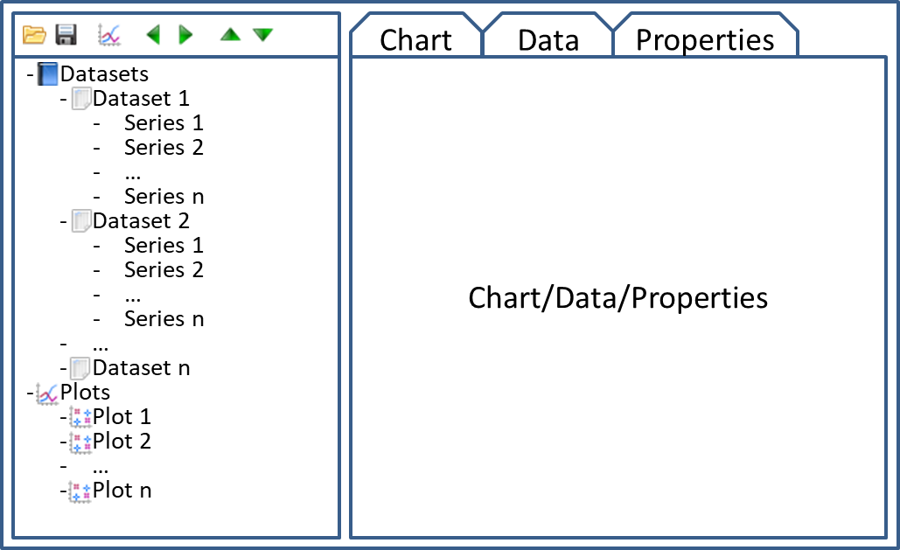

## Auto-Ticks

Auto-tick calculation should result in ticks that show a difference between each mark. This difference should be of a consistent delta along an axis and should be in 1/10, 1/2, 1/5, or 1/4 increments. The physical width between tick marks shall be no less than 0.5 inches and no greater than 1.75 inches.

Inputs:

* Length – Physical length of the axis.
* Min – Minimum bound of the viewable area in axis coordinates.
* Max – Maximum bound of the viewable area in axis coordinates.
* Tick Min – Minimum physical distance between tick marks.
* Tick Max – Maximum physical distance between tick marks.

Outputs

* Tick Count – The number of tick marks to be drawn (one more than the number of sections between ticks).
* Tick Start – The first tick mark in axis coordinates.
* Tick End – The last tick mark in axis coordinates.
* Format – Decimal or Scientific notation.
* Precision – The number of reserved digits after the decimal for the decimal format and number of total digits for scientific format.

Other requirements

* The distance between tick marks may not be less than double precision allows.
* Precision will be a maximum of 20.

Use Cases

|  |  |  |  |  |  |  |  |
| --- | --- | --- | --- | --- | --- | --- | --- |
| Axis Length | Min | Max | Tick Count | Tick Start | Tick End | Format | Precision |
| 5” | -5 | 5 | 6 | -4 | 4 | Dec | 1 |
| 5” | 0 | 0 | 3 | -1 | 1 | Dec | 1 |
| 5” | 0.00001 | 0.0001 | 3 | 0.0000 | 0.0002 | Dec | 4 |
| 5” | Max | Max | 3 | (Max--)-- | Max | Sci | 20 |
| 5” | Min | Min | 3 | Min | (Min++)++ | Sci | 20 |

# Library Widgets

* JChartFrameView
* JChartView
* ChartView
  + ChartNavView
  + PlotView
    - PropertiesView

# Technical Implementation



* File I/O:
  + the default file reader will look for tab-delimited data and plot the first column vs. the last column (all columns are loaded).
  + the default file reader may be replaced.
  + additional file readers may be added (each must be associated with a file extension).

## Auto-Ticks

Spacing for tick marks is driven by the intent to create human readable numbers for each tick. For instance, one could always create n ticks. The number of spaces would be n-1. The distance between tick marks in axis coordinates would be range/(n-1). This method would result in uncomfortable distances between tick marks. Consider a range of 13 (2.4 - 15.4) with 11 tick marks; the result would be a distance between ticks of 1.3 and marks at 2.4, 3.7, 5.0, 6.3, 7.6, 8.9, etc. This makes the data between tick marks difficult to visually estimate. A much better solution to this example would a smaller distance between ticks such as 1 resulting in 13 ticks from 3 to 15. Another good option would be a little larger distance between ticks of 2 resulting in 7 ticks starting at either 3 or 4.

## Buffers

* TextWidget (1) – orientation: It looks better when transforms are applied to a buffer than the text directly.
* Axes (1) - time to calculate ticks.
  + Each Plot (n) – time to walk each point, determine if it should be drawn, and draw it.

## Drawing Order

1. Draw chart title.
2. Draw subtitle.
3. Determine size of axis titles.
4. Determine rough tick sizes.
5. Determine rough plots size.
6. Determine actual tick sizes and draw.
7. Draw plots.
8. Draw axis titles.
9. Top/bottom labels.

## Drawing Updates

* Add, remove, hide, or reveal a series.
* Move highlighted value.
* Draw crosshairs.
* Change range (zoom).
* Draw selected region.
* Select points.

## Notes

* Need a way to determine the size of a TextWidget. This depends on the text set.
* Need a way to determine the size of the legend. This depends on the available area of drawing.
* Need a way to determine the size needed to display tick labels without clipping. This depends on the area of the chart.

|  |  |  |
| --- | --- | --- |
| **Widget** | **Uses Size** | **Relates Size** |
| Chart | X |  |
| Legend | X | X |
| Titles | X |  |
| Text |  | X |
| Axes | X |  |
| Plots | X |  |
| Plot | X |  |
| Selection |  | X |