Cairo University  
Faculty of Computers and Artificial Intelligent

**CS251**

**Software Engineering I**

Project Name

Software Design

Team Names

Month & Year

Contents

Instructions [To be removed] 3

Team 3

Document Purpose and Audience 3

System Models 3

I. Class diagrams 3

Important Algorithm 4

II. Sequence diagrams 5

Class - Sequence Usage Table 6

Ownership Report 6

Policy Regarding Plagiarism: 7

# Instructions [To be removed]

* **IMPORTANT. Rename this document according to the naming style stated in the project description.**
* **Remove the following notes and any red notes**
* **This document is the template document for your Software Design.**
* **For further guidelines and information, READ project details document (C251-Project Description-ParkingGarage-v1.0).**

# Team

|  |  |  |  |
| --- | --- | --- | --- |
| **ID** | **Name** | **Email** | **Mobile** |
|  | 1st name is team leader |  |  |
|  |  |  |  |
|  |  |  |  |

# Document Purpose and Audience

**What is this document?**

This document shows the System’s models (Class Diagram and Sequence Diagram) .

**Who is excepted to read it?**

The project Manager and the customer.

# System Models

## I. Class diagrams

* **Put stereotypes of the classes to give more information. UML predefines some stereotypes like: <<interface>>, <<type>>, <<implementationClass>>, <<enumeration>>, etc. and you create your own also.**

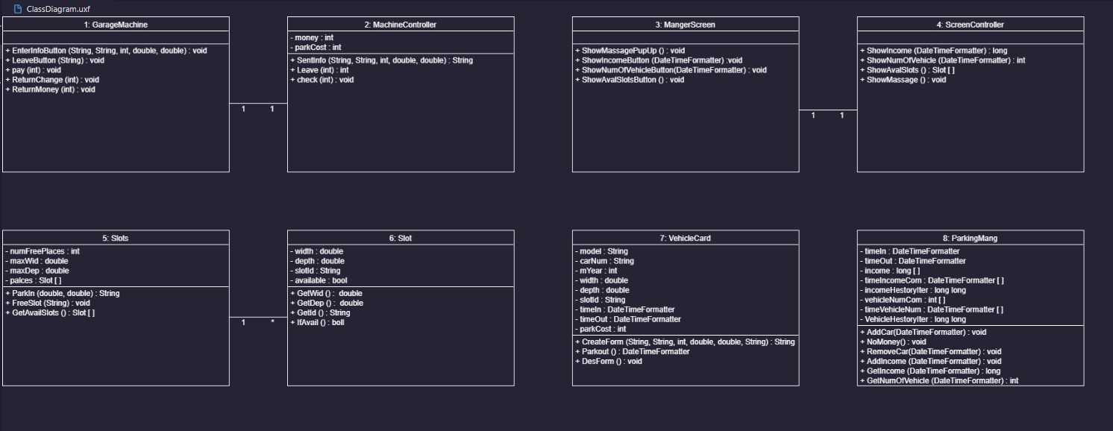

**List down your classes and describe them**

| **Class ID** | **Class Name** | **Description & Responsibility** |
| --- | --- | --- |
|  |  |  |

### Important Algorithm

* **If any method in a class is implementing an algorithm (complex enough), then you should describe it here.**

## 

## II. Sequence diagrams

### 

### Class - Sequence Usage Table

* **In this table, we will list EVERY class in class diagram and which sequences used this class diagram. This helps in avoiding either unused classes or extra classes appears in sequence diagrams. In "Overall used methods" section, put all functions appeared in all sequences. If this table was built in ignorance of actual class / sequence diagrams = REJECTED for whole document.**

| **Class Name** | **Sequence Diagrams** | **Overall used methods** |
| --- | --- | --- |
| E.g. Employee | 1, 3, 5 (means Seq Ids 1, 3, 5 used Employee class) | Save, GetData |
|  |  |  |

# Ownership Report

* **Remove the following notes and any red notes**
* **For every item in this document, write the owners. If someone is owner of something, s/he understands it 100.%**
* **Team leader must verify the table with the team members.**

|  |  |
| --- | --- |
| **Item** | **Owners** |
|  |  |
|  |  |

# Policy Regarding Plagiarism:

**Students have collective ownership and responsibility of their project. Any violation of academic honesty will have severe consequences and punishment for ALL team members.**

1. تشجع الكلية على مناقشة الأفكار و تبادل المعلومات و مناقشات الطلاب حيث يعتبر هذا جوهريا لعملية تعليمية سليمة
2. ساعد زملاءك على قدر ما تستطيع و حل لهم مشاكلهم فى الكود و لكن تبادل الحلول غير مقبول و يعتبر غشا.
3. أى حل يتشابه مع أى حل آخر بدرجة تقطع بأنهما منقولان من نفس المصدر سيعتبر أن صاحبيهما قد قاما بالغش.
4. قد توجد على النت برامج مشابهة لما نكتبه هنا أى نسخ من على النت يعتبر غشا يحاسب عليه صاحبه.
5. إذا لم تكن متأكدا أن فعلا ما يعد غشا فلتسأل المعيد أو أستاذ المادة.
6. فى حالة ثبوت الغش سيأخذ الطالب سالب درجة المسألة ، و فى حالة تكرار الغش سيرسب الطالب فى المقرر.