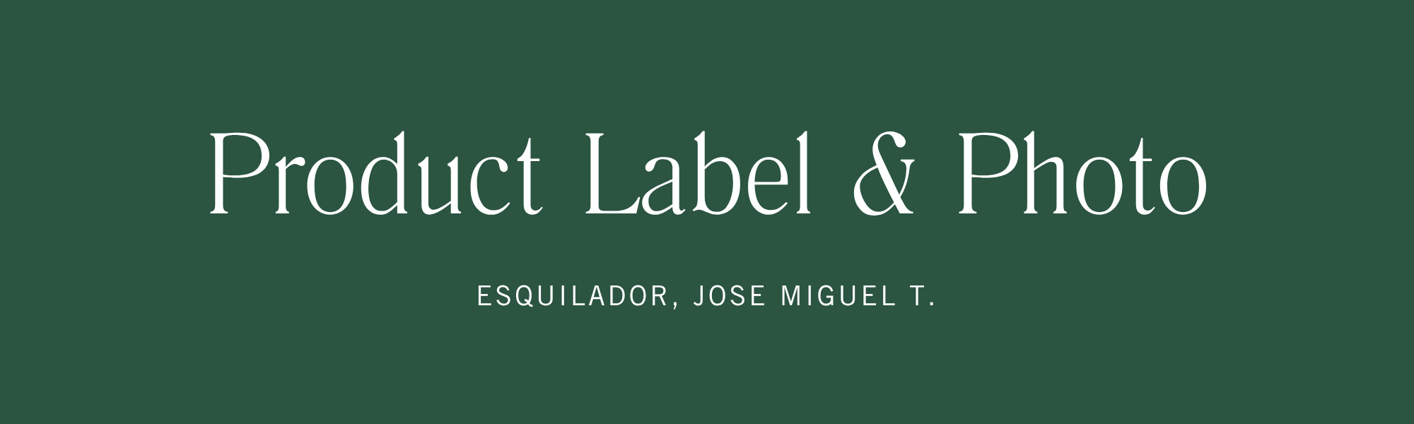
Nutrition Facts | Label
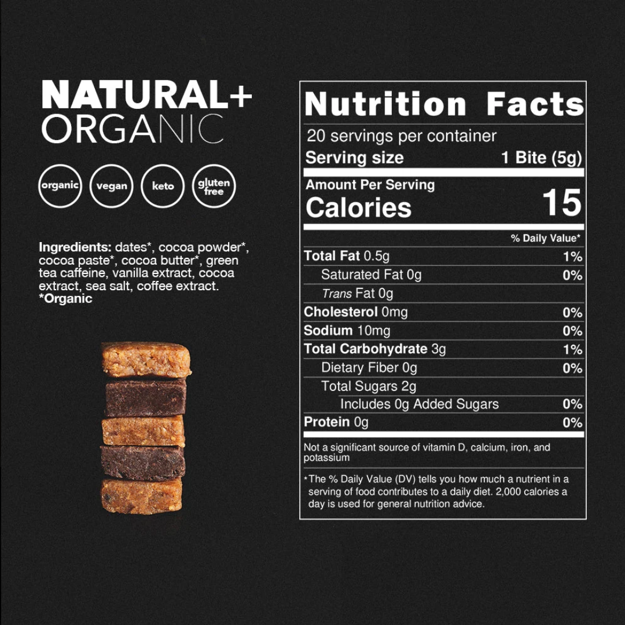 | 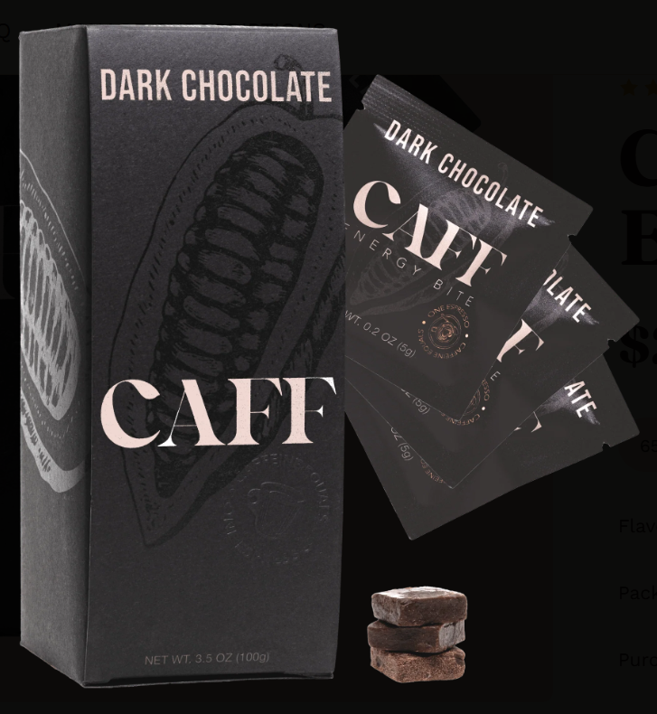
NOTES:
Most of the information used in this infographic was obtained through research and verified sources to ensure the accuracy and reliability of the data. The product label provided the relevant product information, while additional details about caffeine, including its molecular formula and molar mass, were obtained from reliable chemical references. The caffeine content per bite and the number of bites per package were used as the basis for the calculations. The product image included in the infographic was sourced online and was not personally photographed by the author.
PHOTO CITATION:
CAFF, Inc. (n.d.). Caffeinated energy bite. https://eatcaff.com/products/energy-bites

