Examining Patient Evaluations of Antidepressant Drug Use and Efficacy

*Introduction*

According to the 2015 report “Depression and Other Common Mental Disorders: Global Health Estimates” by the World Health Organization, depression is the leading cause of disability and burden of disease worldwide. Evidence-based guidelines generally recommend that second-generation antidepressants (e.g. selective serotonin reuptake inhibitors and selective norepinephrine reuptake inhibitors)—in conjunction with psychotherapy—be taken as the first line of treatment for depression (Anderson et al., 2008; Qaseem, Barry, & Kansagara, 2016; Won et al., 2014). Research indicates however that efforts to maximize treatment benefits for patients with psychiatric illnesses are hampered by poor adherence to prescribed medications (McDonald, Garg, & Haynes, 2002). Among the many different patient factors known to affect adherence to psychiatric treatment (e.g. patient beliefs, stigmas, cost, fears of addiction, etc.), adverse drug side effects are commonly reported as a reason for reluctance to accept or continue pharmacological treatment programs (Fortney et al., 2011; Sansone & Sansone, 2012).

Given the considerably large array of existing pharmacological treatment options for depression and variability in risk/benefit trade-offs thereof, it is worth examining critical aspects of patients’ subjective treatment experiences across a representative sample of the antidepressant drug landscape.

*Data Description and Preparation*

For the current research, we utilized a publicly available data set obtained from the UCI Machine Learning Repository, which contains patient reviews for specific drugs being taken to treat various conditions (Gräßer, Kallumadi, Malberg, & Zaunseder, 2018). The authors of the data set obtained the patient drug review data by pooling across multiple online pharmaceutical review sites. Each patient review for a specific drug consisted of the following:

The drug name (brand), overall satisfaction rating, perceived effectiveness rating, side effects rating, the condition being treated, benefits comment, side effects review, and overall comments.

*Overall Satisfaction* was rated on a scale of 1 to 10, with 10 representing highest possible satisfaction. *Perceived Effectiveness* and *Side Effects* ratings were given on a 5-step Likert response scale (Table 1). The remaining review aspects (benefits comment, side effects comment, overall comments) were written responses and excluded from our analyses.

|  |  |
| --- | --- |
| Perceived Effectiveness | Side Effects |
| Highly Effective (5) | No Side Effects (5) |
| Considerably Effective (4) | Mild Side Effects (4) |
| Moderately Effective (3) | Moderate Side Effects (3) |
| Marginally Effective (2) | Severe Side Effects (2) |
| Ineffective (1) | Extremely Severe Side Effects (1) |

**Table 1.** Categorical response options for effectiveness and side effects reviews and associated

ordinal scale numerical values in parentheses.

The raw dataset included patient reviews on drugs taken for various non-psychiatric (depression-related) medical conditions/needs (e.g. common cold, acid reflux, high cholesterol, contraceptives, etc.). We filtered all cases where depression was at least one of the conditions listed by the patient as a reason for drug treatment. To simplify our analyses and to maximize sample size, we chose not to further subdivide filtered cases by presence or absence of comorbid conditions; cases with condition listed as “depression & anxiety” were not differentiated from those listing only “depression”. This filtering resulted in a total of 499 cases. Next, we converted the *perceived effectiveness* and *side effects ratings* responses to be numerically represented on an ordinal scale ranging from 1 to 5, representing the lowest to best possible ratings respectively (Table 1). We also defined an additional categorical variable, “Drug Type”, which was not included in the original data. This variable provides a higher order grouping of specific drug brands in terms of the primary mechanisms of action by which they achieve their pharmacological effects. For example, drugs such as Prozac and Citalopram belong to a family of drugs known as selective serotonin reuptake inhibitors (SSRIs).

*Choice of Drug Brands and Type*

Based on our filtering criteria, we identified 46 distinct drug brands across multiple drug types. One question we aimed to address was how different drug types were distributed across the patient sample, as indexed by the relative number of reviews associated with specific drugs.

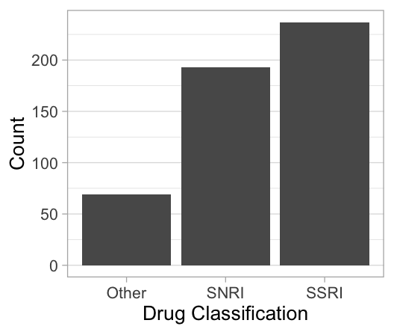

**Figure 1.**

SSRIs and SNRIs accounted for a vast majority of the reviews in the data (Figure 1). Out of the 499 patient reviews, 193 (39%) were for drugs classified as SNRIs, and 237 (47%) for drugs falling under the SSRI category. The “Other” category encompassed drugs spanning several unique types including, but not limited to, monoamine oxidase inhibitors (MOAIs), amphetamines, benzodiazepines, atypical antipsychotics, and tricyclic antidepressants. Although each of the aforementioned drug types are like SSRIs and SNRIs, insofar as they each represent distinct biochemical mechanisms of action, we chose to group all other drugs into a single category due to the relatively small number of reviews available for drugs not accounted for by the two dominant categories. That SSRIs are the most popular choice of antidepressant drug is consistent with existing literature.

References

Anderson, I. M., Ferrier, I. N., Baldwin, R. C., Cowen, P. J., Howard, L., Lewis, G., & Tylee, A. (2008). Evidence-based guidelines for treating depressive disorders with antidepressants: a revision of the 2000 British Association for Psychopharmacology guidelines. *Journal of Psychopharmacology*, *22*(4), 343-396.

Fortney, J. C., Pyne, J. M., Edlund, M. J., Stecker, T., Mittal, D., Robinson, D. E., & Henderson, K. L. (2011). Reasons for antidepressant nonadherence among veterans treated in primary care clinics. *The Journal of Clinical Psychiatry*, *72*(6), 827-834.

McDonald, H. P., Garg, A. X., & Haynes, R. B. (2002). Interventions to enhance patient adherence to medication prescriptions: scientific review. *JAMA*, *288*(22), 2868-2879.

Qaseem, A., Barry, M. J., & Kansagara, D. (2016). Nonpharmacologic versus pharmacologic treatment of adult patients with major depressive disorder: a clinical practice guideline from the American College of Physicians. *Annals of Internal Medicine*, *164*(5), 350-359.

Sansone, R. A., & Sansone, L. A. (2012). Antidepressant adherence: are patients taking their medications?. *Innovations in Clinical Neuroscience*, *9*(5-6), 41-6.

Won, E., Park, S. C., Han, K. M., Sung, S. H., Lee, H. Y., Paik, J. W., & Lee, K. J. (2014). Evidence-based, pharmacological treatment guideline for depression in Korea. *Journal of Korean Medical Science*, *29*(4), 468-484.