Turn in a handwritten or typed mini-report consisting of the following:
- Clear explanation of what you decided to explore.
- Write-up of your work and what you discovered.
- One or two ideas of what you would do next on this if you were to put additional time into it.

I added on to this report recently. Before going into my main thing I wanted to show some experimentation I did on Leetcode.com which is a coding interview prep website. They actually have a problem called Fibonacci Sequence. I didn’t spend too much time on this but my basic idea was to use the closed form solution in class to see if I can beat 100% of other users submissions in terms of runtime. Here is the result:
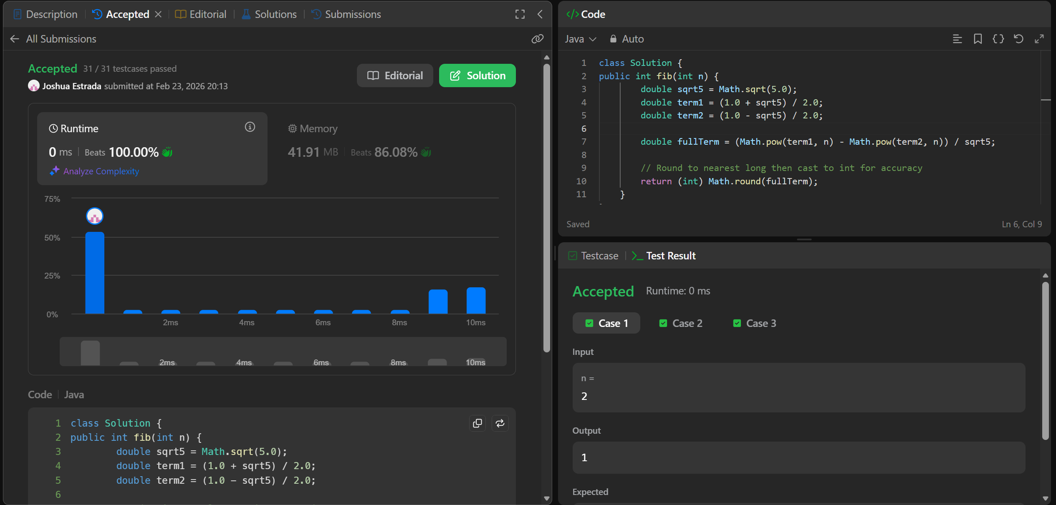
It did beat them in terms of time complexity but a regular iterative solutions also runs in 0 ms. I guess leetcode isn’t precise enough which its submissions but in theory this one is way faster than the iterative approach.

https://link.springer.com/chapter/10.1007/978-3-030-24318-0_1
So I found this research paper which explores an implementation of image segmentation using random walks which I found very interesting because I used to dabble a lot in image processing and related things with images and I was not aware an implementation existed using random walks. So I went ahead and read the abstract of the paper and skimmed it a little bit and then implemented what they talked about in the paper. Essentially, every pixel is a node of the graph which is the image. You place a few “seeds” which are basically the target of the segmentation. Then for every unassigned pixel you release a biased random walker. The walker is biased towards pixels of similar colors or intensities. The algorithm calculates the probability of a walker starting at a specific pixel hitting a foreground seed before a background seed. This idea is pretty solid but it needs a slight modification to make it better which the paper also explores. The current pitfall is that this walker can very likely walk into a place even though it shouldn’t. To circumvent this, they added a k-means clustering step beforehand which groups the image into K clusters beforehand to create more visual contrast and in turn, make each section of the image a lot more distinct. The impact of the k-means on the overall segmentation can be seen in the image below where I also show the results.
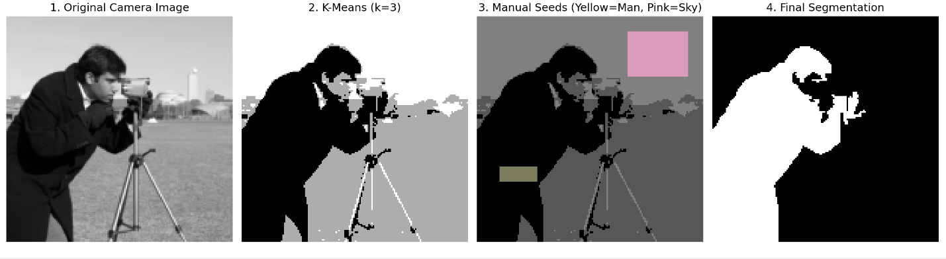
If I were to put additional time into this maybe I would find a way to get the “optimal” K for this clustering. I kind of just picked K=3 because there seems to be 3 main color sections within the image, the man, the sky, and the ground and I wanted to distinguish those for the walker. But technically I could have made K=2 so the sky and the ground get grouped together. I actually went ahead and did that which I attached below this paragraph.
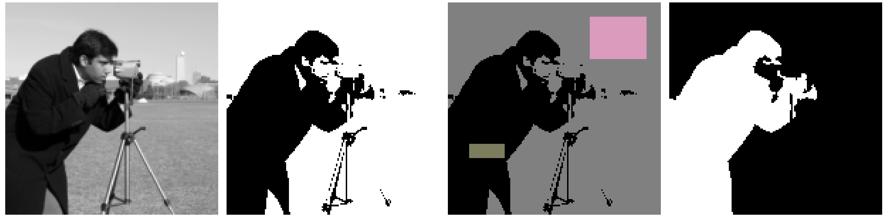For more complex images, this “optimal” clustering is not trivial to find, even then for this one, I can’t really tell if K=2 or K=3 is better for the walkers. So maybe some algorithmic or mathematical approach to estimating an optimal K for this task would be good.

