PHC 6020, Spring 2026: Homework #1

Name: Joseph Dickerson Student ID #: 9116-0693

Problem 1:
(a)
One of the primary differences between Epidemiology and a Clinical Trial is that Epidemiology predominantly uses observational data to study disease etiology, while Clinical Trials are performed in a controlled setting, often in which subjects are given a placebo or an intervention (a drug, for example) to determine the effect or lack thereof on the subjects. As discussed in the lectures, there are many definitions of a Clinical Trial, but a commonality between them is the existence of an intervention. One example of an Epidemiological study is the cross-sectional study, and an example of a Clinical Trial study is the Continual Reassessment Method, which is a Phase 1 clinical trial.

(b)
A cross-sectional study uses data that is acquired from a random sample of the population of interest at a single point in time to examine the prevalence of the disease in question at that moment in time. A case-control study is retrospective, in which individuals who have the disease in question (cases) and those without the disease (controls) are examined and compared using prior medical records or questionnaires to explore risk factors and exposure. Case control studies can estimate odds ratios to better understand the exposure circumstances of a disease.

(c)
You estimate relative risk as follows:

Which represents the prevalence of disease among exposed over the prevalence of the disease among the unexposed. If relative risk is greater than 1, there is a positive association of risk when exposed. If relative risk equals 1, there is no association. And if it is less than 1, there is a negative association. However, it is not proper to use relative risk with a case-control study because the cases and controls are selected by the researchers and not random. It is more appropriate to use odds ratio for a case-control study:

This can be calculated as

with the two-way table as follows:
D
E

(d)
One of the most clear benefits of the case-control study is speed. Because you do not need to track the disease over time, it is quicker to obtain the results of the study. This is a very significant pro because it is typically preferred to obtain results quicker in order to better understand the disease and help people sooner. Another pro is case-control being a stronger study design for rare diseases because they are more likely to have small amounts of participants, and a prospective study is liable to over-represent the study design. The cons of case-control, however, are relying on patient memory and record history. There are biases involved due to this factor (such as recall bias, recency bias, etc.) that can negatively impact the data as individuals might not remember all the details of their particular situation, or might over-emphasize areas due to biases.

Problem 2:
(a)
This project is a cross-sectional study, and the exposed variable is smoking status and the disease variable is liver cancer status.

(b)
The relative risk is as follows

Using the information from part (c), we can use the patient counts to perform the calculations for readability and interpretability:
(90/300) / (70/700) = 0.3 / 0.1 = 3
For the odds ratio, we find the odds of cancer in smokers and the odds of cancer in non-smokers:

((90/300)/(1 – 90/300)) / ((70/700)/(1 – (70/700))
= (0.3/0.7) / (0.1/0.9) = 0.429/0.111 = 3.857

In plain terms, the relative risk value indicates that smokers have 3 times the risk of developing the liver cancer compared to non-smokers. The odds ratio indicates that smokers have 3.857 times the odds of having the liver cancer.

(c)
 | Having liver cancer | Not having liver cancer | Total
Smoker | 90 | 210 | 300
Non-smoker | 70 | 630 | 700
Total | 160 | 840 | 1000

Per the lecture notes, we can calculate the variance estimate of with:

and can use that variance to find our 95% confidence interval:

Our odds ratio from part (c) is 3.857, and we use 1.96 for zeta per the lecture slide #33 so our 95% confidence interval is as follows:

exponentiated to be on the appropriate scale:

and a 95% confidence interval of (2.720, 5.469)
We can say that based on this sample, there appears to be a significant relationship between smoking and liver cancer because the 95% confidence interval does not pass through 0, which would indicate no association of risk.

Problem 3:
(a)
We will approach this problem as a Simon’s two stage design. Our integers per the design notes in the lectures will be:

Per the lectures, X₁ = responses in stage 1, and X₂ = responses in stage 2, so:
X₁ ~ Binomial(3, 0.25)
X₂ ~ Binomial(6, 0.25)
If X₁ > 0 and (X₁ + X₂) > 3, the drug is a success.

p=0.25
The probabilities for stage 1 are computed as follows:
P(X₁ = 3) = 0.25³ = 0.01563
P(X₁ = 2) = 3(0.25)²(0.75) = 0.1406
P(X₁ = 1) = 3(0.25)(0.75)² = 0.4219

The probabilities for stage 2 are computed:
P(X₂ = 0) = 0.75⁶ = 0.1780
P(X₂ = 1) = 6(0.25)(0.75)⁵ = 0.3560
P(X₂ = 2) = 6(0.25)²(0.75)⁴ = 0.2966
We can subtract these from 1 to get the probability of positive response:
1 – (0.1780+0.3560+0.2966) = 0.1694
And lastly:
1 – (0.1780 + 0.3560) = 0.466
per the study design. We compute the probability of success:
Prob(success) = 0.01563 + 0.1694(0.4219) + 0.466(0.1406) = 0.153
We can check this in R:
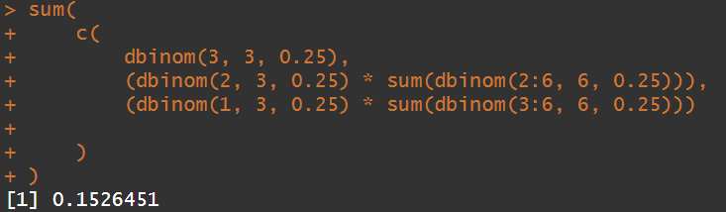
And we get the same result

p=0.5
We are successful if:
X
P(X₁ = 3) = 0.125
P(X₁ = 2) = 0.375
P(X₁ = 1) = 0.375
P(X₂ >=3) = 0.6563
P(X₂ >=2) = 0.8906
Doing the same computation but for p=0.5 gives us:
Prob(Success) = 0.705
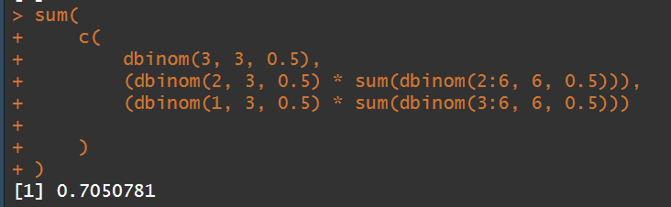

(b)
Per the lecture, we have:

=
+
And as noted in part (a),

So, plugging in we have:

We can again use R to compute from this equation:
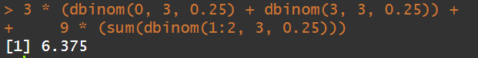
The result is 6.375, but we can round down to 6 since we cannot have a fraction of a patient. So, the expected number of patients using the two-stage decision rule at probability of response 0.25 is 6. Performing the same with 0.5 probability gives us 7.5, or 8 rounded up.
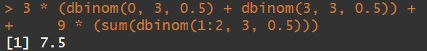

Problem 4:
(a)
Per the lecture, we are given:

Per the assignment instructions, we will have π₀ = 0.3 and α₀ = 0.05. Using these we have:

Therefore, 9 patients would be appropriate for the first stage. Though we rounded down in the previous problem, I would round up in this scenario.
For the second stage, assuming at least one patient responds, we add (n – n₀) and select a patient count by the formula provided in the lectures:
= 0.10, per the instructions indicating margin of error is +-0.10.

We round up to 81, which means we would study 81 – 9 = 72 individuals in stage II. For the decision rule, we would need to count how many patients respond in stage II to estimate pi and determine if the treatment is significant in a 95% confidence interval. We would want to see at least 0.3 in the interval to meet the minimal acceptable response rate per the requirements of the trial.

(b)
We want to determine:

Where our response rate is 0.5 and n₀ is 9 per part (a).

Which is very high probability. With a true response rate of 1/2, we can understand that it is very unlikely for all 9 patients to not respond. This is why the probability of continuing is 0.998.

