PHC 6020, Spring 2026: Homework #2

Name: Joseph Dickerson Student ID #: 9116-0693

Problem 1:
(a)
Per the set up of the problem:

with and
We know via binomial distribution:

So, with
we can reason:
We calculate :

Again, with

We then need
Via binomial distribution:

And
Therefore,

So,

Recall from before:

So,

Finally:

So, is an unbiased estimator for

Problem 2:
(a)
With no variation, we have:

where X is the sum of responses across studies, and n the total number of patients across studies. Therefore, for our estimate of π we have:

For the standard error, we have:

(b)
Per the lecture slides, we have:

and our standard error as follows:
where and

(c)
Per the lecture slides, we have:

This is shown in R:
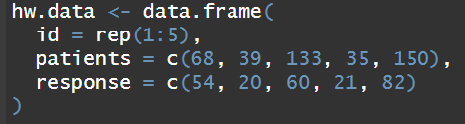
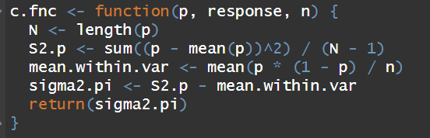

Problem 3:
(a)
Null hypothesis H₀: There is no difference in response between treatment A and treatment B at the 0.05 significance level.
Alternate hypothesis H₁: There is a difference in response between treatment A and treatment B at the 0.05 significance level.
With notation of our statistical model:
are iid
are iid

And we reject H₀ if the observed:

is too large

(b)
Per our design-based inference:
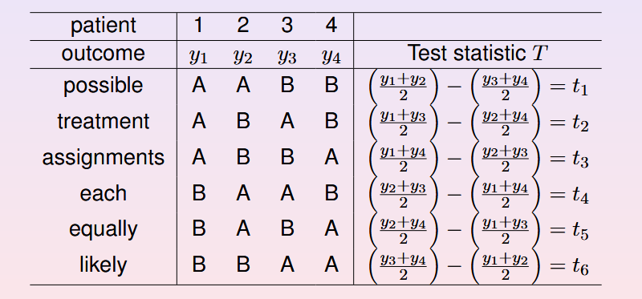
In our case, where patients 1 and 4 received treatment A, and patients 2 and 3 received treatment B. Our values for are as follows:
Patient | 1 | 2 | 3 | 4
Outcome | y₁=23 | y₂=18 | y₃=11 | y₄=30 | Test statistic
 | A | A | B | B | t₁ = 0
 | A | B | A | B | t₂ = -7
 | A | B | B | A | t₃ = 12
 | B | A | A | B | t₄ = -12
 | B | A | B | A | t₅ = 7
 | B | B | A | A | t₆ = 0

We are interested in determining if the treatment A is significantly different than B at the 0.05 level. We will perform a test to obtain a two-sided P-value:
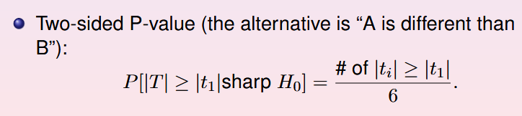
In this case, our t₁ is 12, as ABBA is our block where patients 1 and 4 received treatment A, and patients 2 and 3 received treatment B. We have two values where , t₃ and t₄. So, our p-value is , or 0.33. We therefore reject the null hypothesis at the 0.05 significance level.

Problem 4:
(a)
Permuted block randomization has a fixed block size so that each block contains some predetermined about of patients, then depending on the number chosen you have some number of possible combinations of each block. So, for example, block size of 4 would give you six possible block combinations, as illustrated in problem 3 (AABB, ABAB, ABBA, BAAB, BABA, BBAA). For each block of 4 patients in this example, they would be assigned one of these six combinations. Simple randomization is a little more straightforward. A patient has probability π of receiving treatment A and 1-π probability of receiving treatment B. π will often be 0.5, a coin flip. Here lies one of the disadvantages of permuted block randomization. Simple randomization is easy to execute, while permuted block randomization is a little more involved. In addition, it is stronger against selection bias, as it is (more or less) not feasible to predict a coin flip, and it would be possible to guess subsequent treatment with a fixed block size. On the other hand, there are many advantages to permuted block randomization. You have more control over having an even spread of patients in treatment A and treatment B. You cannot control for this when assigning patients truly at random with a coin flip (probability 0.5). This means permuted block randomization is better equipped to handle smaller sample sizes than simple randomization is, as n=20, though not likely, could leave a researcher with 5 in treatment A and 15 in treatment B with simple randomization. Though it is more involved to implement the advantages of permuted block randomization seem to outweigh the disadvantages.

