PHC 6020, Spring 2026: Homework #3

Name: Joseph Dickerson Student ID #: 9116-0693

Problem 1:
(a)
Covariate adaptive randomization is such that the allocation probability depends on the allocation of treatment for previous patients. An example of this design is the Efron-based coin design. Response adaptive randomization is such that the allocation probability is determined by the outcome of previous patients. This aims to maximize the amount of patients receiving the best treatment. Play-the-winner is an example of this allocation scheme.

(b)
Efron-based coin design is a covariate adaptation allocation. You choose an integer D and a probability that is less than 0.5. n_{A} and n_{B} are the number of patients receiving either treatment A or treatment B. In the example, D=3 and =0.25. A patient is assigned to treatment A with π_{A}:
if
if
if
and again, n_{A} and n_{B} are patients with treatment A and B before current treatment assignment.

(c)
Play-the-winner rule is a response adaptive randomization. The procedure starts with the first patient being assigned to treatment A or B with equal probability (0.5). If this patient has a success with their treatment, then the following patient is assigned the same treatment. If that first patient experiences a failure with response, then the subsequent patient receives the other treatment. You stay with the winner until a failure happens, then switch treatment. Below is an example:
 | Patient 1 | Patient 2 | Patient 3 | Patient 4 | Patient 5 | Patient 6 | Patient 7
Treatment
A | S | S | F |  |  | S | S
B |  |  |  | S | F
(d)
The most apparent difficulty with response adaptive allocation schemes is related to time. Information regarding the success and failures of patients may not be available immediately, which can lead to issues with sample size. Further, by taking more time with the trial, it could prevent the general population from having access to the treatment as quickly as they would otherwise due to the slower nature of the response adaptive allocation scheme. Additionally, the allocation scheme may require more patients to get the result, and such an allocation scheme may not be up to par with the ethical principle of equipoise, which pertains to uncertainty when assigning treatments to patients.

Problem 2:
(a)
The studies approved by the Internal Review Board ought to adhere to certain prerequisites. The study must minimize risk to its participants, and the risk must be reasonable compared to the potential benefit. There should be equitable access to the study, and each participant must be informed adequately in order to provide informed consent to participate in the study, which includes information on the drug being study and preexisting drugs, as well as the ability to drop out of the study at any time. The safety of the patients should be properly monitored, and the patients’ privacy and data should be protected.

(b)
A protocol document has several benefits. It aides investigators in approaching the research and prepares staff involved with the research for pragmatic preparations, such as forms and processing. It also helps with patient and study management during the planning stage of the study, and provides a sounding board for external comments. It is also useful for other investigators who wish to review and perhaps replicate the results.

Problem 3:
(a)
From slide 32, we have:
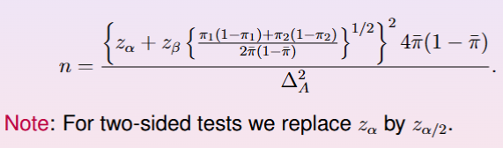
And we will conduct a two-sided test.
Our given variables:

Power = 0.9, therefore
Control response:
Treatment response:

Our will be 1.28
We find:
We compute:

= 0.9*0.1 + 0.8*0.2 = 0.25
Denominator:

= 2*0.85*0.15 = 0.255
Plugging into the formula:

Plugging it all back into our formula:

Rounding, we would have a sample size of 531, so with equal allocation we will take 531/2 to get 265.5, or rounded 266 per treatment group.

(b)
We will use the test statistic from slide 39:
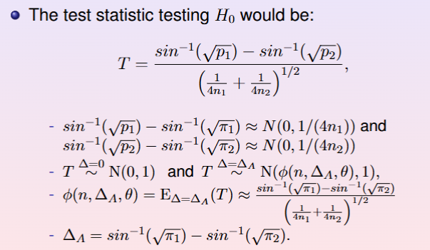

which is equal to

From the problem instructions:

We use the formula for test statistic T with
from equal allocation (slide 40).
Also from slide 40, sample size n has to satisfy

Returning to the formula on slide 39:

Our Z values are:

Combining, we get 3.24. Plugging into our formula for n:

Rounding, we get 521. So, with equal allocation, 521/2 = 260.5 for each group, or rounded up 261 per group.

Problem 4:
(a)
We use the formula provided from slide 26:
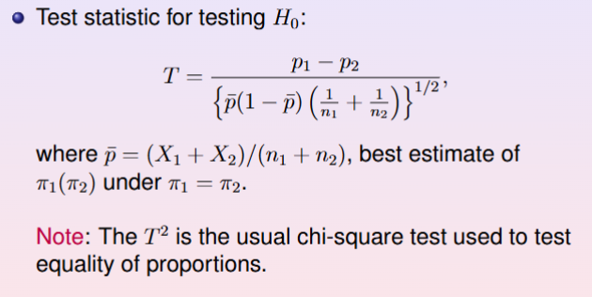
Where X₁=54, n₁=79 and X₂=63, n₂=81.
We can compute p₁ and p₂:

and:

We then obtain our test statistic:

We use the example on slide 22 for finding a two-sided p-value:
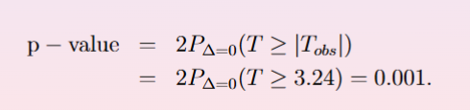
Where our T_{obs} is 1.341 because we take absolute value:

We use R to find the two-sided p-value:
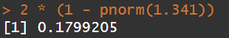
Our two-sided p-value is 0.1799, which indicates a lack of statistical significance.

(b)
We will approach using the equation from slide 39:
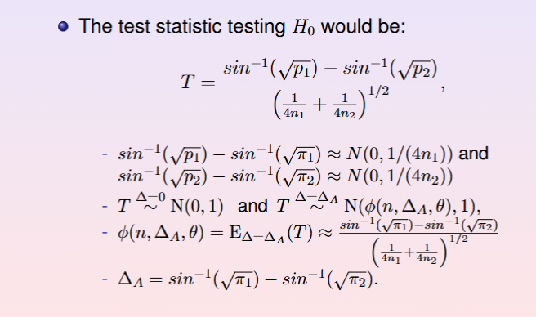
We will use the given information as noted in the previous slide to find T:

We take the absolute value for our T_{obs} to find the two sided p-value:

And we can again use R to compute:
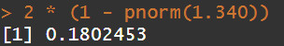
Our two-sided p-value is 0.1802, which is very similar to part a. and also lacks statistical significance.

(c)
We fail to reject the null hypothesis with either test, so we cannot say that there is a significant difference between treatment 1 and treatment 2 in the testing population.

