Joe Dickerson
PHC6063
Homework 03
03/11/2026

1.

The primary endpoint of this study is the overall response rate, the proportion of patients who respond to the treatment. This is the main variable of interest in the context of this problem.

The research hypothesis states that the overall response rates are different between the treatments. In other terms:
H₀: Response rates between treatments are the same (p₁=p₂)
H₁: Response rates between treatments are different (p₁≠ p₂)

The information we will need from the investigators to determine an appropriate sample size is the effect size/difference of importance (∆), desired power, desired significance level, the variance/variability, and though the investigators will not provide this we need to understand what kind of test to perform (one or two sided).

A two-sided test will be performed to test the hypothesis as we want to test the difference between the two treatments in either direction. An example of a two-sided test is the Chi-square test for independence.

2.
Retraction watch case: https://retractionwatch.com/2026/02/23/glp-1-study-retracted-ozempic-saxenda-contrave-statistics/
The case selected involves a retracted study about GLP-1 treatment (Ozempic being the common name-brand treatment) when paired with an additional drug, bupropion/naltrexone, intended to promote weight loss. The study was a retrospective cohort study involving obese adults who were already taking the GLP-1 (Ozempic) and introduced the additional drug in some of the participants in an effort to determine if there would be additional weight loss. A statistical editor by the name of David Allison came across the study and noticed discrepancies with the paper’s results, noting that the results were not reproducible after analyzing the raw data. His group analyzed the raw data in conjunction with the results to determine this. Allison brought this to the attention of the International Journal of Obesity, the journal the published the article, and after reassessing the results and investigating the data, it was retracted for the concerns brought up by Allison. As of the time of the article, the authors of the study disagree with the retraction. They are under the impression that there isn’t enough information present that detail specific issues with the methods. Allison has alluded to the main error in analysis stemming from improper methods of analyzing heterogeneity of treatment effect. Ultimately, after reviewing the study, the journal retracted the study.

3.
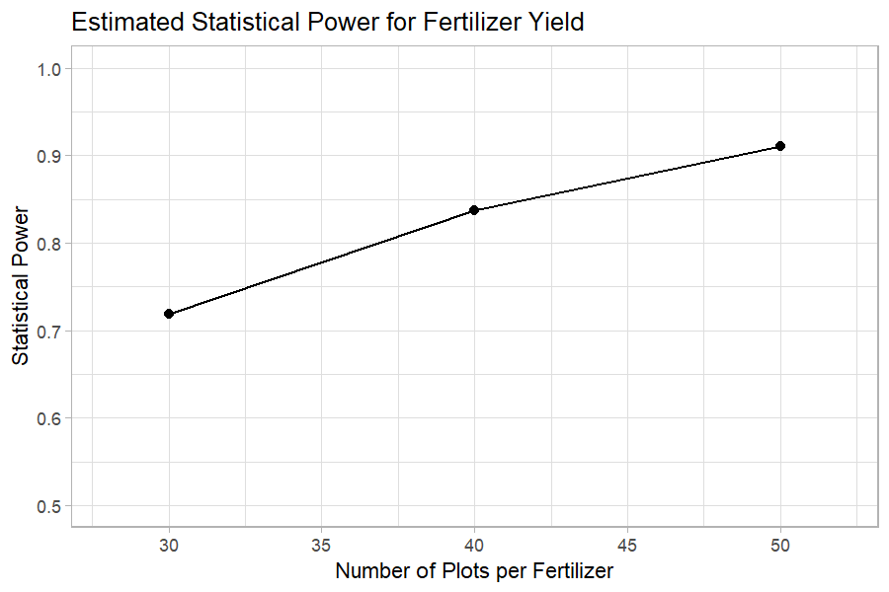
As we can see from the plot, 50 plots per fertilizer appears to have the largest power, while 30 plots per fertilizer appears to have the smallest power. We can also check the specific power values in a simple R output:
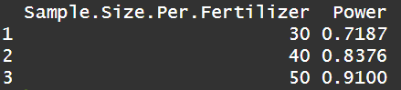
Below is the code that produced the plot and table. I used the power.t.test() function in base R to obtain the powers and the ggplot2 package within the tidyverse to create the figure.
