Problem Set 2
Joe Dickerson
2026-02-14

1.
We use the provided code to make the LOD score plot with 100 marker map and then recreate the LOD score plots using 10 marker map as follows:
########################################
## Original method, Dense Marker Map: ##
########################################
library(qtl)
set.seed(899)
## Simulated genetic map with 100 markers:
map1 <- sim.map(100, n.mar = 100, include.x=FALSE, eq.spacing=FALSE)
plot(map1)
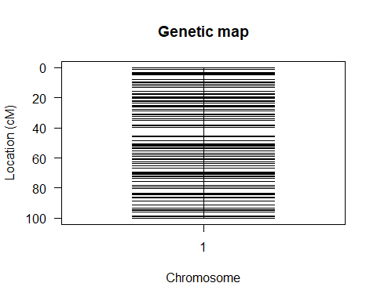
## Simulating phenotype and genotyping data
## ONE QTL model: chr, cM position, a, d
fake1 <- sim.cross(map1, type="f2", n.ind=100, model = rbind(c(1,50,4,0)))
## True QTL
boxplot(fake1$pheno[,1]~fake1$qtlgeno[,1])
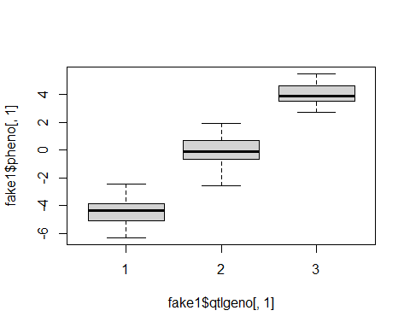
## First Marker
boxplot(fake1$pheno[,1]~fake1$geno$`1`$data[,1])
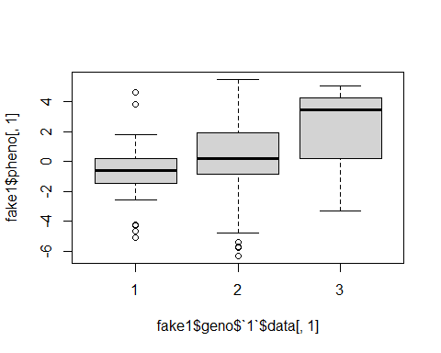
## Step 1, pre-calculate probabilities.
tt <- calc.genoprob(fake1, step=.1)
# Step 2, run each method:
temp.1 <- scanone(tt, chr=1, pheno.col=1, method="mr")
temp.2 <- scanone(tt, chr=1, pheno.col=1, method="em")
temp.3 <- scanone(tt, chr=1, pheno.col=1, method="hk")
# Step 3, plot results:
plot(temp.1, temp.2, temp.3, col=c("red","blue","black"))
abline(v=50)
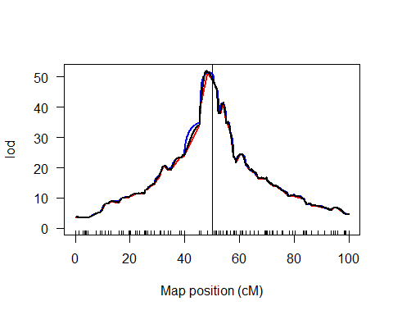
#######################
## Sparse Marker Map ##
#######################
## 10 markers
map2 <- sim.map(100, n.mar = 10, include.x=FALSE, eq.spacing=FALSE)
plot(map2)
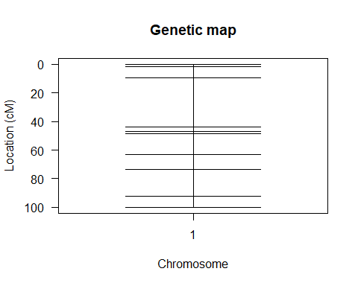
## Phenotype and genotype simulation for 10 markers
fake2 <- sim.cross(map2, type="f2", n.ind=100, model = rbind(c(1,50,4,0))) # ONE QTL model: chr, cM position, a, d
## True QTL
boxplot(fake2$pheno[,1]~fake2$qtlgeno[,1])
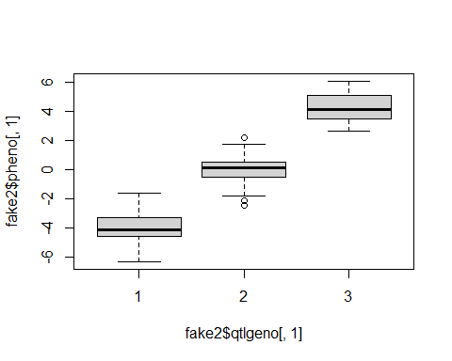
## First Marker
boxplot(fake2$pheno[,1]~fake2$geno$`1`$data[,1])
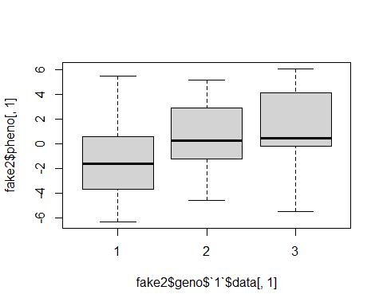
## mapping step 1
tt2 <- calc.genoprob(fake2, step=.1)
# The three methods:
temp2.1 <- scanone(tt2, chr=1, pheno.col=1, method="mr")
temp2.2 <- scanone(tt2, chr=1, pheno.col=1, method="em")
temp2.3 <- scanone(tt2, chr=1, pheno.col=1, method="hk")
# Plot:
plot(temp2.1, temp2.2, temp2.3, col=c("red","blue","black"))
abline(v=50)
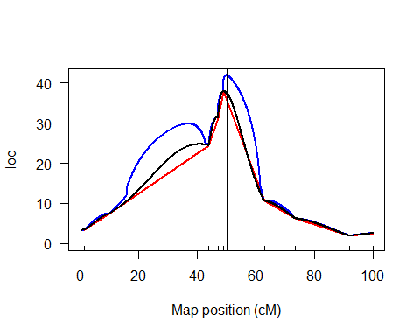
Both appear to peak around 50 cM, though the dense marker map peaks higher with a LOD of approximately 50 for each of the three methods, while the sparse marker map peaks closer to 40 with the EM algorithm, and around 35 for the other two methods. The dense marker map appears to be more consistent between the three methods, while there is a notable difference between the LOD scores of the three methods in the sparse marker map.

2.
We perform the selective genotyping example and the example that includes individuals with only complete data.
## Keeping all Phenotypes but setting Genotypes to missing
selective.geno <- which(abs(fake1$pheno$phenotype) < 2)
fake1$geno$`1`$data[selective.geno,] <- NA
## Mapping step 1
tt3 <- calc.genoprob(fake1, step=.1)
## Step 2:
temp3.1 <- scanone(tt3, chr=1, pheno.col=1, method="mr")
temp3.2 <- scanone(tt3, chr=1, pheno.col=1, method="em")
temp3.3 <- scanone(tt3, chr=1, pheno.col=1, method="hk")
plot(temp3.1, temp3.2, temp3.3, col=c("red","blue","black"))
abline(v=50)
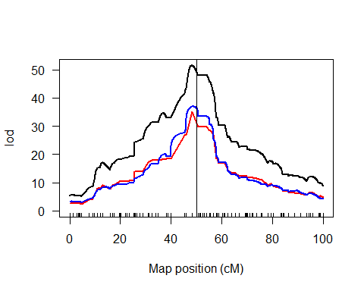
## Individuals with complete data:
fake1_sub <- subset(fake1, ind=(ntyped(fake1) > 0))
## Step 1:
tt4 <- calc.genoprob(fake1_sub, step=.1)
## Step 2:
temp4.1 <- scanone(tt4, chr=1, pheno.col=1, method="mr")
temp4.2 <- scanone(tt4, chr=1, pheno.col=1, method="em")
temp4.3 <- scanone(tt4, chr=1, pheno.col=1, method="hk")
plot(temp4.1, temp4.2, temp4.3, col=c("red","blue","black"))
abline(v=50)
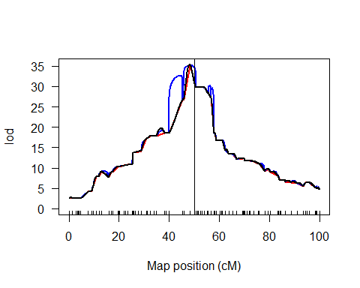
We see much more variation in the LOD score plot with all individuals. The Haley-Knott method has the highest LOD score at 50 or so, while the other two methods peak around 35. In the LOD score plot of consisting only of individuals with complete data, we see more similar results between the three methods, though the EM algorithm has an interesting feature between 40 cM and 50 cM.

3.
The “DiPetrillo3” dataset is downloaded from https://phenome.jax.org/projects/DiPetrillo3 and a LOD score plot is made. It appears at map position of 50 cM Haley-Knott method has a LOD score of 0.6, while EM method peaks closer to 45 cM with a LOD score of 0.4. However, there is not nearly as clear of a high point as in the previous plots, so it is hard to say with certainty. The marker regression line has higher variation, with a spike at 45 and 70 cM with a LOD score of just over 1.
data <- read.cross(file="DiPetrillo2004_C3HxSWR_B37_Data.csv", format="csv")
## --Read the following data:
## 217 individuals
## 103 markers
## 6 phenotypes
## --Cross type: f2
tt0 <- calc.genoprob(data, step=1)
temp0.1 <- scanone(tt0, chr=1, pheno.col=1, method="mr-imp")
temp0.2 <- scanone(tt0, chr=1, pheno.col=1, method="em")
temp0.3 <- scanone(tt0, chr=1, pheno.col=1, method="hk")
plot(temp0.1, temp0.2, temp0.3, col=c("red","blue","black"))
abline(v=50)
