6097-final-proj.R
Joe
2025-12-01
library(tidyverse)
## Warning: package 'tidyverse' was built under R version 4.4.2
## Warning: package 'tidyr' was built under R version 4.4.2
## Warning: package 'readr' was built under R version 4.4.2
## Warning: package 'purrr' was built under R version 4.4.2
## Warning: package 'forcats' was built under R version 4.4.2
## Warning: package 'lubridate' was built under R version 4.4.2
## ── Attaching core tidyverse packages ──────────────────────── tidyverse 2.0.0 ──
## ✔ dplyr 1.1.4 ✔ readr 2.1.5
## ✔ forcats 1.0.0 ✔ stringr 1.5.1
## ✔ ggplot2 3.5.1 ✔ tibble 3.2.1
## ✔ lubridate 1.9.3 ✔ tidyr 1.3.1
## ✔ purrr 1.0.2
## ── Conflicts ────────────────────────────────────────── tidyverse_conflicts() ──
## ✖ dplyr::filter() masks stats::filter()
## ✖ dplyr::lag() masks stats::lag()
## ℹ Use the conflicted package (<http://conflicted.r-lib.org/>) to force all conflicts to become errors
library(ggplot2)
library(gridExtra)
## Warning: package 'gridExtra' was built under R version 4.4.3
##
## Attaching package: 'gridExtra'
##
## The following object is masked from 'package:dplyr':
##
## combine
library(randomForest)
## Warning: package 'randomForest' was built under R version 4.4.3
## randomForest 4.7-1.2
## Type rfNews() to see new features/changes/bug fixes.
##
## Attaching package: 'randomForest'
##
## The following object is masked from 'package:gridExtra':
##
## combine
##
## The following object is masked from 'package:dplyr':
##
## combine
##
## The following object is masked from 'package:ggplot2':
##
## margin
library(tree)
## Warning: package 'tree' was built under R version 4.4.3
library(e1071)
## Warning: package 'e1071' was built under R version 4.4.3
data <- read.csv("social-media.csv")
data <- data %>%
mutate(GenderNumeric = ifelse(Gender == "Male", 1, 0)) %>%
mutate(Affects_Academic_Performance_Numeric = ifelse(
Affects_Academic_Performance == "No", 0, 1)) %>%
mutate(Mental_Health_Score_Class = ifelse(
Mental_Health_Score <= 5, 0, 1
))
data <- data[, -5]
attach(data)
g1 <- data %>%
ggplot(aes(y = Avg_Daily_Usage_Hours, x = Addicted_Score)) +
geom_point() +
geom_smooth(fill = NA) +
theme_minimal()
g2 <- data %>%
ggplot(aes(y = Avg_Daily_Usage_Hours, x = Mental_Health_Score)) +
geom_point() +
geom_smooth(fill = NA) +
theme_minimal() +
theme(axis.title.y = element_blank())
data %>%
ggplot(aes(x = Gender, y = Avg_Daily_Usage_Hours)) +
geom_boxplot()
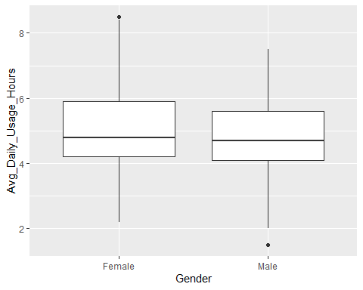
data %>%
ggplot(aes(x = Most_Used_Platform, y = Avg_Daily_Usage_Hours)) +
geom_boxplot()
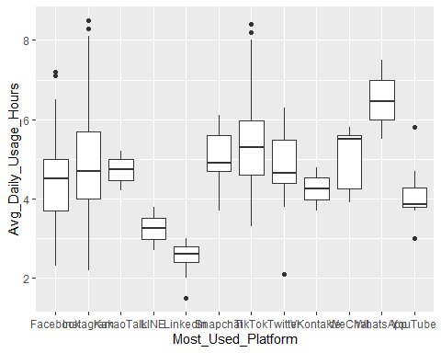
data %>%
ggplot(aes(x = Most_Used_Platform, color = Gender)) +
geom_bar()
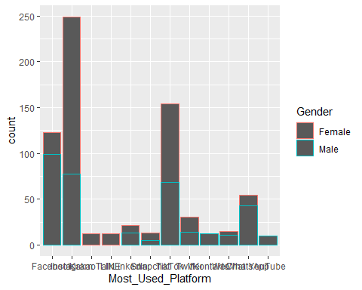
grid.arrange(g1, g2, nrow = 1)
## `geom_smooth()` using method = 'loess' and formula = 'y ~ x'
## `geom_smooth()` using method = 'loess' and formula = 'y ~ x'
## Warning in simpleLoess(y, x, w, span, degree = degree, parametric = parametric,
## : pseudoinverse used at 6
## Warning in simpleLoess(y, x, w, span, degree = degree, parametric = parametric,
## : neighborhood radius 1
## Warning in simpleLoess(y, x, w, span, degree = degree, parametric = parametric,
## : reciprocal condition number 0
## Warning in predLoess(object$y, object$x, newx = if (is.null(newdata)) object$x
## else if (is.data.frame(newdata))
## as.matrix(model.frame(delete.response(terms(object)), : pseudoinverse used at 6
## Warning in predLoess(object$y, object$x, newx = if (is.null(newdata)) object$x
## else if (is.data.frame(newdata))
## as.matrix(model.frame(delete.response(terms(object)), : neighborhood radius 1
## Warning in predLoess(object$y, object$x, newx = if (is.null(newdata)) object$x
## else if (is.data.frame(newdata))
## as.matrix(model.frame(delete.response(terms(object)), : reciprocal condition
## number 0
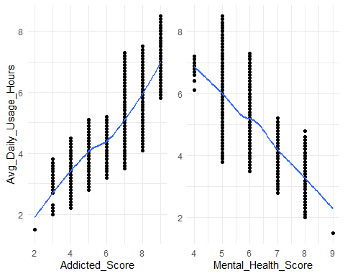
## Linear Model
lmod <- glm(Mental_Health_Score ~ Age + GenderNumeric +
Avg_Daily_Usage_Hours +
Affects_Academic_Performance_Numeric +
Sleep_Hours_Per_Night +
Avg_Daily_Usage_Hours +
Addicted_Score,
data = data, family = "gaussian")
summary(lmod)
##
## Call:
## glm(formula = Mental_Health_Score ~ Age + GenderNumeric + Avg_Daily_Usage_Hours +
## Affects_Academic_Performance_Numeric + Sleep_Hours_Per_Night +
## Avg_Daily_Usage_Hours + Addicted_Score, family = "gaussian",
## data = data)
##
## Coefficients:
## Estimate Std. Error t value Pr(>|t|)
## (Intercept) 11.147459 0.329321 33.850 < 2e-16 ***
## Age 0.006459 0.011310 0.571 0.56809
## GenderNumeric -0.015184 0.031244 -0.486 0.62713
## Avg_Daily_Usage_Hours -0.068503 0.021957 -3.120 0.00188 **
## Affects_Academic_Performance_Numeric 0.069518 0.057719 1.204 0.22883
## Sleep_Hours_Per_Night -0.067233 0.020650 -3.256 0.00119 **
## Addicted_Score -0.666826 0.024349 -27.387 < 2e-16 ***
## ---
## Signif. codes: 0 '***' 0.001 '**' 0.01 '*' 0.05 '.' 0.1 ' ' 1
##
## (Dispersion parameter for gaussian family taken to be 0.1285306)
##
## Null deviance: 859.688 on 704 degrees of freedom
## Residual deviance: 89.714 on 698 degrees of freedom
## AIC: 563.3
##
## Number of Fisher Scoring iterations: 2
## Logistic Model
glmod <- glm(Mental_Health_Score_Class ~
Avg_Daily_Usage_Hours +
Sleep_Hours_Per_Night,
data = data, family = "binomial")
summary(glmod)
##
## Call:
## glm(formula = Mental_Health_Score_Class ~ Avg_Daily_Usage_Hours +
## Sleep_Hours_Per_Night, family = "binomial", data = data)
##
## Coefficients:
## Estimate Std. Error z value Pr(>|z|)
## (Intercept) 7.2914 1.7466 4.175 2.99e-05 ***
## Avg_Daily_Usage_Hours -1.5234 0.1642 -9.277 < 2e-16 ***
## Sleep_Hours_Per_Night 0.2575 0.1639 1.572 0.116
## ---
## Signif. codes: 0 '***' 0.001 '**' 0.01 '*' 0.05 '.' 0.1 ' ' 1
##
## (Dispersion parameter for binomial family taken to be 1)
##
## Null deviance: 844.61 on 704 degrees of freedom
## Residual deviance: 519.86 on 702 degrees of freedom
## AIC: 525.86
##
## Number of Fisher Scoring iterations: 6
## Random Forest
set.seed(1)
seq <- sample(1:nrow(data), (nrow(data)/2))
train <- data[seq, ]
test <- data[-seq, ]
rf.model <- randomForest(Mental_Health_Score ~ Avg_Daily_Usage_Hours +
Age + GenderNumeric +
Affects_Academic_Performance_Numeric +
Sleep_Hours_Per_Night + Addicted_Score,
data = train)
## Warning in randomForest.default(m, y, ...): The response has five or fewer
## unique values. Are you sure you want to do regression?
yhat.rf <- predict(rf.model, newdata = test)
mean((yhat.rf - test[,"Mental_Health_Score"])^2) ## test mse 0.0997
## [1] 0.09971568
## similar to rf.model summary
plot(yhat.rf, test[,"Mental_Health_Score"])
abline(0, 1)
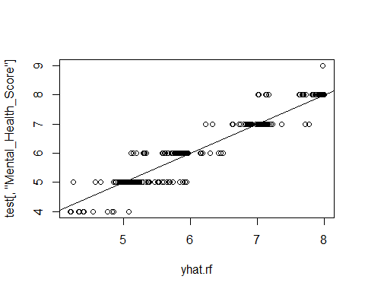
## SVM
# svm.fit <- svm(Mental_Health_Score_Class ~ ., data = train, kernel = "linear",
# cost = 0.01, scale = FALSE)
#
# summary(svm.fit)
tune.out <- e1071::tune(svm, Mental_Health_Score_Class ~ .,
data = train, kernel = "linear",
ranges = list(cost = c(.01, 1, 2, 4, 6, 8, 10)))
summary(tune.out)
##
## Parameter tuning of 'svm':
##
## - sampling method: 10-fold cross validation
##
## - best parameters:
## cost
## 1
##
## - best performance: 0.06209493
##
## - Detailed performance results:
## cost error dispersion
## 1 0.01 0.08110882 0.01217837
## 2 1.00 0.06209493 0.02332672
## 3 2.00 0.06334118 0.02345247
## 4 4.00 0.06722372 0.02832819
## 5 6.00 0.07326988 0.04242303
## 6 8.00 0.07316319 0.04213852
## 7 10.00 0.07309227 0.04212643
plot(tune.out) ## cost = 1
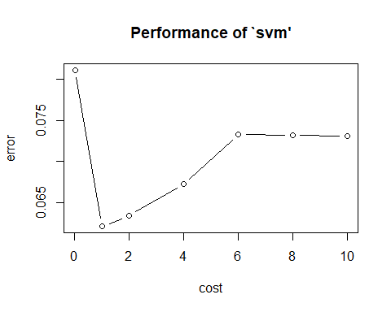
svm.fit <- svm(Mental_Health_Score_Class ~ ., data = train, kernel = "linear",
cost = 1, scale = FALSE)
summary(svm.fit)
##
## Call:
## svm(formula = Mental_Health_Score_Class ~ ., data = train, kernel = "linear",
## cost = 1, scale = FALSE)
##
##
## Parameters:
## SVM-Type: eps-regression
## SVM-Kernel: linear
## cost: 1
## gamma: 0.03703704
## epsilon: 0.1
##
##
## Number of Support Vectors: 236
yhat.svm <- predict(svm.fit, newdata = test, type = "class")
table(yhat.svm, test$Mental_Health_Score_Class)
##
## yhat.svm 0 1
## -0.796358008885979 1 0
## -0.687964971283852 1 0
## -0.676799548721807 1 0
## -0.639872679942688 1 0
## -0.612575954049295 1 0
## -0.611759764481737 1 0
## -0.582945916442601 1 0
## -0.526353542974154 1 0
## -0.450964524109783 1 0
## -0.28540690646803 1 0
## -0.237662245491426 1 0
## -0.225892444364196 1 0
## -0.201652089184042 1 0
## -0.19393430935195 1 0
## -0.170886801145731 1 0
## -0.159596766524534 1 0
## -0.155213652227009 1 0
## -0.151965727466792 1 0
## -0.143805903678346 1 0
## -0.129981188181024 1 0
## -0.124864915317791 1 0
## -0.119748643240361 1 0
## -0.114632370202504 1 0
## -0.111839197882706 1 0
## -0.0870964640245591 1 0
## -0.0474094782631953 1 0
## -0.0204295481864181 1 0
## -0.00856314249283674 1 0
## -0.0082149271303722 1 0
## 0.00166940401943361 1 0
## 0.0343215807614099 1 0
## 0.0412566011462543 1 0
## 0.0414405522850059 1 0
## 0.0445541274191994 1 0
## 0.0463728748826027 1 0
## 0.0477287535821445 1 0
## 0.0560483902352855 1 0
## 0.0563775729340916 1 0
## 0.0599150707883593 1 0
## 0.0668379660153944 1 0
## 0.0719542386457972 1 0
## 0.074881603792913 1 0
## 0.0784808683773219 1 0
## 0.0892575997957676 1 0
## 0.0935834187356006 1 0
## 0.0943738716985747 1 0
## 0.099490144940158 1 0
## 0.0997013935073694 1 0
## 0.0997608341375082 1 0
## 0.109722690812144 1 0
## 0.114136585509935 1 0
## 0.123457658609207 1 0
## 0.127603381474567 1 0
## 0.13499431027851 1 0
## 0.135444824942918 1 0
## 0.13981426706125 1 0
## 0.141999603084353 1 0
## 0.142113158736559 1 0
## 0.145458161029477 1 0
## 0.146182460545627 1 0
## 0.154929244573235 1 0
## 0.162322139319097 1 0
## 0.165214736664733 1 0
## 0.16724401124777 1 0
## 0.169189519669838 1 0
## 0.176513787310635 1 0
## 0.178793836001954 1 0
## 0.20673432213773 1 0
## 0.210402565319622 1 0
## 0.212117713071005 1 0
## 0.219309549730336 1 0
## 0.222006628037728 1 0
## 0.234502036308935 1 0
## 0.234709522027354 1 0
## 0.241667050878116 1 0
## 0.243731723409677 1 0
## 0.257015869031259 1 0
## 0.257048434456759 1 0
## 0.259016479419027 1 0
## 0.262132142942231 1 0
## 0.262882632504282 1 0
## 0.270620543010248 1 0
## 0.277023509176455 1 0
## 0.282597234831722 1 0
## 0.284266844358011 1 0
## 0.289627503264295 1 0
## 0.297826538337925 1 0
## 0.299216384907434 1 0
## 0.311496546690999 1 0
## 0.313025228776335 1 0
## 0.33580350338418 1 0
## 0.337556539869932 1 0
## 0.347789085771022 1 0
## 0.362934453689216 1 0
## 0.453566504943249 0 1
## 0.597641219467572 1 0
## 0.63063428696007 1 0
## 0.659392670621695 1 0
## 0.659818239054242 0 1
## 0.680564859018726 0 1
## 0.69768405009638 0 1
## 0.701140848223825 0 1
## 0.704871816599574 0 1
## 0.708737968593435 0 1
## 0.713789503179963 0 1
## 0.7153074035112 0 1
## 0.729178773947591 0 1
## 0.737996331338603 0 1
## 0.74817101507035 0 1
## 0.751519585794834 0 1
## 0.753485730538908 0 1
## 0.755549608885143 0 1
## 0.756933416046034 0 1
## 0.757351883187606 0 1
## 0.760589119464224 0 1
## 0.777250076217409 0 1
## 0.781658840550175 0 1
## 0.793737801878545 0 1
## 0.798174378122734 0 1
## 0.803754388786568 0 1
## 0.808474790780404 0 1
## 0.809159481849586 0 1
## 0.81174158867618 0 1
## 0.821434805732518 0 1
## 0.823034533091071 0 1
## 0.828908199308738 0 1
## 0.829024854948169 0 1
## 0.830735964768631 0 1
## 0.832512774369046 0 1
## 0.835002017217287 0 1
## 0.835027285257477 0 1
## 0.835193052097405 0 1
## 0.837586482181744 0 1
## 0.842475411084545 0 1
## 0.843348266654014 0 1
## 0.844619067075494 0 1
## 0.845284571939213 0 1
## 0.846258371088719 0 1
## 0.846891914998944 0 1
## 0.849083268486377 0 1
## 0.850395094991494 0 1
## 0.852443222752139 0 1
## 0.85529545934953 0 1
## 0.855511369164399 0 1
## 0.857494031863847 0 1
## 0.858590777885932 0 1
## 0.858851782958321 0 1
## 0.860365170627868 0 1
## 0.860413943427214 0 1
## 0.862100751134515 0 1
## 0.862136438906258 0 1
## 0.862630050502797 0 1
## 0.86574391393044 0 1
## 0.866010434004077 0 1
## 0.867624203888066 0 1
## 0.868658450692986 0 1
## 0.868983290924755 0 1
## 0.872418994035637 0 1
## 0.875976460326295 0 1
## 0.876044430081332 0 1
## 0.877331217542472 0 1
## 0.878518085936615 0 1
## 0.881092732199998 0 1
## 0.882910804600054 0 1
## 0.883177043909039 0 1
## 0.884049899071054 0 1
## 0.886202553762653 0 1
## 0.886209004888609 0 1
## 0.886917345599453 0 1
## 0.887026643623197 0 1
## 0.887536670935172 0 1
## 0.888515848327027 0 1
## 0.889270862079523 0 1
## 0.890216948998225 0 1
## 0.89193116129429 0 1
## 0.893246336107789 0 1
## 0.89637759983709 0 1
## 0.896503474107543 0 1
## 0.896744255190081 0 1
## 0.896965387636395 0 1
## 0.899235533531122 0 1
## 0.901313771663648 0 1
## 0.902476798811061 0 1
## 0.903999140583276 0 1
## 0.905545944299614 0 1
## 0.907577861546836 0 1
## 0.907982551706321 0 1
## 0.908628640269693 0 1
## 0.912450363170886 0 1
## 0.913120627325791 0 1
## 0.913614674626682 0 1
## 0.917566353785172 0 1
## 0.919920861290687 0 1
## 0.920104271232797 0 1
## 0.921145072565944 0 1
## 0.921549763453025 0 1
## 0.921949203834468 0 1
## 0.923520580991702 0 1
## 0.923977456443775 0 1
## 0.924751532477624 0 1
## 0.925853391362419 0 1
## 0.92750136368961 0 1
## 0.928138974729175 0 1
## 0.929023157727737 0 1
## 0.929093730121916 0 1
## 0.930064173657978 0 1
## 0.935116974413925 0 1
## 0.93831874416612 0 1
## 0.941877867861716 0 1
## 0.942590367582691 0 1
## 0.943463224199898 0 1
## 0.946964748475533 0 1
## 0.948684185462137 0 1
## 0.954155774444028 0 1
## 0.962251396248415 0 1
## 0.965441118120746 0 1
## 0.968657913161972 0 1
## 0.968718185943383 0 1
## 0.969139732197458 0 1
## 0.970646951168258 0 1
## 0.971837607164001 0 1
## 0.972656871842285 0 1
## 0.974256004973379 0 1
## 0.976992136750435 0 1
## 0.979589831821452 0 1
## 0.980233079792764 0 1
## 0.983292001978792 0 1
## 0.983886382319564 0 1
## 0.984164857810195 0 1
## 0.984706105499593 0 1
## 0.984888343615988 0 1
## 0.989822378188204 0 1
## 0.991931942330505 0 1
## 0.993025142403734 0 1
## 0.993831514070574 0 1
## 0.996859213405354 0 1
## 1.00295303029527 0 1
## 1.00341764260777 0 1
## 1.00618649468636 0 1
## 1.00648658374377 0 1
## 1.00652399450594 0 1
## 1.01042642480281 0 1
## 1.01626954970818 0 1
## 1.0215274211758 0 1
## 1.02310755689798 0 1
## 1.0261936753621 0 1
## 1.02892810252781 0 1
## 1.03162469017372 0 1
## 1.03178152149014 0 1
## 1.03296364264208 0 1
## 1.0342064609966 0 1
## 1.0362453241931 0 1
## 1.04037611239876 0 1
## 1.04062696535659 0 1
## 1.04251138989168 0 1
## 1.04439528776386 0 1
## 1.04839920284105 0 1
## 1.05118000738259 0 1
## 1.05191964073567 0 1
## 1.05232582757419 0 1
## 1.06317398498761 0 1
## 1.06337974544551 0 1
## 1.06863761461393 0 1
## 1.07066423514591 0 1
## 1.07343010408915 0 1
## 1.07477770687076 0 1
## 1.07897900400969 0 1
## 1.07927953578003 0 1
## 1.08657616547391 0 1
## 1.09097839796852 0 1
## 1.09188164070185 0 1
## 1.09254621456314 0 1
## 1.0933405150525 0 1
## 1.09494954009535 0 1
## 1.09578738563398 0 1
## 1.09682782920829 0 1
## 1.09921841656144 0 1
## 1.10219594522898 0 1
## 1.10267726053537 0 1
## 1.1061134260188 0 1
## 1.10984991445259 0 1
## 1.11437612345146 0 1
## 1.11576315613167 0 1
## 1.11616462970671 0 1
## 1.11899986424653 0 1
## 1.11901606236172 0 1
## 1.1224419776848 0 1
## 1.1234171254717 0 1
## 1.12608919736051 0 1
## 1.13052614249575 0 1
## 1.1325832747196 0 1
## 1.13324784782419 0 1
## 1.13346522335162 0 1
## 1.1351449571983 0 1
## 1.13965640739009 0 1
## 1.14615048387607 0 1
## 1.14681505936717 0 1
## 1.14970322377742 0 1
## 1.1505515481502 0 1
## 1.15426674548673 0 1
## 1.15971769725258 0 1
## 1.16049779015413 0 1
## 1.16486217489985 0 1
## 1.16895932542122 0 1
## 1.17043347465626 0 1
## 1.1739494823076 0 1
## 1.17542391365971 0 1
## 1.17684203553183 0 1
## 1.17952379262244 0 1
## 1.19040924527037 0 1
## 1.19511620313899 0 1
## 1.20397645757005 0 1
## 1.20476883559133 0 1
## 1.20749246434827 0 1
## 1.20763575889107 0 1
## 1.20929879316356 0 1
## 1.20996487167833 0 1
## 1.21113510646212 0 1
## 1.21650363014016 0 1
## 1.21754366791977 0 1
## 1.21882481911855 0 1
## 1.21913102080982 0 1
## 1.2210596740286 0 1
## 1.22353208223178 0 1
## 1.22470231788868 0 1
## 1.23269823095581 0 1
## 1.23288080279128 0 1
## 1.23474240798789 0 1
## 1.23709929432773 0 1
## 1.24559726234549 0 1
## 1.24693678626029 0 1
## 1.26873059699831 0 1
## 1.28407109237271 0 1
## 1.30044422445901 0 1
## 1.31462050796365 0 1
## 1.31559760770581 0 1
## 1.33243066836878 0 1
## 1.34862705332746 0 1
## 1.38112623222225 0 1
## 1.39098662860745 0 1
## 1.39317441208579 0 1
## 1.40746380879848 0 1
## 1.4542940796626 0 1
## 1.48712936183058 0 1
## 1.564875220817 0 1
## 1.57262984365282 0 1
## 1.59729852285347 0 1
## 1.60899738537666 0 1
## 1.61880632348659 0 1
## 1.63719923420724 0 1
## 1.65232242001623 0 1
## 1.6757201457611 0 1
## 1.68741900879361 0 1

