IN THE CIRCUIT COURT OF THE FIFTEENTH JUDICIAL CIRCUIT
IN AND FOR Sarasota BEACH COUNTY, FLORIDA

[% data.casetype %] DIVISION [% data.DivisionID %]
CASE NO. [% data.extendedcaseid %]

[% FOREACH plaintiff IN data.PLT %][% plaintiff %],
[% END %] Plaintiff(s)
v.
[% FOREACH defendant IN data.DFT %][% defendant %],
[% END %] Defendant(s).
________________________________/

MOTION, NOTICE AND ORDER OF DISMISSAL FOR LACK OF PROSECUTION

This matter came before the Court on its own motion. The Court finds that it on the face of the record that there have been no filings for a period of ten (10) months or more immediately preceding service of this Notice and no stay has been issued or approved by the Court. Pursuant to Florida Rule of Civil Procedure 1.420(e), if there are no filings within sixty (60) days following the service of this Notice, and no stay is issued or approved during such sixty (60) day period, this action may be dismissed by the Court on its own motion. It is therefore,
ORDERED AND ADJUDGED as follows:
This action shall be dismissed for lack of prosecution by further order of court unless a filing has made within sixty (60) days from the date of this order or a stay has been issued or approved by this Court.
DONE AND ORDERED in West Sarasota Beach, Sarasota Beach County, Florida this [% data.today %].

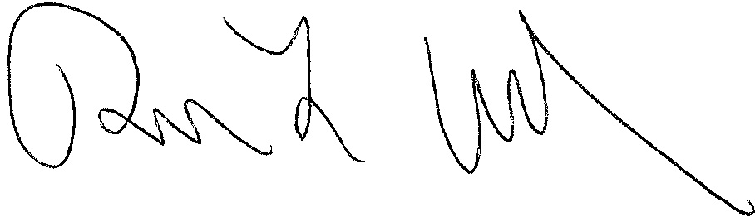
[% data.JUDG %]
[% data.TITLE %]

[% IF data.ccAddressList.size > 0 %]Copies furnished to:
[% FOREACH copy IN data.ccAddressList %][% copy %]
[% END %][% END %]

