IN THE CIRCUIT COURT OF THE FIFTEENTH JUDICIAL CIRCUIT
IN AND FOR Sarasota BEACH COUNTY, FLORIDA

[% data.casetype %] DIVISION [% data.DivisionID %]
CASE NO. [% data.extendedcaseid %]

[% FOREACH plaintiff IN data.PLT %][% plaintiff %],
[% END %] Plaintiff(s)
v.
[% FOREACH defendant IN data.DFT %][% defendant %],
[% END %] Defendant(s).
___________________________________________/
ORDER DIRECTING PLAINTIFF TO EFFECT SERVICE UPON DEFENDANT(S)
THIS CAUSE came before the Court upon a sua sponte review of the court file. One hundred and twenty (120) days has elapsed since the filing of the complaint, the Defendant(s) has not been served with process, and no court order extending the time has been entered.
IT IS HEREBY ORDERED that pursuant to Florida Rule of Civil Procedure 1.070(j), the Plaintiff is directed, within [% data.sdays %] days from the date of this order, to either serve process on the Defendant(s) or file a motion showing good cause or excusable neglect why the Defendant(s) has not yet been served with process. In the event that Plaintiff elects to file a motion for good cause or excusable neglect, Plaintiff shall set the motion for hearing before the Court and shall make a good faith effort to provide notice to all parties named herein.

Failure to comply with this Order in the time frame set forth above will result in this Order being deemed a dismissal of the case against the unserved Defendant(s) without further notice or order of court.
DONE AND ORDERED in Chambers at [% data.ddallcities %], Sarasota Beach County, Florida, on the [% data.today %].

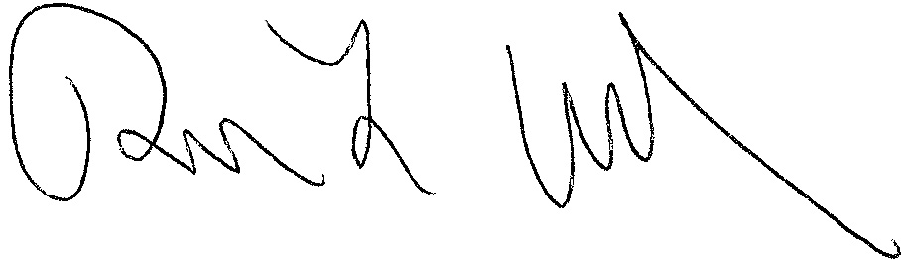
[% data.JUDG %]
[% data.TITLE %]

[% IF data.ccAddressList.size > 0 %]Copies furnished to:
[% FOREACH copy IN data.ccAddressList %][% copy %]
[% END %][% END %]

