IN THE [% IF data.isCircuit %]CIRCUIT[% ELSE %]COUNTY[% END %] COURT OF THE FIFTEENTH JUDICIAL CIRCUIT
IN AND FOR PALM BEACH COUNTY, FLORIDA

[% data.casetype %] DIVISION [% data.DivisionID %]
CASE NO. [% data.extendedcaseid %]

[% FOREACH plaintiff IN data.PLT %][% plaintiff %],
[% END %] Plaintiff(s)
and
[% FOREACH defendant IN data.DFT %][% defendant %],
[% END %] Defendant(s).

________________________________________/

ORDER SPECIAL SETTING HEARING
([% data.timeres %] minutes reserved)

THIS CAUSE came before this Court and is hereby set for hearing on Motion for [% data.motion %] on [% data.edate %] at [% data.etime %], at the Palm Beach County [% data.eaddr %] in Courtroom [% data.eloc %]. Please go to the white board on the 4th floor outside of courtroom 4A to confirm courtroom assignment.

THE SETTING PARTY, HAVING ELECTRONICALLY RECEIVED THE SIGNED ORDER SPECIALLY SETTING THIS HEARING, SHALL IMMEDIATELY SEND COPIES OF THIS ORDER TO ALL PARTIES ON THE SERVICE LIST.

This matter cannot be cancelled without further order of the court unless the parties have reached an agreement as to disposition of the motion. If an agreement is reached immediately email the CAD-DivisionAW-specialsethearings@jud12.flcourts.org an order cancelling the special set and submit the agreement via regular mail with the appropriate copies, envelopes and service list.

DONE AND ORDERED in [% data.ddallcities %], Palm Beach County, Florida, this [% data.today %].

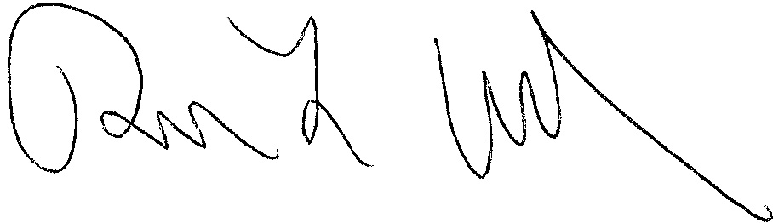
RICHARD L. OFTEDAL
Circuit Judge

[% IF data.ccAddressList.size > 0 %]Copies furnished to:
[% FOREACH copy IN data.ccAddressList %][% copy %]
[% END %][% END %]
This notice is provided pursuant to Administrative Order No. 2.207-9/12

“If you are a person with a disability who needs any accommodation in order to participate in this proceeding, you are entitled, at no cost to you, to the provision of certain assistance. Please contact [% data.ADACoordinator %], Americans with Disabilities Act Coordinator, Palm Beach County Courthouse, 205 North Dixie Highway West Palm Beach, Florida 33401; telephone number (561) 355-4380 at least 7 days before your scheduled court appearance, or immediately upon receiving this notification if the time before the scheduled appearance is less than 7 days; if you are hearing or voice impaired, call 711.”

“Si usted es una persona minusválida que necesita algún acomodamiento para poder participar en este procedimiento, usted tiene derecho, sin tener gastos propios, a que se le provea cierta ayuda. Tenga la amabilidad de ponerse en contacto con 205 N. Dixie Highway, West Palm Beach, Florida 33401; teléfono número (561) 355-4380, por lo menos 7 días antes de la cita fijada para su comparecencia en los tribunales, o inmediatamente después de recibir esta notificación si el tiempo antes de la comparecencia que se ha programado es menos de 7 días; si usted tiene discapacitación del oído o de la voz, llame al 711.”

“Si ou se yon moun ki enfim ki bezwen akomodasyon pou w ka patisipe nan pwosedi sa, ou kalifye san ou pa gen okenn lajan pou w peye, gen pwovizyon pou jwen kèk èd. Tanpri kontakte kòòdonatè pwogram Lwa pou ameriken ki Enfim yo nan Tribinal Konte Palm Beach la ki nan 205 North Dixie Highway, West Palm Beach, Florida 33401; telefòn li se (561) 355-4380 nan 7 jou anvan dat ou gen randevou pou parèt nan tribinal la, oubyen imedyatman apre ou fin resevwa konvokasyon an si lè ou gen pou w parèt nan tribinal la mwens ke 7 jou; si ou gen pwoblèm pou w tande oubyen pale, rele 711.”

