IN THE CIRCUIT COURT OF THE FIFTEENTH JUDICIAL CIRCUIT
IN AND FOR PALM BEACH COUNTY, FLORIDA

[% data.casetype %] DIVISION [% data.DivisionID %]
CASE NO. [% data.extendedcaseid %]

[% FOREACH plaintiff IN data.PLT %][% plaintiff %],
[% END %] Plaintiff(s)
And
[% FOREACH defendant IN data.DFT %][% defendant %],
[% END %] Defendant(s).
/

ORDER SETTING CASE MANAGEMENT CONFERENCE

THIS MATTER came before the Court, sua sponte, and is set for a Case Management Conference. This cause is NOT AT ISSUE and CANNOT BE SET FOR TRIAL for one or more of the following reasons:

- Failure to file a motion for default against parties that have failed to serve a responsive pleading (if served by publication, a default is still needed);
- Failure to file a notice of dropping and/or notice of voluntary dismissal of any parties that have not been served within the time required by law; and/or
- Failure to set for hearing (on the court’s uniform motion calendar) any motions directed to the pleadings (i.e. motion for leave to file amended complaint, amended answer and affirmative defenses; motion to dismiss; motion to strike affirmative defenses).

The Court sets this cause for a Case Management Conference on [% data.edate %] at [% data.etime %] in Courtroom [% data.courtroom %], 205 North Dixie Highway, West Palm Beach, Florida.

IT IS ORDERED AND ADJUDGED that Counsel review the court file and set by notice of hearing, all matters, whether plaintiff’s or defendant’s motions, that would prevent the case from being at issue. The motions are to be set on the above date and time with proper notice to all parties including but not limited to, Motions for Default sent to the Clerk but not entered.
IT IS FURTHER ORDERED AND ADJUDGED that Plaintiff’s counsel shall provide at the hearing, proposed orders for each motion to be heard and shall also submit a complete service list and set of envelopes for the case to be set for trial.

Failure to appear or timely comply with the terms of this order may result in the imposition of SANCTIONS, including DISMISSAL and/or STRIKING OF PLEADINGS.

DONE AND ORDERED at West Palm Beach, Palm Beach County, Florida, this [% data.today %].

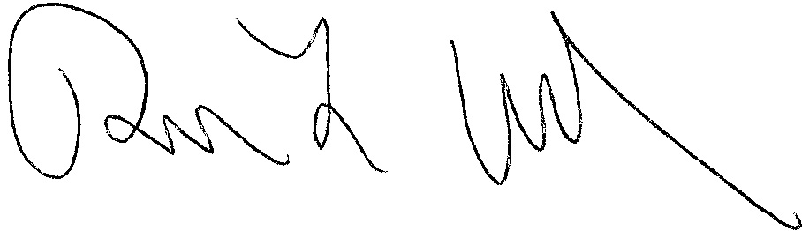
[% data.JUDG %]
[% data.TITLE %]

[% IF data.ccAddressList.size > 0 %]Copies furnished to:
[% FOREACH copy IN data.ccAddressList %][% copy %]
[% END %][% END %]

This notice is provided pursuant to Administrative Order No. 2.207-9/12

“If you are a person with a disability who needs any accommodation in order to participate in this proceeding, you are entitled, at no cost to you, to the provision of certain assistance. Please contact [% data.ADACoordinator %], Americans with Disabilities Act Coordinator, Palm Beach County Courthouse, 205 North Dixie Highway West Palm Beach, Florida 33401; telephone number (561) 355-4380 at least 7 days before your scheduled court appearance, or immediately upon receiving this notification if the time before the scheduled appearance is less than 7 days; if you are hearing or voice impaired, call 711.”

“Si usted es una persona minusválida que necesita algún acomodamiento para poder participar en este procedimiento, usted tiene derecho, sin tener gastos propios, a que se le provea cierta ayuda. Tenga la amabilidad de ponerse en contacto con 205 N. Dixie Highway, West Palm Beach, Florida 33401; teléfono número (561) 355-4380, por lo menos 7 días antes de la cita fijada para su comparecencia en los tribunales, o inmediatamente después de recibir esta notificación si el tiempo antes de la comparecencia que se ha programado es menos de 7 días; si usted tiene discapacitación del oído o de la voz, llame al 711.”

“Si ou se yon moun ki enfim ki bezwen akomodasyon pou w ka patisipe nan pwosedi sa, ou kalifye san ou pa gen okenn lajan pou w peye, gen pwovizyon pou jwen kèk èd. Tanpri kontakte kòòdonatè pwogram Lwa pou ameriken ki Enfim yo nan Tribinal Konte Palm Beach la ki nan 205 North Dixie Highway, West Palm Beach, Florida 33401; telefòn li se (561) 355-4380 nan 7 jou anvan dat ou gen randevou pou parèt nan tribinal la, oubyen imedyatman apre ou fin resevwa konvokasyon an si lè ou gen pou w parèt nan tribinal la mwens ke 7 jou; si ou gen pwoblèm pou w tande oubyen pale, rele 711.”

