IN THE [% IF data.isCircuit %]CIRCUIT[% ELSE %]COUNTY[% END %] COURT OF THE TWELFTH JUDICIAL CIRCUIT
IN AND FOR SARASOTA COUNTY, FLORIDA

[% data.casetype %] DIVISION [% data.DivisionID %]
CASE NO. [% data.extendedcaseid %]

[% FOREACH plaintiff IN data.PLT %][% plaintiff %],
[% END %] Plaintiff(s)
and
[% FOREACH defendant IN data.DFT %][% defendant %],
[% END %] Defendant(s).
/

NOTICE AND ORDER ADMINISTRATIVELY CLOSING REOPENED CASE

THIS MATTER comes before the court sua sponte upon a review of the case file and it appearing the case was reopened more than six months ago but that no action has been taken to close out the case or set for hearing any pending post judgment motion(s), it is hereby

ORDERED AND ADJUDGED as follows:
1. The Clerk is to administratively close out this case and any pending post trial motions not previously set for a hearing are considered abandoned.
2. This Order is without prejudice to any party to move to reopen the case and refile any motion deemed by this Order to have been abandoned.

DONE AND ORDERED in West Sarasota, Sarasota County, Florida, this [% data.today %].

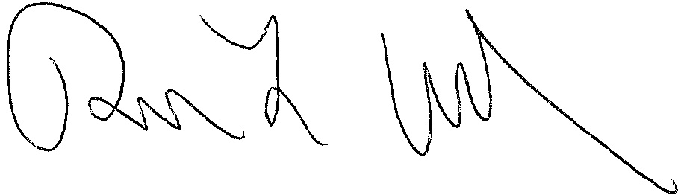
[% data.JUDG %]
[% data.TITLE %]

[% IF data.ccAddressList.size > 0 %]Copies furnished to:
[% FOREACH copy IN data.ccAddressList %][% copy %]
[% END %][% END %]

