IN THE [% IF data.isCircuit %]CIRCUIT[% ELSE %]COUNTY[% END %] COURT OF THE TWELFTH JUDICIAL CIRCUIT
IN AND FOR SARASOTA COUNTY, FLORIDA

[% data.casetype %] DIVISION [% data.DivisionID %]
CASE NO. [% data.extendedcaseid %]

[% IF data.DFT %][% IF ! data.PLT %]STATE OF FLORIDA,
[% ELSE %][% FOREACH plaintiff IN data.PLT %][% plaintiff %],
[% END %][% END %] Plaintiff(s)
v.
[% FOREACH defendant IN data.DFT %][% defendant %],
[% END %] Defendant(s).[% ELSIF data.PET %]
[% FOREACH petitioner IN data.PET %][% petitioner %],
[% END %] Petitioners(s)
v.
[% FOREACH respondent IN data.RESP %][% respondent %],
[% END %] Respondents(s).
[% END %]
/

ORDER ON MOTION, NOTICE AND ORDER OF DISMISSAL
FOR LACK OF PROSECUTION

THIS CAUSE came before the Court on a Motion, Notice and Order of Dismissal for Lack of Prosecution.

It is ORDERED AND ADJUDGED that the Court finds that (1) notice prescribed by Rule 1.420(e) was properly served; (2) there was no record activity during the 10 months immediately preceding service of the foregoing notice; (3) there was no record activity during the 60 days immediately following the service of the foregoing notice; (4) no stay has been issued or approved by the Court; and (5) no party has shown good cause why this action should remain pending.

This action is DISMISSED FOR LACK OF PROSECUTION.

DONE AND ORDERED in West Sarasota Beach, Sarasota Beach County, Florida this [% data.today %].

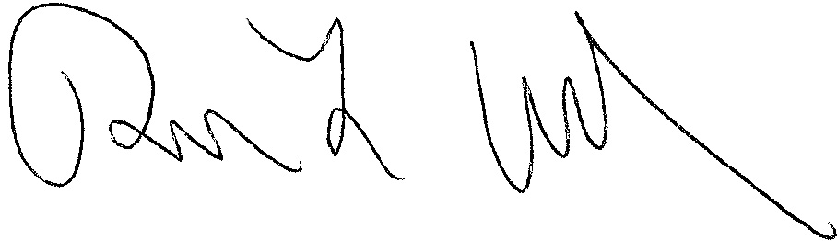

[% data.JUDG %]
[% data.TITLE %]

[% IF data.ccAddressList.size > 0 %]Copies furnished to:
[% FOREACH copy IN data.ccAddressList %][% copy %]
[% END %][% END %]

