IN THE CIRCUIT COURT OF THE FIFTEENTH JUDICIAL CIRCUIT
IN AND FOR PALM BEACH COUNTY, FLORIDA

[% data.casetype %] DIVISION [% data.DivisionID %]
CASE NO. [% data.extendedcaseid %]

[% FOREACH plaintiff IN data.PLT %][% plaintiff %],
[% END %] Plaintiff(s)
and
[% FOREACH defendant IN data.DFT %][% defendant %],
[% END %] Defendant(s).
/

MOTION, NOTICE AND ORDER OF DISMISSAL FOR LACK OF PROSECUTION

This matter came before the Court on its own motion. The Court finds that it on the face of the record that there have been no filings for a period of ten (10) months or more immediately preceding service of this Notice and no stay has been issued or approved by the Court. Pursuant to Florida Rule of Civil Procedure 1.420(e), if there are no filings within sixty (60) days following the service of this Notice, and no stay is issued or approved during such sixty (60) day period, this action may be dismissed by the Court on its own motion. This Court further finds that the Plaintiff has failed to comply with Administrative Order 3.312-3/13. It is therefore,

ORDERED AND ADJUDGED as follows:

- This action shall stand dismissed for lack of prosecution without further order of court unless a filing has been made within sixty (60) days from the date of this order or a stay has been issued or approved by this Court.

- Should the Plaintiff make a filing in order to avoid lack of prosecution, such filing shall include a statement as to why the Plaintiff failed to timely comply with Administrative Order 3.312-3/13.

- Should the Plaintiff make a filing in order to avoid lack of prosecution, Plaintiff shall also submit directly to Judge Richard L. Oftedal - Foreclosure Division - 205 North Dixie Highway, 4th Floor, West Sarasota, Florida 33401

  - A current, accurate service list for All parties, including plaintiff's counsel, defense counsel, and pro se defendants as appropriate (mailing and email addresses, as applicable); and

  - Pre-addressed, postage paid standard business size mailing envelopes for the entire service list, including plaintiff's counsel, with the case number referenced on the face of the envelope; and

  - An accurate and fully executed Foreclosure Case Status Form as attached to the Administrative Order.

- Failure to comply with the instructions in paragraph 2 and 3 of this Order may result in the imposition of sanctions up to and including dismissal of the action.

DONE AND ORDERED in West Sarasota Beach, Sarasota Beach County, Florida this [% data.today %].
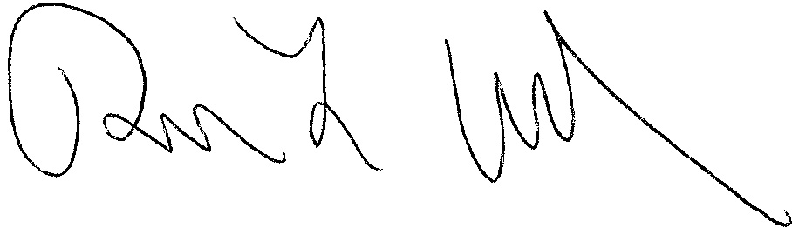
[% data.JUDG %]
[% data.TITLE %]

[% IF data.ccAddressList.size > 0 %]Copies furnished to:
[% FOREACH copy IN data.ccAddressList %][% copy %]
[% END %][% END %]

