FORM 1.998. FINAL DISPOSITION FORM
This form shall be filed by the prevailing party for the use of the Clerk of Court for the purpose of reporting judicial workload data pursuant to Florida Statutes section 25.075.

- CASE STYLE
([% IF data.isCircuit %]CIRCUIT[% ELSE %]COUNTY[% END %] COURT)
Case #: [% data.ucn %]
Judge: [% data.JUDG %]

[% IF data.PLT %][% FOREACH plaintiff IN data.PLT %][% plaintiff %],
[% END %] Plaintiff(s)
v.
[% FOREACH defendant IN data.DFT %][% defendant %],
[% END %] Defendant(s).[% ELSE %]
[% FOREACH petitioner IN data.PET %][% petitioner %],
[% END %] Petitioners(s)
v.
[% FOREACH respondent IN data.RESP %][% respondent %],
[% END %] Respondent(s).[% END %]
/

- MEANS OF FINAL DISPOSITION (Place an “x” in one box for major category and one subcategory, if applicable, only)
[[% IF data.dbh %]X[% ELSE %] [% END %]] Dismissed Before Hearing
[[% IF data.dpsbh %]X[% ELSE %] [% END %] ] Dismissed Pursuant to Settlement - Before Hearing
[[% IF data.dpmsbh %]X[% ELSE %] [% END %]] Dismissed Pursuant to Mediated Settlement - Before Hearing
[[% IF data.dobh %]X[% ELSE %] [% END %]] Other - Before Hearing
[[% IF data.dah %]X[% ELSE %] [% END %]] Dismissed After Hearing
[[% IF data.dpsah %]X[% ELSE %] [% END %]] Dismissed Pursuant to Settlement - After Hearing
[[% IF data.dpmsah %]X[% ELSE %] [% END %]] Dismissed Pursuant to Mediated Settlement - After Hearing
[[% IF data.doah %]X[% ELSE %] [% END %]] Other - After Hearing
[[% IF data.dbd %]X[% ELSE %] [% END %]] Disposed by Default
[[% IF data.dbj %]X[% ELSE %] [% END %]] Disposed by Judge
[[% IF data.dnjt %]X[% ELSE %] [% END %]] Disposed by Non-jury Trial
[[% IF data.djt %]X[% ELSE %] [% END %]] Disposed by Jury Trial
[[% IF data.other %]X[% ELSE %] [% END %]] Other

DATE [% data.today %].

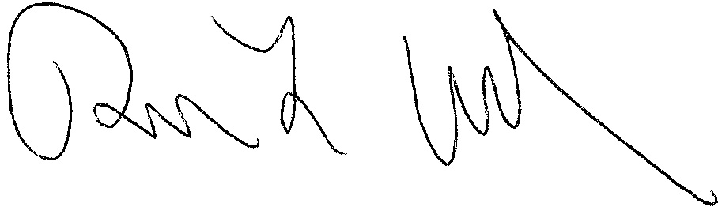

SIGNATURE OF
[% data.JUDG %]
[% data.TITLE %]

